Name: Adelotan Rafiat Mojisola.
Matric No.: 17/MHS01/018.
Department: MBBS.
Level: 300.
Course Title: Renal Physiology Body Fluid and Temperature Regulation.
Course Code: PHS 303.
Question:
- Discuss the pathophysiological process involved in renal failure.
- With the aid of suitable diagrams discuss the types of dialysis you know.
Question 1:
Renal failure is defined as a significant loss of renal function in both kidneys to the point where less than 10 to 20% of normal GFR remains. Renal failure may occur as an acute and rapidly progressing process or may present as a chronic form in which there is a progressive loss of renal function over a number of years. Acute renal failure has an abrupt onset and is potentially reversible. Chronic failure progresses slowly over at least three months and can lead to permanent renal failure.
Acute Renal Failure:
Sudden decrease in renal function. Acute renal failure may be pre-renal, intra-renal or post-renal in nature. Acute renal failure is often reversible so long as permanent injury to the kidney has not occurred.
Manifestations:
- Oliguria (reduced urine output)
- Possible edema and fluid retention
- Elevated blood urea nitrogen levels (BUN) and serum creatinine
- Alterations in serum electrolytes

Causes:
- Myocardial infarction
- Rhabdomyolysis
- Decreased blood flow
- Obstruction
- Hemolytic uremic syndrome
- Glomerulonephritis
Acute renal failure can be classified as pre-renal failure, intra-renal failure and post-renal failure.
- Pre-renal Failure: Results from impaired or reduced blood flow to the kidney. Possible causes: shock, hypotension, anaphylaxis, ischemic formation.
- Intra-renal failure: Results from acute damage to renal structures. Possible causes: acute glomerulonephritis, pyelonephritis. It may also result from acute tubular necrosis (ATN); damage of kidney structure from exposure to toxins, solvents, drugs and heavy metals. ATN is the most common cause of acute renal failure.
- Post-renal failure: Results from conditions block of urine outflow. Possible causes: obstruction of urine outflow by calculi, tumors, prostatic hypertrophy.
Symptoms:
- Decreased kidney function (electrolyte imbalance)
- Obstruction in the urinary tract
- Blood in urine
- Reduced urine output
- Dehydration
- Detectable abnormal mass
- Pale skin
- Poor appetite
Treatment:
- Prevention of acute renal failure through support of blood pressure and blood volume.
- Correction of fluid and electrolyte imbalances.
- Dialysis, which may be employed while the kidneys are in the recovery phase.
- Low protein, high carbohydrate diet to minimize the formation of nitrogenous wastes.
Chronic Renal Failure:
Chronic renal failure is the end result of progressive kidney damage and loss of function. Chronic renal failure is often classified into four progressive stages based on the loss of GFR.

Stages of Chronic Renal Failure:
- Diminished renal reserve: GFR decreased to 35 to 50% of normal
- Renal insufficiency: GFR decreased to 20 to 35% of normal
- Renal failure: GFR reduced to less than 20% of normal
- End-Stage Renal Disease: GFR is less than 5% of normal
Manifestation:
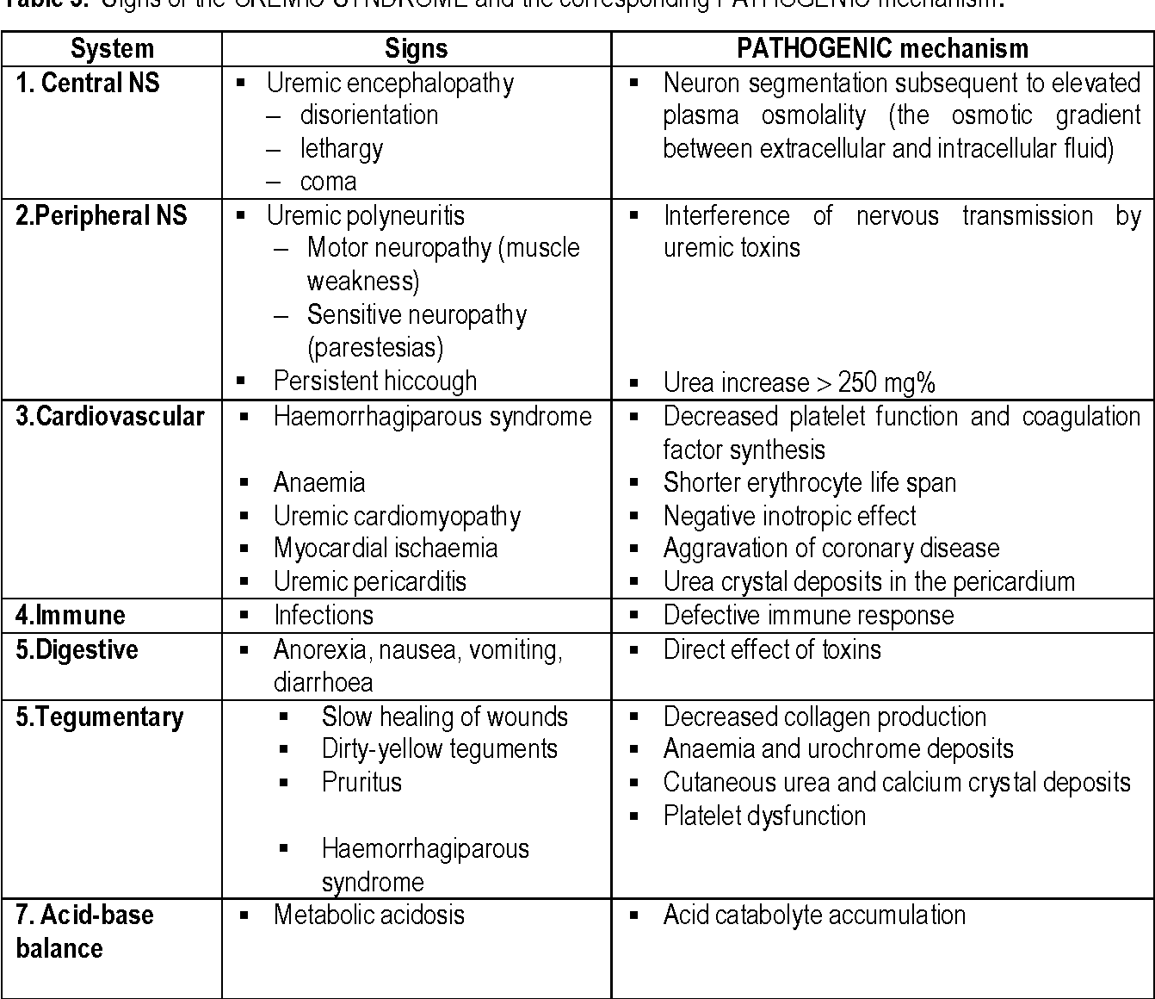
This is a multisystem disease:

Causes:
- Chronic glomerulonephritis
- Chronic infections
- Renal obstruction (prolonged)
- Exposure to toxic chemicals, toxins or drugs
- (aminoglycoside antibiotics and nephrotoxicity)
- Diabetes
- Hypertension
- Nephrosclerosis (atherosclerosis of the renal artery)
- Diabetic nephropathy
- Alport syndrome (inherited disorder causes deafness,
- progressive kidney damage and eye defects)
- Polycystic kidney disease
- Interstitial nephritis or pyelonephritis
Symptoms:
- Until very kidney function remains, chronic renal failure may not develop
- Anemia, increased levels of phosphates (in blood) are complications of kidney failure
- Malaise
- Dry skin
- Poor appetite
- Vomiting
- Bone pain
- Metallic taste in mouth
- Detectable abdominal mass
Treatment:
- Careful management of fluids and electrolytes
- Prudent use of diuretics
- Careful dietary management; restriction of dietary
- protein intake
- Recombinant erythropoietin to treat anemia
- Renal dialysis
- Renal transplantation

Question 2:
In medicine, dialysis is the process of removing excess water, solutes, and toxins from the blood in people whose kidneys can no longer perform these functions naturally. This is referred to as Renal Replacement Therapy.
There are 2 main types of dialysis, namely:
- Hemodialysis
- Peritoneal dialysis

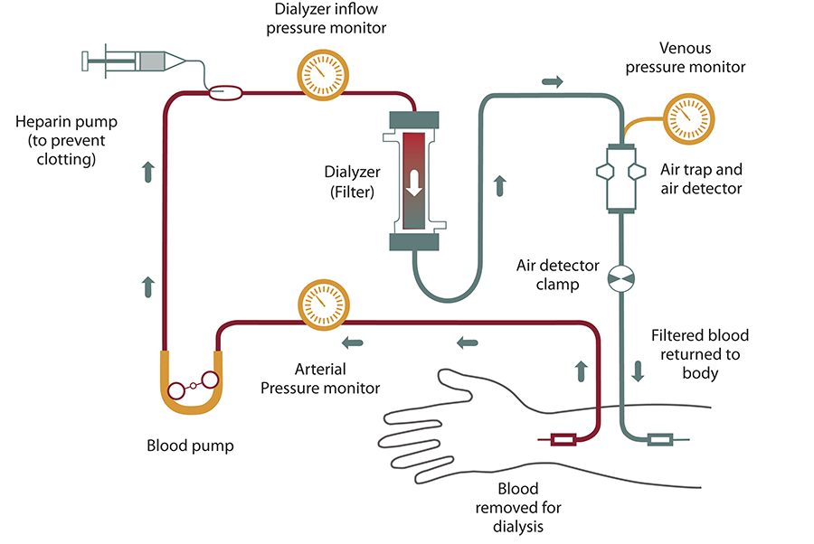
- Hemodialysis:

This is the most common type of dialysis. During hemodialysis, your blood goes through a filter, called a dialyzer, outside your body. A dialyzer is sometimes called an “artificial kidney”. The dialysis machine pumps blood through the filter and returns the blood to your body. During the process, the dialysis machine checks your blood pressure and controls how quickly:
- blood flows through the filter
- fluid is removed from your body
At the start of a hemodialysis treatment, a dialysis nurse or technician places two needles into your arm. In hemodialysis, the patient's blood is pumped through the blood compartment of a dialyzer, exposing it to a partially permeable membrane. The dialyzer is composed of thousands of tiny hollow synthetic fibers. The fiber wall acts as the semipermeable membrane. Blood flows through the fibers, dialysis solution flows around the outside of the fibers, and water and wastes move between these two solutions. The cleansed blood is then returned via the circuit back to the body. Ultrafiltration occurs by increasing the hydrostatic pressure across the dialyzer membrane This usually is done by applying a negative pressure to the dialysate compartment of the dialyzer. This pressure gradient causes water and dissolved solutes to move from blood to dialysate and allows the removal of several litres of excess fluid during a typical 4-hour treatment.
One important step before starting hemodialysis treatment is having minor surgery to create a vascular access. There are 3 types of vascular access:
- Arteriovenous (AV) Fistula:
This is the best type of long-term access is an AV fistula. The surgeon connects an artery to a vein, usually in your arm, to create an AV fistula. When an artery is connected to a vein, the vein grows wider and thicker, making it easier to place the needles for dialysis. The AV fistula also has a large diameter that allows your blood to flow out and back into your body quickly. The goal is to allow high blood flow so that the largest amount of blood can pass through the dialyzer. The AV fistula is considered the best option because it:
- provides highest blood flow for dialysis
- is less likely to become infected or clot
- lasts longer
An AV fistula needs 6 weeks or longer to heal before it can be used for hemodialysis. Then, it can be used for many years.
- Arteriovenous (AV) Graft:
If problems with your veins prevent you from having an AV fistula, you may need an AV graft instead. To create an AV graft, the surgeon uses a plastic tube to connect an artery to a vein under the skin. This heals in only 2 weeks, so hemodialysis can start faster. However, there is more likely to be problems with infection and blood clots. Repeated blood clots can block the flow of blood through the graft and make it hard or impossible to have dialysis.
- Central Venous Catheter:
This method is an option if you need to start hemodialysis very quickly. A flexible tube (catheter) is put into a vein in your neck, below your collarbone, or next to your groin. It’s only meant to be used for a short time.

Hemodialysis can be done in a hospital, a dialysis treatment center, or at home. If it is done in a center, the sessions last 3 to 5 hours, and you’ll likely only need them three times a week. If you have hemodialysis at home, you’ll need treatments 6 or 7 days for 2 to 3 hours each time.
Possible complications of hemodialysis include muscle cramps and hypotension. Hypotension may cause you to feel dizzy, weak or sick to your stomach. You can usually avoid side effects by following the proper diet and taking your medications.

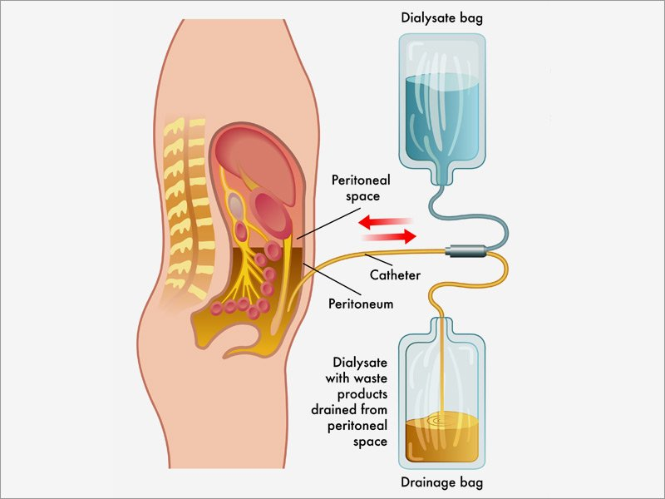
- Peritoneal Dialysis:

Peritoneal dialysis is a treatment for kidney failure that uses the lining (peritoneum) of your abdomen, or belly, to filter your blood inside your body. A few weeks before you start peritoneal dialysis, a surgeon places a soft tube, called a catheter, in your belly near your navel. In peritoneal dialysis, a sterile solution containing water with salt and other additives (called dialysate) is run through the catheter into the peritoneal cavity, the abdominal body cavity around the intestine, where the peritoneal membrane acts as a partially permeable membrane. It soaks up waste and extra fluids inside your body. After a few hours, you’ll drain it out into a separate bag. This process is called an “exchange”. This process takes a few hours and is repeated 4-6 times per day.
There are 2 types of peritoneal dialysis:
- Continuous ambulatory peritoneal dialysis (CAPD)
- Continuous cycling peritoneal dialysis (CCPD)
The main differences between the two types of peritoneal dialysis are:
- the schedule of exchanges
- one uses a machine and the other is done by hand

- Continuous Ambulatory Peritoneal Dialysis (CAPD):
You can do exchanges by hand in any clean, well-lit place. Each exchange takes about 30 to 40 minutes. During an exchange, you can read, talk, watch television, or sleep. With CAPD, you keep the solution in your belly for 4 to 6 hours or more. The time that the dialysis solution is in your belly is called the dwell time. Usually, you change the solution at least four times a day and sleep with solution in your belly at night. You do not have to wake up at night to do an exchange.

- Continuous Cycling Peritoneal Dialysis (CCPD):
It can also be called Automated Peritoneal Dialysis. In this case, a machine called a cycler fills and empties your belly three to five times during the night. In the morning, you begin the day with fresh solution in your belly. You may leave this solution in your belly all day or do one exchange in the middle of the afternoon without the machine.

Possible complications of peritoneal dialysis include an infection of the peritoneum, or peritonitis, where the catheter enters the body. Peritonitis causes fever and stomach pain. A dietician will help plan your diet during peritoneal dialysis, so we can ensure you are choosing appropriate meals.

