ABASIAKARA SAMUEL UMANA
17/MHS01/311
NEUROHISTOLOGY: ANA 305

ORGAN OF CORTI.

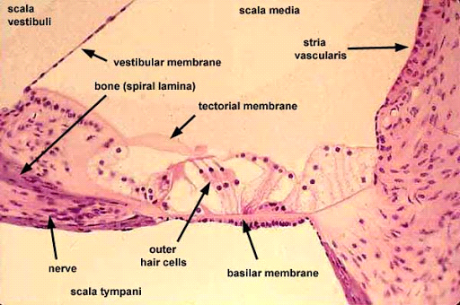
The organ of corti is part of the cochlea, it mediates sense of hearing and transducing pressure waves to action potentials. It is localized in the Scala media on the Basilar membrane and it contains 2 types of hair cells: Inner and outer hair cells, Nervous terminations of spiral ganglion and supporting cells. It covers the basilar membrane and its under the tectorial membarne(acellular gelatinous substance).
The organ of corti is a specialized sensory epithelium that allows for transduction of sound vibrations into neural signals. The apical ends of hair cells touch the tectorial membrane. When the basilar membrane flexes in respond to sound waves, the organ of Corti also moves.
The inner hair cells: are specialized in mechanoelectrical transduction. They are connected to type 1 neuron peripheral fibres of spiral aganglion, these connection are very divergent. Its luminal part is immerged in endolymph and the basal part is immersed in normal extracellular fluid. The luminal part is formed by bundles of stereocilia. They are about 3500 cells.
The outer hair cells: are acoustical pre-amplifiers. These are connected to type 2 amyelinic neurons, the connections are convergent. They have cntractile activity. They are about 1200 cells. In humans the arrangement of the outer hair cells in the basal turn of the cochlea is quite regular, with three distinct and orderly rows; but in the higher turns of the cochlea the arrangement becomes slightly irregular, as scattered cells form fourth or fifth rows. The spaces between the outer hair cells are filled by oddly shaped extensions (phalangeal plates) of the supporting cells.
Each hair cell has a cytoskeleton composed of filaments of the protein actin, which imparts stiffness to structures in which it is found. The hair cell is capped by a dense cuticular plate, composed of actin filaments, which bears a tuft of stiffly erect stereocilia, also containing actin, of graded lengths arranged in a staircase pattern. On the top of the inner hair cells 40 to 60 stereocilia are arranged in two or more irregularly parallel rows. On the outer hair cells approximately 100 stereocilia form a W pattern. At the notch of the W the plate is incomplete, with only a thin cell membrane taking its place. Beneath the membrane is the basal body of a kinocilium, although no motile ciliary (hairlike) portion is present as is the case on the hair cells of the vestibular system. The stereocilia are about 3 to 5 μm in length. The longest make contact with but do not penetrate the tectorial membrane. This membrane is an acellular gelatinous structure that covers the top of the spiral limbus as a thin fibrillar layer, then becomes thicker as it extends outward over the inner sulcus and the reticular lamina. Its fibrils extend radially and somewhat obliquely to end at its lateral border, just above the junction of the reticular lamina and the cells of Hensen. In the upper turns of the cochlea, the margin of the membrane ends in fingerlike projections that make contact with the stereocilia of the outermost hair cells.

Corti pillars: the most striking feature of the organ of Corti is the arch, or tunnel, of Corti, formed by two rows of pillar cells, or rods. The pillar cells contribute to the major support of this structure. They separate a single row of larger, pear-shaped inner hair cells from three or more rows of smaller, cylindrical outer hair cells. The inner hair cells are supported and enclosed by the inner phalangeal cells, which rest on the thin outer portion, called the tympanic lip, of the spiral limbus. On the inner side of the inner hair cells and the cells that support them is a curved furrow called the inner sulcus. This is lined with more or less undifferentiated cuboidal cells.
Deiter's cells: each outer hair cell is supported by a phalangeal cell of Deiters, or supporting cell, which holds the base of the hair cell in a cup-shaped depression. From each Deiters’ cell a projection extends upward to the stiff membrane, the reticular lamina, that covers the organ of Corti. The top of the hair cell is firmly held by the lamina, but the body is suspended in fluid that fills the space of Nuel and the tunnel of Corti. Although this fluid is sometimes referred to as cortilymph, its composition is thought to be similar, if not identical, to that of the perilymph
Hensen and Claudius cells: they help to maintain the composition of endolymph by ion transport and absorptive activity.

