NAME: ALAO BOLAJI WILLIAMS

MATRIC NO: 17/MHS01/049

CLASS: 300 LEVEL

COURSE: PHYSIOLOGY

ASSIGNMENT: 1.Discuss the pathophysiological process involved in renal failure. 2. With the aid of suitable diagrams discuss the types of dialysis you know.

1. Discuss the pathophysiological process involved in renal failure.

THE PATHOPHYSIOLOGICAL PROCESS INVOLVED IN RENAL FAILURE.
Renal failure refers to failure of excretory functions of kidney. It is usually, characterized by decrease in glomerular filtration rate (GFR). So GFR is considered as the best index of renal failure. However, decrease in GFR is not affected much during the initial stages of renal failure. If 50% of the nephrons are affected, GFR decreases only by 20% to 30%. It is because of the compensatory mechanism by the unaffected nephrons. The renal failure may be either acute or chronic. Renal failure is always accompanied by other complications such as:
- Deficiency of calcitriol (activated vitamin D) resulting in reduction of calcium absorption from intestine and hypocalcaemia. Deficiency of calcitriol and hypocalcaemia may cause secondary hyperparathyroidism in some patients
- Deficiency of erythropoietin resulting in anaemia
- Disturbances in acid­base balance.
It is of two types:
- Acute renal failure and
- Chronic renal failure.
Acute renal failure
Acute renal failure is the abrupt or sudden stoppage of renal functions. It is often reversible within few days to few weeks. Acute renal failure may result in sudden life-threatening reactions in the body with the need for emergency treatment.
CAUSES
- Acute nephritis (inflammation of kidneys), which usually develops by immune reaction
- Damage of renal tissues by poisons like lead, mercury and carbon tetrachloride
- Renal ischemia, which develops during circulatory shock
- Acute tubular necrosis (necrosis of tubular cells in kidney) caused by burns, haemorrhage, snake bite, toxins (like insecticides, heavy metals and carbon tetrachloride) and drugs (like diuretics, aminoglycosides and platinum derivatives)
Chronic renal failure
Chronic renal failure is the progressive, long standing and irreversible impairment of renal functions. When some of the nephrons loose the function, the unaffected nephrons can compensate it. However, when more and more nephrons start losing the function over the months or years, the compensatory mechanism fails and chronic renal failure develops.
CAUSES
- Chronic nephritis
- Polycystic kidney disease
- Renal calculi (kidney stones)
- Urethral constriction
- Hypertension

Distinguishing features of acute and chronic renal failure
Feature | Acute renal failure | Chronic renal failure
Onset | Sudden over days or to weeks | Gradual, over months or years
Reversibility | Invariably reversible | Usually irreversible
Causes | May be pre-renal or post-renal | Mostly renal may be extra renal
Urinary volume | Oliguria and anuria | Polyuria and nocturia
Signs and symptoms of uraemia | Of recent onset | Of recent onset
Characteristic features | Sudden reduction in GFR Rapid rise in blood pressure, urea and creatinine level  High urine osmolality (> 400 mOsm/kg water | Of chronicity, i.e. uraemic symptoms of long duration e.g. water retention, small-sized kidneys, anaemia, hypertension and so on
Dialysis | Required for short period | Repeated chronic maintenance dialysis required
Renal transplantation | Usually not required | Usually, is the final answer

2. With the aid of suitable diagrams discuss the types of dialysis you know.
DIALYSIS
The term dialysis in physiological sense refers to the diffusion of solutes from an area of higher concentration to the area of lower concentration through a semipermeable membrane. This principle has been used to dialyse the blood of patients with renal failure especially those developing uraemia.
By dialysis, the dissolved crystalloids of the plasma pass through a semipermeable membrane so that their levels are brought down to lower levels. Two types of dialysis procedures are available:
- Haemodialysis or artificial kidney and
- Peritoneal dialysis.
HAEMODIALYSIS OR ARTIFICIAL KIDNEY
Haemodialysis machine is also called artificial kidney. Haemodialysis is done in a hospitalized patient through intravenous (IV) line for 3–5 h. During haemodialysis, the patient’s radial artery is connected to the haemodialysis machine. Inside the haemodialysis machine, the blood is passed through a long and coiled cellophane tube immersed in a dialysis fluid. Heparin is used as an anticoagulant while passing the blood through the machine. Dialyzing fluid. The composition of a dialyzing fluid is similar to that of the plasma, except it is free of waste products like urea, uric acid, etc. The fluid contains less amount of sodium, potassium and chloride ions than in the uraemic blood. But the quantity of glucose, bicarbonate and calcium ions are more in the dialyzing fluid than in the uraemic blood. During haemolysis, the semipermeable cellophane membrane permits the free diffusion of the constituents of plasma except proteins. In this way, the dialysis of patient’s blood removes the toxic waste products and restores normal electrolyte concentration in the plasma. The dialysed blood is returned back to the patient’s body through a peripheral vein. At a time about 500 mL is passed through the artificial kidney. Haemodialysis is done usually thrice a week in severe uraemia. Haemodialysis can save the life in many types of acute renal failure. The intermittent haemodialysis may prolong the life of many patients with chronic renal failure, which may lead an active life for many useful years. The dialysis can partially replace the excretory function of the kidneys but does not replace endocrine and metabolic functions.
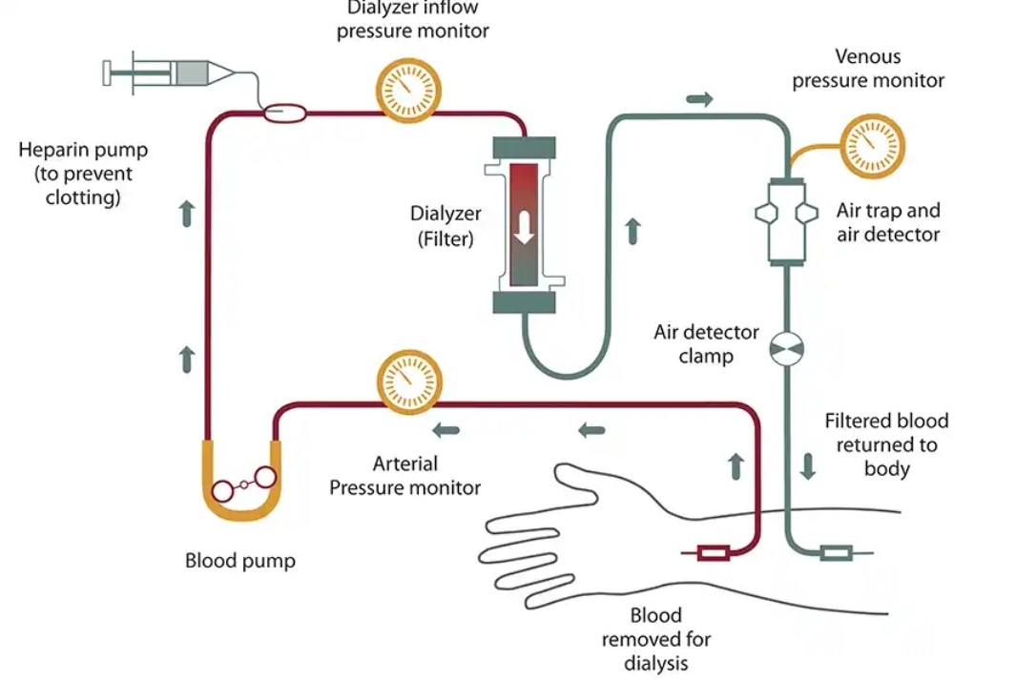
PERITONEAL DIALYSIS
Peritoneal dialysis is a form of long-term dialysis done by the patients at home or at work. In this type of dialysis, the peritoneum acts as a semipermeable membrane. Two litres of dialyzing fluid is introduced through an intraperitoneal catheter. It is then kept in the peritoneal cavity for exchange to take place for a period of 15–20 min called dwell time. Fluid is then drained out and measured. A strict input and output chart is maintained. The whole procedure constitutes one cycle. It is done at 6 h intervals (4 cycles/day), even when the patient is ambulatory or mobile. There is no need for hospitalization. It is useful for young children and old patients with cardiovascular disorders. It prolongs survival in patients with chronic renal failure for many years. Peritoneal dialysis is not very suitable for drug poisoning cases.
