NAME: ABIWO, ENIAYO AYOWOLE.
DEPARTMENT: MEDICINE AND SURGERY.
MATRIC NO: 17/MHS05/OO3.
COURSE: HISTOLOGY OF SPECIAL SENSES AND NEUROHISTOLOGY (ANA 305).
ASSIGNMENT TITLE: HISTOLOGY OF THE EAR.
QUESTION.
- With the aid of a diagram, write an essay on the histology of an organ of Corti.
ANSWER.
- DEFINITION.
The organ of Corti, or spiral organ, is the receptor organ for hearing and is located in the mammalian cochlea. The Organ of Corti includes three rows of outer hair cells and one row of inner hair cells. This highly varied strip of epithelial cells allows for transduction of auditory signals into nerve impulses' action potential. Transduction occurs through vibrations of structures in the inner ear causing displacement of cochlear fluid and movement of hair cells at the organ of Corti to produce electrochemical signals. Italian anatomist Alfonso Giacomo Gaspare Corti (1822–1876) discovered the organ of Corti in 1851. The structure evolved from the basilar papilla and is crucial for mechanotransduction in mammals.
SRUCTURE.
The organ of Corti is located in the Scala media of the cochlea of the inner ear between the vestibular duct and the tympanic duct and is composed of mechanosensory cells, known as hair cells. Strategically positioned on the basilar membrane of the organ of Corti are three rows of outer hair cells (OHCs) and one row of inner hair cells (IHCs). Separating these hair cells are supporting cells: Deiters cells, also called phalangeal cells, which separate and support both the OHCs and the IHCs.
Projecting from the tops of the hair cells are tiny finger like projections called stereo cilia, which are arranged in a graduated fashion with the shortest stereo cilia on the outer rows and the longest in the center. This
gradation is thought to be the most important anatomic feature of the organ of Corti because this allows the sensory cells superior tuning capability.
Viewed in cross section, the most striking feature of the organ of Corti is the arch, or tunnel, of Corti, formed by two rows of pillar cells, or rods. The pillar cells furnish the major support of this structure. They separate a single row of larger, pear-shaped inner hair cells from three or more rows of smaller, cylindrical outer hair cells. The inner hair cells are supported and enclosed by the inner phalangeal cells, which rest on the thin outer portion, called the tympanic lip, of the spiral limbus. On the inner side of the inner hair cells and the cells that support them is a curved furrow called the inner sulcus. This is lined with more or less undifferentiated cuboidal cells.
Each outer hair cell is supported by a phalangeal cell of Deiters, or supporting cell, which holds the base of the hair cell in a cup-shaped depression. From each Deiters’ cell a projection extends upward to the stiff membrane, the reticular lamina, that covers the organ of Corti. The top of the hair cell is firmly held by the lamina, but the body is suspended in fluid that fills the space of Nuel and the tunnel of Corti. Although this fluid is sometimes referred to as cortilymph, its composition is thought to be similar, if not identical, to that of the perilymph. Beyond the hair cells and the Deiters’ cells are three other types of epithelial cells, usually called the cells of Hensen, Claudius, and Boettcher, after the 19th-century anatomists who first described them. Their function has not been established, but they are assumed to help in maintaining the composition of the endolymph by ion transport and absorptive activity.
Each hair cell has a cytoskeleton composed of filaments of the protein actin, which imparts stiffness to structures in which it is found. The hair cell is capped by a dense cuticular plate, composed of actin filaments, which bears a tuft of stiffly erect stereocilia, also containing actin, of graded lengths arranged in a staircase pattern. This so-called hair bundle has rootlets anchored firmly in the cuticular plate. On the top of the inner hair cells 40 to 60 stereocilia are arranged in two or more irregularly parallel rows. On the outer hair cells approximately 100 stereocilia form a W pattern. At the notch of the W the plate is incomplete, with only a thin cell membrane taking its place. Beneath the membrane is the basal body of a kinocilium, although no motile ciliary (hair like) portion is present as is the case on the hair cells of the vestibular system.

The stereocilia are about 3 to 5 μm in length. The longest make contact with but do not penetrate the tectorial membrane. This membrane is an acellular gelatinous structure that covers the top of the spiral limbus as a thin fibrillar layer, then becomes thicker as it extends outward over the inner sulcus and the reticular lamina. Its fibrils extend radially and somewhat obliquely to end at its lateral border, just above the junction of the reticular lamina and the cells of Hensen. In the upper turns of the cochlea, the margin of the membrane ends in fingerlike projections that make contact with the stereocilia of the outermost hair cells.
The myelin-ensheathed fibers of the vestibulocochlear nerve fan out in spiral fashion from the modiolus to pass into the channel near the root of the osseous spiral lamina, called the canal of Rosenthal. The bipolar cell bodies of these neurons constitute the spiral ganglion. Beyond the ganglion their distal processes extend radially outward in the bony lamina beneath the limbus to pass through an array of small pores directly under the inner hair cells, called the habenula perforata. Here the fibers abruptly lose their multilayered coats of myelin and continue as thin, naked, unmyelinated fibers into the organ of Corti. Some fibers form a longitudinally directed bundle running beneath the inner hair cells and another bundle just inside the tunnel, above the feet of the inner pillar cells. The majority of the fibers (some 95 percent in the human ear) end on the inner hair cells. The remainder cross the tunnel to form longitudinal bundles beneath the rows of the outer hair cells on which they eventually terminate.
The endings of the nerve fibers beneath the hair cells are of two distinct types. The larger and more numerous endings contain many minute vesicles, or liquid-filled sacs, containing neurotransmitters, which mediate impulse transmission at neural junctions. These endings belong to a special bundle of nerve fibers that arise in the brainstem and constitute an efferent system, or feedback loop, to the cochlea. The smaller and less numerous endings contain few vesicles or other cell structures. They are the terminations of the afferent fibers of the cochlear nerve, which transmit impulses from the hair cells to the brainstem. The total number of outer hair cells in the cochlea has been estimated at 12,000 and the number of inner hair cells at 3,500. Although there are about 30,000 fibers in the cochlear nerve, there is considerable overlap in the innervation of the outer hair cells. A single fibre may supply endings to many hair cells, which thus share a “party line.” Furthermore, a single hair cell may receive nerve endings from many fibres. The actual distribution of nerve fibers in the organ of Corti has not been worked out in detail, but it is known that the inner hair cells receive the majority of afferent fiber endings without the overlapping and sharing of fibers that are characteristic of the outer hair cells.
Viewed from above, the organ of Corti with its covering, the reticular lamina, forms a well-defined mosaic pattern. In humans the arrangement of the outer hair cells in the basal turn of the cochlea is quite regular, with three distinct and orderly rows; but in the higher turns of the cochlea the arrangement becomes slightly irregular, as scattered cells form fourth or fifth rows. The spaces between the outer hair cells are filled by oddly shaped extensions (phalangeal plates) of the supporting cells. The double row of head plates of the inner and outer pillar cells covers the tunnel and separate the inner from the outer hair cells. The reticular lamina extends from the inner border cells near the inner sulcus to the Hensen cells but does not include either of these cell groups. When a hair cell degenerates and disappears as a result of aging, disease, or noise-induced injury, its place is quickly covered by the adjacent phalangeal plates, which expand to form an easily recognized “scar.”
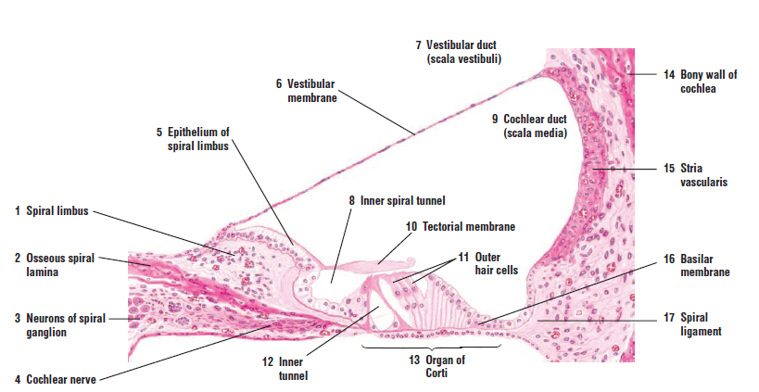
DIAGRAM SHOWING THE ORGAN OF CORTI.
FUNCTIONS.
The function of the organ of Corti is to change (transduce) auditory signals and minimize the hair cells’ extraction of sound energy. It is the auricle and middle ear that act as mechanical transformers and amplifiers so that the sound waves end up with amplitudes 22 times greater than when they entered the ear.
- Auditory transduction.
In normal hearing, the majority of the auditory signals that reach the organ of Corti in the first place come from the outer ear. Sound waves enter through the auditory canal and vibrate the tympanic membrane, also known as the eardrum, which vibrates three small bones called the ossicles. As a result, the attached oval window moves and causes movement of the round window, which leads to displacement of the cochlear fluid. However, the stimulation can happen also via direct vibration of the cochlea from the skull. The latter is referred to as Bone Conduction (or BC) hearing, as complementary to the first one described, which is instead called Air Conduction (or AC) hearing. Both AC and BC stimulate the basilar membrane in the same way.
The basilar membrane on the tympanic duct presses against the hair cells of the organ as perilymphatic pressure waves pass. The stereocilia atop the IHCs move with this fluid displacement and in response their cation, or positive ion selective, channels are pulled open by cadherin structures called tip links that connect adjacent stereocilia. The organ of Corti, surrounded in potassium rich fluid endolymph, lies on the basilar membrane at the base of the Scala media. Under the organ of Corti is the Scala tympani and above it, the scala vestibuli. Both structures exist in a low potassium fluid called perilymph. Because those stereocilia are in the midst of a high concentration of potassium, once their cation channels are pulled open, potassium ions as well as calcium ions flow into the top of the hair cell. With this influx of positive ions, the IHC becomes depolarized, opening voltage-gated calcium channels at the basolateral region of the hair cells and triggering the release of the neurotransmitter glutamate. An electrical signal is then sent through the auditory nerve and into the auditory cortex of the brain as a neural message.
- Cochlear amplification.
The organ of Corti is also capable of modulating the auditory signal. The outer hair cells (OHCs) can amplify the signal through a process called electro motility where they increase movement of the basilar and tectorial membranes and therefore increase deflection of stereocilia in the IHCs.
A crucial piece to this cochlear amplification is the motor protein prestin, which changes shape based on the voltage potential inside of the hair cell. When the cell is depolarized, prestin shortens, and because it is located on the membrane of OHCs it then pulls on the basilar membrane and increasing how much the membrane is deflected, creating a more intense effect on the inner hair cells (IHCs). When the cell hyperpolarizes prestin lengthens and eases tension on the IHCs, which decreases the neural impulses to the brain. In this way, the hair cell itself is able to modify the auditory signal before it even reaches the brain.
CLINICAL SIGNIFICANCE.
- Hearing loss: The organ of Corti can be damaged by excessive sound levels, leading to noise-induced impairment. The most common kind of hearing impairment, sensorineural hearing loss, includes as one major cause the reduction of function in the organ of Corti. Specifically, the active amplification function of the outer hair cells is very sensitive to damage from exposure to trauma from overly-loud sounds or to certain ototoxic drugs. Once outer hair cells are damaged, they do not regenerate, and the result is a loss of sensitivity and an abnormally large growth of loudness (known as recruitment) in the part of the spectrum that the damaged cells serve.
While hearing loss has always been considered irreversible in mammals, fish and birds routinely repair such damage.

