NAME: ALAO BOLAJI WILLIAMS

MATRIC NO: 17/MHS01/049

CLASS: 300 LEVEL

COURSE: NEUROHISTOLOGY

ASSIGNMENT: With the aid of a diagram, discuss the histology of the organ of corti.

The Organ of Corti is a part of the cochlea and it mediates the sense of hearing transducing pressure waves to action potentials. This structure is localized in the scala media and it is formed by a series of hair cells, nervous terminations of spiral ganglion and supporting cells.
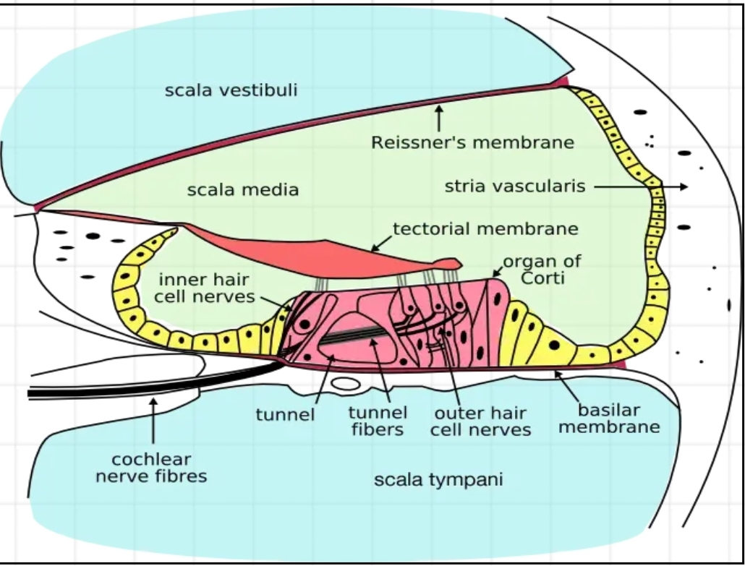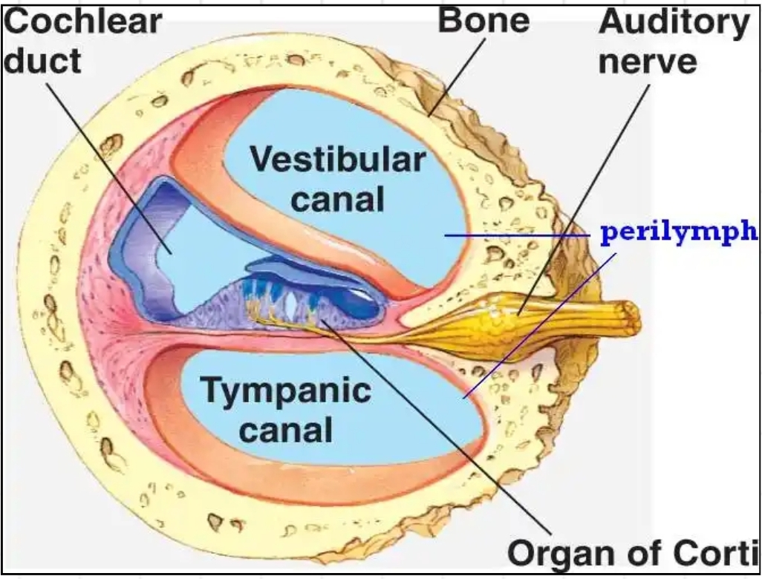
GROSS ANATOMY
The scala media, or cochlear duct, is located between scala tympani and scala vestibuli and it is filled with endolymph. This structure is delimited by the basilar membrane and Reissner’s membrane. The Organ of Corti covers the basilar membrane and it is under the tectorial membrane, an acellular gel into which hair cell stereocilia are immersed. The peripheral process of acoustic nerve fibers provides synaptic connections between hair cells and cochlear nucleus. The upper portion of the cochlear duct is formed by the stria vascularis, which contains numerous capillary loops and small blood vessels and produces endolymph.
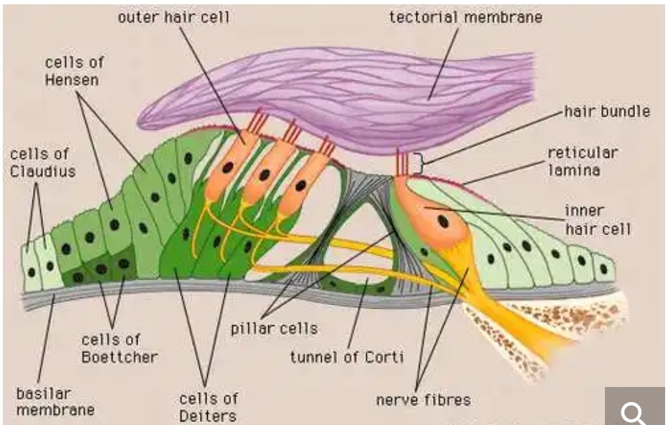
HISTOLOGY
Organ of Corti consists of different types of cells:*Inner hair cells, *Outer hair cells and *Supporting cells
Inner Hair Cell
These cells are specialized in the mechanoelectrical transduction. There are almost 3500 cells disposed in one line along all the basilar membrane. They are connected to type I neuron peripheral fibers of spiral ganglion, these connection are very divergent (10/1). The luminal part of the cell is immerged in endolymph, the basal one is immerged in normal extracellular fluid. The luminal portion is formed by bundles of stereocilia(inner_ear), whose tips are connected by filamentous structures called tip-links.
Outer Hair Cell
These cells are acoustical pre-amplifiers. They are almost 12000, disposed in three parallel lines. These cells are connected to type II amyelinic neurons, the connections are very convergent. They have also an afference from superior olivary nucleus. They have contractile activity. Myosin light chain kinase regulates hearing in mice by influencing the F-actin cytoskeleton of outer hair cells and cochleae.
Supporting Cells
These cells are of four different types: Corti pillars, Hensen cells, Deiters cells and Claudius cells.
Projecting from the tops of the hair cells are tiny finger like projections called stereocilia , which are arranged in a graduated fashion with the shortest stereocilia on the outer rows and the longest in the center. This gradation is thought to be the most important anatomic feature of the organ of Corti because this allows the sensory cells superior tuning capability.
If the cochlea were uncoiled, it would roll out to be about 33 mm long in women and 34 mm in men, with about 2.28 mm of standard deviation for the population. The cochlea is also tonotopically organized, meaning that different frequencies of sound waves interact with different locations on the structure. The base of the cochlea, closest to the outer ear, is the most stiff and narrow and is where the high frequency sounds are transduced. The apex, or top, of the cochlea is wider and much more flexible and loose and functions as the transduction site for low frequency sounds.
Endolymph Endolymph fills the scala media and it is produced by stria vascularis. Potassium secreted into the endolymph by the stria vascularis enters the hair cells through apical mechanosensitive channels. It is recycled back to the stria vascularis through supporting cells and fibrocytes of the spiral ligament for another round of secretion. Hair cells and stria vascularis are tied together in a "push-pull" or "pump-leak" balance that determines endocochlear potential (EP +85mV), endolymph composition and ultimately the sensivity and stability of hair cells and hearing over a lifetime. The evolutionary strategy of using K receptors currents is due to the fact that it reduces metabolic requirements because it has a passive outflow from hair cells to the basal membrane, instead of active Na extrusion.
Endolymph has a particular ion concentration
Ion Perilymph (mM) Endolymph (mM)
Na 154 1
K 3 161
Cl 128 131
There is a potential difference of -140 mV between endolymph and inner receptor.
Function of organ of corti
The function of the organ of Corti is to change ( transduce) auditory signals and minimise the hair cells’ extraction of sound energy. It is the auricle and middle ear that act as mechanical transformers and amplifiers so that the sound waves end up with amplitudes 22 times greater than when they entered the ear.
Auditory transduction
In normal hearing, the majority of the auditory signals that reach the organ of Corti in the first place come from the outer ear. Sound waves enter through the auditory canal and vibrate the tympanic membrane, also known as the eardrum, which vibrates three small bones called the ossicles . As a result, the attached oval window moves and causes movement of the round window , which leads to displacement of the cochlear fluid. However, the stimulation can happen also via direct vibration of the cochlea from the skull. The latter is referred to as Bone Conduction (or BC) hearing, as complementary to the first one described, which is instead called Air Conduction (or AC) hearing. Both AC and BC stimulate the basilar membrane in the same way. The basilar membrane on the tympanic duct presses against the hair cells of the organ as perilymphatic pressure waves pass. The stereocilia atop the IHCs move with this fluid displacement and in response their cation , or positive ion selective, channels are pulled open by cadherin structures called tip links that connect adjacent stereocilia. The organ of Corti, surrounded in potassium rich fluid endolymph , lies on the basilar membrane at the base of the scala media . Under the organ of Corti is the scala tympani and above it, the scala vestibuli . Both structures exist in a low potassium fluid called perilymph. Because those stereocilia are in the midst of a high concentration of potassium, once their cation channels are pulled open, potassium ions as well as calcium ions flow into the top of the hair cell. With this influx of positive ions the IHC becomes depolarized , opening voltage-gated calcium channels at the basolateral region of the hair cells and triggering the release of the neurotransmitter glutamate . An electrical signal is then sent through the auditory nerve and into the auditory cortex of the brain as a neural message.
Cochlear amplification
The organ of Corti is also capable of modulating the auditory signal. [7] The outer hair cells (OHCs) can amplify the signal through a process called electromotility where they increase movement of the basilar and tectorial membranes and therefore increase deflection of stereocilia in the IHCs. A crucial piece to this cochlear amplification is the motor protein prestin , which changes shape based on the voltage potential inside of the hair cell. When the cell is depolarized, prestin shortens, and because it is located on the membrane of OHCs it then pulls on the basilar membrane and increasing how much the membrane is deflected, creating a more intense effect on the inner hair cells (IHCs). When the cell hyperpolarizes prestin lengthens and eases tension on the IHCs, which decreases the neural impulses to the brain. In this way, the hair cell itself is able to modify the auditory signal before it even reaches the brain.
Clinical significance
Hearing loss
The organ of Corti can be damaged by excessive sound levels, leading to noise-induced impairment. The most common kind of hearing impairment, sensorineural hearing loss , includes as one major cause the reduction of function in the organ of Corti. Specifically, the active amplification function of the outer hair cells is very sensitive to damage from exposure to trauma from overly-loud sounds or to certain ototoxic drugs. Once outer hair cells are damaged, they do not regenerate, and the result is a loss of sensitivity and an abnormally large growth of loudness (known as recruitment ) in the part of the spectrum that the damaged cells serve.

