Name: GONTO SALIHU UMAR
MATRIC NUM: 17/MHS01/135
MBBS 300 LEVEL
ASSGNMENT (HISTOLOGY OF SPECIAL SENSES)
Question
- With the aid of a diagram, write an essay on the histology of an organ of Corti
The organ of Corti is an organ of the inner ear contained within the scala media of the cochlea. It resides on the basilar membrane, a stiff membrane separating the scala tympani and scala media. The scala media is a cavity within the cochlea that contains endolymph which has a high (150 mM) K+ concentration. The endolymph helps to regulate the electrochemical impulses of the auditory hair cells.
Cells found in the organ of corti
- Outer hair cells
- Inner hair cells
- Pillar cells
- Cells of dieters
- Cells of Boettcher
- Cells of Hensen
- Calls of Claudius

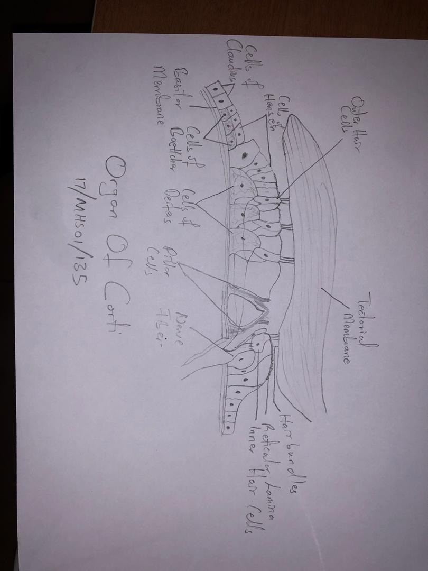
Arranged on the surface of the basilar membrane are orderly rows of the sensory hair cells, which generate nerve impulses in response to sound vibrations. Viewed in cross section, the most striking feature of the organ of Corti is the arch, or tunnel, of Corti, formed by two rows of pillar cells, or rods. The pillar cells furnish the major support of this structure. They separate a single row of larger, pear-shaped inner cells from three or more rows of smaller, cylindrical outer cells. The inner hair cells are supported and enclosed by the inner phalangeal cells, which rest on the thin outer portion, called the tympanic lip, of the spiral limbus. On the inner side of the inner hair cells and the cells that support them is a curved furrow called the inner sulcus. This is lined with more or less undifferentiated cuboidal cells.
Each outer hair cell is supported by a phalangeal cell of Deiters, or supporting cell, which holds the base of the hair cell in a cup-shaped depression. From each Deiters’ cell a projection extends upward to the stiff membrane, the reticular lamina,that covers the organ of Corti. The top of the hair cell is firmly held by the lamina, but the body is suspended in fluid that fills the space of Nuel and the tunnel of Corti. Although this fluid is sometimes referred to as cortilymph, its composition is thought to be similar, if not identical, to that of the perilymph. Beyond the hair cells and the Deiters’ cells are three other types of epithelial cells, usually called the cells of Hensen, Claudius, and Boettcher, after the 19th-century anatomists who first described them. Their function has not been established, but they are assumed to help in maintaining the composition of the endolymph by ion transport and absorptive activity.
Each hair cell has a cytoskeleton composed of filaments of the protein actin, which imparts stiffness to structures in which it is found. The hair cell is capped by a dense cuticular plate, composed of actin filaments, which bears a tuft of stiffly erect stereocilia , also containing actin, of graded lengths arranged in a staircase pattern. This so-called hair bundle has rootlets anchored firmly in the cuticular plate. On the top of the inner hair cells 40 to 60 stereocilia are arranged in two or more irregularly parallel rows. On the outer hair cells approximately 100 stereocilia form a W pattern. At the notch of the W the plate is incomplete, with only a thin cell membrane taking its place. Beneath the membrane is the basal body of a kinocilum, although no motile ciliary (hairlike) portion is present as is the case on the hair cells of the vestibular system. The stereocilia are about 3 to 5 μm in length. The longest make contact with but do not penetrate the tectorial membrane. his membrane is an acellular gelatinous structure that covers the top of the spiral limbus as a thin fibrillar layer, then becomes thicker as it extends outward over the inner sulcus and the reticular lamina. Its fibrils extend radially and somewhat obliquely to end at its lateral border, just above the junction of the reticular lamina and the cells of Hensen. In the upper turns of the cochlea, the margin of the membrane ends in fingerlike projections that make contact with the stereocilia of the outermost hair cells.
The myelin- ensheathed fibres of the vestibulocochlear nerve fan out in spiral fashion from the modiolus to pass into the channel near the root of the osseous spiral lamina, called the canal of Rosenthal. The bipolar cell bodies of these neurons constitute the spiral ganglion. Beyond the ganglion their distal processes extend radially outward in the bony lamina beneath the limbus to pass through an array of small pores directly under the inner hair cells, called the habenula perforata. Here the fibres abruptly lose their multilayered coats of myelin and continue as thin, naked, unmyelinated fibres into the organ of Corti. Some fibres form a longitudinally directed bundle running beneath the inner hair cells and another bundle just inside the tunnel, above the feet of the inner pillar cells. The majority of the fibres (some 95 percent in the human ear) end on the inner hair cells. The remainder crosses the tunnel to form longitudinal bundles beneath the rows of the outer hair cells on which they eventually terminate.

