Name: Nathan Sharon

Matric Number: 17/MHS01/196

Department: Medicine and Surgery

NEUROHISTOLOGY ASSIGNMENT

- With the aid of a diagram, write an essay on the histology of an organ of Corti

Introduction
The Organ of Corti is an organ of the inner ear located within the cochlea which contributes to audition. The Organ of Corti includes three rows of outer hair cells and one row of inner hair cells. Vibrations caused by sound waves bend the stereocilia on these hair cells via an electromechanical force. The hair cells convert mechanical energy into electrical energy that is transmitted to the central nervous system via the auditory nerve to facilitate audition.
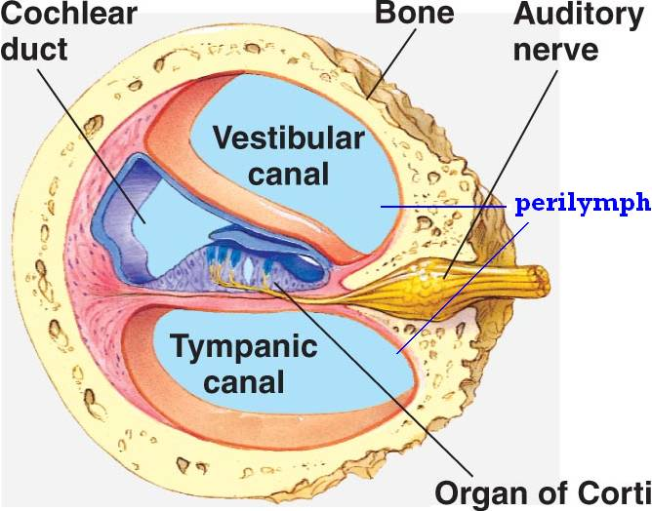

Histology of organ of Corti
The primary function of the organ of Corti is the transduction of auditory signals. Sound waves enter the ear via the auditory canal and cause vibration of the tympanic membrane. Movement of the tympanic membrane causes subsequent vibrations within the ossicles, the three bones of the middle ear which transfer the energy to the cochlea through the oval window. As the oval window moves, waves transfer to the perilymph fluid inside the scala tympani and then the scala vestibule of the cochlea. When fluid moves through these structures, the basilar membrane (located between the scala media and scala tympani) shifts respectively to the tectorial membrane.
The organ of Corti is an organ of the inner ear contained within the scala media of the cochlea. It resides on the basilar membrane, a stiff membrane separating the scala tympani and scala media. The scala media is a cavity within the cochlea that contains endolymph which has a high (150 mM) K+ concentration. The endolymph helps to regulate the electrochemical impulses of the auditory hair cells.
The organ of Corti is composed of both supporting cells and mechanosensory hair cells. The arrangement of mechanosensory cells are into inner and outer hair cells along rows. There is a single row of inner hair cells and three rows of outer hair cells which are separated by the supporting cells. The supporting cells are also named Dieters or phalangeal cells.
The hair cells within the organ of Corti have sterocilia that attach to the tectorial membrane. Shifts between the tectorial and basilar membranes move these sterocilia and activate or deactivate receptors on the hair cell surface. When cation channels open on the hair cells, potassium ions flow into the hair cells, the cells depolarize, and the depolarization causes voltage-gated calcium channels to open. The calcium influx results in glutamate release from the hair cells onto the auditory nerve. The auditory nerve then sends information about the sound wave to the brain.
Inner hair cells function primarily as the sensory organs for audition. They provide input to 95% of the auditory nerve fibers that project to the brain. The stiffness and size of the hair cell arrangement throughout the cochlea enable hair cells to respond to a variety of frequencies from low to high. Cells at the apex to respond to lower frequencies while hair cells at the base of the cochlea (near the oval window) respond to higher frequencies, which creates a tonotopic gradient throughout the cochlea.
While inner hair cells are the output center of the cochlea, the outer hair cells are the input center. They receive descending inputs from the brain to assist with the modulation of inner hair cell function (i.e., modulating tuning and intensity information). Unlike other regions of the brain, the modulation of inner hair cells by outer hair cells is not electrical but mechanical. Activation of outer hair cells changes the stiffness of their cell bodies; this manipulates the resonance of perilymph fluid movement within the scala media and allows for fine-tuning of inner hair cell activation.
Inner and outer hair cells are distinctly different in structure. Both types of hair cells have stereocilia on the apical surface; however, the arrangement of sterocilia and their connection to the tectorial membrane are distinctly different. For both types of hair cells, the mechanical bending of the sterocilia opens potassium channels at the tips of the sterocilia that allow hyperpolarization of the cells. The tallest of the stereocilia of outer hair cells are embedded into the tectorial membrane. These stereocilia get displaced as the basilar membrane moves with the tectorial membrane. The stereocilia of inner hair cells are free-floating. Movement of the viscous perilymph fluid provides the mechanical force to open these channels.
Inner hair cell activation is much more complicated than outer hair cell activation. The movement of fluid within the scala media relies on the resonance (vibration) of both the tectorial membrane and organ of Corti. Cells within the organ of Corti are much more flexible than cells within the basilar membrane. Alterations in the stiffness of these cells change the resonance of the organ of Corti and subsequently the movement of fluid within the scala media.
The outer hair cells alter the stiffness of the organ of Corti through a motor protein, prestin, located on the lateral membrane of these cells. These proteins vary in shape in response to voltage changes. Depolarization of the outer hair cells causes prestin to shorten, shifting the basilar membrane and increasing the membrane deflection, thereby intensifying the effect on the inner hair cells.
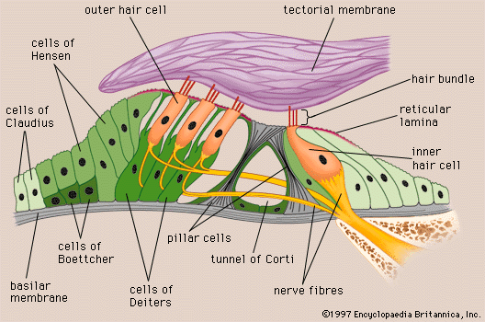

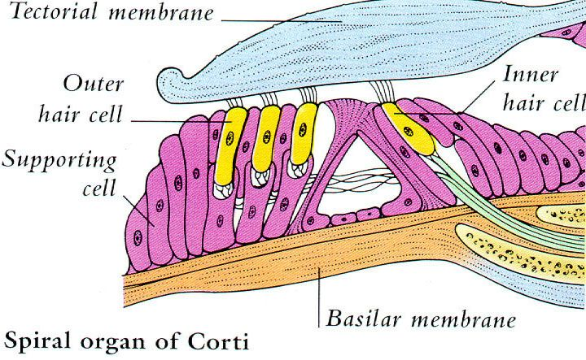

Clinical Significance
Sensorineural hearing loss is the most commonly reported cause of auditory deficits. This type of hearing loss often results from exposure to either loud sounds or ototoxic drugs. Exposure to loud noises causes the vibrational shift between the tectorial and basilar membranes to increase. This shift can damage the stereocilia of the outer hair cells. When damage occurs to the outer hair cells, the stiffness of the organ of Corti decreases which in turn increases vibrational forces on the inner hair cells. Damage to the outer hair cells decreases the protection of inner hair cells and causes them to become more sensitive. Over time, the inner hair cells will also become damaged and audition affected.
Aminoglycoside antibiotics are an example of ototoxic drugs. These drugs are K+ channel blockers. As such, they block the ability of both inner and outer hair cells to depolarize. These types of drugs can also change the concentration of ions within the perilymph which can lead to damage or death of both inner and outer hair cells; destruction of the hair cells causes permanent auditory deficits because they do not regenerate.

