NAME: Ibezim, Emily Chika
MATRIC NUMBER: 17/mhs01/143
COURSE TITLE: Histology of Special Senses and Neurohistology
COURSE CODE: ANA 305

QUESTION:
With the aid of a diagram, write an essay on the histology of on an organ of corti

ORGAN OF CORTI
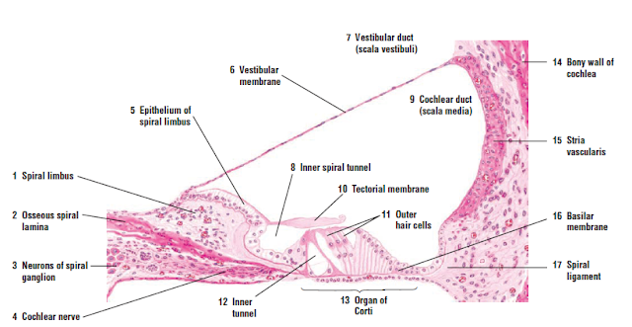
DEFINITION
The Organ of Corti is a part of the cochlea and it mediates the sense of hearing transducing pressure waves to action potentials. This structure is localized in the scala media and it is formed by a series of hair cells, nervous terminations of spiral ganglion and supporting cells.
It is a specialized sensory epithelium that allows for the transduction of sound vibrations into neural signals. The organ of Corti itself is located on the basilar membrane. The organ of Corti rests on the basilar membrane. Strategically positioned on the basilar membrane of the organ of Corti are three rows of outer hair cells (OHCs) and one row of inner hair cells (IHCs). Inner hair cells transduce sound from vibrations to neural signals via the shearing action of their stereocilia. Outer hair cells serve a function as acoustic pre-amplifiers which improve frequency selectivity by allowing the organ of Corti to become attuned to specific frequencies, like those of speech or music. Projecting from the tops of the hair cells are tiny finger like projections called stereocilia, which are arranged in a graduated fashion with the shortest stereocilia on the outer rows and the longest in the center.
The fibrous tectorial membrane rests on top of the stereocilia or the outer hair cells. Mutations in a alpha-tectorin, which encodes a protein specific to the tectorial membrane, cause deafness.
Organ of Corti consists of different types of cells:
*Inner hair cells
*Outer hair cells
*Supporting cells

Inner Hair Cell
These cells are specialized in the mechanoelectrical transduction. There are almost 3500 cells disposed in one line along all the basilar membrane. They are connected to type I neuron peripheral fibers of spiral ganglion, these connection are very divergent (10/1). The luminal part of the cell is immerged in endolymph, the basal one is immerged in normal extracellular fluid. The luminal portion is formed by bundles of stereocilia(inner_ear), whose tips are connected by filamentous structures called tip-links.
Outer Hair Cell
These cells are acoustical pre-amplifiers. They are almost 12000, disposed in three parallel lines. These cells are connected to type II amyelinic neurons, the connections are very convergent. They have also an afference from superior olivary nucleus. They have contractile activity.
Supporting Cells
These cells are of four different types: Corti pillars, Hensen cells, Deiters cells and Claudius cells.
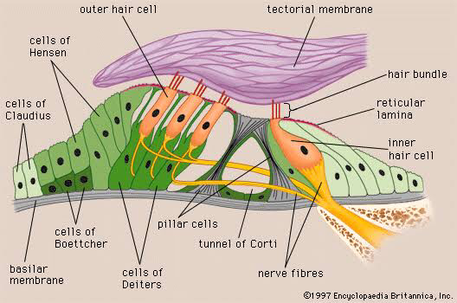
Diagram showing the Organ of Corti and its supporting cells.

Deiters' cells, also known as phalangeal cells or cells of Deiters, are a cell type found within the inner ear. They contain both micro-filaments and micro-tubules which run from the basilar membrane to the reticular membrane of the inner ear. They separate and support both the Outer Hair Cells and the Inner Hair Cells.
Beyond the hair cells and the Deiters’ cells are three other types of epithelial cells, usually called the cells of Hensen, Claudius, and Boettcher, after the 19th-century anatomists who first described them. Their function has not been established, but they are assumed to help in maintaining the composition of the endolymph by ion transport and absorptive activity.
In addition, Endolymph fills the scala media and it is produced by stria vascularis.

