NAME : ADAKU ENUNWA
MATRIC NUMBER:17/MHS01/117
DEPARTMENT:MEDICINE AND SURGERY
ASSIGNMENT: HISTOLOGY OF THE SPECIAL SENSES ( organ of corti)
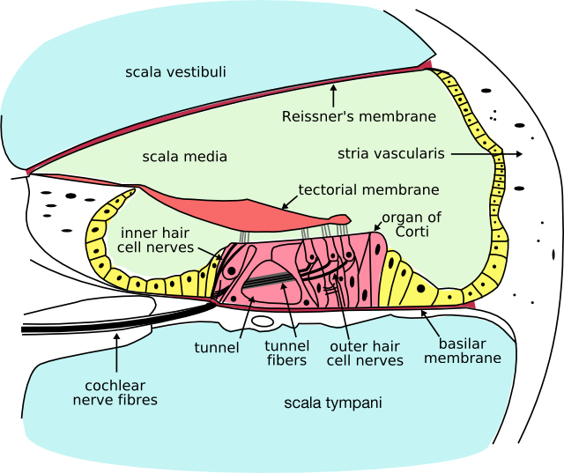
The organ of Corti is a specialized sensory epithelium that allows for the transduction of sound vibrations into neural signals. The organ of Corti itself is located on the basilar membrane. ... The fibrous tectorial membrane rests on top of the stereocilia or the outer hair cells.
The Organ of Corti is an organ of the inner ear located within the cochlea which contributes to audition. The Organ of Corti includes three rows of outer hair cells and one row of inner hair cells. Vibrations caused by sound waves bend the stereocilia on these hair cells via an electromechanical force.

HISTOLOGY
Organ of Corti consists of different types of cells:
*Inner hair cells
*Outer hair cells
*Supporting cells

Inner Hair Cell
These cells are specialized in the mechanoelectrical transduction. There are almost 3500 cells disposed in one line along all the basilar membrane. They are connected to type I neuron peripheral fibers of spiral ganglion, these connection are very divergent (10/1). The luminal part of the cell is immerged in endolymph, the basal one is immerged in normal extracellular fluid. The luminal portion is formed by bundles of sterocilia (inner_ear), whose tips are connected by filamentous structures called tip-links

Outer Hair Cell
These cells are acoustical pre-amplifiers. They are almost 12000, disposed in three parallel lines. These cells are connected to type II amyelinic neurons, the connections are very convergent. They have also an afference from superior olivary nucleus. They have contractile activity.

Supporting Cells
These cells are of four different types: Corti pillars, Hensen cells, Deiters cells and Claudius cells.

Endolymph
Endolymph fills the scala media and it is produced by stria vascularis.
Potassium secreted into the endolymph by the stria vascularis enters the hair cells through apical mechanosensitive channels. It is recycled back to the stria vascularis through supporting cells and fibrocytes of the spiral ligament for another round of secretion. Hair cells and stria vascularis are tied together in a "push-pull" or "pump-leak" balance that determines endocochlear potential (EP +85mV), endolymph composition and ultimately the sensivity and stability of hair cells and hearing over a lifetime.

