NAME: SUOWARI OYINEBI PASCHELIA
MATRIC NUMBER: 17/MHS01/299
DEPARTMENT: MEDICINE AND SURGERY
HISTOLOGY OF SPECIAL SENSES ASSIGNMENT
With the aid of a diagram, write an essay on the histology of an organ of Corti
ANSWER
The organ of Corti, also known as the spiral organ, is the receptor organ for hearing, located in the cochlea (housed inside the Scala media). It is a strip of sensory epithelium made of hair cells which act as the sensory receptors of the inner ear. The organ of Corti is a long strip of tissue that extends the length of the Scala media, from the base of the cochlea to its apex; it is usually illustrated in cross-section. Tissue sections of the cochlea typically contain several appearances of the organ of Corti, as the organ is sliced in each turn of the helix. The fluid environment for the organ of Corti is endolymph, which fills the Scala media. (Endolymph is secreted by cells of the stria vascularis.) The organ was discovered in 1851 by Italian anatomist Alfonso Giamoco Gaspare Corti (1822-1876).
Within the complex strip of tissue that comprises the organ of Corti are specialized sensory hair cells. The entire complex (the whole organ of Corti) rests on the basilar membrane. This basilar membrane supports the basal ends of the hair cells in the organ of Corti. The apical ends of hair cells touch the tectorial membrane, a "shelf" of jelly that is supported immovably on the spiral lamina. When the basilar membrane flexes in respond to sound waves (i.e., pressure waves delivered to inner-ear fluid by the middle-ear ossicles), the organ of Corti, including its hair cells, also moves. Thus, when the basilar membrane is moved by pressure waves (i.e., sound), the hair cells move relative to the tectorial membrane, causing stimulatory deflection of the apical ends of the hair cells.
The organ of Corti consists of different types of cells:
- Inner hair cells: These cells are specialized in the mechanoelectrical transduction. There are almost 3500 cells disposed in one line along all the basilar membrane. They are connected to type I neuron peripheral fibers of spiral ganglion, these connection are very divergent. The luminal part of the cell is immerged in endolymph; the basal one is immerged in normal extracellular fluid. The luminal portion is formed by bundles of stereocilia (inner ear), whose tips are connected by filamentous structures called tip-links. Molecular remodelling of tip links underlies mechanosensory regeneration in auditory hair cells. The composition and role of cross links in mechanoelectrical transduction in vertebrate sensory hair cells.
- Outer hair cells: These cells are acoustical pre-amplifiers. They are almost 12000, disposed in three parallel lines. These cells are connected to type II amyelinic neurons, the connections are very convergent. They have also afference from superior olivary nucleus. They have contractile activity. Myosin light chain kinase regulates hearing in mice by influencing the F-actin cytoskeleton of outer hair cells and cochleae.
- Supporting cells: These cells are of four different types:
- Corti pillars
- Hensen cells
- Deiters cells
- Claudius cells

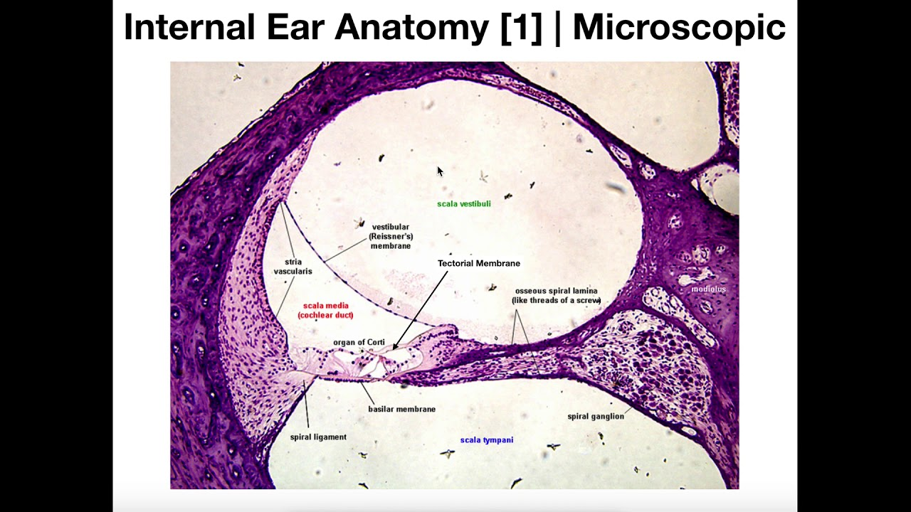
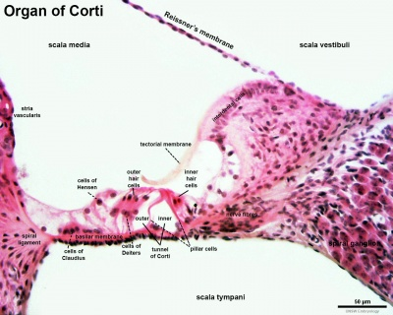

Functions of the organ of Corti
- The primary function of the organ of Corti is the transduction of auditory signals. Sound waves enter the ear via the auditory canal and cause vibration of the tympanic membrane. Movement of the tympanic membrane causes subsequent vibrations within the ossicles, the three bones of the middle ear which transfer the energy to the cochlea through the oval window. As the oval window moves, waves transfer to the perilymph fluid inside the Scala tympani and then the Scala vestibule of the cochlea. When fluid moves through these structures, the basilar membrane (located between the Scala media and Scala tympani) shifts respectively to the tectorial membrane. Transduction of signals occur either through the vibration of structures in the inner ear (air conduction) or through vibration of the skull (bone conduction), causing displacement of cochlear fluid (endolymph) and movement of hair cells in the organ of Corti, which in turn produces electrochemical signals that release the neurotransmitter glutamate and then signals the auditory (cochlear) nerve.
- Cochlear amplification: The organ of Corti is also capable of modulating the auditory signal. The outer hair cells (OHCs) can amplify the signal through a process called electro motility where they increase movement of the basilar and tectorial membranes and therefore increase deflection of stereocilia in the IHCs. A crucial piece to this cochlear amplification is the motor protein pristine, which changes shape based on the voltage potential inside of the hair cell. When the cell is depolarized, prestin shortens, and because it is located on the membrane of OHCs it then pulls on the basilar membrane and increasing how much the membrane is deflected, creating a more intense effect on the inner hair cells (IHCs). When the cell hyperpolarizes prestin lengthens and eases tension on the IHCs, which decreases the neural impulses to the brain. In this way, the hair cell itself is able to modify the auditory signal before it even reaches the brain.

Clinical significance
- Sensorineural hearing loss is the most commonly reported cause of auditory deficits. This type of hearing loss often results from exposure to either loud sounds or ototoxic drugs. Exposure to loud noises causes the vibrational shift between the tectorial and basilar membranes to increase. This shift can damage the stereocilia of the outer hair cells. When damage occurs to the outer hair cells, the stiffness of the organ of Corti decreases which in turn increases vibrational forces on the inner hair cells. Damage to the outer hair cells decreases the protection of inner hair cells and causes them to become more sensitive. Over time, the inner hair cells will also become damaged and audition affected.
- A cochlear implant is inserted into the Scala tympani, where it lies close to the organ of Corti and can artificially stimulate axons of the auditory nerve.

