UDOUKPO BLESSING OLIVER
17/MHS01/309

The organ of curti is an organ of the inner ear located within the cochlea which contributes to the audition. The Organ of Corti includs 3 rows of outer hair cells and 1 row of inner ear cells. This strusture is localized in the scale media and it is formed by a aseries of hair cells, nervous terminations of spiral ganglion and supporting cells.

INNER HAIR CELLS
These cells are specialized in the mechanoelectrical transduction. There are almost 3500 cells disposed in one line along all the basilar membrane. They are connected to type I neuron peripheral fibers of spiralganglion, these connections are very divergent. The luminal part of the cell is immerged in endolymph, the basal one is immerged in normal extracellular fluid. The luminal portion is formed by bundles of sterocillia, whose tips are connected by filamentous structures called tip links.

- Hair cells are housed within an elaborately-shaped chamber called the membranous labyrinth.
- The membranous labyrinth is filled with a unique fluid called endolymph, secreted by cells of the stria vascularis. Endolymph differs substantially from all other fluids of the body and provides a special fluid environment for the hair cells
- The membranous labyrinth includes interconnection among the cochlea, saccule, utricle, and semicircular canals.
- The membranous labyrinth is housed within the bony labyrinth.
- Perilymph fills the space of the bony labyrinth around the membranous labyrinth.

BONY LABYRINTH and MEMBRANOUS LABYRINTH
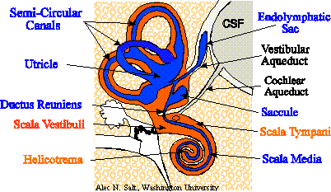
Image courtesy Alec Salt, Cochlear Fluids Laboratory, Washington University; used with permission.
The inner ear resides within a space called the bony labyrinth.
- The oval window forms a potential opening from the middle ear into the bony labyrinth.
  - The stapes of the middle ear plugs this opening; but . . .
  - The stapes is flexibly attached and can vibrate to transmit pressure waves to the fluid that fills the bony labyrinth. (Sound is carried from the eardrum across the middle ear by the three middle ear ossicles, ending with the stapes at the oval window.)

Suspended within the bony labyrinth, and approximating its shape, is an interconnected set of membrane-lined chambers and passageways called the membranous labyrinth.
- In the diagram, the color orange occupies the space of the bony labyrinth, while the membranous labyrinth is blue.
- The name labyrinth suggests the complex shape of these chambers and passageways.
  - The vestibule is (logically enough) the "entry room" into the deeper passageways.
    - The vestibule of the bony labyrinth contains the saccule and utricle of the membranous labyrinth;
  - Three semicircular canals comprise looping tubules which leave and return to the vestibule.
    - Within each semicircular canal of the bony labyrinth is a semicircular canal of the membranous labyrinth.
  - The cochlea is shaped like a snail-shell which spirals away from the vestibule.
    - A single coiled tunnel of the bony labyrinth is subdivided into three levels ("scalae") by membranes of the membranous labyrinth.
    - The portion of the membranous labyrinth within the cochlea is called the scala media.
- Inside the membranous labyrinth is a unique fluid called endolymph. Surrounding the membranous labyrinth (i.e., filling the remaining space of the bony labyrinth) is a fluid called perilymph.

