NAME: OBUNADIKE CHINENYE BLESSING
MATRIC NUMBER 17/MHS01/225
COURSE TITLE: HISTOLOGY OF SPECIAL SENSES AND NEUROHISTOLOGY
COURSE CODE: ANA 305

QUESTION
WITH THE AID OF A DIAGRAM, WRITE AN ESSAY ON THE HISTOLOGY OF AN ORGAN OF CORTI.

INTRODUCTION

The Organ of Corti is a part of the cochlea and it mediates the sense of hearing transducing pressure waves to action potentials. This structure is localized in the scala media and it is formed by a series of hair cells, nervous terminations of spiral ganglion and supporting cells.

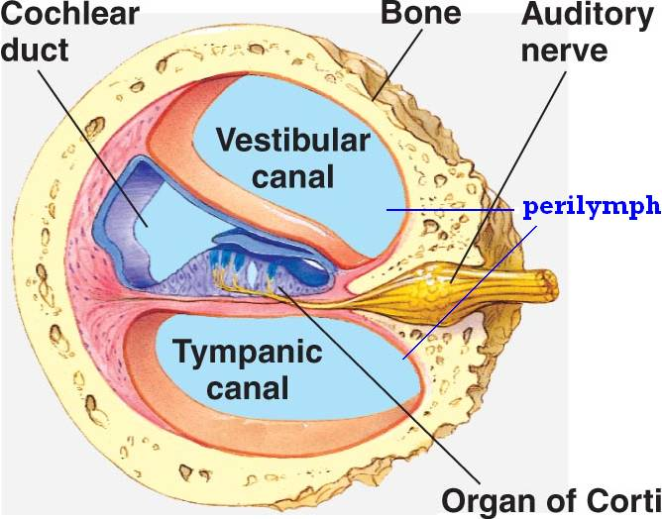
Diagram showing the position of the organ of corti within the cochlea

GROSS ANATOMICALLY, The scala media, or cochlear duct, is located between scala tympani and scala vestibuli and it is filled with endolymph. This structure is delimited by the basilar membrane and Reissner’s membrane. The Organ of Corti covers the basilar membrane and it is under the tectorial membrane, an acellular gel into which hair cell stereocilia are immersed. The peripheral process of acoustic nerve fibers provides synaptic connections between hair cells and cochlear nucleus. The upper portion of the cochlear duct is formed by the stria vascularis, which contains numerous capillary loops and small blood vessels and produces endolymph.

COCHLEA

The cochlea is a spiral cavity containing the organ of corti that is responsible for converting fluid waves into nerve signals using hair cells that are interpreted by the central nervous system. The cochlea is made up of three chambers(vestibular duct,tympanic duct and cochlear duct) The structures identified within the cochlear include;
- Outer spiral ligament - periosteum of outer wall of cochlear duct
- Spiral prominence - thickened region of outer spiral ligament adjacent to stria vascularis
- Stria vascularis - portion of spiral ligament lined by vascularized stratified epithelium, secretes endolymph
- Bipolar ganglion cells of spiral ganglion and their processes
- Organ of corti.

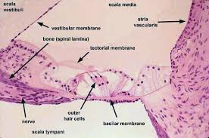
Histological representation of the cochlea showing the structures within

THE ORGAN OF CORTI
The Organ of Corti is an organ of the inner ear located within the cochlea which contributes to audition. The Organ of Corti includes three rows of outer hair cells and one row of inner hair cells. Vibrations caused by sound waves bend the stereocilia on these hair cells via an electromechanical force. The hair cells convert mechanical energy into electrical energy that is transmitted to the central nervous system via the auditory nerve to facilitate audition.

STRUCTURE AND FUNCTION

The primary function of the organ of Corti is the transduction of auditory signals. Sound waves enter the ear via the auditory canal and cause vibration of the tympanic membrane. Movement of the tympanic membrane causes subsequent vibrations within the ossicles, the three bones of the middle ear which transfer the energy to the cochlea through the oval window. As the oval window moves, waves transfer to the perilymph fluid inside the scala tympani and then the scala vestibule of the cochlea. When fluid moves through these structures, the basilar membrane (located between the scala media and scala tympani) shifts respectively to the tectorial membrane.
The organ of Corti is an organ of the inner ear contained within the scala media of the cochlea . It resides on the basilar membrane, a stiff membrane separating the scala tympani and scala media. The scala media is a cavity within the cochlea that contains endolymph which has a high (150 mM) K+ concentration. The endolymph helps to regulate the electrochemical impulses of the auditory hair cells.

THE CELLS OF ORGAN OF CORTI
The organ of corti has several cells, they include;

- Limbus spiralis - periosteal connective tissue at the inner angle of the scala media from which the vestibular lip protrudes
- Vestibular lip - pointed tip of the limbus spiralis from which the tectorial membrane arises
- Tectorial membrane - secretory product of cells of vestibular lip (proteoglycans and fine fibers), overlying organ of Corti
- Inner border cells - lining of internal spiral tunnel (inner spiral sulcus) from vestibular lip to inner hair cells
- Inner hair cells - single row of hair cells near internal spiral lamina
- Phalangeal cells (inner and outer) - support inner and outer hair cells
- Outer hair cells - external hair cells, arranged in three rows
- Inner and outer pillar cells - form borders of inner tunnel
- Inner tunnel - space formed by inner and outer pillar cells across which fibers of the cochlear nerve pass
- Supporting cells external to outer phalangeal cells (cells of Hensen, Claudius and Boettcher)
- Outer tunnel - space between outer phalangeal cells and cells of Hensen
- Habenula perforata – this is the region in the osseous spiral lamina where nerves enter and exit the organ of Corti.
Generally, the organ of corti can be divided into three broad cell types. They include;

- Outer hair cells
- Inner hair cells
- Supporting cells

Inner Hair Cell
These cells are specialized in the mechanoelectrical transduction. There are almost 3500 cells disposed in one line along all the basilar membrane. They are connected to type I neuron peripheral fibers of spiral ganglion, these connection are very divergent (10/1). The luminal part of the cell is immerged in endolymph, the basal one is immerged in normal extracellular fluid. The luminal portion is formed by bundles of stereocilia(inner_ear), whose tips are connected by filamentous structures called tip-links. Inner hair cells function primarily as the sensory organs for audition. They provide input to 95% of the auditory nerve fibers that project to the brain.[1] The stiffness and size of the hair cell arrangement throughout the cochlea enable hair cells to respond to a variety of frequencies from low to high. Cells at the apex to respond to lower frequencies while hair cells at the base of the cochlea (near the oval window) respond to higher frequencies, which creates a tonotopic gradient throughout the cochlea.

Outer Hair Cell
Outer hair cells (OHC) occur in three rows near the oval window, increasing to five rows near the apex of the cochlea. These cells are acoustical pre-amplifiers. They are almost 12000, disposed in three parallel lines. These cells are connected to type II amyelinic neurons, the connections are very convergent. They have also an afference from superior olivary nucleus. They have contractile activity. The outer hair cells alter the stiffness of the organ of Corti through a motor protein, prestin, located on the lateral membrane of these cells. These proteins vary in shape in response to voltage changes. Depolarization of the outer hair cells causes prestin to shorten, shifting the basilar membrane and increasing the membrane deflection, thereby intensifying the effect on the inner hair cells

Supporting Cells

These cells are of four different types: Corti pillars, Hensen cells, Deiters cells and Claudius cells.
Endolymph
Endolymph fills the scala media and it is produced by stria vascularis.
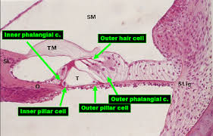
Diagram of the organ of corti showing the different cells

The function of the organ of Corti, for a soft sound (such as speech), can schematically be summed up in 5 sequences:
(1) Sound waves, transmitted by the perilymph, make the basilar membrane vibrate up and down. Passive tonotopy mobilises the basilar membrane from the base (high sounds) to the apex (low sounds) of the cochlea
(2) Stereocilia of the OHCs, embedded to the tectorial membrane, bend when the basilar membrane rises, causing the OHCs to depolarise (by the influx of K+ ions).
(3) Excited (depolarised) OHCs react by contracting (= electromotility). Due to the close link between the OHCs, the basilar membrane, and the reticular lamina, this active mechanism creates energy that amplifies the initial vibration. It also plays a role in active frequency filtering (active tonotopy).
(4) The IHC is excited, probably via direct contact with Hensen’s stripe within the tectorial membrane.
(5) The synapse between the IHC and the auditory nerve fibre is activated, and a message is sent to the brain.

FUNCTION OF ORGAN OF CORTI IN HEARING

As sound waves enter the ear, they travel through the outer ear, the external auditory canal, and strike the eardrum causing it to vibrate.
The central part of the eardrum is connected to a small bone of the middle ear called the malleus (hammer). As the malleus vibrates, it transmits the sound vibrations to the other two small bones or ossicles of the middle ear, the incus and stapes.
As the stapes moves, it pushes a structure called the oval window in and out. This action is passed onto the cochlea, which is a fluid-filled snail-like structure that contains the receptor organ for hearing.
The cochlea contains the spiral organ of Corti, which is the receptor organ for hearing. It consists of tiny hair cells that translate the fluid vibration of sounds from its surrounding ducts into electrical impulses that are carried to the brain by sensory nerves.
As the stapes rocks back and forth against the oval window, it transmits pressure waves of sound through the fluid of the cochlea, sending the organ of Corti in the cochlear duct into motion. The fibers near the cochlear apex resonate to lower frequency sound while fibers near the oval window respond to higher frequency sound.

CLINICAL SIGNIFICANCE.
HEARING LOSS
The organ of Corti can be damaged by excessive sound levels, leading to noise-induced impairment. The most common kind of hearing impairment, sensorineural hearing loss, includes as one major cause the reduction of function in the organ of Corti. Specifically, the active amplification function of the outer hair cells is very sensitive to damage from exposure to trauma from overly-loud sounds or to certain ototoxic drugs. Once outer hair cells are damaged, they do not regenerate, and the result is a loss of sensitivity and an abnormally large growth of loudness (known as recruitment) in the part of the spectrum that the damaged cells serve

