OMOTOSO MOYOSOREOLUWA OMONE
17/MHS01/259
Medicine and Surgery
ANA 305: Histology of Special Senses and Neurohistology
Histology of the Ear assignment

Question 1
With the aid of a diagram, write an essay on the histology of an organ of Corti.
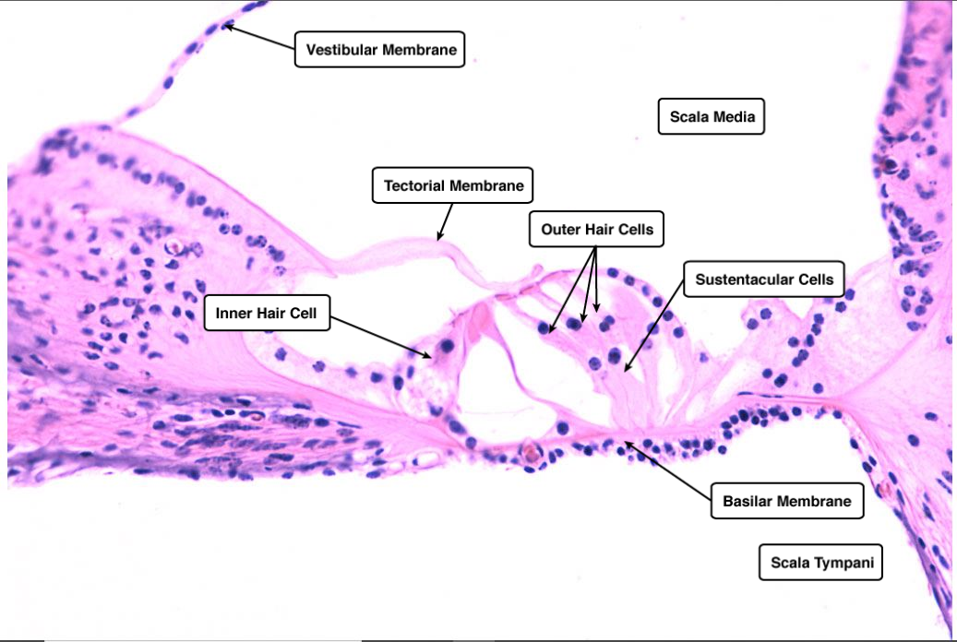
The Organ of Corti is an organ of the inner ear located within the cochlea which contributes to hearing. The Organ of Corti includes three rows of outer hair cells and one row of inner hair cells. Vibrations caused by sound waves bend the stereocilia on these hair cells via an electromechanical force. The hair cells convert mechanical energy into electrical energy that is transmitted to the central nervous system via the auditory nerve to facilitate hearing. Italian anatomist Alfonso Giacomo Gaspare Corti discovered the organ of Corti in 1851.
The primary function of the organ of Corti is the transduction of auditory signals. Sound waves enter the ear via the auditory canal and cause vibration of the tympanic membrane. Movement of the tympanic membrane causes subsequent vibrations within the ossicles, the three bones of the middle ear which transfer the energy to the cochlea through the oval window. As the oval window moves, waves transfer to the perilymph fluid inside the scala tympani and then the scala vestibule of the cochlea. When fluid moves through these structures, the basilar membrane, located between the scala media and scala tympani, shifts respectively to the tectorial membrane.
The organ of Corti is an organ of the inner ear contained within the scala media of the cochlea. It resides on the basilar membrane, a stiff membrane separating the scala tympani and scala media. The scala media is a cavity within the cochlea that contains endolymph, a fluid which has a high potassium ion concentration. The endolymph helps to regulate the electrochemical impulses of the auditory hair cells.
The organ of Corti is composed of both supporting cells and mechanosensory hair cells. The arrangement of mechanosensory cells are into inner and outer hair cells along rows. There is a single row of inner hair cells and three rows of outer hair cells which are separated by the supporting cells. The supporting cells are also named Dieters or phalangeal cells.
Inner hair cells function primarily as the sensory organs for audition. They provide input to 95% of the auditory nerve fibers that project to the brain. The stiffness and size of the hair cell arrangement throughout the cochlea enable hair cells to respond to a variety of frequencies from low to high.
While inner hair cells are the output center of the cochlea, the outer hair cells are the input center. They receive descending inputs from the brain to assist with the modulation of inner hair cell function (i.e., modulating tuning and intensity information). Unlike other regions of the brain, the modulation of inner hair cells by outer hair cells is not electrical but mechanical. 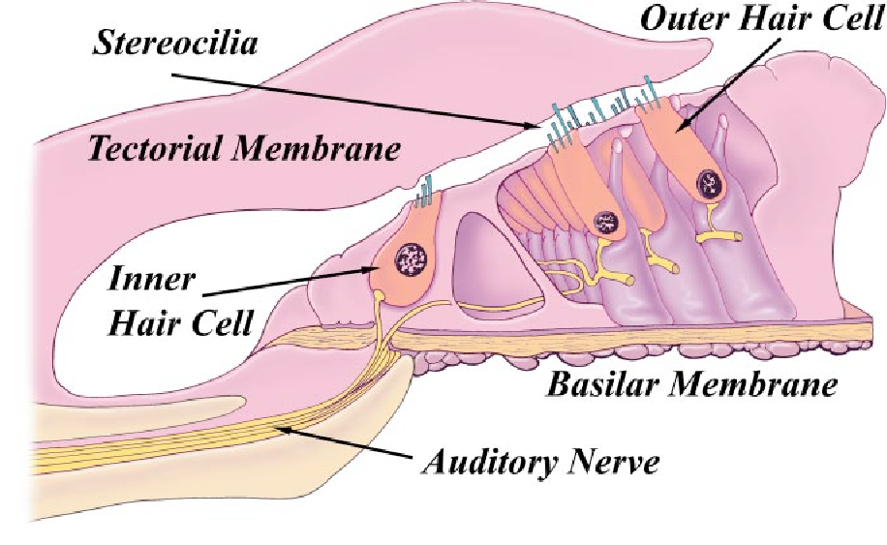

Inner and outer hair cells are distinctly different in structure. Both types of hair cells have stereocilia on the apical surface; however, the arrangement of sterocilia and their connection to the tectorial membrane are distinctly different. For both types of hair cells, the mechanical bending of the sterocilia opens potassium channels at the tips of the sterocilia that allow hyperpolarization of the cells. The tallest of the stereocilia of outer hair cells are embedded into the tectorial membrane. These stereocilia get displaced as the basilar membrane moves with the tectorial membrane. The stereocilia of inner hair cells are free-floating. Movement of the viscous perilymph fluid provides the mechanical force to open these channels.

