NEUROHISTOLOGY ASSIGNMENT
NAME: OLORUNFEMI PEACE TOLUWALASE
MATRIC NO: 17/MHS01/257
DEPT: MBBS

QUESTION
With the aid of diagram, write an essay on the histology of the organ of corti.
The organ of Corti is a specialized sensory epithelium that allows for the transduction of sound vibrations into neural signals. The organ of Corti is located in the scala media of the cochlea of the inner ear between the vestibular duct and the tympanic duct and is composed of mechanosensory cells.
Transduction occurs through vibrations of structures in the inner ear causing displacement of cochlear fluid and movement of hair cells at the organ of Corti to produce electrochemical signals. It is located in the mammalian cochlea. The organ of Corti itself is located on the basilar membrane.
The organ of Corti rests on the basilar membrane and contains two types of hair cells: inner hair cells and outer hair cells. The Organ of Corti includes three rows of outer hair cells and one row of inner hair cells. Hair cells are basically columnar epithelial cell.
- Inner hair cells transduce sound from vibrations to neural signals via the shearing action of their stereocilia.
- Outer hair cells serve a function as acoustic pre-amplifiers which improve frequency selectivity by allowing the organ of Corti to become attuned to specific frequencies, like those of speech or music.
The fibrous tectorial membrane rests on top of the stereocilia or the outer hair cells. Mutations in a alpha-tectorin, which encodes a protein specific to the tectorial membrane, cause deafness.

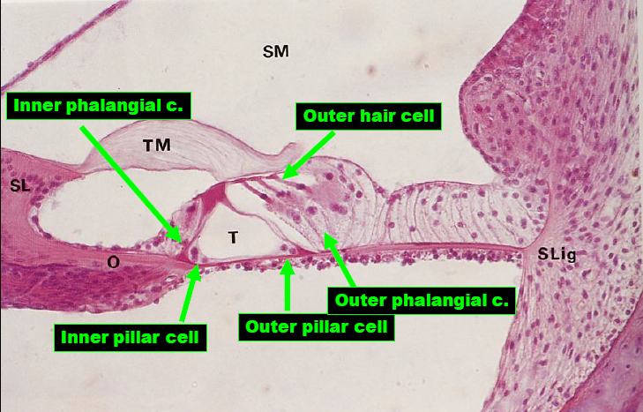
The hair cells within the organ of Corti have sterocilia that attach to the tectorial membrane. Shifts between the tectorial and basilar membranes move these sterocilia and activate or deactivate receptors on the hair cell surface. When cation channels open on the hair cells, potassium ions flow into the hair cells, the cells depolarize, and the depolarization causes voltage-gated calcium channels to open. The calcium influx results in glutamate release from the hair cells onto the auditory nerve. The auditory nerve then sends information about the sound wave to the brain.
Inner hair cells function primarily as the sensory organs for audition. They provide input to 95% of the auditory nerve fibers that project to the brain.The stiffness and size of the hair cell arrangement throughout the cochlea enable hair cells to respond to a variety of frequencies from low to high. Cells at the apex to respond to lower frequencies while hair cells at the base of the cochlea (near the oval window) respond to higher frequencies, which creates a tonotopic gradient throughout the cochlea.
While inner hair cells are the output center of the cochlea, the outer hair cells are the input center. They receive descending inputs from the brain to assist with the modulation of inner hair cell function (i.e., modulating tuning and intensity information). Unlike other regions of the brain, the modulation of inner hair cells by outer hair cells is not electrical but mechanical. Activation of outer hair cells changes the stiffness of their cell bodies; this manipulates the resonance of perilymph fluid movement within the scala media and allows for fine-tuning of inner hair cell activation.
Inner and outer hair cells are distinctly different in structure. Both types of hair cells have stereocilia on the apical surface; however, the arrangement of sterocilia and their connection to the tectorial membrane are distinctly different. For both types of hair cells, the mechanical bending of the sterocilia opens potassium channels at the tips of the sterocilia that allow hyperpolarization of the cells. The tallest of the stereocilia of outer hair cells are embedded into the tectorial membrane. These stereocilia get displaced as the basilar membrane moves with the tectorial membrane. The stereocilia of inner hair cells are free-floating. Movement of the viscous perilymph fluid provides the mechanical force to open these channels.
Inner hair cell activation is much more complicated than outer hair cell activation. The movement of fluid within the scala media relies on the resonance (vibration) of both the tectorial membrane and organ of Corti. Cells within the organ of Corti are much more flexible than cells within the basilar membrane. Alterations in the stiffness of these cells change the resonance of the organ of Corti and subsequently the movement of fluid within the scala media.
The outer hair cells alter the stiffness of the organ of Corti through a motor protein, prestin, located on the lateral membrane of these cells. These proteins vary in shape in response to voltage changes. Depolarization of the outer hair cells causes prestin to shorten, shifting the basilar membrane and increasing the membrane deflection, thereby intensifying the effect on the inner hair cells.

