Mark Enobong Ofonime
17/MhS01/185
300level
Histology of ear assignment
ANA 305

Question
With the aid of a diagram, write an essay on the histology of an organ of Corti.
Answer
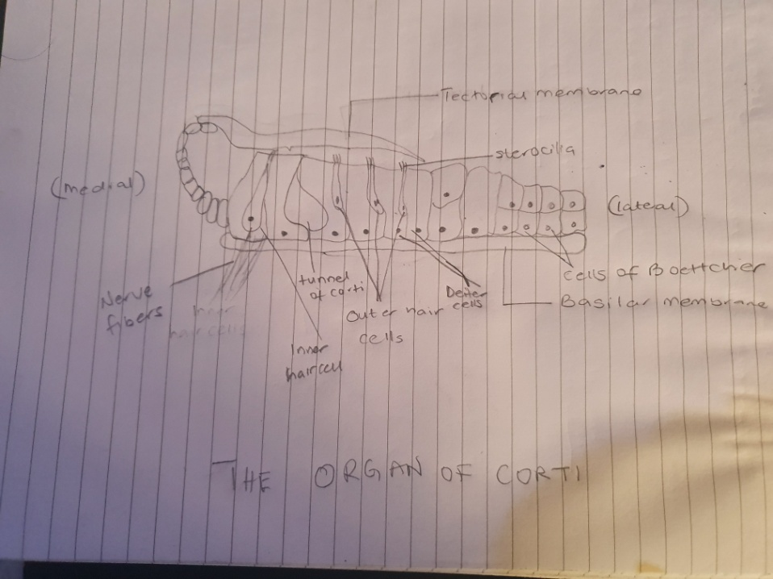
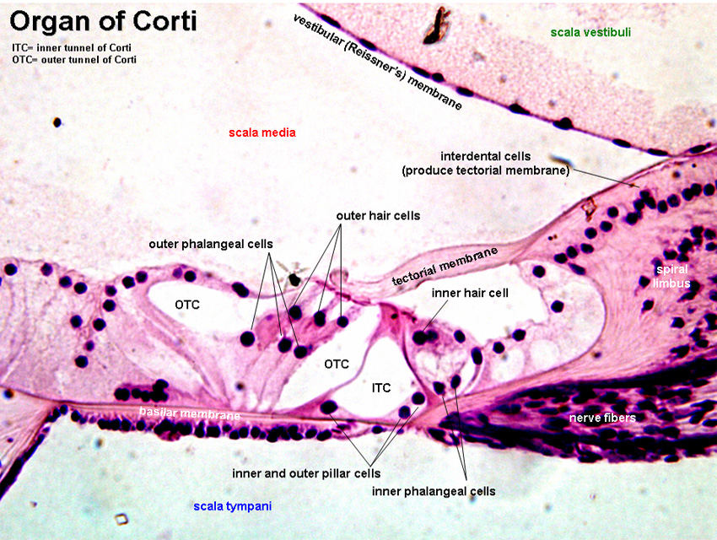
The organ of Corti is an organ of the inner ear located within the cochlea which contributes to audition. It is a long and spiral organ which is located in the scala media of the cochlea of the inner ear between the vestibular duct and the tympanic duct. It is surrounded by potassium fluid. It is composed of mechanosensory cells known as hair cells. It is the receptor organ for hearing. This highly varied strip of epithelial cells allows for transduction of auditory signals into nerve impulses’ action potential. Transduction occurs through vibrations of structures in the inner ear causing displacement of cochlear fluid and movement of hair cells at the organ of corti to produce electrochemical signals. Strategically positioned on the basiar membrane of the organ of Corti are three rows of outer hair cells and one row of inner hair cells. Separating these hair cells are supporting cells, deiters cells, also called phalangeal cells, which separate and support both the outer hair cells and the inner hair cells.
Projecting from the tops of the hair cells are tiny finger like projections called sterocilia, which are arranged in a graduated fashion with the shortest sterocilia on the outer row and the longest in the center. This gradation allows the sensory cells superior tuning capability.
The function of the organ of Corti is to change (transduce) auditory signals and minimize the hair cells’ extraction of sound energy. The organ of corti is also capable of modulating the auditory signal. The outer hair cells can amplify the signal through a process called electromotility where they increase movement of the basilar and tectorial membrane and therefore increase deflection of sterociliia in the inner hair cells.
The organ of Corti develops after the formation and growth of the cochlear duct. The inner and outer hair cells then differentiate into their appropriate positions and are followed by the organization of the supporting cells. The topology of the supporting cells lends itself to the actual mechanical properties that are needed for the highly specialized sound–induced movements within the organ of corti.
The organ of Corti can be damaged by excessive sound levels, leading to noise induced impairment. The most common kind of hearing impairment, sensorineural hearing loss, includes as one major cause the reduction of function in the organ of corti. Specifically, the active amplification function of the outer hair cell is very sensitive to damage from exposure to trauma from overly loud sounds or to certain ototoxic drugs. Once outer hairs are damaged, they do not regenerate, and the result is a loss of sensitivity and an abnormally large growth of loudness in the part of the spectrum that the damaged cells serve.

