EGWU PIUS KEDONOJO
17/MHS01/103
MBBS 300L
ANA 305

HISTOLOGY OF THE ORGAN OF CORTI
The internal ear is a highly specialized end organ that performs the dual functions of hearing and of providing information about the position and movements of the head. The impulses in question are converted into nerve impulses by a number of structures that act as transducers. One of these structures is the organ of corti.
The end organ for hearing is the spiral organ (of Corti). It lies in the duct of the cochlea, just above the basilar membrane.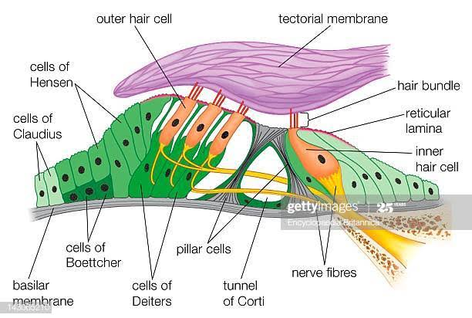
DIAGRAM OF THE ORGAN OF CORTI

The spiral organ of Corti is so called because (like other structures in the cochlea) it extends in a spiral manner through the turns of the cochlea. In sections it is seen to be placed on the basilar membrane and to be made up of epithelial cells that are arranged in a complicated manner. The cells are divisible into:
- The true receptor cells or hair cells and
- The supporting elements which are given different names depending on their location.
The cells of the spiral organ are covered from above by a gelatinous mass called the membrana tectoria. The cells of the spiral organ enclose a triangular cavity called the tunnel of Corti (or cuniculum internum). The base of the tunnel lies over the basilar membrane. It has a sloping inner wall that is formed by internal rod cells; and a sloping outer wall that is formed by external rod cells. To the internal side of the inner rod cells there is a single row of inner hair cells. The inner hair cell is supported by tall cells lining the tympanic lip of the internal spiral sulcus. On the outer side of each external rod cell there are three or four outer hair cells.
The outer hair cells do not lie directly on the basilar membrane, but are supported by the phalangeal cells (of Dieters) which rest on the basilar membrane. To the outer side of the outer hair cells and the phalangeal cells, there are tall supporting cells (cells of Hensen). Still more externally the outer spiral sulcus is lined by cubical cells (cells of Claudius.
A narrow space the cuniculum externum intervenes between the outermost hair cells and the cells of Hensen. A third space, the cuniculum medium (or space of Nuel) lies between the outer rod cell and the outer hair cells. The spaces are filled with perilymph (or cortilymph).

