AGOMAH GIDEON
17/MHS01/035
MEDICINE AND SURGERY

1. Discuss the pathophysiological process involves in renal failure?
ANSWER
Renal failure refers to the deterioration of renal functions resulting in a decline in glomerular filtration rate (GFR) and rise in urea and non-nitrogenous substances in the blood. It is of two types:
- Acute renal failure(ARF) - It refers to the sudden decline in glomerular filtration rate over a period of days or weeks associated with a rapid rise in blood urea.
- Chronic renal failure(CRF) - It refers to a slow, insidious, irreversible deterioration of renal functions resulting in the development of clinical syndrome of uraemia, manifested by excretory, metabolic, neurological, haematological and endocrinal abnormalities.

Pathophysiology of Acute Renal Failure
Common causes of acute renal failure (ARF) can be grouped as:
1. Prerenal causes: include Reduced blood supply to the kidneys. Normally, kidneys receive about 20–25% of the cardiac output (1100 ml/min). Decreased renal blood flow is usually accompanied by decreased glomerular filtration rate and reduced urinary output. When blood flow is reduced below the basal requirements (i.e. 20–25% less than normal renal blood flow), renal ischemia occurs causing damage to renal cells, particularly tubular epithelial cells. The common causes of reduced blood flow to kidney are severe haemorrhage, shock, severe burns, hypovolaemia, septicaemia, cardiac failure and so on.
2. Intrarenal causes: include acute glomerulonephritis and acute tubular necrosis
- Acute glomerulonephritis is usually caused by an abnormal immune reaction, which causes damage to the glomeruli. In 95% of cases of glomerulonephritis, streptococcal infection involving other parts of body (tonsillitis or skin infection). The antibodies develop against the streptococcal antigen (within few weeks), react and form insoluble antigen–antibody complexes, which get deposited in the glomeruli and evoke an inflammatory reaction. The glomeruli get blocked and those which are not blocked, their permeability increases and allow leak of proteins and red cells from the glomerular capillaries into the glomerular filtrate. In severe cases, there is renal shutdown and this results in acute renal failure.
- Acute tubular necrosis means destruction of tubular epithelial cells. Tubular necrosis occurs due to diminution of oxygen and nutrition to epithelial cells. Toxins, poisons and certain drugs also damage the tubular epithelium resulting in acute renal failure due to toxins or ischaemia.
3. Obstructive causes: include urinary tract obstruction at any site. Postrenal or obstructive renal failure occurs due to abnormalities of lower urinary tract which partially or completely blocks urinary flow (though renal blood flow is normal). If the urine output of only one kidney is blocked, no major changes occur in body fluids composition because the contralateral kidney undergoes compensation. The causes of postrenal acute renal failure include:
i. Bilateral obstruction of ureters, or of renal pelvis, by large stones or blood clots
ii. Bladder or urethral obstruction
Physiological effects of acute renal failure include:
- Retention of salt and water, waste metabolites and electrolytes (rise in creatinine and urea) in blood and extracellular fluid can lead to oedema and hypertension.
- Excessive retention of potassium (hyperkalaemia) is a serious threat to a patient with acute renal failure.
- Kidneys are unable to excrete hydrogen ions resulting in metabolic acidosis and that itself is a fatal condition and also aggravates hyperkalaemia.
- In severe cases of acute renal failure, oliguria or complete anuria occurs and the patient may die unless kidney functions are restored.

Characteristic features of Acute renal failure include:
- No history of pre-existing renal disease
- Presence of oliguria or anuria
- Rapid rise in blood urea and creatinine levels
- High urine osmolality (>400 mOsm/kg H2O).

Treatment
- Medical management consists of:
• Maintenance of adequate water and electrolyte balance
• Control of infection
• Control of blood pressure
• Control of metabolic acidosis by I/V use of sodium bicarbonate, so that the bicarbonate levels are maintained around 18 mmol/dL.
• Control of diet—protein, Na+, K+, Mg+ and water. About 20–40 g of protein should be given per day to prevent endogenous breakdown of proteins.
- Dialysis is frequently needed in cases with oliguria, hyperkalaemia, or acidosis or fluid overload

Pathophysiology of chronic renal failure
Chronic renal failure, like acute renal failure, also occurs in a wide variety of diseases, but the end result is reduction of functional nephrons and deterioration of the kidney function to the point, where the patient must be placed on dialysis treatment or transplanted with a functional kidney for survival. This condition is referred as end-stage renal disease (ESRD). The exact mechanism of this stage is not well understood, but a slowly progressing vicious cycle due to renal adaptive changes may be responsible.

Common causes which lead on to slow, progressive nephron loss and ultimately chronic renal failure can be grouped as under:
- Congenital disorders, e.g. polycystic kidney.
2. Vascular diseases of kidney, renal hypertension. Injury to renal vasculature can lead to renal ischemia. The most common cause of renal vascular injury is atherosclerosis. Atherosclerosis of the larger renal arteries leads to hypertension and involvement of smaller arteries (interlobular arteries and efferent arterioles) results in thickening of vessel walls due to deposits of fibrinoid tissue (nephrosclerosis), eventually leading to constriction (ischemic injury).
3. Glomerular diseases, e.g. proliferative glomerulonephritis and diabetic nephropathy. Chronic glomerulonephritis: injury to glomeruli can be caused by several diseases. In most cases, it begins with accumulation of antigen–antibody complexes in the glomerular membrane and ultimately glomeruli are replaced by fibrous tissue, therefore unable to filter the fluid. Therefore, glomerular capillary filtration coefficient gets markedly reduced.
4. Tubulointerstitial disease, e.g. chronic pyelonephritis and analgesic nephropathy. These diseases are referred to as interstitial nephritis. Injury to renal interstitium can be caused by bacterial infection (called as pyelonephritis) or as a result of vascular, glomerular and tubular damage by poison and toxic drugs.
5. Obstructive renal diseases, e.g. benign enlargement of prostate, renal calculi and ureteral constriction.

Treatment
I. Medical management consists of:
- Treat, if the cause is reversible, e.g. hypertension, urinary tract obstruction, etc.
- Nephrotoxic drugs to be avoided.
- Measures to limit the adverse effects of uraemia and to prevent further progression include:
- Control of infection
- Control of hypertension
- Control of diet as regards proteins, Na+, K+, water and Mg+ content
- Control of anaemia
- Control of metabolic acidosis
- Maintenance of electrolyte and water balance
II. Dialysis and renal transplantation is frequently needed

2. With the aid of suitable diagrams discuss the types of dialysis you know?
ANSWER
There are three different types of dialysis.
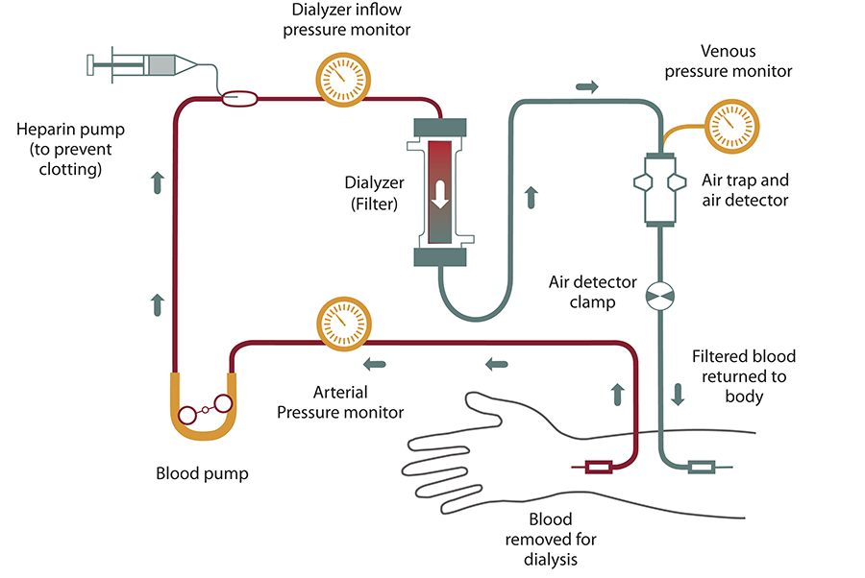
1. Hemodialysis: It is the most common type of dialysis. This process uses an artificial kidney (hemodialyzer) to remove waste and extra fluid from the blood. The blood is removed from the body and filtered through the artificial kidney. The filtered blood is then returned to the body with the help of a dialysis machine. To get the blood to flow to the artificial kidney, your doctor will perform surgery to create an entrance point (vascular access) into your blood vessels. The three types of entrance points are:
- Arteriovenous (AV) fistula: This type connects an artery and a vein. It’s the preferred option.
- AV graft: This type is a looped tube.
- Vascular access catheter: This may be inserted into the large vein in your neck.
Both the AV fistula and AV graft are designed for long-term dialysis treatments. People who receive AV fistulas are healed and ready to begin hemodialysis two to three months after their surgery. People who receive AV grafts are ready in two to three weeks. Catheters are designed for short-term or temporary use.
Hemodialysis treatments usually last three to five hours and are performed three times per week. However, hemodialysis treatment can also be completed in shorter, more frequent sessions. The length of treatment depends on your body size, the amount of waste in your body, and the current state of your health.
Hemodialysis risks include: low blood pressure, muscle cramping, difficulty sleeping, itching, high blood potassium levels, etc.
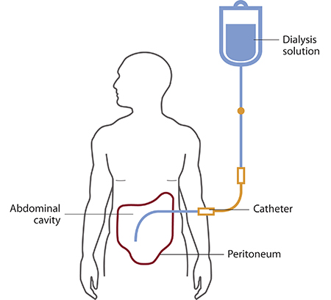
2. Peritoneal dialysis: It involves surgery to implant a peritoneal dialysis (PD) catheter into your abdomen. The catheter helps filter your blood through the peritoneum, a membrane in your abdomen. During treatment, a special fluid called dialysate flows into the peritoneum. The dialysate absorbs waste. Once the dialysate draws waste out of the bloodstream, it’s drained from your abdomen. This process takes a few hours and needs to be repeated four to six times per day. However, the exchange of fluids can be performed while you’re sleeping or awake.
There are numerous different types of peritoneal dialysis. The main ones are:
- Continuous ambulatory peritoneal dialysis (CAPD). In CAPD, your abdomen is filled and drained multiple times each day. This method doesn’t require a machine and must be performed while awake.
- Continuous cycling peritoneal dialysis (CCPD). CCPD uses a machine to cycle the fluid in and out of your abdomen. It’s usually done at night while you sleep.
- Intermittent peritoneal dialysis (IPD). This treatment is usually performed in the hospital, though it may be performed at home. It uses the same machine as CCPD, but the process takes longer.
Risks associated with peritoneal dialysis include: weight gain, hernia, fever, stomach pain, etc.
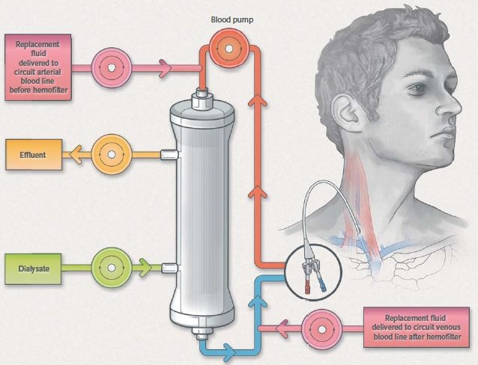
3. Continuous renal replacement therapy (CRRT): This therapy is used primarily in the intensive care unit for people with acute renal failure. It’s also known as hemofiltration. A machine passes the blood through tubing. A filter then removes waste products and water. The blood is returned to the body, along with replacement fluid. This procedure is performed 12 to 24 hours a day, generally every day.
The risks associated with CRRT include: infection, hypothermia, low blood pressure, electrolyte disturbances, bleeding, etc.

