OJENIYI DANIEL AYOOLUWA
17/MHS01/238
MEDICINE AND SURGERY

With the aid of a diagram, write an essay on the histology of an organ of Corti.
ANSWER
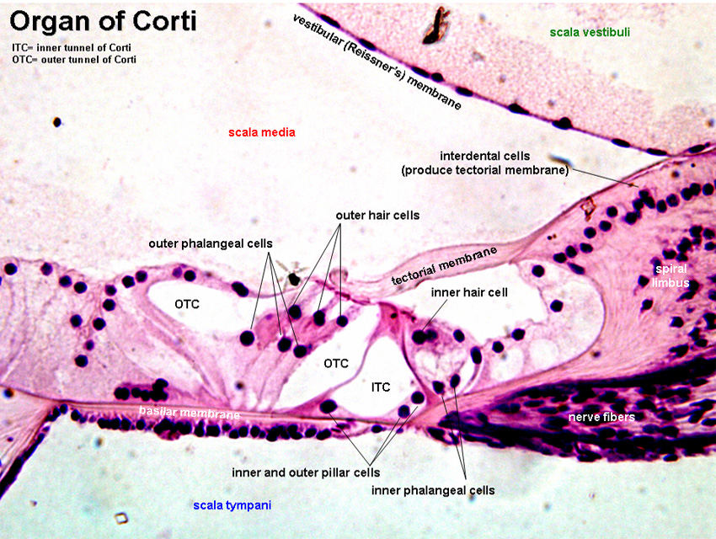
The organ of Corti is a specialized sensory epithelium that allows for the transduction of sound vibrations into neural signals. The Organ of Corti is a part of the cochlea and it mediates the sense of hearing transducing pressure waves to action potentials. This structure is localized in the scala media and it is formed by a series of hair cells, nervous terminations of spiral ganglion and supporting cells.The organ of Corti itself is located on the basilar membrane.
Strategically positioned on the basilar membrane of the organ of Corti are three rows of outer hair cells (OHCs) and one row of inner hair cells (IHCs). Separating these hair cells are supporting cells: Deiters cells, also called phalangeal cells, which separate and support both the OHCs and the IHCs.
Organ of Corti consists of different types of cells:
i. Inner hair cells
ii. Outer hair cells
iii. Supporting cells

Inner Hair Cell
These cells are specialized in the mechanoelectrical transduction. There are almost 3500 cells disposed in one line along all the basilar membrane. They are connected to type I neuron peripheral fibers of spiral ganglion, these connection are very divergent (10/1). The luminal part of the cell is immerged in endolymph, the basal one is immerged in normal extracellular fluid. The luminal portion is formed by bundles of stereocilia(inner_ear), whose tips are connected by filamentous structures called tip-links.
Outer Hair Cell
These cells are acoustical pre-amplifiers. They are almost 12000, disposed in three parallel lines. These cells are connected to type II amyelinic neurons, the connections are very convergent. They have also an afference from superior olivary nucleus. They have contractile activity.
Supporting Cells
These cells are of four different types: Corti pillars, Hensen cells, Deiters cells and Claudius cells.
