NAME: Okunuga Titilayo
COURSE: Histology of special senses and Neurohistology
DEPARTMENT: Medicine & Surgery
MATRIC NO: 17/mhs0/251
Essay on the organ of corti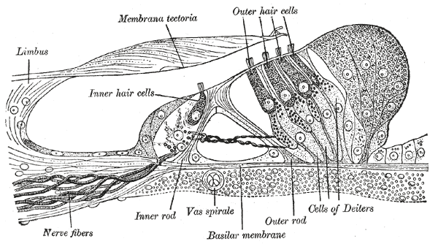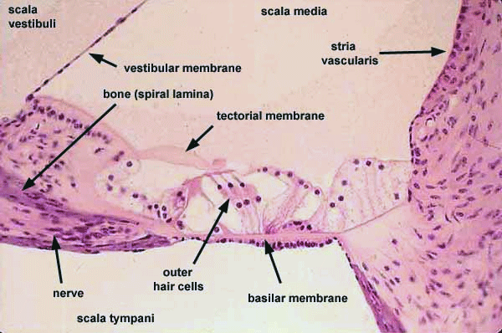
On the surface of the basilar membrane are orderly rows of the sensory hair cells which are arranged to generate nerve impulses in response to sound vibrations. Together with their supporting cells they form a complex neuroepithelium which is the Organ of Corti. The organ of Corti is larger and the basilar membrane on which it sits is longer as it gets further away from the base of the cochlea. This difference in size is consistent with the fact that different frequencies of sound result in greater vibrations of the organ of Corti depending on where along the length of the cochlea you are measuring. The shorter, smaller structures near the base of the cochlea respond best to high frequencies, while the longer, larger structures near the top of cochlea respond best to low frequencies. This is similar to the organization of a piano where the longer, larger strings produce the lower frequency sounds. This organ contains two types of hair cells:
A) Inner hair cells
B) Outer hair cells.
The cochlear hair cells in humans consist of one row of inner hair cells and three rows of outer hair cells separated by supporting cells which are called Dieters or phalangeal cells.
INNER HAIR CELLS: The inner hair cells transform the sound vibrations in the fluids of the cochlea into electrical signals that are then relayed via the auditory nerve to the auditory brainstem and to the auditory cortex. Inner hair cells, the sensory cells of the cochlea, are responsible for signal transduction. Lying in a single row along the internal side of the tunnel of Corti, they are connected to type I spiral ganglion neurons (of which the axons represent about 95% of auditory nerve fibres). A human cochlea has between 3000 and 3500 Inner hair cells.
OUTER HAIR CELLS: Outer hair cells (OHCs) are disposed in three rows on the external side of the tunnel of Corti. OHCs are quite atypical sensory cells. They start transduction classically, being excited by K+ entrance into the tips of stereocilia. However, this excitation instead of initiating an auditory message, triggers a reverse transduction process, feeding energy back into the Corti's organ. This electro-mechano transduction (also called active mechanism), due to OHC electro-motile properties, enhances the cochlear sensitivity and frequency selectivity. The human cochlea has ten to twelve thousands OHCs.
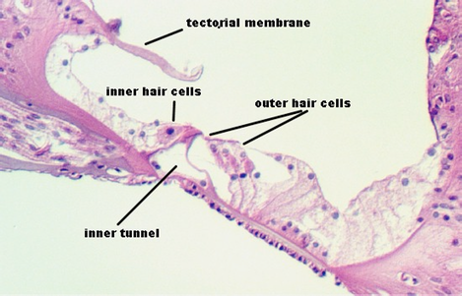

The hair cells located in the organ of Corti transduce mechanical sound vibrations into nerve impulses. They are stimulated when the basilar membrane, on which the organ of Corti rests, vibrates. The hair cells are held in place by the reticular lamina, a rigid structure supported by the pillar cells, or rods of Corti, which are attached to the basilar fibres. At the base of the hair cells is a network of cochlear nerve endings, leading to the spiral ganglion of Corti in the modulus of the cochlea. The spiral ganglion then sends axons into the cochlear nerve. The outer hair cells contain actin and myosin, which are the same contractile proteins that make up muscles, and this allows cells to contract rhythmically in response to tonal stimuli. The ability of an outer hair cell to respond to a particular frequency may depend not only on its position along the length of the basilar membrane but also on its mechanical resonance, which probably varies with the length of its bundle of stereocilia and with that of its cell body. The inner hair cells are much more uniform in size. Local groups of outer hair cells not only act as detectors of low-level sound stimuli but they can also act as mechanical-electrical stimulators and feedback elements, and they are believed to modify and enhance the discriminatory responses of the inner hair cells.

