NAME: MUOKWE UGOCHUKWU
MATRIC. NO: 17/MHS01/191
DEPARTMENT: MEDICINE AND SURGERY
LEVEL: 300L
COURSE CODE: ANA 305
COURSE TITLE: HISTOLOGY OF SPECIAL SENSES & NEUROHISTOLOGY

Question: With the aid of a diagram, write an essay on the histology of an organ of Corti.
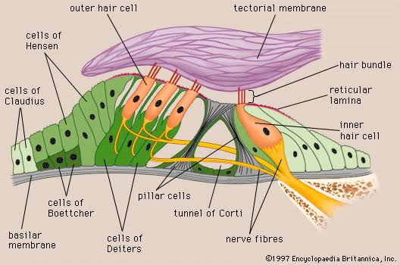

The organ of Corti is a specialized sensory epithelium that allows for the transduction of sound vibrations into neural signals. The Organ of Corti is a part of the cochlea and it mediates the sense of hearing transducing pressure waves to action potentials. This structure is localized in the scala media and it is formed by a series of hair cells, nervous terminations of spiral ganglion and supporting cells. The organ of Corti itself is located on the basilar membrane.
Positioned on the basilar membrane of the organ of Corti are three rows of outer hair cells (OHCs) and one row of inner hair cells (IHCs). Separating these hair cells are supporting cells: Deiters cells, also called phalangeal cells, which separate and support both the outer hair cells and the inner hair cells.
TYPES OF CELLS IN THE ORGAN OF CORTI
i. Inner hair cells
ii. Outer hair cells
iii. Supporting cells

- Inner hair cells
These cells are specialized in the mechanoelectrical transduction. There are almost 3500 cells disposed in one line along all the basilar membrane. They are connected to type I neuron peripheral fibers of spiral ganglion, these connection are very divergent (10/1). The luminal part of the cell is immerged in endolymph, the basal one is immerged in normal extracellular fluid. The luminal portion is formed by bundles of stereocilia(inner ear), whose tips are connected by filamentous structures called tip-links.
- Outer hair cell
These cells are acoustical pre-amplifiers. They are almost 12000, disposed in three parallel lines. These cells are connected to type II amyelinic neurons, the connections are very convergent. They have also an afference from superior olivary nucleus. They have contractile activity.
- Supporting cells
These cells are of four different types: Corti pillars, Hensen cells, Deiters cells and Claudius cells.
Corti pillars: These cells form the outer walls and inner walls of the tunnel in the organ of Corti.
Hensen cells: Hensen's cells are a layer of tall cells arranged in the organ of Corti in the cochlea, which are part of the supporting cells lie on the outer hair cells. Their appearance are upper part wide with lower part narrow, column like cells. One significant morphologic feature of Hensen's cells is the lipid droplets, which are most noticeable at the third and fourth turns of the cochlear, the lipid droplets are thought to have association with the auditory process because they are parallel to the innervation. One significant structure found among the Hensen's cells and the hair cells are the gap junctions, they are made of connexins which serve important function in distribution and connection between cells, the gaps enable the long distance of electric communication.
Deiter’s cells: Deiters' cells, also known as phalangeal cells or cells of Deiters , are a cell type found within the inner ear. They contain both micro-filaments and micro-tubules which run from the basilar membrane to the reticular membrane of the inner ear.
Claudius cells: Claudius cells are considered as supporting cells within the organ of Corti in the cochlea. These cells extend from Hensen's cells to the spiral prominence epithelium, forming the outer sulcus. They are in direct contact with the endolymph of the cochlear duct. These cells are sealed via tight junctions that prevent flow of endolymph between them.

