Name: Ezeugo Philip chukwuebuka
Matric no: 17/mhs01/130

ANA 305: HISTOLOGY OF SPECIAL SENSES AND NEUROHISTOLOGY
QUESTION: WITH THE AID OF A DIAGRAM, WRITE AN ESSAY ON THE HISTOLOGY OF AN ORGAN OR CORTI.
The organ of Corti is a highly specialized epithelial structure containing receptor cells, which convert mechanical energy in the form of vibrations into electrochemical energy resulting in the excitation of auditory sensory receptors.
LOCATION
The organ of Corti rests on the basilar membrane supported by the scala media.
HISTOLOGICAL FEAUTURES
It is made up of two basic cell types:
1. Supporting Cells
• Pillar cells: These are a single row of columnar cells bounding the tunnel of Corti
• Inner phalangeal cells: They support a row of inner sensory hair cells. They are flask-shaped. They have microtubules, some of which support the base of the hair cells, while others extend to the free surface around the hair cells
• The outer phalangeal cells: These are three to five rows of cells, which support the same number of rows of outer sensory cells.
2. Sensory (hair cells): They are about three to five rows of outer hair cells lateral to the tunnel and 1 row of inner hair cells medial to tunnel. Both types of hair cells are columnar with basally located nuclei, numerous mitochondria and smooth endoplasmic reticulum.
FUNCTIONS
The basilar membrane is the thinnest at the base of the cochlear, thickest at the apex. At every point on the spiral, the membrane is tuned to vibrate to a particular frequency of sound waves reaching the ear, the highest frequency sensed towards apex. For a given sound frequency, only a specific point of basilar membrane and organ of Corti is through to vibrate and thereby activate the appropriate receptor cells to initiate afferent sensory impulses which then pass to auditory cortex of the brain. Thus it functions in the transmission of sound waves from the scala media to the scala tympani.
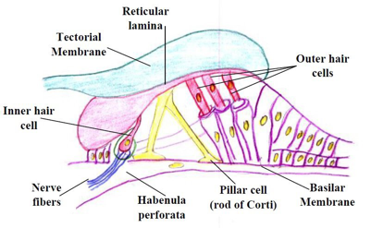
FIG1. DIAGRAM OF THE ORGAN OF CORTI

