NAME: ERUVWETOPHURE JEMILAND
MAT NO: 17/MHS01/121
LEVEL: 300L
COURSE TITLE: HISTOLOGY OF SPECIAL SENSES (EAR)
HISTOLOGY ON THE ORGAN OF CORTI

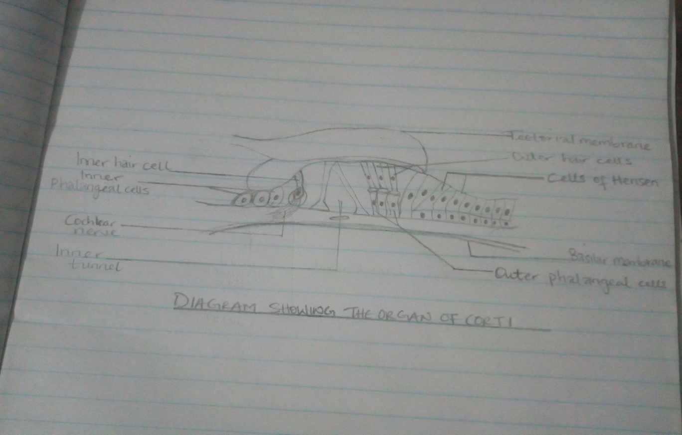

The organ of corti is a specialized sensory epithelium that allows for the transduction of sound vibrations into neural signals. Transduction occurs through vibrations of structures in the inner ear causing displacement of cochlear fluid and movement of hair cells at the organ of corti to produce electrochemical signals. The organ of corti is also known as the spiral organ and it is the receptor organ for hearing. It is located in the media sclera cochlear of the inner ear between the vestibular duct and the tympanic duct and it is composed of hair cells.
Three rows of outer hair cells and one row of inner hair cell is positioned on the basilar membrane of the organ of corti. Separating these hair cells are supporting cells, which separate and support both the outer hair cells and the inner hair cells.
The organ of corti is overlain by the gel-like tectorial membrane, produced and maintained by the columnar cells found atop the spiral limbus just medial to the organ of corti. Only the stereocilia of the outer hair cells appear to be in contact with the tectorial membrane. Shearing movements between the basilar membrane with the sensory epithelium and the tectorial membrane cause receptor potentials to be produced in the hair cells, by means of deflections of their stereocilia.
CELLS OF THE ORGAN OF CORTI
- Inner hair cells: they are flask-shaped with a globular cell soma tapering into a thinner elongated neck. Their nucleus is rounded and located halfway along the length of the cells, dividing them into two topographic domains. At the basal end are found synaptic contacts from afferent cochlear nerve fibers, hence this pole is also referred to as the neural pole. The neural pole receives about 90-95% of all afferent contacts with cochlear nerve fibers. The apical pole is characterized by a bundle of stereocilia in nearly straight rows and is synapse free.
- Outer hair cells: they rest on the supporting cells that comprise 75-80% of all hair cells. The outer hair cells are cylindrically shaped and possess a large spherical nucleus located at the neural pole. Outer hair cells are characterized by having several cisterns of endoplasmic reticulum distinctly located under the cellular membrane in a laminar fashion extending from the nucleus up to the apical pole.
- Phalangeal cells
- Outer phalangeal cells: they are tall columnar cells that are attached to the basilar membrane. Their apical portions are cup-shaped to support the basilar portions of outer hair cells along with efferent and afferent nerve fibers. They do not reach the free surface of the organ of corti and they communicate with the inner tunnel. There’s presence of the space of nuel (a fluid-filled gap around unsupported regions of the outer hair cells.
- Inner phalangeal cells: they are located deep to the inner pillar cells and they are completely surrounded by the inner hair cells
- Border cells: they are slender cells that support inner aspects of the organ of corti and they mark out the inner border of the organ of corti
- Cells of Hensen: they define the outer border and are located between the outer phalangeal cells and cells of Claudius
FUNCTION OF THE ORGAN OF CORTI
The function of the organ of corti is to change auditory signals and minimize the hair cells extraction of sound energy. It is the auricle and middle ear that act as mechanical transformers and amplifiers so that the sound waves end up with amplitudes 22 times greater than when they entered the ear.
CLINICAL HISTOLOGY
Hearing loss: the organ of corti can be damaged by excessive sound levels, leading to noise induced impairment. The most common kind of hearing impairment; sensorineural hearing loss, includes as one major cause of the reduction of function in the organ of corti. Specifically, the active amplification function of the outer hair cells is very sensitive to damage from exposure to trauma from overly loud sounds or to certain ototoxic drugs. Once outer hair cells are damaged, they do not regenerate, and the result is a loss of sensitivity and an abnormally large growth of loudness in the part of the spectrum that the damaged cells serve.

