Pathophysiological process of renal failure
Renal failure or kidney failure, also called end-stage renal disease (ESRD), is the last stage of chronic kidney disease. When your kidneys fail, it means they have stopped working well enough for you to survive without dialysis or a kidney transplant.
Chronic kidney disease (CKD) is initially described as diminished renal reserve or renal insufficiency, which may progress to renal failure . Initially, as renal tissue loses function, there are few noticeable abnormalities because the remaining tissue increases its performance (renal functional adaptation).Decreased renal function interferes with the kidneys’ ability to maintain fluid and electrolyte homeostasis. The ability to concentrate urine declines early and is followed by decreases in ability to excrete excess phosphate, acid, and potassium. When renal failure is advanced (glomerular filtration rate [GFR] ≤ 15 mL/min/1.73 m2), the ability to effectively dilute or concentrate urine is lost; thus, urine osmolality is usually fixed at about 300 to 320 mOsm/kg, close to that of plasma (275 to 295 mOsm/kg), and urinary volume does not respond readily to variations in water intake.

Creatinine and urea
Plasma concentrations of creatinine and urea (which are highly dependent on glomerular filtration) begin a hyperbolic rise as GFR diminishes. These changes are minimal early on. When the GFR falls below 15 mL/min/1.73 m2 (normal > 90 mL/min/1.73 m2), creatinine and urea levels are high and are usually associated with systemic manifestations (uremia). Urea and creatinine are not major contributors to the uremic symptoms; they are markers for many other substances (some not yet well defined) that cause the symptoms.

Sodium and water
Despite a diminishing GFR, sodium and water balance is well maintained by increased fractional excretion of sodium in urine and a normal response to thirst. Thus, the plasma sodium concentration is typically normal, and hypervolemia is infrequent unless dietary intake of sodium or water is very restricted or excessive. Heart failure can occur due to sodium and water overload, particularly in patients with decreased cardiac reserve.

Potassium
For substances whose secretion is controlled mainly through distal nephron secretion (eg, potassium), renal adaptation usually maintains plasma levels at normal until renal failure is advanced or dietary potassium intake is excessive. Potassium-sparing diuretics, angiotensin-converting enzyme inhibitors, beta-blockers, nonsteroidal anti-inflammatory drugs, cyclosporine, tacrolimus, trimethoprim/sulfamethoxazole, pentamidine, or angiotensin II receptor blockers may raise plasma potassium levels in patients with less advanced renal failure.

Calcium and phosphate
Abnormalities of calcium, phosphate, parathyroid hormone (PTH), and vitamin D metabolism can occur, as can renal osteodystrophy. Decreased renal production of calcitriol (1,25(OH)2D, the active vitamin D hormone) contributes to hypocalcemia. Decreased renal excretion of phosphate results in hyperphosphatemia. Secondary hyperparathyroidism is common and can develop in renal failure before abnormalities in calcium or phosphate concentrations occur. For this reason, monitoring PTH in patients with moderate CKD, even before hyperphosphatemia occurs, has been recommended.

Renal osteodystrophy (abnormal bone mineralization resulting from hyperparathyroidism, calcitriol deficiency, elevated serum phosphate, or low or normal serum calcium) usually takes the form of increased bone turnover due to hyperparathyroid bone disease (osteitis fibrosa) but can also involve decreased bone turnover due to adynamic bone disease (with increased parathyroid suppression) or osteomalacia. Calcitriol deficiency may cause osteopenia or osteomalacia.

pH and bicarbonate
Moderate metabolic acidosis (plasma bicarbonate content 15 to 20 mmol/L) is characteristic. Acidosis causes muscle wasting due to protein catabolism, bone loss due to bone buffering of acid, and accelerated progression of kidney disease.

Anemia
Anemia is characteristic of moderate to advanced CKD (≥ stage 3). The anemia of CKD is normochromic-normocytic, with an Hct of 20 to 30% (35 to 40% in patients with polycystic kidney disease). It is usually caused by deficient erythropoietin production due to a reduction of functional renal mass (see Overview of Decreased Erythropoiesis). Other causes include deficiencies of iron, folate, and vitamin B12.

DIALYIS
Dialysis is a treatment that takes over your kidney functions if those organs stop doing their job. If your kidney disease becomes very severe and crosses a point where there’s not enough function to maintain the body, then you will need dialysis.
There are two types of dialysis:
1)Hemodialysis:
This describes the classical form of dialysis where blood is passed via a tube into a dialysis machine which removes excess water, waste products and toxins from the blood before returning it to the body. Each session of dialysis can last for around four hours. The filtration barrier in this type of dialysis is present inside the dialysis machine.
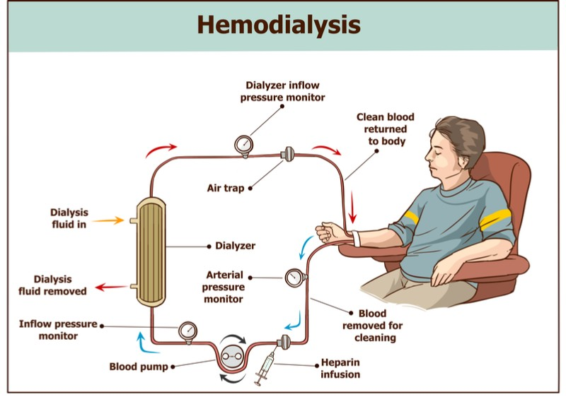

2)Peritoneal dialysis:
This type of dialysis uses the serous membrane that forms the lining of the abdominal cavity as a filter for removing the excess fluids and waste. The dialysate is pumped into the peritoneal cavity through a catheter in the abdomen where it sits and absorbs waste products before being flushed back out.
