NAME: VALERIE N. AMINIA-JUMBO
MATRIC NO: 17/MHS01/059
COURSE TITLE: RENAL PHYSIOLOGY,BODY FLUID AND TEMPERATURE REGULATION
COURSE CODE: PHS303

- Discuss the pathophysiological process involved in renal failure?
Firstly, the rate of renal blood flow of approximately 400 ml/100g of tissue per minute is much greater than that observed in other well perfused vascular beds such as heart, liver and brain. As a consequence, renal tissue might be exposed to a significant quantity of any potentially harmful circulating agents or substances. Secondly, glomerular filtration is dependent on rather high intra- and transglomerular pressure (even under physiologic conditions), rendering the glomerular capillaries vulnerable to hemodynamic injury, in contrast to other capillary beds. In line with this, Brenner and coworkers identified glomerular hypertension and hyperfiltration as major contributors to the progression of chronic renal disease. Thirdly, glomerular filtration membrane has negatively charged molecules which serve as a barrier retarding anionic macromolecules. With disruption in this electrostatic barrier, as is the case in many forms of glomerular injury, plasma protein gains access to the glomerular filtrate. Fourthly, the sequential organization of nephron’s microvasculature (glomerular convolute and the peritubular capillary network) and the downstream position of the tubuli with respect to glomeruli, not only maintains the glomerulo-tubular balance but also facilitates the spreading of glomerular injury to tubulointerstitial compartment in disease, exposing tubular epithelial cells to abnormal ultrafiltrate. As peritubular vasculature underlies glomerular circulation, some mediators of glomerular inflammatory reaction may overflow into the peritubular circulation contributing to the interstitial inflammatory reaction frequently recorded in glomerular disease. Moreover, any decrease in preglomerular or glomerular perfusion leads to decrease in peritubular blood flow, which, depending on the degree of hypoxia, entails tubulointerstitial injury and tissue remodeling. Thus, the concept of the nephron as a functional unit applies not only to renal physiology, but also to the pathophysiology of renal diseases. In the fifth place, the glomerulus itself should also be regarded as a functional unit with each of its individual constituents, i.e. endothothelial, mesangial, visceral and parietal epithelial cells - podocytes, and their extracellular matrix representing an integral part of the normal function. Damage to one will in part affect the other through different mechanisms, direct cell-cell connections (e.g., gap junctions), soluble mediators such as chemokines, cytokines, growth factors, and changes in matrix and basement membrane composition.
The main causes of renal injury are based on immunologic reactions (initiated by immune complexes or immune cells), tissue hypoxia and ischaemia, exogenic agents like drugs, endogenous substances like glucose or paraproteins and others, and genetic defects. Irrespective of the underlying cause glomerulosclerosis and tubulointerstitial fibrosis are common to chronic kidney disease.

- With the aid of suitable diagrams discuss the types of dialysis you know?
Dialysis is the process of removing excess water, solutes, and toxins from the blood in people whose kidneys can no longer perform these functions naturally. This is referred to as renal replacement therapy. Dialysis is used in patients with rapidly developing loss of kidney function, called acute kidney injury, or slowly worsening kidney function, called Stage 5 chronic kidney disease. Dialysis is used as a temporary measure in either acute kidney injury or in those awaiting kidney transplant and as a permanent measure in those for whom a transplant is not indicated or not possible.
Types of Dialysis
There are three primary and two secondary types of dialysis: hemodialysis (primary), peritoneal dialysis (primary), hemofiltration (primary), hemodiafiltration (secondary) and intestinal dialysis (secondary). Out of these peritoneal and hemodialysis are the main types of dialysis.
HEMODIALYSIS
In hemodialysis, the patient's blood is pumped through the blood compartment of a dialyzer, exposing it to a partially permeable membrane. The dialyzer is composed of thousands of tiny hollow synthetic fibers. The fiber wall acts as the semipermeable membrane. Blood flows through the fibers, dialysis solution flows around the outside of the fibers, and water and wastes move between these two solutions. The cleansed blood is then returned via the circuit back to the body. Ultrafiltration occurs by increasing the hydrostatic pressure across the dialyzer membrane .This usually is done by applying a negative pressure to the dialysate compartment of the dialyzer. This pressure gradient causes water and dissolved solutes to move from blood to dialysate and allows the removal of several litres of excess fluid during a typical 4-hour treatment. This procedure is best done 5 to 7 times a week, up to 4-6 hours depending on the recommendation of the nephrologist.
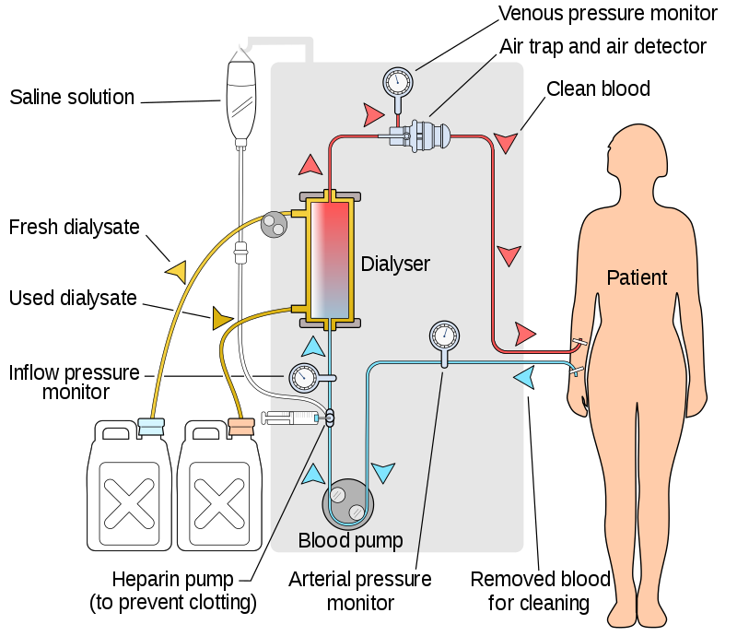
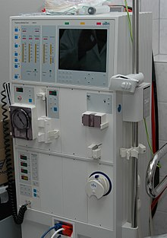 A HEMODIALYSIS MACHINE.
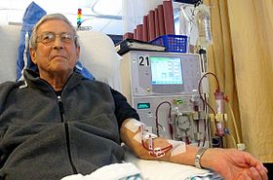 A HEMODIALYSIS PATIENT.

Peritoneal dialysis
Peritoneal dialysis involves surgery to implant a peritoneal dialysis (PD) catheter into your abdomen. The catheter helps filter your blood through the peritoneum, a membrane in your abdomen. During treatment, a special fluid called dialysate flows into the peritoneum. The dialysate absorbs waste. Once the dialysate draws waste out of the bloodstream, it’s drained from your abdomen.
This process takes a few hours and needs to be repeated four to six times per day. However, the exchange of fluids can be performed while you’re sleeping or awake.
There are numerous different types of peritoneal dialysis. The main ones are:
- Continuous ambulatory peritoneal dialysis (CAPD). In CAPD, your abdomen is filled and drained multiple times each day. This method doesn’t require a machine and must be performed while awake.
- Continuous cycling peritoneal dialysis (CCPD). CCPD uses a machine to cycle the fluid in and out of your abdomen. It’s usually done at night while you sleep.
- Intermittent peritoneal dialysis (IPD). This treatment is usually performed in the hospital, though it may be performed at home. It uses the same machine as CCPD, but the process takes longer.

Continuous renal replacement therapy (CRRT)
This therapy is used primarily in the intensive care unit for people with acute kidney failure. It’s also known as hemofiltration. A machine passes the blood through tubing. A filter then removes waste products and water. The blood is returned to the body, along with replacement fluid. This procedure is performed 12 to 24 hours a day, generally every day.
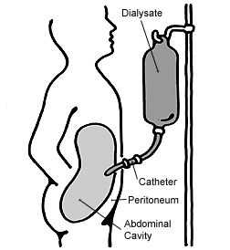
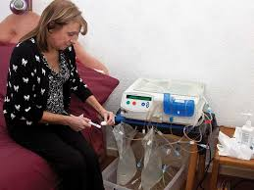 A PATIENT ABOUT TO PERFORM PERITONEAL DIALYSIS AT HOME.
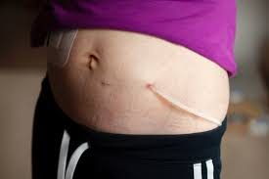 AN EXAMPLE OF THE CATHETER IMPLANTED INTO A PATIENT.

Other forms of dialysis are;

Hemofiltration
Hemofiltration is a similar treatment to hemodialysis, but it makes use of a different principle. The blood is pumped through a dialyzer or "hemofilter" as in dialysis, but no dialysate is used. A pressure gradient is applied; as a result, water moves across the very permeable membrane rapidly, "dragging" along with it many dissolved substances, including ones with large molecular weights, which are not cleared as well by hemodialysis. Salts and water lost from the blood during this process are replaced with a "substitution fluid" that is infused into the extracorporeal circuit during the treatment.

Hemodiafiltration
Hemodiafiltration is a combination of hemodialysis and hemofiltration, thus used to purify the blood from toxins when the kidney is not working normally and also used to treat acute kidney injury.

Intestinal dialysis
In intestinal dialysis, the diet is supplemented with soluble fibres such as acacia fibre, which is digested by bacteria in the colon. This bacterial growth increases the amount of nitrogen that is eliminated in fecal waste. An alternative approach utilizes the ingestion of 1 to 1.5 liters of non-absorbable solutions of polyethylene glycol or mannitol every fourth hour.

