NAME: EKEANYANWU CHUKWUEBUKA CHRISTIAN
MATRIC NO: 19/SCI01/044
DEPARTMENT: COMPUTER SCIENCE
TOPIC: HUMAN TRAFFICKING AND POSSIBLE SOLUTIONS
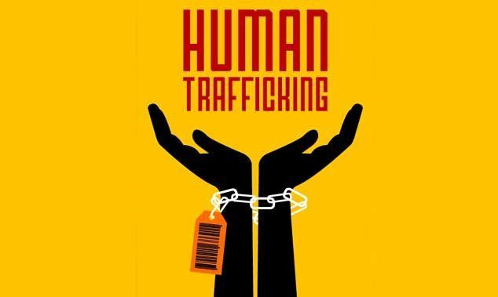 | 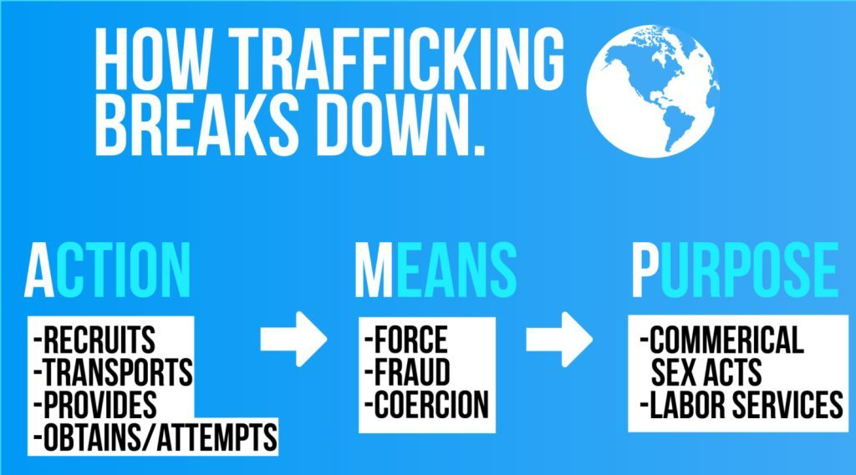
Human trafficking is simply not a surprise to us in our country Nigeria. Human trafficking can be defined to my own understanding as the use of force, fraud, or coercion to obtain some type of labor or commercial sex act. OR by the Wikipedia as the trade of humans for the purpose of forced labor, sexual slavery, or commercial sexual exploitation for the trafficker or others. Human trafficking can occur within a country or trans-nationally. Human trafficking is a crime against the person because of the violation of the victim's rights of movement through coercion and because of their commercial exploitation. Human trafficking is the trade in people, especially women and children, and does not necessarily involve the movement of the person from one place to another.

Human trafficking involves recruitment, harbouring or transporting people into a profession of exploitation through the use of deception, violence or coercion and forced to work against their will. Traffickers prey on others’ weaknesses, unfortunate circumstances, unfamiliarity, and inexperience. Traffickers are trained to identify vulnerability and use expert manipulation tactics to persuade and control their victims. They see a void and offer to fill it.
Conditions That Create Vulnerability
POVERTY: When someone is living in poverty, such as a widow or single mother who struggles to provide for her children, is desperate to meet a basic need, she is in a vulnerable position. A trafficker, familiar with this scenario, might offer her a job that enables her to feed her children. If this appears to be her only option, she may accept and be willing to do whatever the trafficker asks of her.
UNEMPLOYMENT: Traffickers target unemployed individuals and often persuade them to leave home and take a job in another city or country. The position may initially sound promising, but once the individual arrives at the destination, it is often much different than what was described. They might also pay for transportation, shelter, clothing, or food so their victims are indebted to them and feel obligated to work.
LACK OF KNOWLEDGE OR EXPERIENCE: Inexperience may lead individuals down a path that ends in exploitation. A teenager who is approached by a trafficker may accept an attractive job offer, seeing it as a great opportunity at such a young age. An immigrant who arrives in a foreign country may not understand his or her rights, may be unfamiliar with the nation’s laws, or may not know the national language. A trafficker will quickly take advantage of these types of situations.
BROKEN FAMILIES: Individuals who are cast out of their homes, abandoned, or placed into the child welfare system are highly vulnerable to human trafficking. They may feel as though they have little to lose or may even find comfort living with their trafficker. Some traffickers offer love and acceptance to lure individuals to work for them.
CULTURAL PRACTICES: In some societies, it’s widely accepted to devalue and abuse women and children. This outlook is ingrained into the minds of men and women in certain cultures, which creates a huge opportunity for traffickers. A parent may be willing to sell a daughter and send her into a world of exploitation.

POSSIBLE SOLUTIONS
- Organize a fundraiser and donate the proceeds to an anti-trafficking organization
- Businesses: Provide jobs, internships, skills training, and other opportunities to trafficking survivour
- Volunteer at a local shelter, mentor in reading programs
- Know the indicators or red flags of potential labor and sexual trafficking victims
- If you suspect someone is being trafficked, call the hot-line or your local police agency
- Consider becoming a foster parent
- Being a voice—speak up for those who have no voice

