NAME: CARL HERO JACHI
COLLEGE: SMS
DEPARTMENT: ACCOUNTING
MATRIC NO. : 19/SMS02/016

Racism, also called racialism, any action, practice, or belief that reflects the racial worldview—the ideology that humans may be divided into separate and exclusive biological entities called “races”; that there is a causal link between inherited physical traits and traits of personality, intellect, morality, and other cultural and behavioural features; and that some races are innately superior to others. Since the late 20th century the notion of biological race has been recognized as a cultural invention, entirely without scientific basis.
a beach in apartheid-era South Africa A sign at a beach in Durban, South Africa, in 1989, during the apartheid era. It restricts use of the beach to “members of the white race group,” in accordance with South Africa's racial segregation laws of the time. Legislated apartheid ended in the early 1990s.Guinnog
Following Germany’s defeat in World War I, that country’s deeply ingrained anti-Semitism was successfully exploited by the Nazi Party, which seized power in 1933 and implemented policies of systematic discrimination, persecution, and eventual mass murder of Jews in Germany and in the territories occupied by the country during World War II (see Holocaust).

Southern Africa: Growth of racism
In North America and apartheid-era South Africa, racism dictated that different races (chiefly blacks and whites) should be segregated from one another; that they should have their own distinct communities and develop their own institutions such as churches, schools, and hospitals; and that it was unnatural for members of different races to marry.
Historically, those who openly professed or practiced racism held that members of low-status races should be limited to low-status jobs and that members of the dominant race should have exclusive access to political power, economic resources, high-status jobs, and unrestricted civil rights. The lived experience of racism for members of low-status races includes acts of physical violence, daily insults, and frequent acts and verbal expressions of contempt and disrespect, all of which have profound effects on self-esteem and social relationships.
Racism was at the heart of North American slavery and the colonization and empire-building activities of western Europeans, especially in the 18th century. The idea of race was invented to magnify the differences between people of European origin and those of African descent whose ancestors had been involuntarily enslaved and transported to the Americas. By characterizing Africans and their African American descendants as lesser human beings, the proponents of slavery attempted to justify and maintain the system of exploitation while portraying the United States as a bastion and champion of human freedom, with human rights, democratic institutions, unlimited opportunities, and equality. The contradiction between slavery and the ideology of human equality, accompanying a philosophy of human freedom and dignity, seemed to demand the dehumanization of those enslaved.
By the 19th century, racism had matured and spread around the world. In many countries, leaders began to think of the ethnic components of their own societies, usually religious or language groups, in racial terms and to designate “higher” and “lower” races. Those seen as the low-status races, especially in colonized areas, were exploited for their labour, and discrimination against them became a common pattern in many areas of the world. The expressions and feelings of racial superiority that accompanied colonialism generated resentment and hostility from those who were colonized and exploited, feelings that continued even after independence.
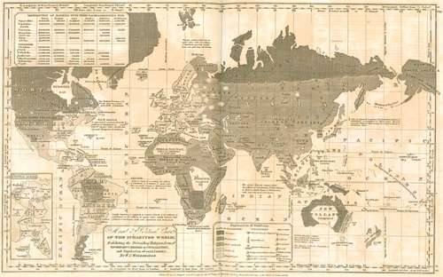
Map designating “savage,” “barbarous,” and “enlightened” regions of the world, from William C. Woodbridge's Modern Atlas (1835).The Newberry Library, Gift of Louise St. John Westervelt (A Britannica Publishing Partner)
Since the mid-20th century many conflicts around the world have been interpreted in racial terms even though their origins were in the ethnic hostilities that have long characterized many human societies (e.g., Arabs and Jews, English and Irish). Racism reflects an acceptance of the deepest forms and degrees of divisiveness and carries the implication that differences between groups are so great that they cannot be transcended.
Racism elicits hatred and distrust and precludes any attempt to understand its victims. For that reason, most human societies have concluded that racism is wrong, at least in principle, and social trends have moved away from racism. Many societies have begun to combat institutionalized racism by denouncing racist beliefs and practices and by promoting human understanding in public policies, as does the Universal Declaration of Human Rights, set forth by the United Nations in 1948.
In the United States, racism came under increasing attack during the civil rights movement of the 1950s and ’60s, and laws and social policies that enforced racial segregation and permitted racial discrimination against African Americans were gradually eliminated. Laws aimed at limiting the voting power of racial minorities were invalidated by the Twenty-fourth Amendment (1964) to the U.S. Constitution, which prohibited poll taxes, and by the federal Voting Rights Act (1965), which required jurisdictions with a history of voter suppression to obtain federal approval (“preclearance”) of any proposed changes to their voting laws (the preclearance requirement was effectively removed by the U.S. Supreme Court in 2013 [see Shelby County v. Holder]). By the 2010s more than two-thirds of the states had adopted varying forms of voter ID law, by which would-be voters were required or requested to present certain forms of identification before casting a ballot. Critics of the laws, some of which were successfully challenged in the courts, contended that they effectively suppressed voting among African Americans and other demographic groups.
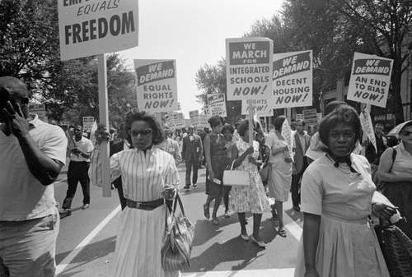
civil rights movement: March on Washington Civil rights supporters carrying placards at the March on Washington, D.C., August 28, 1963.Library of Congress, Washington, D.C.; Warren K. Leffler
Despite constitutional and legal measures aimed at protecting the rights of racial minorities in the United States, the private beliefs and practices of many Americans remained racist, and some group of assumed lower status was often made a scapegoat. That tendency has persisted well into the 21st century.
Because, in the popular mind, “race” is linked to physical differences among peoples, and such features as dark skin colour have been seen as markers of low status, some experts believe that racism may be difficult to eradicate. Indeed, minds cannot be changed by laws, but beliefs about human differences can and do change, as do all cultural elements.

