NAME: OKORO EBONY ADAEZE

MATRIC NUMBER: 18/MHS02/137

COURSE CODE: PHS 212

DEPARTMENT: NURSING

QUESTION: EXPLAIN URINE FORMATION AND CONCENTRATION

URINE FORMATION
The kidneys filter unwanted substances from the blood and produce urine to excrete them. There are three main steps of urine formation: glomerular filtration, reabsorption, and secretion. These processes ensure that only waste and excess water are removed from the body.
The Glomerulus
The Glomerulus Filters Water and Other Substances from the Bloodstream. Each kidney contains over 1 million tiny structures called nephrons. Each nephron has a glomerulus, the site of blood filtration. The glomerulus is a network of capillaries surrounded by a cuplike structure, the glomerular capsule (or Bowman’s capsule). As blood flows through the glomerulus, blood pressure pushes water and solutes from the capillaries into the capsule through a filtration membrane. This glomerular filtration begins the urine formation process.
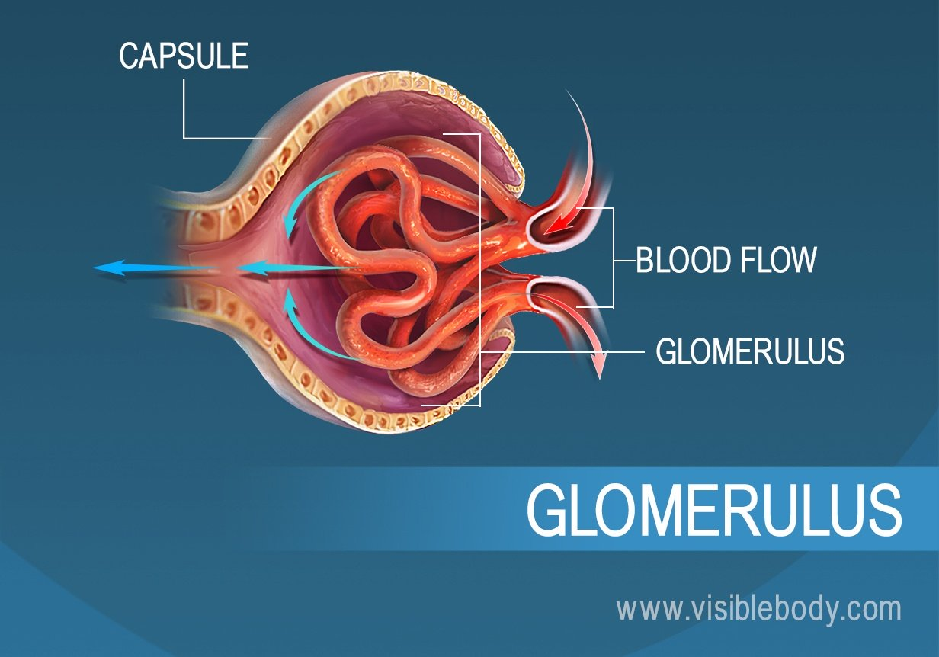

The Filtration Membrane
The filtration membrane Keeps Blood Cells and Large Proteins in the Bloodstream. Inside the glomerulus, blood pressure pushes fluid from capillaries into the glomerular capsule through a specialized layer of cells. This layer, the filtration membrane, allows water and small solutes to pass but blocks blood cells and large proteins. Those components remain in the bloodstream. The filtrate (the fluid that has passed through the membrane) flows from the glomerular capsule further into the nephron.

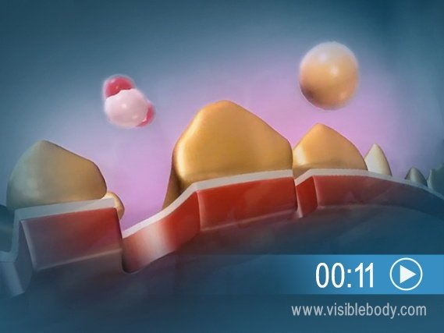

Renal Tubules
Reabsorption moves nutrients and water back into the bloodstream. The glomerulus filters water and small solutes out of the bloodstream. The resulting filtrate contains waste, but also other substances the body needs: essential ions, glucose, amino acids, and smaller proteins. When the filtrate exits the glomerulus, it flows into a duct in the nephron called the renal tubule. As it moves, the needed substances and some water are reabsorbed through the tube wall into adjacent capillaries. This reabsorption of vital nutrients from the filtrate is the second step in urine creation.

Secretion
Waste ions and hydrogen ions secreted from the blood complete the formation of urine. The filtrate absorbed in the glomerulus flows through the renal tubule, where nutrients and water are reabsorbed into capillaries. At the same time, waste ions and hydrogen ions pass from the capillaries into the renal tubule. This process is called secretion. The secreted ions combine with the remaining filtrate and become urine. The urine flows out of the nephron tubule into a collecting duct. It passes out of the kidney through the renal pelvis, into the ureter, and down to the bladder.
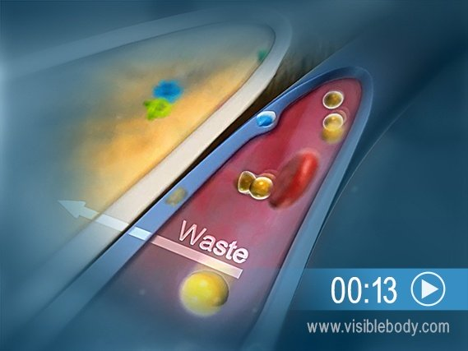

Urine composition
Urine is 95% of water. The nephrons of the kidneys process blood and create urine through a process of filtration, reabsorption, and secretion. Urine is about 95% water and 5% waste products. Nitrogenous wastes excreted in urine include urea, creatinine, ammonia, and uric acid. Ions such as sodium, potassium, hydrogen, and calcium are also excreted.
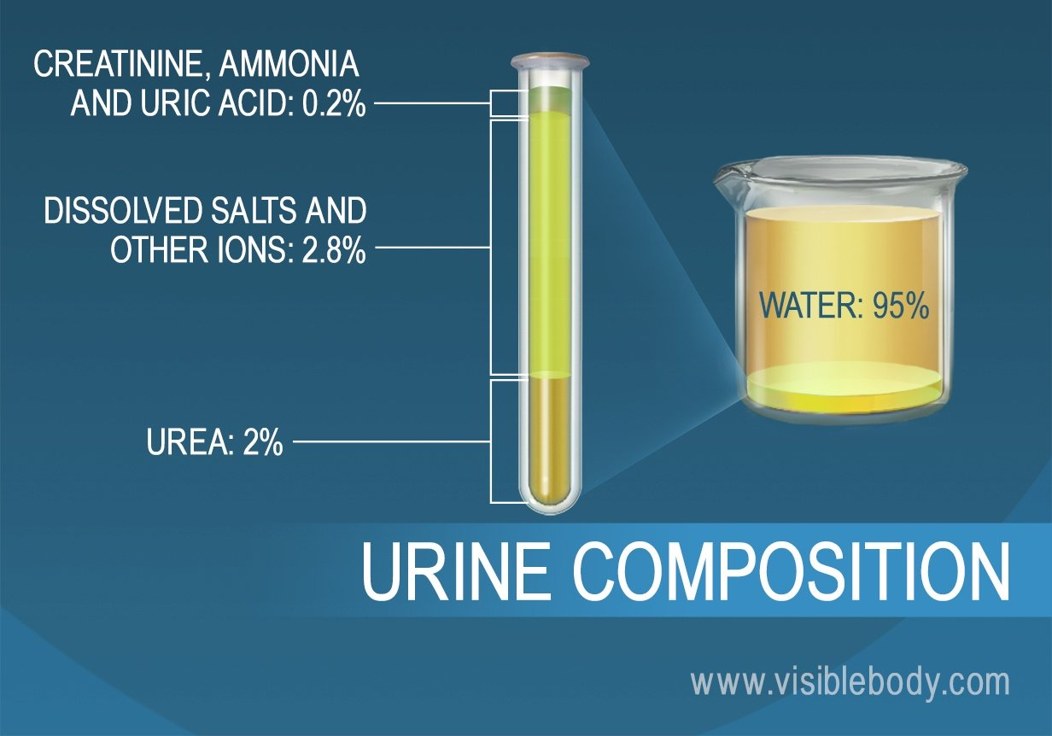
Urine concentration
A urine concentration test determines how well your kidneys are functioning. The test may be used to test the kidneys’ response to:
- too much fluid intake (water loading)
- too little fluid intake (dehydration)
- a hormone that should concentrate your urine, antidiuretic hormone (ADH)
You may take the test several times under different circumstances.
The test itself is painless and all you have to do is provide a clean-catch urine sample. However, the preparation phase may be uncomfortable.
Purpose of a Urine Concentration Test
A doctor may recommend urine concentration testing if you are urinating too much or too little. The test can help identify specific types of problems with your kidneys.
The main reason this test is ordered is to see if you are suffering from central diabetes insipidus, a disease that causes excessive urination. This form of diabetes can occur when a head injury affects how your brain releases antidiuretic hormone (ADH). ADH normally increases the amount of water the kidneys retain. In central diabetes insipidus, your brain does not release enough ADH.
A urine concentration test can also be used to evaluate:
- dehydration
- kidney failure
- heart failure
- other hormone problems
- complications of a urinary tract infection
Interpreting the Results of Your Urine Concentration Test
The laboratory will test how concentrated your urine is. More concentrated urine means that there are more solutes and less water in the sample. Solutes are dissolved particles, such as sugars, salts, and proteins.
Normal values may vary based on the laboratory used. However, typically, your urine is measured in specific gravity, the ratio of the density of your urine to the density of water (1.000). Normal values tend to be in the range of at and slightly above the density of water (1.000 to 1.030). Your urine should be more concentrated after being given ADH.

If your urine is very concentrated, your doctor may suspect one or more of the following conditions:
- dehydration
- diarrhea
- excess sweating
- glycosuria (too much sugar in your urine)
- heart failure
- narrowing of the renal arteries
- inappropriate ADH secretion
- excess vomiting
- fluid restriction
Low urine concentration suggests:
- too much fluid intake
- diabetes insipidus
- kidney failure
- pyelonephritis
Combining multiple test preparations can help your doctor determine if your diabetes insipidus is due to a head injury and a resulting lack of ADH production, or because your kidneys can’t properly respond to ADH (this condition is called nephrogenic diabetes insipidus).
Potential Side Effects of Taking the Test
This test is not associated with any adverse side effects. However, refraining from drinking fluids for the test may make you feel dehydrated. Once the test is completed, ask your doctor if you can resume drinking fluids. This will rehydrate your body.

