IMOUHUEDE LOVE EHIMWENMA
17/MHS01/158
- Pathophysiological process of renal failure
Renal failure is the failure of excretory functions of the kidney. Here, the glomerular filtration rate is decreased. It can either be acute or chronic.
- Acute renal failure.
It is the abrupt stoppage of renal functions. It is often reversible within the next few days or weeks. It may result in sudden life threatening reactions .
Causes
- Acute nephritis(inflammation to kidneys) developing from immune reaction.
- Damage to renal tissues like poison like lead
- Renal ischaemia developing during circulatory shock
- Several transfusion reactions
- Sudden fall in blood pressure
Features
- Oliguria (decreased urinary output)
- Anuria (cessation of urine formation)
- Edema
- Haematuria
- Proteinuria
- Acidosis
- Chronic renal failure
Progressive, long standing and irreversible impairment of renal function.
Causes
- Chronic nephritis
- Polycystic kidney disease
- Kidney stones
- Hypertension
- Tuberculosis
Features
- Uremia: excess accumulation o end products o protein metabolism in the blood. Features includes:
Anorexia
Lethargy
Drowsiness
Skin pigmentation
Coma
Mental deterioration and confusion
- Acidosis
- Edema
- Blood loss
- Anaemia
- Hyperparathyroidism

- Type of dialysis
Dialysis is the procedure to remove waste materials and toxic substances and to restore normal volume and composition of body fluid in severe renal failure.
There are three different types of dialysis.
Haemodialysis
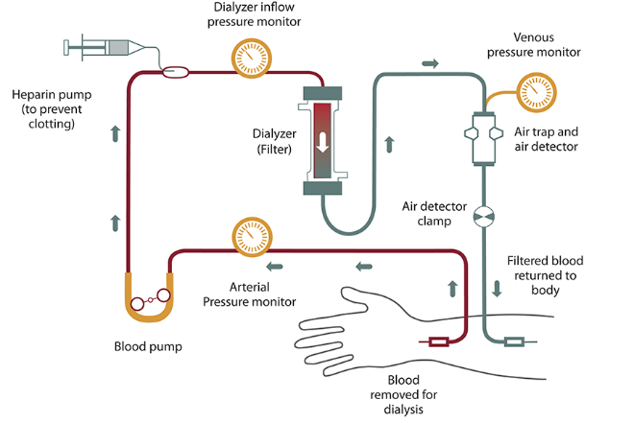
Haemodialysis is the most common type of dialysis. This process uses an artificial kidney (hemodialyzer) to remove waste and extra fluid from the blood. The blood is removed from the body and filtered through the artificial kidney. The filtered blood is then returned to the body with the help of a dialysis machine.
To get the blood to flow to the artificial kidney, your doctor will perform surgery to create an entrance point (vascular access) into your blood vessels. The three types of entrance points are:
Arteriovenous (AV) fistula: This type connects an artery and a vein. It’s the preferred option.
AV graft: This type is a looped tube.
Vascular access catheter: This may be inserted into the large vein in your neck.
Both the AV fistula and AV graft are designed for long-term dialysis treatments. People who receive AV fistulas are healed and ready to begin hemodialysis two to three months after their surgery. People who receive AV grafts are ready in two to three weeks. Catheters are designed for short-term or temporary use.
Hemodialysis treatments usually last three to five hours and are performed three times per week. However, hemodialysis treatment can also be completed in shorter, more frequent sessions.
Peritoneal dialysis
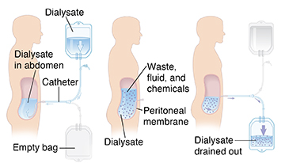
Peritoneal dialysis involves surgery to implant a peritoneal dialysis (PD) catheter into your abdomen. The catheter helps filter your blood through the peritoneum, a membrane in your abdomen. During treatment, a special fluid called dialysate flows into the peritoneum. The dialysate absorbs waste. Once the dialysate draws waste out of the bloodstream, it’s drained from your abdomen.
This process takes a few hours and needs to be repeated four to six times per day. However, the exchange of fluids can be performed while you’re sleeping or awake.
There are numerous different types of peritoneal dialysis. The main ones are:
Continuous ambulatory peritoneal dialysis (CAPD): In CAPD, your abdomen is filled and drained multiple times each day. This method doesn’t require a machine and must be performed while awake.
Continuous cycling peritoneal dialysis (CCPD): CCPD uses a machine to cycle the fluid in and out of your abdomen. It’s usually done at night while you sleep.
Intermittent peritoneal dialysis (IPD): This treatment is usually performed in the hospital, though it may be performed at home. It uses the same machine as CCPD, but the process takes longer.
Continuous renal replacement therapy (CRRT)
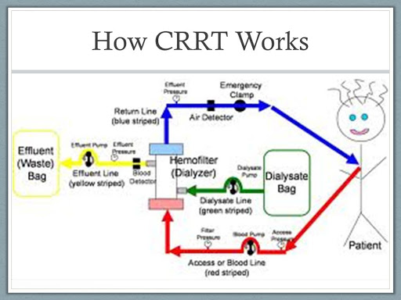
This therapy is used primarily in the intensive care unit for people with acute kidney failure. It’s also known as hemofiltration. A machine passes the blood through tubing. A filter then removes waste products and water. The blood is returned to the body, along with replacement fluid. This procedure is performed 12 to 24 hours a day, generally every day.

Risks associated with hemodialysis
- low blood pressure
- anemia, or not having enough red blood cells
- muscle cramping
- difficulty sleeping
- itching
- pericarditis, an inflammation of the membrane around the heart
- irregular heartbeat
Risks associated with peritoneal dialysis
Peritoneal dialysis is associated with an increased risk for infections in or around the catheter site in the abdominal cavity. For example, after catheter implantation, a person can experience peritonitis. Peritonitis is an infection of the membrane lining the abdominal wall.
Other risks include:
- abdominal muscle weakening
- high blood sugar due to the dextrose in the dialysate
- weight gain
- fever
Risks associated with CRRT
- infection
- hypothermia
- bleeding
- delayed renal recovery
- weakening of bones
- anaphylaxis

