QUESTION.
1. Discuss the pathophysiological process involves in renal failure?
2. With the aid of suitable diagrams discuss the types of dialysis you know?

ANSWER.
- Acute renal failure (ARF) is defined clinically as the sudden loss of renal function that may result from inadequate renal perfusion associated with a decrease in effective circulation, arterial or venous obstruction, renal cell injury, or obstruction to urine flow as occurs in obstructive uropathy. Renal cell injury, commonly termed intrinsic ARF, results from an ischemic or toxicant insult that causes acute tubular damage with accompanying loss of ability to reabsorb filtered solute. The resulting decrease in glomerular filtration rate (GFR), an invariable component of ARF, is then a successful adaptive response, since continued filtration of plasma across the glomerular basement membrane without reabsorption of the filtrate by injured renal tubules would result in massive losses of salt and water. Thus, the decreased GFR associated with ARF prevents severe depletion of extracellular fluid.
- In medicine, dialysis is the process of removing excess water, solutes, and toxins from the blood in people whose kidneys can no longer perform these functions naturally. This is referred to as renal replacement therapy.
Dialysis is used in patients with rapidly developing loss of kidney function, called acute kidney injury (previously called acute renal failure), or slowly worsening kidney function, called Stage 5 chronic kidney disease (previously called chronic kidney failure, end-stage renal disease, and end-stage kidney disease).
Dialysis works on the principles of the diffusion of solutes and ultrafiltration of fluid across a semi-permeable membrane. Diffusion is a property of substances in water; substances in water tend to move from an area of high concentration to an area of low concentration.^{[7]} Blood flows by one side of a semi-permeable membrane, and a dialysate, or special dialysis fluid, flows by the opposite side. A semipermeable membrane is a thin layer of material that contains holes of various sizes, or pores. Smaller solutes and fluid pass through the membrane, but the membrane blocks the passage of larger substances (for example, red blood cells and large proteins). This replicates the filtering process that takes place in the kidneys when the blood enters the kidneys and the larger substances are separated from the smaller ones in the glomerulus.

TYPES.
There are three primary and two secondary types of dialysis:
- hemodialysis (primary),
- peritoneal dialysis (primary),
- hemofiltration (primary),
- hemodiafiltration (secondary)
- intestinal dialysis (secondary)

Hemodialysis
In hemodialysis, the patient's blood is pumped through the blood compartment of a dialyzer, exposing it to a partially permeable membrane. The dialyzer is composed of thousands of tiny hollow synthetic fibers. The fiber wall acts as the semipermeable membrane. Blood flows through the fibers, dialysis solution flows around the outside of the fibers, and water and wastes move between these two solutions. The cleansed blood is then returned via the circuit back to the body. Ultrafiltration occurs by increasing the hydrostatic pressure across the dialyzer membrane This usually is done by applying a negative pressure to the dialysate compartment of the dialyzer. This pressure gradient causes water and dissolved solutes to move from blood to dialysate and allows the removal of several litres of excess fluid during a typical 4-hour treatment. In the United States, hemodialysis treatments are typically given in a dialysis center three times per week (due in the United States to Medicare reimbursement rules); however, as of 2005 over 2,500 people in the United States are dialyzing at home more frequently for various treatment lengths.Studies have demonstrated the clinical benefits of dialyzing 5 to 7 times a week, for 6 to 8 hours. This type of hemodialysis is usually called nocturnal daily hemodialysis, which a study has shown it provides a significant improvement in both small and large molecular weight clearance and decreases the need for phosphate binders.These frequent long treatments are often done at home while sleeping, but home dialysis is a flexible modality and schedules can be changed day to day, week to week. In general, studies show that both increased treatment length and frequency are clinically beneficial.
Hemo-dialysis was one of the most common procedures performed in U.S. hospitals in 2011, occurring in 909,000 stays (a rate of 29 stays per 10,000 population).

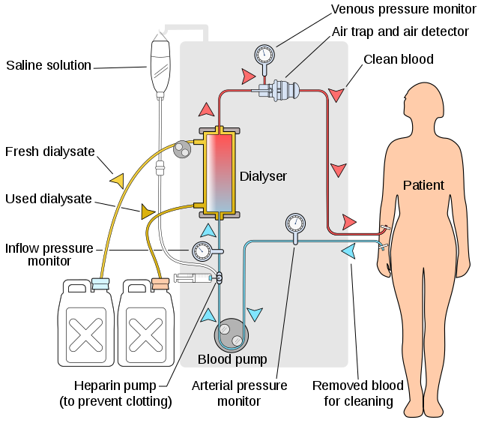

DIAGRAM OF HEMODIALYSIS.

Peritoneal dialysis
In peritoneal dialysis, a sterile solution containing glucose (called dialysate) is run through a tube into the peritoneal cavity, the abdominal body cavity around the intestine, where the peritoneal membrane acts as a partially permeable membrane.
This exchange is repeated 4–5 times per day; automatic systems can run more frequent exchange cycles overnight. Peritoneal dialysis is less efficient than hemodialysis, but because it is carried out for a longer period of time the net effect in terms of removal of waste products and of salt and water are similar to hemodialysis. Peritoneal dialysis is carried out at home by the patient, often without help. This frees patients from the routine of having to go to a dialysis clinic on a fixed schedule multiple times per week. Peritoneal dialysis can be performed with little to no specialized equipment (other than bags of fresh dialysate).

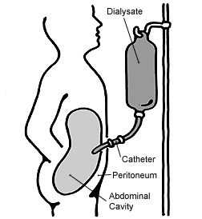
DIAGRAM OF PERITONIAL DIALYSIS.

Hemofiltration
Hemofiltration is a similar treatment to hemodialysis, but it makes use of a different principle. The blood is pumped through a dialyzer or "hemofilter" as in dialysis, but no dialysate is used. A pressure gradient is applied; as a result, water moves across the very permeable membrane rapidly, "dragging" along with it many dissolved substances, including ones with large molecular weights, which are not cleared as well by hemodialysis. Salts and water lost from the blood during this process are replaced with a "substitution fluid" that is infused into the extracorporeal circuit during the treatment.
Diagram of Hemofilteration:
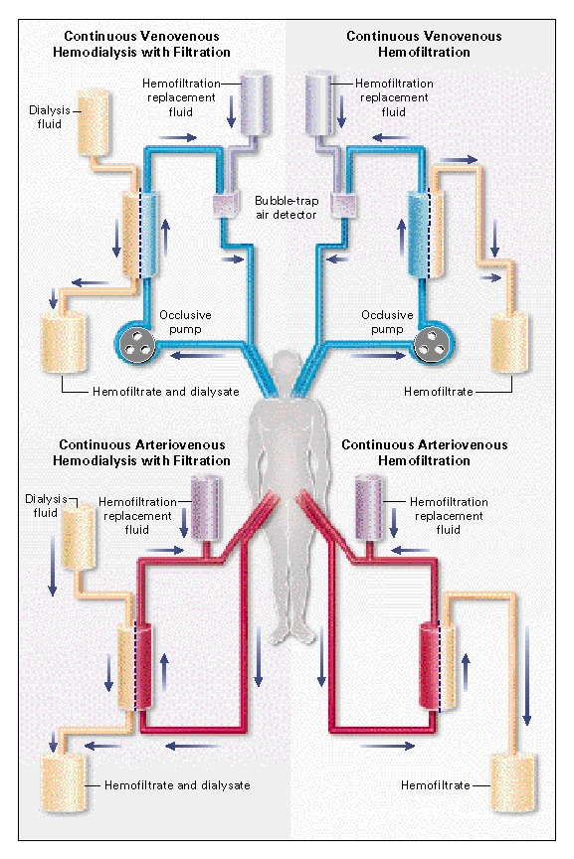

Hemodiafiltration
In intestinal dialysis, the diet is supplemented with soluble fibres such as acacia fibre, which is digested by bacteria in the colon. This bacterial growth increases the amount of nitrogen that is eliminated in fecal waste. An alternative approach utilizes the ingestion of 1 to 1.5 liters of non-absorbable solutions of polyethylene glycol or mannitol every fourth hour.
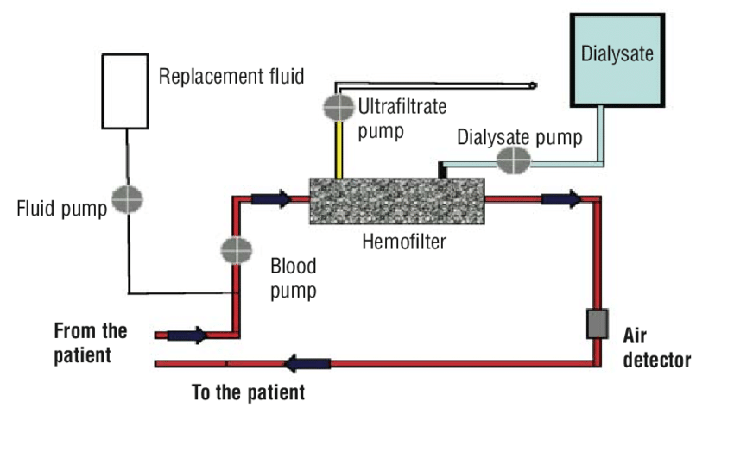
DIAGRAM OF HEMODIAFILTERATION.

