ASSIGNMENT

QUESTION 1: Discuss the pathophysiological process involved in renal failure.
Kidney failure, also called end-stage renal disease (ESRD), is the last stage of chronic kidney disease. When your kidneys fail, it means they have stopped working well enough for you to survive without dialysis or a kidney transplant. In most cases, kidney failure is caused by other health problems that have done permanent damage (harm) to your kidneys little by little, over time.
When your kidneys are damaged, they may not work as well as they should. If the damage to your kidneys continues to get worse and your kidneys are less and less able to do their job, you have chronic kidney disease. Kidney failure is the last (most severe) stage of chronic kidney disease. This is why kidney failure is also called end-stage renal disease, or ESRD for short.
When discussing the pathophysiology of CKD, renal structural and physiological characteristics, as well as the principles of renal tissue injury and repair should be taken into consideration.
Firstly, the rate of renal blood flow of approximately 400 ml/100g of tissue per minute is much greater than that observed in other well perfused vascular beds such as heart, liver and brain. As a consequence, renal tissue might be exposed to a significant quantity of any potentially harmful circulating agents or substances. Secondly, glomerular filtration is dependent on rather high intra- and transglomerular pressure (even under physiologic conditions), rendering the glomerular capillaries vulnerable to hemodynamic injury, in contrast to other capillary beds. In line with this, Brenner and coworkers identified glomerular hypertension and hyperfiltration as major contributors to the progression of chronic renal disease. Thirdly, glomerular filtration membrane has negatively charged molecules which serve as a barrier retarding anionic macromolecules. With disruption in this electrostatic barrier, as is the case in many forms of glomerular injury, plasma protein gains access to the glomerular filtrate. Fourthly, the sequential organization of nephron’s microvasculature (glomerular convolute and the peritubular capillary network) and the downstream position of the tubuli with respect to glomeruli, not only maintains the glomerulo-tubular balance but also facilitates the spreading of glomerular injury to tubulointerstitial compartment in disease, exposing tubular epithelial cells to abnormal ultrafiltrate. As peritubular vasculature underlies glomerular circulation, some mediators of glomerular inflammatory reaction may overflow into the peritubular circulation contributing to the interstitial inflammatory reaction frequently recorded in glomerular disease. Moreover, any decrease in preglomerular or glomerular perfusion leads to decrease in peritubular blood flow, which, depending on the degree of hypoxia, entails tubulointerstitial injury and tissue remodeling. Thus, the concept of the nephron as a functional unit applies not only to renal physiology, but also to the pathophysiology of renal diseases. In the fifth place, the glomerulus itself should also be regarded as a functional unit with each of its individual constituents, i.e. endothothelial, mesangial, visceral and parietal epithelial cells - podocytes, and their extracellular matrix representing an integral part of the normal function. Damage to one will in part affect the other through different mechanisms, direct cell-cell connections (e.g., gap junctions), soluble mediators such as chemokines, cytokines, growth factors, and changes in matrix and basement membrane composition.
The main causes of renal injury are based on immunologic reactions (initiated by immune complexes or immune cells), tissue hypoxia and ischaemia, exogenic agents like drugs, endogenous substances like glucose or paraproteins and others, and genetic defects. Irrespective of the underlying cause glomerulosclerosis and tubulointerstitial fibrosis are common to CKD.
An overview of the pathophysiology of CKD should give special consideration to mechanisms of glomerular, tubular and vascular injury.
QUESTION 2: With the aid of suitable diagrams, discuss the types of dialysis you know.
Dialysis is a treatment that filters and purifies the blood using a machine. This helps keep your fluids and electrolytes in balance when the kidneys can’t do their job.
TYPES OF DIALYSIS
HEMODIALYSIS
Hemodialysis is the most common type of dialysis. This process uses an artificial kidney (hemodialyzer) to remove waste and extra fluid from the blood. The blood is removed from the body and filtered through the artificial kidney. The filtered blood is then returned to the body with the help of a dialysis machine.
To get the blood to flow to the artificial kidney, your doctor will perform surgery to create an entrance point (vascular access) into your blood vessels. The three types of entrance points are:
- Arteriovenous (AV) fistula: This type connects an artery and a vein. It’s the preferred option.
- AV graft: This type is a looped tube.
- Vascular access catheter: This may be inserted into the large vein in your neck.
Both the AV fistula and AV graft are designed for long-term dialysis treatments. People who receive AV fistulas are healed and ready to begin hemodialysis two to three months after their surgery. People who receive AV grafts are ready in two to three weeks. Catheters are designed for short-term or temporary use.
Hemodialysis treatments usually last three to five hours and are performed three times per week. However, hemodialysis treatment can also be completed in shorter, more frequent sessions.Most hemodialysis treatments are performed at a hospital, doctor’s office, or dialysis center. The length of treatment depends on your body size, the amount of waste in your body, and the current state of your health.

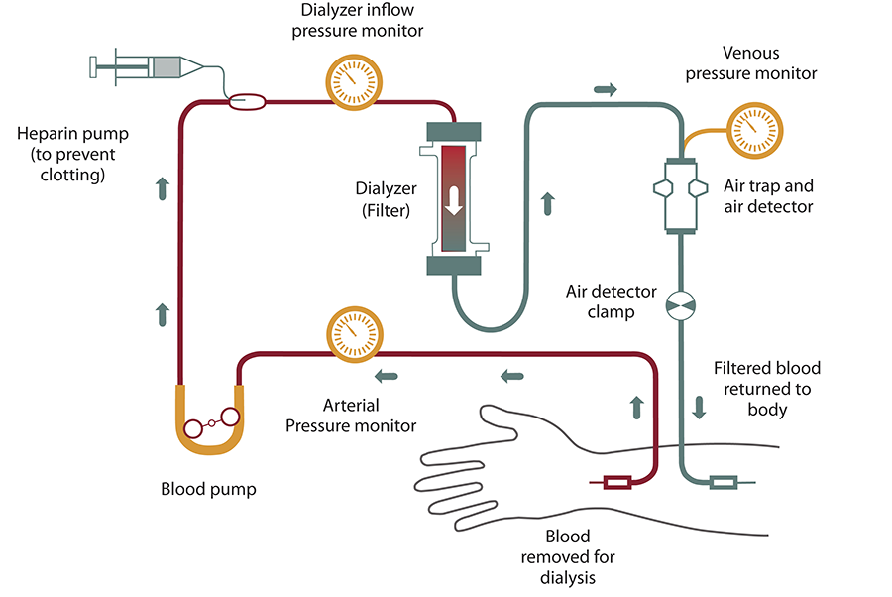

PERITONEAL DIALYSIS
Peritoneal dialysis involves surgery to implant a peritoneal dialysis (PD) catheter into your abdomen. The catheter helps filter your blood through the peritoneum, a membrane in your abdomen. During treatment, a special fluid called dialysate flows into the peritoneum. The dialysate absorbs waste. Once the dialysate draws waste out of the bloodstream, it’s drained from your abdomen.
This process takes a few hours and needs to be repeated four to six times per day. However, the exchange of fluids can be performed while you’re sleeping or awake.There are numerous different types of peritoneal dialysis. The main ones are:

- Continuous ambulatory peritoneal dialysis (CAPD: In CAPD, your abdomen is filled and drained multiple times each day. This method doesn’t require a machine and must be performed while awake.
- Continuous cycling peritoneal dialysis (CCPD): CCPD uses a machine to cycle the fluid in and out of your abdomen. It’s usually done at night while you sleep.
- Intermittent peritoneal dialysis (IPD): This treatment is usually performed in the hospital, though it may be performed at home. It uses the same machine as CCPD, but the process takes longer.
- Continuous renal replacement therapy (CRRT): This therapy is used primarily in the intensive care unit for people with acute kidney failure. It’s also known as hemofiltration. A machine passes the blood through tubing. A filter then removes waste products and water. The blood is returned to the body, along with replacement fluid. This procedure is performed 12 to 24 hours a day, generally every day,

