Aliu Kudirat Oshione
17/MHS01/054
Medicine and Surgery 300lvl
Physiology
- Discuss the pathophysiological process involved in renal failure
Renal failure refers to failure of excretory functions of kidney. It is usually, characterized by decrease in glomerular filtration rate (GFR). So GFR is considered as the best index of renal failure.
Acute renal failure is the abrupt or sudden stoppage of renal functions. It is often reversible within few days to few weeks. Acute renal failure may result in sudden life-threatening reactions in the body with the need for emergency treatment.
Chronic renal failure is the progressive, long standing and irreversible impairment of renal functions. When some of the nephrons loose the function, the unaffected nephrons can compensate it. However, when more and more nephrons start losing the function over the months or years, the compensatory mechanism fails and chronic renal failure develops.
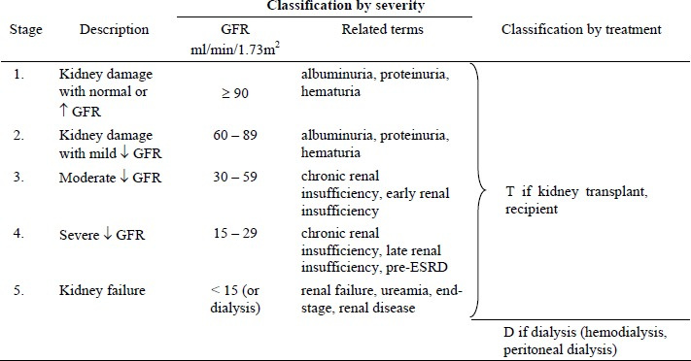
Fig: Classification of chronic kidney disease
When discussing the pathophysiology of renal diseases, renal structural and physiological characteristics, as well as the principles of renal tissue injury and repair should be taken into consideration.
Firstly, the rate of renal blood flow of approximately 400 ml/100g of tissue per minute is much greater than that observed in other well perfused vascular beds such as heart, liver and brain. As a consequence, renal tissue might be exposed to a significant quantity of any potentially harmful circulating agents or substances.
Secondly, glomerular filtration is dependent on rather high intra- and transglomerular pressure (even under physiologic conditions), rendering the glomerular capillaries vulnerable to hemodynamic injury, in contrast to other capillary beds. In line with this, Brenner and coworkers identified glomerular hypertension and hyperfiltration as major contributors to the progression of chronic renal disease.
Thirdly, glomerular filtration membrane has negatively charged molecules which serve as a barrier retarding anionic macromolecules. With disruption in this electrostatic barrier, as is the case in many forms of glomerular injury, plasma protein gains access to the glomerular filtrate.
Fourthly, the sequential organization of nephron’s microvasculature (glomerular convolute and the peritubular capillary network) and the downstream position of the tubuli with respect to glomeruli, not only maintains the glomerulo-tubular balance but also facilitates the spreading of glomerular injury to tubulointerstitial compartment in disease, exposing tubular epithelial cells to abnormal ultrafiltrate. Moreover, any decrease in preglomerular or glomerular perfusion leads to decrease in peritubular blood flow, which, depending on the degree of hypoxia, entails tubulointerstitial injury and tissue remodeling. Thus, the concept of the nephron as a functional unit applies not only to renal physiology, but also to the pathophysiology of renal diseases.
In the fifth place, the glomerulus itself should also be regarded as a functional unit with each of its individual constituents, i.e. endothothelial, mesangial, visceral and parietal epithelial cells - podocytes, and their extracellular matrix representing an integral part of the normal function. Damage to one will in part affect the other through different mechanisms, direct cell-cell connections (e.g., gap junctions), soluble mediators such as chemokines, cytokines, growth factors, and changes in matrix and basement membrane composition.
The main causes of renal injury are based on immunologic reactions (initiated by immune complexes or immune cells), tissue hypoxia and ischaemia, exogenic agents like drugs, endogenous substances like glucose or paraproteins and others, and genetic defects. Irrespective of the underlying cause glomerulosclerosis and tubulointerstitial fibrosis are common to chronic kidney diseases (CKD).
Fluid and electrolyte derangement
Sodium: In a normal individual, more than 25,000 mmol of sodium ions are filtered daily with < 1% being excreted. Chronic Renal Failure (CRF) can be associated with sodium retention, sodium depletion or normal sodium balance and is influenced by factors such as diuretic use and cardiac function. However, most patients demonstrate a mild degree of sodium and water retention whist the extracellular fluid volume remains isotonic. Ironically, the patient with CRF also has impaired renal concentrating mechanisms and thus extrarenal fluid losses such as vomiting, diarrhoea or pyrexia may rapidly cause hypovolaemia. Potassium and magnesium Adaptive processes increase potassium secretion in the distal nephron (collecting tubules) and also in the gut. Whilst a wide range of plasma potassium concentrations can be encountered dependent on factors such as diuretic use, it tends to be elevated. A range of drugs may cause acute hyperkalaemia. Magnesium is handled by the kidney much like potassium. Reduced excretion may cause hypermagnesaemia, muscle weakness and potentiate non-depolarising muscle relaxants.
Acidosis: The inability to secrete protons and buffers (e.g. phosphate) or to regenerate bicarbonate limits the clearance of hydrogen ions. Furthermore, reduction in glutamine utilisation reduces ammonia production and secretion into the proximal tubule. Retention of organic anions causes a progressive increase in the anion gap and a further fall in plasma bicarbonate concentration. Although plasma bicarbonate concentrations rarely fall below 12–15 mmol litre–1, there is little reserve to counter acute acidosis caused by ketoacidosis or sepsis.
Calcium, phosphate, parathormone and renal osteodystrophy: Total plasma calcium concentration is reduced in CRF. Renal production of calcitriol (1,25-(OH)2D3) declines causing decreased intestinal absorption of calcium. Phosphate excretion is impaired as GFR falls below 20 ml min–1 and hyperphosphataemia develops. As phosphate concentrations increase, calcium phosphate is deposited in soft tissues such as skin and blood vessels further lowering plasma calcium concentration. Hyperphosphataemia also has a negative effect on 1-α-hydroxylase, the enzyme responsible for renal calcitriol production. Both hypocalcaemia and hyperphosphataemia are potent stimuli to parathormone secretion, leading to hyperplasia of the parathyroid gland and secondary hyperparathyroidism. This causes increased osteoclast and osteoblastic activity causing osteitis fibrosa cystica.
Haematological abnormalities
A normochromic normocytic anaemia is a common finding in CRF. Decreased renal parenchymal erythropoietin production reduces stem cell transformation into erythrocytes, while uraemic toxins reduce red cell life. Chronic upper GI tract losses and those from dialysis further compound the problem. Dietary deficiency in iron and folate also occurs.
Coagulopathy: Patients with CRF have a tendency to excessive bleeding in the peri-operative period. Standard tests of coagulation are usually normal (i.e. prothrombin time, activated partial thromboplastin time, international normalised ratio) and platelet count is within normal limits. However, platelet activity is deranged with decreased adhesiveness and aggregation, probably caused by inadequate vascular endothelial release of a von Willebrand factor/factor VIII complex which binds to and activates platelets. Increased platelet release of β-thromboglobulin and vascular production of PGI2 also contribute to the coagulopathy. Defects in platelet adhesion may also be related to excessive nitric oxide (NO) production. The plasma from patients with CRF has been shown to be a potent inducer of endothelial NO production.
Cardiovascular and pulmonary abnormalities:
Cardiovascular abnormalities are common in CRF and are responsible for 48% of deaths in these patients. Systemic hypertension is the most common with an incidence approaching 80%, although it is often not a feature of sodium-wasting nephropathies such as polycystic kidney disease or papillary necrosis. Plasma volume expansion resulting from sodium and water retention is the most frequent cause of hypertension; it may be improved significantly by dialysis. Some patients may require β-blockers, ACE inhibitors, α-antagonists and vasodilators to control their blood pressure adequately. Alteration in the control of renin and angiotensin secretion may also contribute to hypertension in 30% of patients. Ischaemic heart disease (IHD) is a frequent cause of mortality in patients with CRF. Accelerated atherosclerosis results from a decreased plasma triglyceride clearance, hypertension and fluid overload causing left ventricular hypertrophy and failure.
Gastrointestinal abnormalities:
Gastrointestinal abnormalities are frequent with anorexia, nausea and vomiting contributing to malnutrition. Urea is a mucosal irritant and bleeding may occur from any part of the GI tract. Gastric emptying is delayed, residual volume increased and pH lowered. Peptic ulcer disease is common and most patients will receive proton pump inhibitors. The use of a rapid sequence induction technique needs be balanced against the risks of difficult intubation in chronically ill patients with poor dentition.
Neurological abnormalities:
Many patients with CRF have abnormalities in central (CNS) and peripheral nervous system function. There is a wide spectrum of CNS changes. for example, from mild personality alterations to asterixis (i.e. lapse of posture, usually manifest by bilateral flapping tremor), myoclonus, encephalopathy and convulsions. Peripheral neuropathy is common in advanced stages of the disease. Initially, it presents as a distal ‘glove and stocking’sensory loss but then progresses to motor changes. Both dialysis and renal transplantation may improve the neuropathy. The presence of a peripheral neuropathy should alert the anaesthetist to the presence of an autonomic neuropathy with delayed gastric emptying, postural hypotension and silent myocardial ischaemia. Two types of neurological disturbances are unique to patients on dialysis. Dialysis dementia with dyspraxia, myoclonus and dementia occurs in patients on dialysis for many years and may be related to aluminium toxicity. The dialysis disequilibrium syndrome is associated with rapid initial reduction in plasma urea concentrations at the start of dialysis.
Endocrine disturbances:
Changes in parathyroid function and lipid clearance have been noted above. Glucose tolerance is impaired but there is a reduced requirement for exogenous insulin in diabetic patients, probably related to the reduced metabolism of insulin by the failing kidney. Patients with CRF have abnormalities of temperature regulation with reduced basal metabolic rate and a tendency to hypothermia. This is may be important when assessing fever.

- With the aid of suitable diagrams, discuss the types of dialysis you know
Dialysis is the procedure to remove waste materials and toxic substances and to restore normal volume and composition of body fluid in severe renal failure. It is also called hemodialysis. Artificial kidney is the machine that is used to carry out dialysis during renal failure. It is used to treat the patients suffering from: acute renal failure or chronic or permanent renal failure. Dialysis is used as a temporary measure in either acute kidney injury or in those awaiting kidney transplant and as a permanent measure in those for whom a transplant is not indicated or not possible.
Types of Dialysis
There are three primary and two secondary types of dialysis: hemodialysis (primary), peritoneal dialysis (primary), hemofiltration (primary), hemodiafiltration (secondary) and intestinal dialysis (secondary).
- Hemodialysis: In hemodialysis, the patient's blood is pumped through the blood compartment of a dialyzer, exposing it to a partially permeable membrane. The dialyzer is composed of thousands of tiny hollow synthetic fibers. The fiber wall acts as the semipermeable membrane. Blood flows through the fibers, dialysis solution flows around the outside of the fibers, and water and wastes move between these two solutions. The cleansed blood is then returned via the circuit back to the body. Ultrafiltration occurs by increasing the hydrostatic pressure across the dialyzer membrane. This usually is done by applying a negative pressure to the dialysate compartment of the dialyzer. This pressure gradient causes water and dissolved solutes to move from blood to dialysate and allows the removal of several litres of excess fluid during a typical 4-hour treatment. In the United States, hemodialysis treatments are typically given in a dialysis center three times per week (due in the United States to Medicare reimbursement rules).
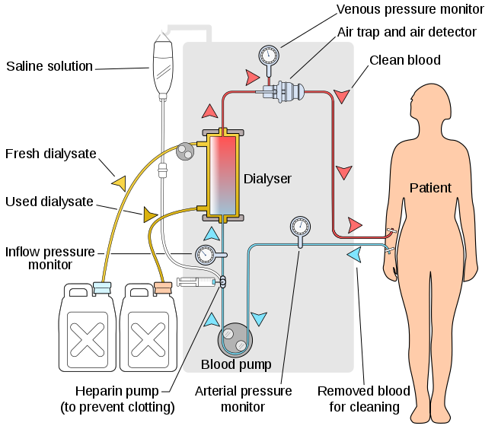
Fig: hemodialysis
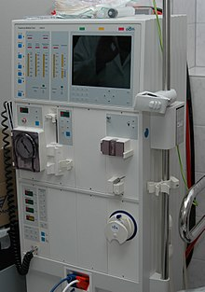
Fig: A Hemodialysis machine
- Peritoneal dialysis: In peritoneal dialysis, a sterile solution containing glucose (called dialysate) is run through a tube into the peritoneal cavity, the abdominal body cavity around the intestine, where the peritoneal membrane acts as a partially permeable membrane. This exchange is repeated 4–5 times per day; automatic systems can run more frequent exchange cycles overnight. Peritoneal dialysis is less efficient than hemodialysis, but because it is carried out for a longer period of time the net effect in terms of removal of waste products and of salt and water are similar to hemodialysis. Peritoneal dialysis is carried out at home by the patient, often without help. This frees patients from the routine of having to go to a dialysis clinic on a fixed schedule multiple times per week. Peritoneal dialysis can be performed with little to no specialized equipment (other than bags of fresh dialysate).
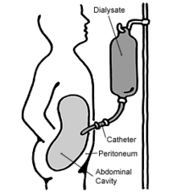
Fig: Peritoneal Dialysis
- Hemofiltration: Hemofiltration is a similar treatment to hemodialysis, but it makes use of a different principle. The blood is pumped through a dialyzer or "hemofilter" as in dialysis, but no dialysate is used. A pressure gradient is applied; as a result, water moves across the very permeable membrane rapidly, "dragging" along with it many dissolved substances, including ones with large molecular weights, which are not cleared as well by hemodialysis. Salts and water lost from the blood during this process are replaced with a "substitution fluid" that is infused into the extracorporeal circuit during the treatment.
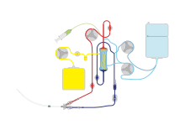
Fig: Continuous veno-venous haemofiltration with pre- and post-dilution (CVVH)
- Hemodiafiltration: This is a combination of hemodialysis and hemofiltration, thus used to purify the blood from toxins when the kidney is not working normally and also used to treat acute kidney injury.
- Intestinal dialysis: In intestinal dialysis, the diet is supplemented with soluble fibres such as acacia fibre, which is digested by bacteria in the colon. This bacterial growth increases the amount of nitrogen that is eliminated in fecal waste. An alternative approach utilizes the ingestion of 1 to 1.5 liters of non-absorbable solutions of polyethylene glycol or mannitol every fourth hour.
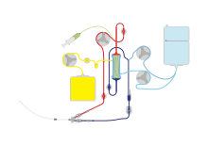
Fig: Continuous veno-venous haemofiltration
COMPLICATIONS OF DIALYSIS
Complications of dialysis depend upon the patient’s condition, age, existence of diseases other than renal failure and many other factors. Common complications of dialysis in individuals having only renal dysfunction are: 1. Sleep disorders 2. Anxiety 3. Depression.

