RENAL FAILURE
Renal failure refers to the deterioration of renal functions resulting in a decline in glomerular filtration rate (GFR) and rise in urea and non-nitrogenous substances in the blood. It is of two types:
- Acute renal failure (ARF) - It refers to the sudden decline in glomerular filtration rate over a period of days or weeks associated with a rapid rise in blood urea.
- Chronic renal failure (CRF) - It refers to a slow, insidious, irreversible deterioration of renal functions resulting in the development of clinical syndrome of uraemia, manifested by excretory, metabolic, neurological, haematological and endocrinal abnormalities.
PATHOPHYSIOLOGY OF ACUTE RENAL FAILURE
Common causes of acute renal failure (ARF) can be grouped as:
1. PRERENAL CAUSES: include reduced blood supply to the kidneys. Normally, kidneys receive about 20–25% of the cardiac output (1100 ml/min). Decreased renal blood flow is usually accompanied by decreased glomerular filtration rate and reduced urinary output. When blood flow is reduced below the basal requirements (i.e. 20–25% less than normal renal blood flow), renal ischemia occurs causing damage to renal cells, particularly tubular epithelial cells. The common causes of reduced blood flow to kidney are severe hemorrhage, shock, severe burns, hypovolaemia, septicaemia, cardiac failure and so on.
2. INTRARENAL CAUSES: include acute glomerulonephritis and acute tubular necrosis
- Acute glomerulonephritis is usually caused by an abnormal immune reaction, which causes damage to the glomeruli. In 95% of cases of glomerulonephritis, streptococcal infection involving other parts of body (tonsillitis or skin infection). The antibodies develop against the streptococcal antigen (within few weeks), react and form insoluble antigen–antibody complexes, which get deposited in the glomeruli and evoke an inflammatory reaction. The glomeruli get blocked and those which are not blocked, their permeability increases and allow leak of proteins and red cells from the glomerular capillaries into the glomerular filtrate. In severe cases, there is renal shutdown and this results in acute renal failure.
- Acute tubular necrosis means destruction of tubular epithelial cells. Tubular necrosis occurs due to diminution of oxygen and nutrition to epithelial cells. Toxins, poisons and certain drugs also damage the tubular epithelium resulting in acute renal failure due to toxins or ischemia.
3. OBSTRUCTIVE CAUSES: include urinary tract obstruction at any site. Post renal or obstructive renal failure occurs due to abnormalities of lower urinary tract which partially or completely blocks urinary flow (though renal blood flow is normal). If the urine output of only one kidney is blocked, no major changes occur in body fluids composition because the contra lateral kidney undergoes compensation. The causes of post renal acute renal failure include:
I. Bilateral obstruction of ureters, or of renal pelvis, by large stones or blood clots
ii. Bladder or urethral obstruction
Physiological effects of acute renal failure include:
- Retention of salt and water, waste metabolites and electrolytes (rise in creatinine and urea) in blood and extracellular fluid can lead to edema and hypertension.
- Excessive retention of potassium (hyperkalaemia) is a serious threat to a patient with acute renal failure.
- Kidneys are unable to excrete hydrogen ions resulting in metabolic acidosis and that it is a fatal condition and also aggravates hyperkalaemia.
- In severe cases of acute renal failure, oliguria or complete anuria occurs and the patient may die unless kidney functions are restored.

CHARACTERISTICS OF AUTE RENAL FAILURE:
- No history of pre-existing renal disease
- Presence of oliguria or anuria
- Rapid rise in blood urea and creatinine levels
- High urine osmolality (>400 mOsm/kg H2O).

TREATMENT
- Medical management consists of:
- Maintenance of adequate water and electrolyte balance
- Control of infection
- Control of blood pressure
- Control of metabolic acidosis by I/V use of sodium bicarbonate, so that the bicarbonate levels are maintained around 18 mmol/dL.
- Control of diet—protein, Na+, K+, Mg+ and water. About 20–40 g of protein should be given per day to prevent endogenous breakdown of proteins.
- Dialysis is frequently needed in cases with oliguria,hyperkalaemia, or acidosis or fluid overload
PATHOPHYSIOLOGY OF CHRONIC RENAL FAILURE
Chronic Renal Disease (CRD) is known as chronic renal insufficiency or chronic renal failure. Chronic renal insufficiency, this term is used by some experts to explain the beginning chronic renal disease (CRD) stages that damages the kidney and has impaired renal function already, but the systemic manifestations are nominal.
Chronic renal failure, like acute renal failure, also occurs in a wide variety of diseases, but the end result is reduction of functional nephrons and deterioration of the kidney function to the point, where the patient must be placed on dialysis treatment or transplanted with a functional kidney for survival. This condition is referred as end-stage renal disease (ESRD). The exact mechanism of this stage is not well understood, but a slowly progressing vicious cycle due to renal adaptive changes may be responsible.
Common causes which lead on to slow, progressive nephron loss and ultimately chronic renal failure can be grouped as under:
- CONGENITAL DISORDERS, e.g. polycystic kidney.
2. VASCULAR DISEASE OF KIDNEY, renal hypertension. Injury to renal vasculature can lead to renal ischemia. The most common cause of renal vascular injury is atherosclerosis. Atherosclerosis of the larger renal arteries leads to hypertension and involvement of smaller arteries (interlobular arteries and efferent arterioles) results in thickening of vessel walls due to deposits of fibrinoid tissue (nephrosclerosis), eventually leading to constriction (ischemic injury).
3. GLOMERULAR DISEASES, e.g. proliferative glomerulonephritis and diabetic nephropathy. Chronic glomerulonephritis: injury to glomeruli can be caused by several diseases. In most cases, it begins with accumulation of antigen–antibody complexes in the glomerular membrane and ultimately glomeruli are replaced by fibrous tissue, therefore unable to filter the fluid. Therefore, glomerular capillary filtration coefficient gets markedly reduced.
4. TUBULOINTERSTITIAL DISEASE, e.g. chronic pyelonephritis and analgesic nephropathy. These diseases are referred to as interstitial nephritis. Injury to renal interstitium can be caused by bacterial infection (called as pyelonephritis) or as a result of vascular, glomerular and tubular damage by poison and toxic drugs.
5. OBSTRUCTIVE RENAL DISEASE, e.g. benign enlargement of prostate, renal calculi and ureteral constriction.

TREATMENT
I. Medical management consists of:
- Treat, if the cause is reversible, e.g. hypertension, urinary tract obstruction, etc.
- Nephrotoxic drugs to be avoided.
- Measures to limit the adverse effects of uraemia and to prevent further progression include:
- Control of infection
- Control of hypertension
- Control of diet as regards proteins, Na+, K+, water and Mg+ content
- Control of anaemia
- Control of metabolic acidosis
- Maintenance of electrolyte and water balance
II. Dialysis and renal transplantation is frequently needed.

TYPES OF DIALYSIS
There are different types of dialysis. All of these types help in purifying the blood in some way or the other. Depending on the method used, the types of dialysis vary. There are three major or primary types of dialysis and two secondary types. They primary types of dialysis are:
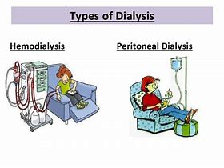

HAEMODIALYSIS:
The most common method of dialysis is the Haemodialysis. In this method, the doctor will create a vascular access into the body, surgically. This will allow more blood to flow through the dialyzer and return back to the body after purification. The vascular access is an entrance to the blood vessels. Inside the dialyzer, there are thousands of tiny synthetic fibres that act as semi-permeable membrane. A dialysis solution, also known as dialysate, is used to purify the blood that runs through this membrane of fibres. A negative pressure is used to remove the water from the blood to the dialysate. The usual span for the Haemodialysis process is 4 hours. Typically a person has to undergo three haemodialysis sessions per week. However, depending on the condition, requirement or disease, haemodialysis can be done more frequently and for shorter or longer sessions.
The body size and the amount of waste in the blood determine the frequency of haemodialysis suitable for the patient. Usually the procedure is done at a doctor’s office or at a hospital or at a dialysis centre. Nowadays, with advanced technology haemodialysis is also being offered at the patient’s home. Those, who are in need for a long-term dialysis, are recommended the at-home haemodialysis treatment.

Hemodialysis: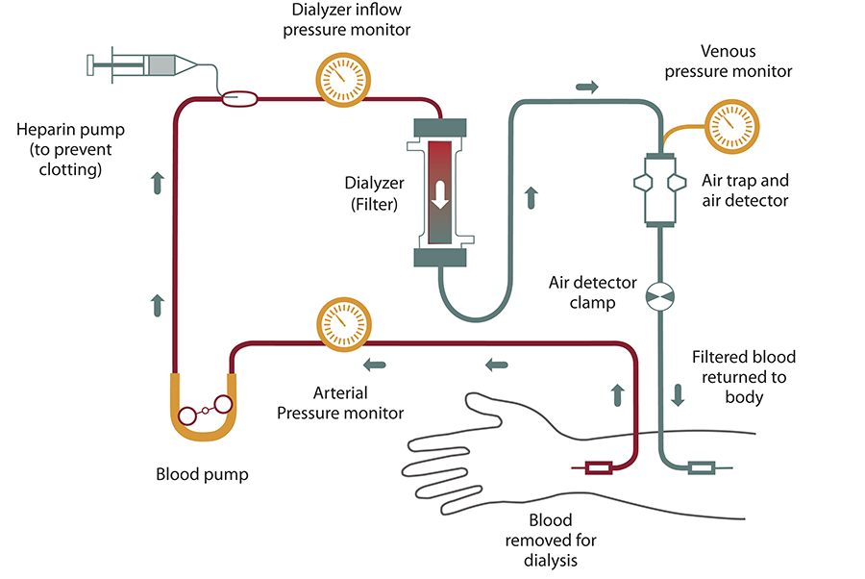

PERITONEAL DIALYSIS:
This is a surgical procedure of dialysis. The doctor implants a catheter into the patient’s belly and this comes out from below the belly button. A dialysate fluid is inserted into the abdomen through the catheter. This fluid draws out the waste materials and extra water from the blood, through the small blood vessels in the abdomen. Once the process is done, the waste materials and extra water from the blood along with the dialysate fluid, all get deposited into a bag through the catheter
Here it must be mentioned that there are two types of peritoneal dialysis –
- Continuous ambulatory peritoneal dialysis (CAPD)
- Continuous cycling peritoneal dialysis (CCPD)
CAPD is useful for those, who want to undergo the dialysis treatment while staying mobile or while doing other tasks. It is carried out multiple times a day. This method does not require any machine to carry out the dialysis treatment. CCPD is useful for those, who do not want any interruption throughout the day. It is done at night, while the patient is asleep.
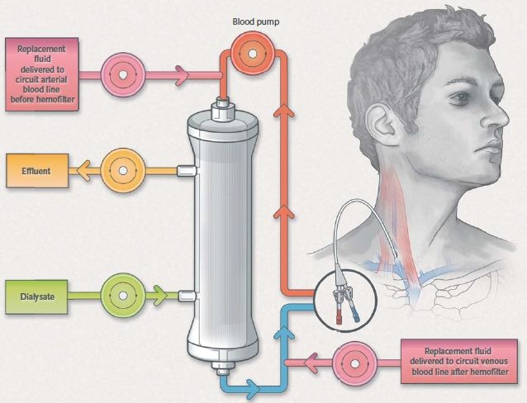

HEMOFILTRATION:
Hemofiltration is similar to haemodialysis except for the principle which it follows. In this process, the blood is passed via the dialyzer but the dialysate is not used. The water is passed through permeable membranes rapidly, taking along with it the dissolved substances including large molecular substances which are usually not cleared in hemodialysis. During the treatment process, water and salts that are replaced during this filtration process is infused back in the extracorporeal circuit.
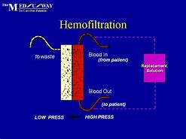

The secondary types of dialysis include:
- Haemodiafiltration: This is actually a combination of hemodialysis and hemofiltration.
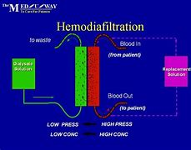
- Intestinal Dialysis: In this type of dialysis, the diet is incorporates acacia fibre, a soluble fibre, which is easily digested by the bacteria in the colon. This bacterial growth increases the nitrogen content in the digestive system which is then eliminated from the body through feaces.

