NAME: CHINENYE CHIDNMA MARY-JOSEPHINE
LEVEL: 300 MBBS
Assignment Title: Renal Physiology for MBBS student
Course Title: Renal Physiology Body Fluid and Temperature Regulation
Course Code: PHS 303
Question
1. Discuss the pathophysiological process involves in renal failure?
2. With the aid of suitable diagrams discuss the types of dialysis you know?
ANSWER
- Renal failure is defined as a significant loss of renal function in both kidneys to the point where less than 10 to 20% of normal GFR remains. Renal failure may occur as an acute and rapidly progressing process or may present as a chronic form in which there is a progressive loss of renal function over a number of years. Acute renal failure has an abrupt onset and is potentially reversible. Chronic failure progresses slowly over at least three months and can lead to permanent renal failure.
- Acute Renal Failure
Sudden decrease in renal function. Acute renal failure may be pre-renal, intra-renal or post-renal in nature. Acute renal failure is often reversible so long as permanent injury to the kidney has not occurred.
Manifestations
- Oliguria (reduced urine output)
- Possible edema and fluid retention
- Elevated blood urea nitrogen levels (BUN) and serum creatinine
- Alterations in serum electrolytes
Causes
Myocardial infarction, rhabdomyolysis, decreased blood flow, obstruction, hemolytic uremic syndrome, Glomerulonephritis are common causes of acute renal failure. Acute Renal Failure classified as pre-renal failure, intra-renal failure and post-renal failure
Pre-renal Failure: Results from impaired or reduced blood flow to the kidney. Possible causes: shock, hypotension, anaphylaxis, ischemic formation
Intra-renal failure: Results from acute damage to renal structures. Possible causes: acute glomerulonephritis, pyelonephritis, May also result from acute tubular necrosis (ATN); damage of kidney structure from exposure to toxins, solvents, drugs and heavy metals. ATN is the most common cause of acute renal failure
Post-renal failure: Results from conditions block of urine outflow. Possible causes: obstruction of urine outflow by calculi, tumors, prostatic hypertrophy
Symptoms
- Decreased kidney function (electrolyte imbalance)
- Obstruction in the urinary tract
- Blood in urine
- Reduced urine output
- Dehydration
- Detectable abnormal mass
- Pale skin
- Poor appetite
Treatment
– Prevention of acute renal failure through support of blood pressure and blood volume
– Correction of fluid and electrolyte imbalances
– Dialysis, which may be employed while the kidneys are in the recovery phase
– Low protein, high carbohydrate diet to minimize the formation of nitrogenous wastes
- Chronic Renal Failure
Chronic renal failure is the end result of progressive kidney damage and loss of function. Chronic renal failure is often classified into four progressive stages based on the loss of GFR.
Stages of Chronic Renal Failure
- Diminished renal reserve — GFR decreased to 35 to 50% of normal
- Renal insufficiency — GFR decreased to 20 to 35% of normal
- Renal failure — GFR reduced to less than 20% of normal
- End-Stage Renal Disease — GFR is less than 5% of normal
Manifestation
This is a multisystem disease
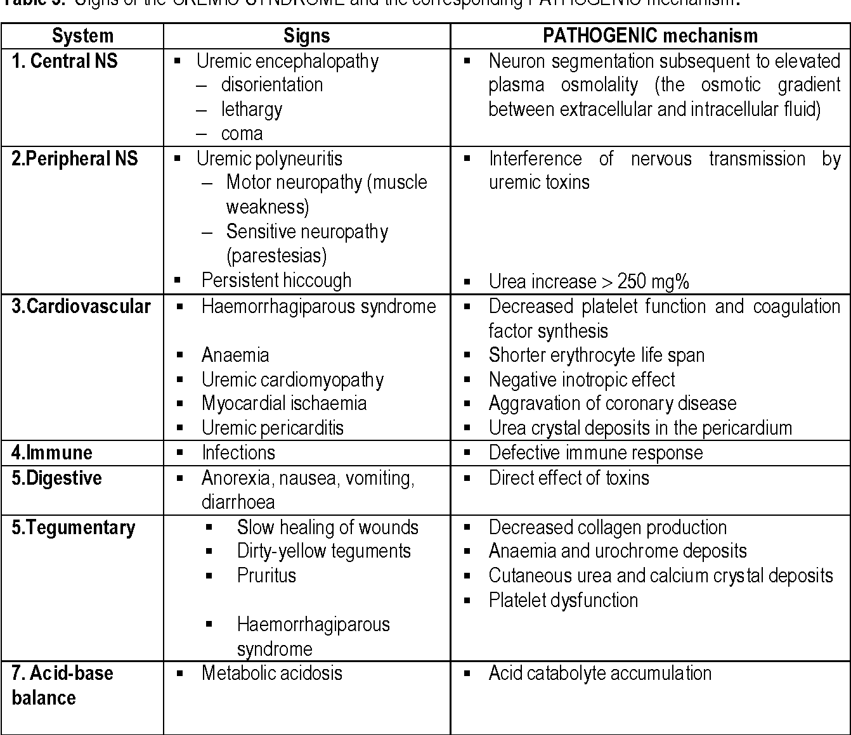
Causes
- Chronic glomerulonephritis
- Chronic infections
- Renal obstruction (prolonged)
- Exposure to toxic chemicals, toxins or drugs
(aminoglycoside antibiotics and nephrotoxicity)
- Diabetes
- Hypertension
- Nephrosclerosis (atherosclerosis of the renal artery)
- Diabetic nephropathy
- Alport syndrome (inherited disorder causes deafness,
progressive kidney damage and eye defects)
- Polycystic kidney disease
- Interstitial nephritis or pyelonephritis
Symptoms
- Until very kidney function remains, chronic renal failure may not developed
Anemia, increased levels of phosphates (in blood) are
complications of kidney failure.
- Malaise
- Dry skin
- Poor appetite
- Vomiting
- Bone pain
- metallic taste in mouth
- detectable abdominal mass
Treatment
- Careful management of fluids and electrolytes
- Prudent use of diuretics
- Careful dietary management; restriction of dietary
- protein intake
- Recombinant erythropoietin to treat anemia
- Renal dialysis
- Renal transplantation
- In medicine, dialysis is the process of removing excess water, solutes, and toxins from the blood in people whose kidneys can no longer perform these functions naturally. This is referred to as renal replacement therapy. However, dialysis isn’t a cure for kidney disease or other problems affecting the kidneys. Different treatments may be needed to address those concerns. Dialysis is of two main types;
- Hemodialysis
Hemodialysis is the most common type of dialysis. This process uses an artificial kidney (hemodialyzer) to remove waste and extra fluid from the blood. The blood is removed from the body and filtered through the artificial kidney. The filtered blood is then returned to the body with the help of a dialysis machine.
To get the blood to flow to the artificial kidney, your doctor will perform surgery to create an entrance point (vascular access) into your blood vessels. The three types of entrance points are:
Arteriovenous (AV) fistula. This type connects an artery and a vein. It’s the preferred option.
AV graft. This type is a looped tube.
Vascular access catheter. This may be inserted into the large vein in your neck.
Both the AV fistula and AV graft are designed for long-term dialysis treatments. People who receive AV fistulas are healed and ready to begin hemodialysis two to three months after their surgery. People who receive AV grafts are ready in two to three weeks. Catheters are designed for short-term or temporary use.
Hemodialysis treatments usually last three to five hours and are performed three times per week. However, hemodialysis treatment can also be completed in shorter, more frequent sessions.
Most hemodialysis treatments are performed at a hospital, doctor’s office, or dialysis center. The length of treatment depends on your body size, the amount of waste in your body, and the current state of your health.
After you’ve been on hemodialysis for an extended period of time, your doctor may feel that you’re ready to give yourself dialysis treatments at home. This option is more common for people who need long-term treatment.
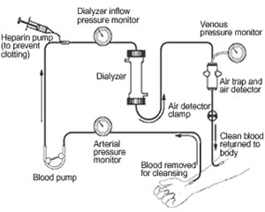
Possible complications of hemodialysis include muscle cramps and hypotension (sudden drop in blood pressure). Hypotension may cause you to feel dizzy, weak or sick to your stomach. You can usually avoid side effects by following the proper diet and taking your medications.

- Peritoneal dialysis
Peritoneal dialysis involves surgery to implant a peritoneal dialysis (PD) catheter into your abdomen. The catheter helps filter your blood through the peritoneum, a membrane in your abdomen. During treatment, a special fluid called dialysate flows into the peritoneum. The dialysate absorbs waste. Once the dialysate draws waste out of the bloodstream, it’s drained from your abdomen.
This process takes a few hours and needs to be repeated four to six times per day. However, the exchange of fluids can be performed while you’re sleeping or awake.
There are numerous different types of peritoneal dialysis. The main ones are:
Continuous ambulatory peritoneal dialysis (CAPD). In CAPD, your abdomen is filled and drained multiple times each day. This method doesn’t require a machine and must be performed while awake.
Continuous cycling peritoneal dialysis (CCPD). CCPD uses a machine to cycle the fluid in and out of your abdomen. It’s usually done at night while you sleep.
Intermittent peritoneal dialysis (IPD). This treatment is usually performed in the hospital, though it may be performed at home. It uses the same machine as CCPD, but the process takes longer.
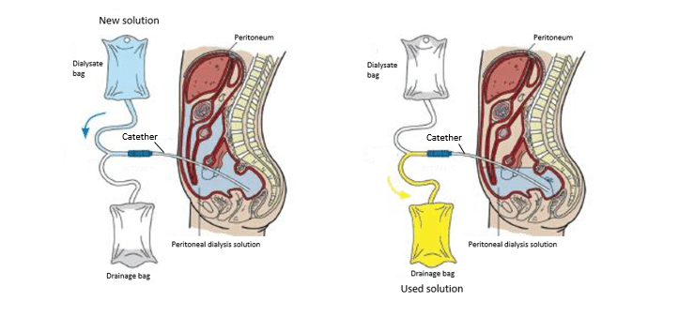
Possible complications of peritoneal dialysis include an infection of the peritoneum, or peritonitis, where the catheter enters the body. Peritonitis causes fever and stomach pain. A dietitian will help plan your diet during peritoneal dialysis, so we can ensure you are choosing appropriate meals.

