NAME: IMAM, MAIMUNAT NNA
MATRIC NO: 18/MHS01/183
LEVEL: 200L MEDICINE AND SURGERY
LECTURER: DR. ADESOLA ONIYIDE
COUSE NAME: PHYSIOLOGY
DATE: June 27, 2020

QUESTION 1
DISCUSS THE LONG TERM REGULATION OF MEAN ARTERIAL BLOOD PRESSURE??

ANSWER:
Definition:
Blood pressure is the force exerted by blood on the walls of the arteries. The blood pressure is expressed in two values (120/80 mmHg) measured in millimeter of mercury (mmHg). These numbers express both the systolic and diastolic pressures. The first number is the systolic pressure in which the pressure of the blood during the heart contraction; while the second number id the diastolic pressure which is the number of the heart at rest. However, Mean arterial pressure is one of the forms in which blood pressure is expressed. The mean arterial pressure (MAP) is the average pressure existing in the arteries. It is the diastolic pressure plus the 1/3 of the pulse pressure.

MAP = Diastole + (1/3) pulse pressure

Factors that can increase or decrease Mean Arterial Blood Pressure
- Physiological factors :
  - Age
  - Exercise
  - Sleep
  - Sex
  - Body weight
  - After meals
- Pathological factors
  - Hypertension
  - Hypotension
Regulation of Mean Arterial Blood Pressure:
There are several ways of regulating mean arterial pressure such as the short –term regulatory mechanism (nervous system); long term regulatory mechanism (renal mechanism); hormonal mechanism; and local mechanism. However, our focus will be on the long term regulatory mechanism.

LONG TERM REGULATORY MECHANISM
The kidney is the main organ responsible for the long term regulation of the arterial blood pressure. However, the kidneys accomplish this in two ways which are:
- By regulation of the extracellular fluid by pressure natriuresis and diuresis mechanisms in the kidney
- By the renin- angiotensin mechanism
By regulation of the extracellular fluid by pressure natriuresis and diuresis mechanisms in the kidney
Pressure natriuresis is the excess excretion of large amount of sodium in urine due to increase in arterial pressure; while the pressure diuresis is the excess excretion of water as a result of increase in pressure. So a slight increase in pressure leads to increase in the amount of water excreated (doubles it). Therefore, increase in arterial pressure leads to decrease in ECF and blood volume and vice versa. This shows that arterial pressure is directly proportional to ECF and blood volume. However, there are two key determinants of long term arterial pressure; which are:
1) Renal output of salt and water: When there is a decrease in blood arterial pressure, the kidneys respond by increase the reabsorption of water and salt from the renal tubules which in turns increase the ECF volume, blood volume, and cardiac output; and thereby restoring blood pressure back to equilibrium. However, when there is an increase in blood arterial pressure, the kidneys respond by decrease the reabsorption of water and salt from the renal tubules which in turns decrease the ECF volume, blood volume, and cardiac output; and thereby decrease blood pressure back to equilibrium.
2) Intake of salt and water: If the arterial falls below the equilibrium point, the intake of water and salt becomes greater than the output; thereby increasing ECF volume, blood volume, and arterial pressure until it returns to the equilibrium point. When arterial pressure rises above the equilibrium point, then the intake of water and salt becomes less than the output; thereby decreasing ECF, blood volume, and the arterial pressure till the equilibrium point.

RENIN- ANGIOTESIN MECHANISM
This is the second way in which the kidney can respond to changes in blood arterial pressure in other to regulate it. When the arterial pressure falls too low, the kidneys release renin, which is a enzyme that helps in increasing the arterial pressure. Renin is synthesized and stored in its inactive form called prorenin in the juxtaglomerular cells (modified smooth muscle cells) of the kidney. So when the arterial pressure falls, intrinsic reaction take place in the kidney causing prorenin molecules to split and release renin. Most of the renin enters the renal blood into the circulatory system and the small amount of renin do remain in the local fluids of the kidney and initiate several intrarenal functions. The renin acts on another plasma protein called angiotessiongen, enzymatically to release a 10-amino acid peptide, angiotensin I. Within a few sec to minutes after the formation of the angiotensin I, two additional amio acids are split from the angiotensin I to form 8 amino acid peptide angiotensin II. This conversion occurs extensively in the small vessels of the lungs catalyzed by an enzyme called angiotensin-converting enzyme that is present in the endothelium of the lung vessels. However, it can also occur in other tissues such as the kidney and blood vessels. Angiotensin II is an extremely powerful vasoconstrictor and persists in the blood for 1 or 2 min because it is rapidly inactivated by multiple blood and tissue enzyme collectively called angiotensinases.
Angiotensin II acts in two ways to restore blood pressure
- Vasoconstriction in many areas of the body, occurs rapidly: There is a constriction in the arterioles which increase the total peripheral resistance; thereby increasing the arterial pressure. In addition to this, it constricts the afferent arterioles in the kidneys which reduces the glomerular filtration; thereby increase water and salts retention and increase both ECF and blood pressure.
- Retention of salt and water: Angiotensin II stimulates adrenal cortex to secrete aldosterone, which in turn increase salt and water reabsorption by the kidney tubules. Thereby, increasing ECF and blood volume and in turn increase blood pressure.
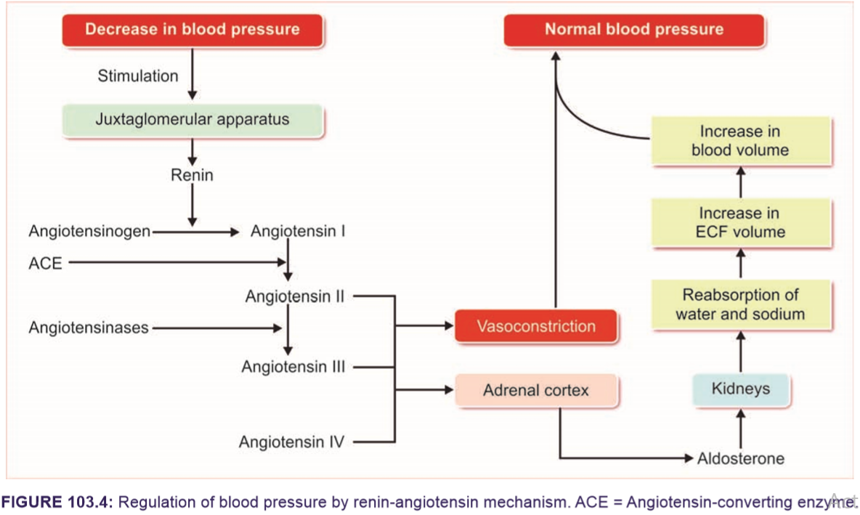
CLINICAL CORRELATION
Renal hypertension: Hypertension caused by renal diseases such as:
a. Stenosis of renal arteries
b. Tumor of juxtaglomerular cells, leading to excess production of angiotensin II
c. Glomerulonephritis.

QUESTION 2
Write short notes on the following:
- Pulmonary circulation
- Circle of Willis
- Splanchnic circulation
- Coronary circulation
- Cutaneous circulation
ANSWER
- PULMONARY CIRCULATION: This is portion of the circulatory system which carries deoxygenated blood away from the right ventricle to the lungs and returns oxygenated blood to the left atrium and ventricle of the heart. The movement of the blood through the pulmonary circulation is quite easy. From the right atrium, the blood gets pumped through the triscuspid valve (or right atrioventricular valve) into the right ventricle. The blood then pumps from the right ventricle through the pulmonary valve and into the main pulmonary arteries.
In the lungs: The deoxygenated blood carried by the pulmonary arteries are then delivered to the lungs. At the capillaries, gaseous molecules are exchanged; thereby carbon dioxide is released and oxygen is picked up during respiration. The oxygenated blood moves through the pulmonary vein and move blood into the left atrium of the heart; therefore completing pulmonary cycle.

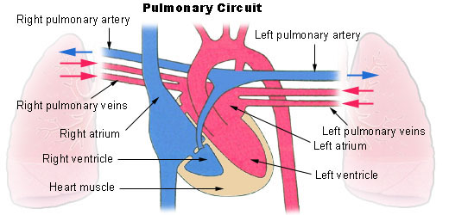

CLINICAL SIGNIFICANCE
- Pulmonary hypertension: this is the increase in resistance in the pulmonary arteries
- Pumonary embolus: Usually from a deep vein thrombosis that has lodged in the pulmonary vasculature.
- Cardiac shunt: is an unnatural connection between parts of the heart that leads to blood flow that bypasses the lungs.
- CIRCLE OF WILLIS
The circle of Willis is a group of blood vessels in the brain that connect with each other, forming a continuous structure that resembles a circle. The circle of Willis is the supplied by the four large arteries – two carotid and two vertebra-basilar arteries which merge to form the circle of Willis at the base of the brain. The circle of Willis encircles the stalk of the pituitary gland and provides important communications between the blood supply of the forebrain and hindbrain. These nine arteries supply blood to a large portion of the brain.
The circle of Willis is composed of the following vessels and blood flows through them in this order:
- One anterior communicating artery (ACOM): The ACOM is short and makes up the front of the circle of Willis.
- The left and right anterior cerebral arteries (ACAs): These vessels run along the sides of the circle of Willis.
- The left and right internal carotid arteries (ICAs): The ICAs travel in the front of the neck, through the carotid canal, to enter into the brain. This large blood vessel divides into the ACA and the middle cerebral artery (MCA). The MCA is not part of the circle of Willis.
- The left and right posterior cerebral arteries (PCAs): The PCAs are branches of the single basilar artery, which is formed by merging of the vertebral arteries in the back of the neck. The left and right PCAs are the longest parts of the circle of Willis and run along its sides, with a corresponding ICA in between the PCA and the ACA on each side.
- The left and right posterior communicating arteries (PCOMs): The PCOMs are found in the back portion of the circle of Willis (nearer to the back of the head) and are relatively short.
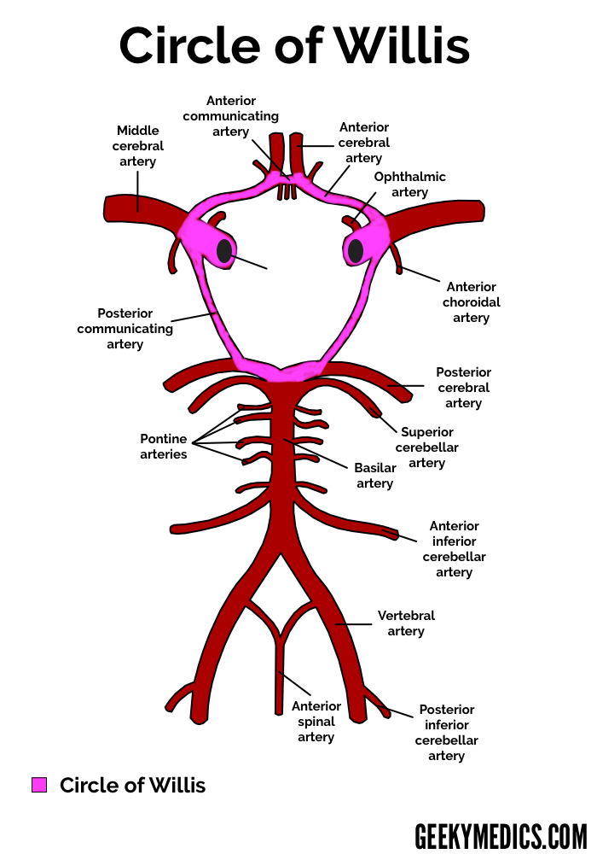

Importance
The circle allows equalization of blood flow between the left and right cerebral hemispheres, and can allow anastomotic circulation if parts are occluded. It also serves as erves as a back-up system or a bypass, allowing for an alternative route if there is an occlusion in the normal route of supply to an area.

Clincal Significance – Blood flow obstruction
Obstruction of blood flow leads to oxygen and nutrients starvation and may ultimately result in conditions such as stroke, paralysis, personality changes, aphasia and many more depending on the degree and site of occlusion.
  - Thrombosis in the anterior spinal artery leads to medial medullary syndrome
  - Complete occlusion of the anterior choroidal artery may lead to contralateral hemiplegia, hemianaesthesia and hemianopia.
  - Stroke: the interruption of blood flow in an artery. This could affect the function of the area deprived of the blood supply.

- SPLANHNIC CIRCULATION
Splanchnic circulation is the blood flow to the gastrointestinal organs such as the stomach, liver, spleen, pancreas, small intestine, and large intestine. The splanchnic circulation is composed of gastric, small intestinal, colonic, pancreatic, hepatic, and splenic circulations, arranged in parallel with one another. The three major branches of the abdominal aorta that supply the splanchnic organs, celiac and superior and inferior mesenteric, give rise to smaller arteries that anastomose extensively. The superior and inferior mesenteric arteries supply the walls of the small and large intestines by the ways of an arching arterial system. Upon entering the walls of the gut, the arteries branches out and circulate the gut in both direction and the smaller smaller branches penetrate the walls of the t=intestines and spread along the muscle bundles and intestinal villi, and the submucosal vessels beneath the epithelium to serve the secretory and absorptive function of the gut.
Arterial Supply
Coeliac artery: The coeliac artery is the first major division of the abdominal aorta, branching at T12 in a horizontal direction ∼1.25 cm in length. It shows three main divisions such as the left gastric artery, common hepatic artery, and splenic artery and is the primary blood supply to the stomach, upper duodenum, spleen, and pancreas.
Superior mesenteric artery: The SMA arises from the abdominal aorta anteriorly at L1, usually 1 cm inferior to the coeliac artery. The five major divisions of the SMA are the inferior pancreaticoduodenal artery, intestinal arteries, ileocolic, right colic, and middle colic arteries. The SMA supplies the lower part of the duodenum, jejunum, ileum, caecum, appendix, ascending colon, and two-thirds of the transverse colon. It is the largest of the splanchnic arterial vessels delivering >10% of the cardiac output.

Inferior mesenteric artery: The IMA branches anteriorly from the abdominal aorta at L3, midway between the renal arteries and the iliac bifurcation. The main branches of the IMA are the left colic artery, the sigmoid branches, and the superior rectal artery. It forms a watershed with the middle colic artery and supplies blood to the final third of the transverse colon, descending colon, and upper rectum.

Factors that can increase Blood flow during GIT circulation
- Vasodilator substances released by thr mucos of the intestinal tract during digestions such as gastrin and secretin and other hormones.
- The release of two kinins. Bradykinin and kallidin, by the GIT glands into the gut
- Decrease in oxygen concentration

NERVOUS CONTROL OF GIT BLOOD SUPPLY

The blood flow is mainly regulated by the sympathetic nerve fibers because it has a direct effect on all the GIT tract to cause an intense vasoconstriction of the arterioles with greatly drecrease blood flow.

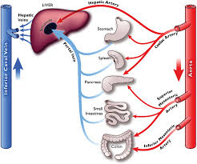

Clinical Correlation
- Portal Hypertension: s an increase in the pressure within the portal vein, which carries blood from the digestive organs to the liver
- Circulatory shock

- CORONARY CIRCULATION:

This is the circulation of blood in the blood vessels that supply the heart muscle (myocardium). The myocardium is mainly supplied by the left and right coronary arteries which are the first branches of the aorta and drains into the coronary sinus. At rest, the heart receives about 200-250ml of blood per minute and 5% of the circulating blood for metabolic heart needs.

ARTERIES
- RIGHT CORONARY ARTERY (RCA): it supplies the whole of the right ventricle and the posterior portion of the left ventricle. The course of the right coronary artery starts off from the aorta andbranches out to give the right marginal branch, which runs towards the apex of the heart and supplies the lateral aspect of the atrium and ventricle. The RCA continues from the right margin of the heat and gives off asmall branch to the Atrioventricular node and then gives rise to a large posterior interventricular branch which gives posterior ventricules of the ventricules and posterior aspect of the interventricular septum.

- LEFT CORONARY ARTERY (LCA): it supplies the anterior and lateral parts of the left ventricle. LCA divides into two and give rise to the anterior intervenicular branch and the circumflex branch. The Anterior interventricular branch travels to the interventricular sulcus to the apexand travels short distance to the posterior where it supplies both ventricles and the anterior 2/3 of the interventricular septum. While the circumflex branch continues around the left side of the heart in the coronary sulcus and gives of the left marginal branch which gives supply to the left margin of the heart and the left ventricle.

However, these branches give rise to smaller arteries of the coronary arteries called epicardial arteries and which further branches out into smaller branches known as final arteries or intramural vessels.

VEINS

The venous return from the heart myocardium take places in three vessels:
- Coronary sinus: it is a large vein that drains 75% of coronary flow. It drains from the left side of the heart and opens into the right atrium near tricuspid valve.
- Anterior coronary veins: It drains blood from the right side and open directly into the right atrium
- Thebesian veins: these are small veins that drains about 5-10% of the coronary blood and opens directly into the heart chambers especially the right ventricle.

Factors regulating coronary blood flow are
- Metabolic factor: Metabolites, such as adenosine and potassium, can cause vasodilation effects; thereby, increasing coronary blood flow.
- Need for oxygen: hypoxia can cause the vasodilation in the arteries and increase in blood flow
- Coronary perfusion pressure is balance between mean arterial pressure and the major factor that maintains the coronary blood flow.
- Nervous factor: Both the sympathetic and parasympathetic nerve fibers influence the coronary blood flow indirectly by acting on the heart musculature.
- 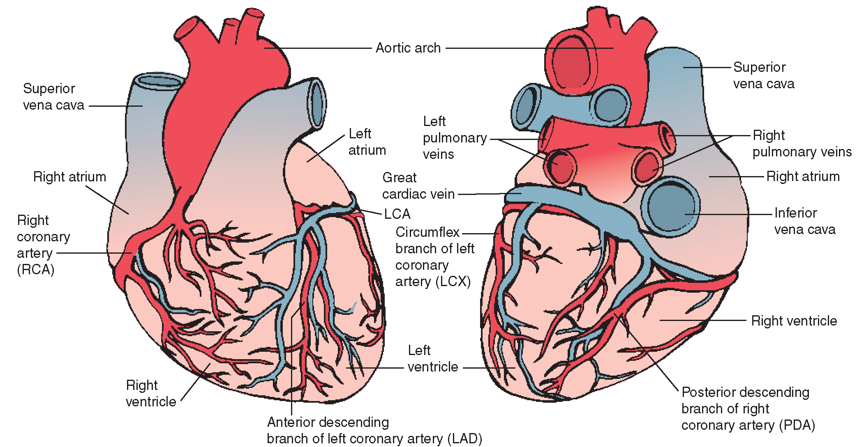

CLINICAL CORRELATION
- Coronary Heart Disease: This is a condition caused by inadequate blood supply to cardiac muscle due to the occlusion of coronary artery.
- Myocardial ischiemia and necrosis: Ischemia is caused by reduction in blood flow to the myocardium as a result of an occlusion of the coronary arteries. Necrosis is the death of cells or tissues by injury in a localized area and can lead to myocardial infraction.
- Angina Pectoris; This is the chest pain that is caused by myocardial ischemia.

- CUTANEOUS CIRCULATION

This circulation is the blood flow through the skin. It’s main function is to supply .nutrition to the skin and to regulate body temperature by heat loss. Under normal conditions, the blood flow to skin is about 250 mL/square meter/minute. When the body temperature increases, cutaneous blood flow increases up to 2,800 mL/square meter/minute because of cutaneous vasodilatation.

ARTERIES
- Cutaneous arterioles: It is a dense network just under dermis.
- Meta arterioles: These are high resistance conduits between arterioles and capillaries.
- Cutaneous Capillaries: They arise from the meta-arterioles. This provides a larger surface area for heat exchange.

Veins
- Collecting venule: After reaching the base of papillae, few venous limbs of neighboring papillae unite.
- Subpapillary venous plexus: Collecting venules anastomose with one another to form subpapillary venous plexus
- Deeper veins: The subpapilary plexus run horizontally and drains into the deeper veins.

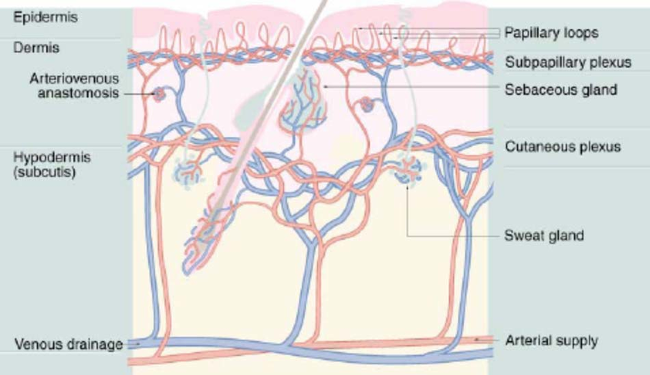

REGULATION OF CUTANEOUS BLOOD FLOW

It is regulated by the hypothalamus which in turns help in regulate body temperature. When body temperature increases, the hypothalamus is activated and causes vasodilation of the cutaneous vessels and thereby increase blood flow in the skin. This cause heat loss through sweat and decrease body temperature. When body temperature decreases, the hypothalamus is activated and causes vasoconstriction of the cutaneous vessels and thereby decrease blood flow in the skin.

Clinical Correlation
- White reaction: is the response of the blood vessels in skin to a mechanical stimulus. This is when a pointed object is stroked over the skin which causes a pale strike line to appear as a result of contraction of the cutaneous capillaries and small veins.
- Lewis triple response: This is when a skin is stroked more firmly with a pointed object and causes 3 reaction which are red reaction, flare, and wheal.

QUESTION 3

DISCUSS THE CARDIOVASUCULAR ADJUSTMENT THAT OCCURS DURING EXERCISE?

ANSWER

The cardiovascular system is regulated by several mechanisms helps it in maintaining equilibrium. However, these factors are forced to be readjusted during exercise to help to maintain a proper body function. The adjustment in the body during exercise is aimed at two reason which are:
- Prevention of increase in body temperature
- Supply of various metabolic requisites such as nutrients and oxygen to the muscles and other tissues involved in exercise.

However, exercise can be categorized based on two things which are
- Muscular contraction
  - Dynamic exercise: This type of exercise involves isotonic muscular contraction that involves external work as well as keeping the joint and muscles moving e.g. swimming, running and jogging. This increase the heart rate, cardiac output, systolic pressure, and fore of contraction; but the diastolic pressure isn’t altered.
  - Static exercise: This type of exercise is an isometric muscular contraction without movement of joint and no external work is needed e.g. pushups and weightlifting. There is an increase in heart rate, systolic pressure, force of contraction and cardiac output as well as in diastolic pressure.
- Metabolism
  - Aerobic exercise: These are activities that require the use of nutrients in the presence of oxygen. It can be performed for a longer period because it requires only low intensity. Examples are jogging, walking, and hockey
  - Anaerobic exercise: This type of exercise can be only done for a short period of time at a high intensity. The energy is obtained without the use of oxygen and this lead to the liberation of lactic acid and they eventually leads to fatigue.

SEVERITY OF THE EXERCISE ON THE CARDIOVASCULAR SYSTEM
- Mild exercise: This is a simple exercise such as walking and it has little or no effect on CVS system
- Moderate exercise: This is not a strenuous exercise but it is performed for a longer period of time. It increase the activities of the CVS such as heart rate, force of contraction, and cardiac output slightly
- Severe exercise: This is a strenuous muscular activity that is done for a short period of time. However, It has increase the activity of the CVS enormously. It increase the systolic pressure, the cardiac output, force of contraction, and many more.

EFFECTS OF EXERCISE ON THE CARDIOVASCULAR SYSTEM
- BLOOD: Exercise cause mild hypoxia which in turn stimulate the the juxtaglomerular apparatus to secrete erythropoietin. It stimulates the bone marrow and causes release of red blood cells. While the increase in Co2 causes decrease in PH of blood
- BLOOD VOLUME: Exercise decrease the blood volume through the secreatio of llarge amount of sweat as a result of the generation of heat and the thermoregulation. It alos leasd to loss of fluid, reduced blood volume, hemoconcentration and dehydration
- HEART RATE: Heart rate increases during exercise as a result of vagal withdrawal. The impulses from cerebral cortex to medullary centers reduces vagal tone and cause sympathetic tone to increase. During moderate exercise, heart Rate can increase up to 180beats per minute and in sever exercise, up to 240-260 beats/ mins.
- Cardiac Output: this also increase up to 20 L/minute in moderate exercise and up to 35 L/minute during severe exercise as a result of vagal withdrawal. Because of vagal withdrawal, sympathetic activity increases leading to increase in rate and force of contraction.
- Venous return: This increases remarkably during exercise because of muscle pump, respiratory pump and splanchnic vasoconstriction
- Blood pressure: During moderate isotonic exercise, the systolic pressure is increased as a result of heart rate and stroke volume; but diastolic pressure is not altered. In severe exercise, the systolic pressure enormously increases but the diastolic pressure decreases.

However after exercise, the body experiences “post exercise hypotension” which is a slightly below the resting level after the exercise as a result of metabolic end products causing vasodilatation. However, pressure returns to resting level quickly as soon as the metabolic end products are removed from muscles.

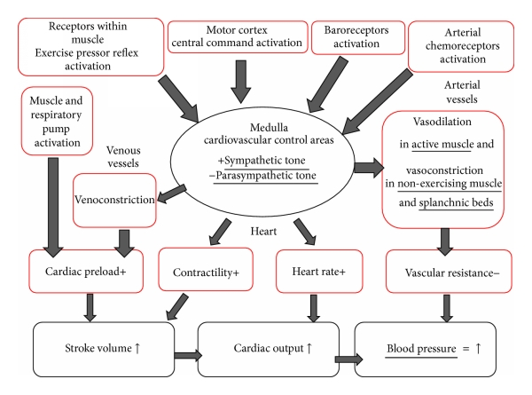

v

