NAME: ABUDU PRECIOUS ESTHER
LEVEL: 300
DEPARTMENT: MBBS
MATRIC NO: 17/MHS01/008
COURSE CODE: PHS 303
COURSE TITLE: RENAL PHYSIOLOGY BODY FLUID AND TEMPERATURE REGULATION
RENAL PHYSIOLOGY FOR MBBS STUDENT
Question
Second assignment
- Discuss the pathophysiological process involves in renal failure?
- With the aid of suitable diagrams discuss the types of dialysis you know?

Answer
- Discuss the pathophysiological process involves in renal failure?
The most common types of renal failure are Chronic Kidney Disease (CKD) and Acute Renal Failure (ARF).

Chronic Kidney Disease (CKD)
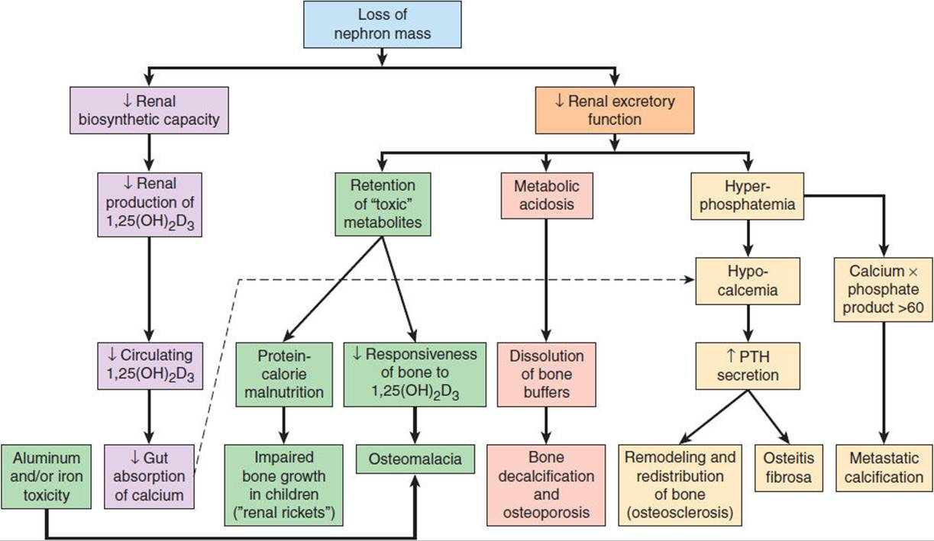

Pathogenesis of bone diseases in chronic kidney disease
Chronic kidney disease (CKD) is initially described as diminished renal reserve or renal insufficiency, which may progress to renal failure (end-stage renal disease). Initially, as renal tissue loses function, there are few noticeable abnormalities because the remaining tissue increases its performance (renal functional adaptation).

Decreased renal function interferes with the kidneys’ ability to maintain fluid and electrolyte homeostasis. The ability to concentrate urine declines early and is followed by decreases in ability to excrete excess phosphate, acid, and potassium. When renal failure is advanced (glomerular filtration rate [GFR] ≤ 15 mL/min/1.73 m²), the ability to effectively dilute or concentrate urine is lost; thus, urine osmolality is usually fixed at about 300 to 320 mOsm/kg, close to that of plasma (275 to 295 mOsm/kg), and urinary volume does not respond readily to variations in water intake.

Plasma concentrations of creatinine and urea (which are highly dependent on glomerular filtration) begin a hyperbolic rise as GFR diminishes. These changes are minimal early on. When the GFR falls below 15 mL/min/1.73 m² (normal > 90 mL/min/1.73 m²), creatinine and urea levels are high and are usually associated with systemic manifestations (uremia). Urea and creatinine are not major contributors to the uremic symptoms; they are markers for many other substances (some not yet well defined) that cause the symptoms.

Despite a diminishing GFR, sodium and water balance is well maintained by increased fractional excretion of sodium in urine and a normal response to thirst. Thus, the plasma sodium concentration is typically normal, and hypervolemia is infrequent unless dietary intake of sodium or water is very restricted or excessive. Heart failure can occur due to sodium and water overload, particularly in patients with decreased cardiac reserve.
For substances whose secretion is controlled mainly through distal nephron secretion (e.g., potassium), renal adaptation usually maintains plasma levels at normal until renal failure is advanced or dietary potassium intake is excessive. Potassium-sparing diuretics, angiotensin-converting enzyme inhibitors, beta-blockers, nonsteroidal anti-inflammatory drugs, cyclosporine, tacrolimus, trimethoprim/sulfamethoxazole, pentamidine, or angiotensin II receptor blockers may raise plasma potassium levels in patients with less advanced renal failure.

Abnormalities of calcium, phosphate, parathyroid hormone (PTH), and vitamin D metabolism can occur, as can renal osteodystrophy. Decreased renal production of calcitriol (1, 25(OH) ₂D, the active vitamin D hormone) contributes to hypocalcemia. Decreased renal excretion of phosphate results in hyperphosphatemia. Secondary hyperparathyroidism is common and can develop in renal failure before abnormalities in calcium or phosphate concentrations occur. For this reason, monitoring PTH in patients with moderate CKD, even before hyperphosphatemia occurs, has been recommended.

Renal osteodystrophy (abnormal bone mineralization resulting from hyperparathyroidism, calcitriol deficiency, elevated serum phosphate, or low or normal serum calcium) usually takes the form of increased bone turnover due to hyperparathyroid bone disease (osteitis fibrosa) but can also involve decreased bone turnover due to adynamic bone disease (with increased parathyroid suppression) or osteomalacia. Calcitriol deficiency may cause osteopenia or osteomalacia.

Moderate metabolic acidosis (plasma bicarbonate content 15 to 20 mmol/L) is characteristic. Acidosis causes muscle wasting due to protein catabolism, bone loss due to bone buffering of acid, and accelerated progression of kidney disease.

Anemia is characteristic of moderate to advanced CKD (≥ stage 3). The anemia of CKD is normochromic-normocytic, with an Hct of 20 to 30% (35 to 40% in patients with polycystic kidney disease). It is usually caused by deficient erythropoietin production due to a reduction of functional renal mass (see Overview of Decreased Erythropoiesis). Other causes include deficiencies of iron, folate, and vitamin B12.

The process is as follows:
Firstly, the rate of renal blood flow of approximately 400 ml/100g of tissue per minute is much greater than that observed in other well perfused vascular beds such as heart, liver and brain. As a consequence, renal tissue might be exposed to a significant quantity of any potentially harmful circulating agents or substances.

Secondly, glomerular filtration is dependent on rather high intra- and transglomerular pressure (even under physiologic conditions), rendering the glomerular capillaries vulnerable to hemodynamic injury, in contrast to other capillary beds. In line with this, Brenner and coworkers identified glomerular hypertension and hyperfiltration as major contributors to the progression of chronic renal disease.

Thirdly, glomerular filtration membrane has negatively charged molecules which serve as a barrier retarding anionic macromolecules. With disruption in this electrostatic barrier, as is the case in many forms of glomerular injury, plasma protein gains access to the glomerular filtrate.

Fourthly, the sequential organization of nephron’s microvasculature (glomerular convolute and the peritubular capillary network) and the downstream position of the tubuli with respect to glomeruli, not only maintains the glomerulo-tubular balance but also facilitates the spreading of glomerular injury to tubulointerstitial compartment in disease, exposing tubular epithelial cells to abnormal ultrafiltrate. As peritubular vasculature underlies glomerular circulation, some mediators of glomerular inflammatory reaction may overflow into the peritubular circulation contributing to the interstitial inflammatory reaction frequently recorded in glomerular disease. Moreover, any decrease in preglomerular or glomerular perfusion leads to decrease in peritubular blood flow, which, depending on the degree of hypoxia, entails tubulointerstitial injury and tissue remodeling. Thus, the concept of the nephron as a functional unit applies not only to renal physiology, but also to the pathophysiology of renal diseases.

In the fifth place, the glomerulus itself should also be regarded as a functional unit with each of its individual constituents, i.e. endothothelial, mesangial, visceral and parietal epithelial cells - podocytes, and their extracellular matrix representing an integral part of the normal function. Damage to one will in part affect the other through different mechanisms, direct cell-cell connections (e.g., gap junctions), soluble mediators such as chemokines, cytokines, growth factors, and changes in matrix and basement membrane composition.

The main causes of renal injury are based on immunologic reactions (initiated by immune complexes or immune cells), tissue hypoxia and ischaemia, exogenic agents like drugs, endogenous substances like glucose or paraproteins and others, and genetic defects. Irrespective of the underlying cause glomerulosclerosis and tubulointerstitial fibrosis are common to CKD.
An overview of the pathophysiology of CKD should give special consideration to mechanisms of glomerular, tubular and vascular injury.

Mechanism of glomerular impairment
Hereditary defects account for a minority of glomerular disease. A prototype of an inherited glomerular disease is the Alport’s syndrome or hereditary nephritis, usually transmitted as an X-linked dominant trait although autosomal dominant and recessive forms have been reported as well. In its classical X-linked form there is a mutation in the COL4A5 gene that encodes the α5 chain of type IV collagen located on the X chromosome. As a consequence, GBM is irregular with longitudinal layering, splitting or thickening, and the patient develops progressive glomerulosclerosis and renal failure. Other types of inherited glomerular disease are thin membrane syndrome, nail-patella syndrome, partial lipodystrophy, and familial lecithin-cholesterol acyltranferase deficiency. Most acquired glomerular disease is triggered by immune mediated injury, metabolic and mechanical stress.

Mechanism of tubulointerstitial impairment
Regardless of the etiology, chronic kidney disease is characterized by renal fibrosis - glomerulosclerosis and tubulointerstitial fibrosis. The impairment of the tubulointerstitium (tubulointerstitial fibrosis and tubular atrophy) is at least as important as that of the glomeruli (glomerulosclerosis). There is a common consensus that the severity of tubulointerstitial injury correlates closely (and better than glomerular injury) with long-term impairment of renal function.

- Acute Kidney Failure
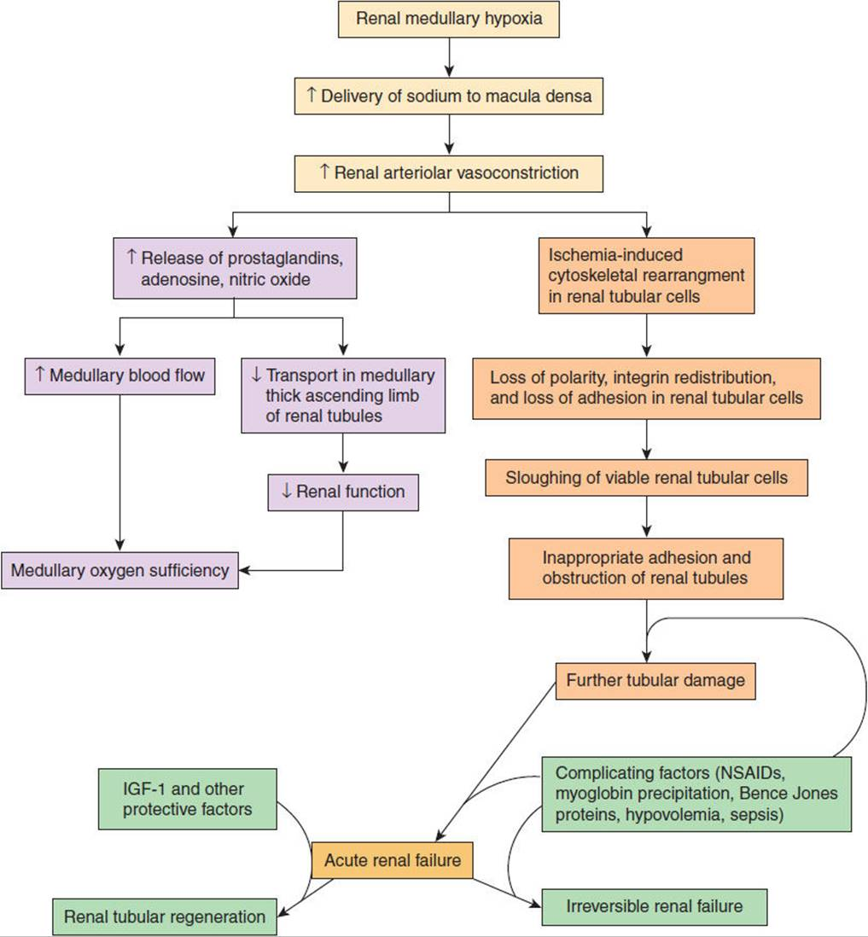
Pathophysiology of ischemia-induced acute kidney injury. Mild or uncomplicated medullary hypoxia results in tubuloglomerular reflex adjustments that restore medullary oxygen sufficiency at the price of diminished renal function. However, in the event of extreme renal medullary hypoxia or when associated with complicating factors such as those indicated in the figure, full-blown acute kidney injury develops. Whether acute kidney injury is reversible or irreversible depends on a balance of reparative and complicating factors.

Acute kidney injury is produced by a heterogeneous group of disorders that have in common the rapid deterioration of renal function, resulting in accumulation in the blood of nitrogenous wastes that would normally be excreted in the urine. The patient presents with a rapidly rising Blood Urea Nitrogen (BUN) (i.e., azotemia) and serum creatinine. Diminished urine volume (oliguria) is commonly but not always seen. Urine volume may be normal early or indeed at any time in milder forms of acute kidney injury. The most widely accepted definition of acute kidney injury is a rise in serum creatinine of 0.3 mg/dL or more within a 48-hour period or a fall in urine output to less than 0.5 mL/kg/h for at least 6 hours.

Regardless of their origin, all forms of acute kidney injury, if untreated, result in acute tubular necrosis, with sloughing of epithelial cells that make up the renal tubule. Depending on the timing of intervention between onset of initial injury and eventual acute tubular necrosis, acute kidney injury may be irreversible or reversible, with either prevention of or recovery from acute tubular necrosis.

The precise molecular mechanisms responsible for the development of acute tubular necrosis remain unknown. Theories favoring either a tubular or vascular basis have been proposed. According to the tubular theory, occlusion of the tubular lumen with cellular debris forms a cast that increases intratubular pressure sufficiently to offset perfusion pressure and decrease or abolish net filtration pressure. Vascular theories propose that decreased renal perfusion pressure from the combination of afferent arteriolar vasoconstriction and efferent arteriolar vasodilation reduces glomerular perfusion pressure and, therefore, glomerular filtration. It may be that both mechanisms act to produce acute kidney injury, varying in relative importance in different individuals depending on the cause and time of presentation.

Studies suggest that one consequence of hypoxia is disordered adhesion of renal tubular epithelial cells, resulting both in their exfoliation and subsequent adhesion to other cells of the tubule, thereby contributing to tubular obstruction. Another consequence may be dysregulation of elements that secure tubular cells together resulting in leak of filtrate out of the tubular lumen and abnormal sorting of cellular transmembrane channels required for the normal function of the nephron. Renal damage, whether caused by tubular occlusion or vascular hypoperfusion, is potentiated by the hypoxic state of the renal medulla, which increases the risk of ischemia.

Research has implicated cytokines and endogenous peptides such as endothelins and the regulation of their production as possible explanations for why, subjected to the same toxic insult, some patients develop acute kidney injury and others do not and why some with acute kidney injury recover and others do not. It appears that these products together with activation of complement and neutrophils increase vasoconstriction in the already ischemic renal medulla and in that way exacerbate the degree of hypoxic injury that occurs in acute kidney injury.

- With the aid of suitable diagrams discuss the types of dialysis you know?
There are three different types of dialysis. They are:
- Hemodialysis
- Peritoneal dialysis
- Continuous renal replacement therapy (CRRT)

- Hemodialysis

Hemodialysis is the most common type of dialysis. This process uses an artificial kidney (hemodialyzer) to remove waste and extra fluid from the blood. The blood is removed from the body and filtered through the artificial kidney. The filtered blood is then returned to the body with the help of a dialysis machine.
To get the blood to flow to the artificial kidney, a doctor will perform surgery to create an entrance point (vascular access) into the blood vessels. The three types of entrance points are:
- Arteriovenous (AV) fistula: This type connects an artery and a vein. It’s the preferred option.
- AV graft: This type is a looped tube.
- Vascular access catheter: This may be inserted into the large vein in your neck.
Both the AV fistula and AV graft are designed for long-term dialysis treatments. People who receive AV fistulas are healed and ready to begin hemodialysis two to three months after their surgery. People who receive AV grafts are ready in two to three weeks. Catheters are designed for short-term or temporary use.

Hemodialysis treatments usually last three to five hours and are performed three times per week. However, hemodialysis treatment can also be completed in shorter, more frequent sessions. Most hemodialysis treatments are performed at a hospital, doctor’s office, or dialysis center. The length of treatment depends on the body size, the amount of waste in the body, and the current state of the patient’s health.

Hemodialysis risks include:
- Low blood pressure
- Anemia, or not having enough red blood cells
- Muscle cramping
- Difficulty sleeping
- Itching
- High blood potassium levels
- Pericarditis, an inflammation of the membrane around the heart
- Sepsis
- Bacteremia, or a bloodstream infection
- Irregular heartbeat
- Sudden cardiac death, the leading cause of death in people undergoing dialysis

- Peritoneal dialysis

Peritoneal dialysis involves surgery to implant a peritoneal dialysis (PD) catheter into the abdomen. The catheter helps filter the blood through the peritoneum, a membrane in the abdomen. During treatment, a special fluid called dialysate flows into the peritoneum. The dialysate absorbs waste. Once the dialysate draws waste out of the bloodstream, it’s drained from the abdomen.
This process takes a few hours and needs to be repeated four to six times per day. However, the exchange of fluids can be performed while the patient is sleeping or awake.

There are numerous different types of peritoneal dialysis. The main ones are:
- Continuous ambulatory peritoneal dialysis (CAPD): In CAPD, the abdomen is filled and drained multiple times each day. This method doesn’t require a machine and must be performed while awake.
- Continuous cycling peritoneal dialysis (CCPD): CCPD uses a machine to cycle the fluid in and out of the abdomen. It’s usually done at night while the patient sleeps.
- Intermittent peritoneal dialysis (IPD: This treatment is usually performed in the hospital, though it may be performed at home. It uses the same machine as CCPD, but the process takes longer.

Peritoneal dialysis is associated with an increased risk for infections in or around the catheter site in the abdominal cavity. For example, after catheter implantation, a person can experience peritonitis. Peritonitis is an infection of the membrane lining the abdominal wall.
Other risks include:
- Abdominal muscle weakening
- High blood sugar due to the dextrose in the dialysate
- Weight gain
- Hernia
- Fever
- Stomach pain

- Continuous renal replacement therapy (CRRT)
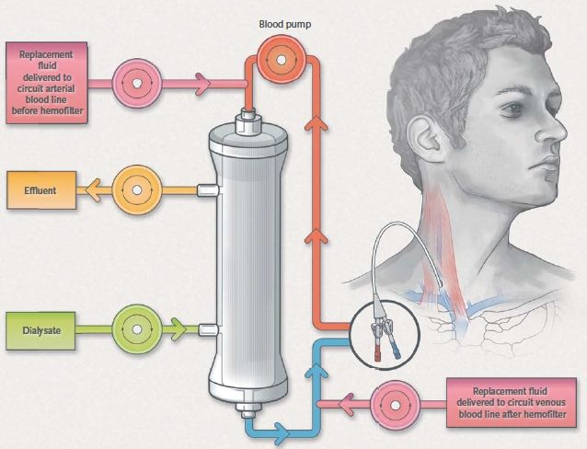
This therapy is used primarily in the intensive care unit for people with acute kidney failure. It’s also known as hemofiltration. A machine passes the blood through tubing. A filter then removes waste products and water. The blood is returned to the body, along with replacement fluid. This procedure is performed 12 to 24 hours a day, generally every day.

The risks associated with CRRT include:
- Infection
- Hypothermia
- Low blood pressure
- Electrolyte disturbances
- Bleeding
- Delayed renal recovery
- Weakening of bones
- Anaphylaxis

