19/MHS01/445(Direct entry)
Famose Kathryn Mofifoluwa
Medicine and surgery
1. LONG-TERM REGULATION
This is also known as renal mechanism for regulation of blood pressure. The Kidneys play an important role in the long­term regulation of arterial blood pressure. When blood pressure alters slowly over several days, months and years, the nervous mechanism adapts to the altered pressure and looses the sensitivity for the changes, hence, cannot regulate the pressure any more. In such conditions, the renal mechanism operates efficiently to regulate the blood pressure. Therefore, it is called long­term regulation.
Kidneys regulate arterial blood pressure by two ways;
- By regulation of ECF volume
- Through renin­angiotensin mechanism.
Regulation of extracellular fluid volume
When the blood pressure increases, kidneys excrete large amounts of water and salt, particularly sodium, by means of pressure diuresis and pressure natriuresis. Pressure diuresis is the excretion of large quantity of water in urine because of increased blood pressure. Even a slight increase in blood pressure doubles the water excretion. Pressure natriuresis is the excretion of large quantity of sodium in urine. Because of diuresis and natriuresis, there is a decrease in ECF volume and blood volume, which in turn brings the arterial blood pressure back to normal level. When blood pressure decreases, the reabsorption of water from renal tubules is increased. This in turn, increases ECF volume, blood volume and cardiac output, resulting in restoration of blood pressure.
Renin-angiotensin mechanism
When blood pressure and ECF volume decrease, renin secretion from kidneys is increased. It converts angiotensinogen into angiotensin I. This is converted into angiotensin II by ACE (angiotensin­converting enzyme). Angiotensin II acts in two ways to restore the blood pressure;
i. It causes constriction of arterioles in the body so that the peripheral resistance is increased and blood pressure rises. In addition, angiotensin II causes constriction of afferent arterioles in kidneys, so that glomerular filtration reduces. This results in retention of water and salts, increases ECF volume to normal level. This in turn increases the blood pressure to normal level.
ii. Simultaneously, angiotensin II stimulates the adrenal cortex to secrete aldosterone. This hormone increases reabsorption of sodium from renal tubules. Sodium reabsorption is followed by water reabsorption, resulting in increased ECF volume and blood volume. It increases the blood pressure to normal level.
Angiotensins III and IV act like angiotensin II; they also increase the blood pressure and stimulate adrenal cortex to secrete aldosterone.
2.
- Pulmonary circulation: This is the system of transportation that shunts de-oxygenated blood from the heart to the lungs to be re-saturated with oxygen before being dispersed into systemic circulation. Deoxygenated blood from the lower half of the body enters the heart from the inferior vena cava while deoxygenated blood from the upper body is delivered to the heart via the superior vena cava. Both the superior vena cava and inferior vena cava empty blood into the right atrium. Blood flows through the tricuspid valve into the right ventricle. It then flows through the pulmonic valve into the pulmonary artery before being delivered to the lungs. While in the lungs, blood diverges into the numerous pulmonary capillaries where it releases carbon dioxide and is replenished with oxygen. Once fully saturated with oxygen, the blood is transported via the pulmonary vein into the left atrium which pumps blood through the mitral valve and into the left ventricle. With a powerful contraction, the left ventricle expels oxygen-rich blood through the aortic valve and into the aorta: This is the beginning of systemic circulation.
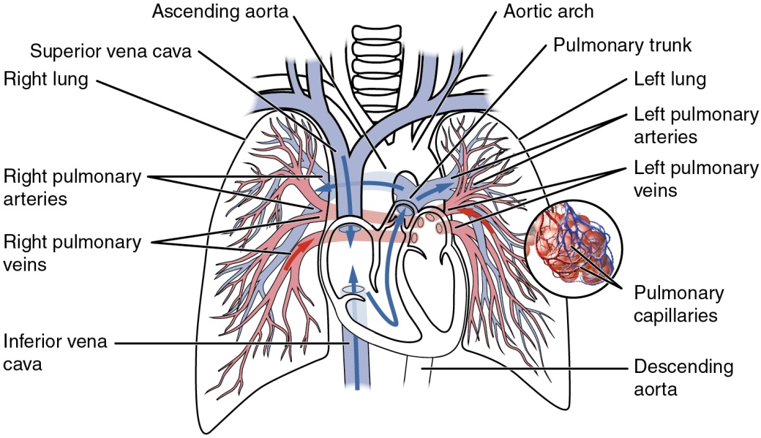
- Circle of Willis: The circle of Willis describes the ring of blood vessels in the base of the brain that connects the main intracerebral blood vessels. It is formed by the anastomosis of the two internal carotid arteries with the two vertebral arteries. The anterior communicating, anterior cerebral, internal carotid, posterior communicating, posterior cerebral, and basilar arteries are all part of the circle of Willis. This formation of arteries allows distribution of the blood entering from the internal carotid artery or vertebral artery to any part of the two cerebral hemispheres. Cortical and central branches arise from the circle and further supply the brain.The bloodstreams from the internal carotid artery and vertebral artery on both sides come together at a certain point in the posterior communicating artery.
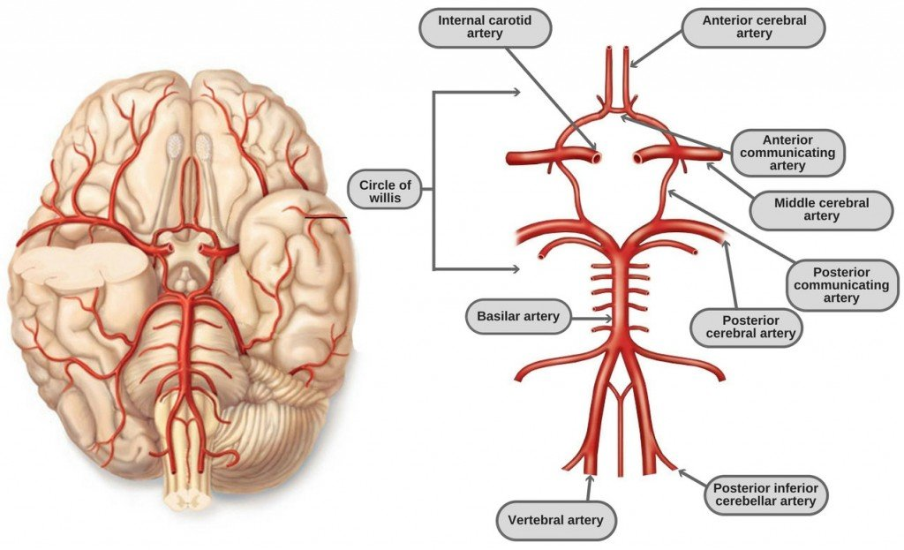
- Splanchnic circulation: It describes the blood flow to the abdominal gastrointestinal organs including the stomach, liver, spleen, pancreas, small intestine, and large intestine. It comprises three major branches of the abdominal aorta; the coeliac artery; superior mesenteric artery (SMA); and inferior mesenteric artery.

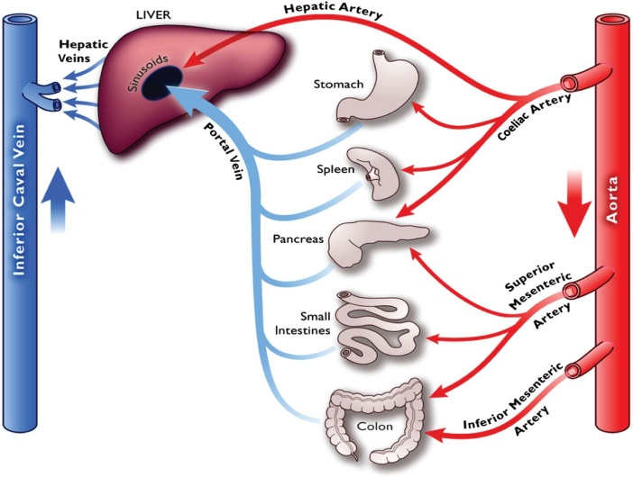
- Coronary circulation: Coronary circulation is the circulation of blood in the blood vessels that supply the heart muscle (myocardium). Coronary arteries supply oxygenated blood to the heart muscle, and cardiac veins drain away the blood once it has been deoxygenated. It is part of the systemic circulatory system that supplies blood to and provides drainage from the tissues of the heart. In the human heart, two coronary arteries arise from the aorta just beyond the semilunar valves; during diastole, the increased aortic pressure above the valves forces blood into the coronary arteries and thence into the musculature of the heart. Deoxygenated blood is returned to the chambers of the heart via coronary veins; most of these converge to form the coronary venous sinus, which drains into the right atrium.

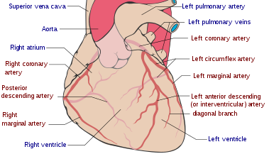
- Cutaneous circulation: The cutaneous circulation is the circulation and blood supply of the skin. The skin is not a very metabolically active tissue and has relatively small energy requirements, so its blood supply is different to that of other tissues. The circulation in skin is involved in the control of systemic blood pressure and plays an essential role in man's thermal homeostasis. Arteriovenous Anastomoses are low-resistance connections between the small arteries and small veins that supply and drain the skin, they play a major role in the thermal homeostasis.

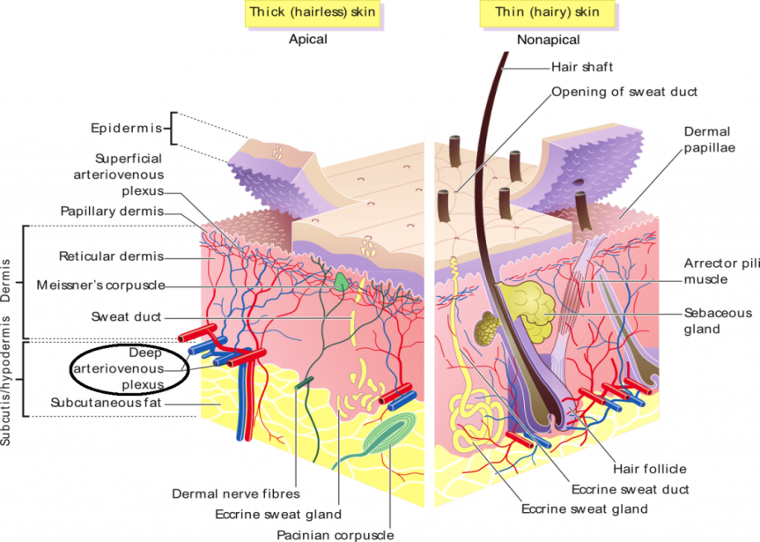

3. CARDIOVASCULAR ADJUSTMENTS DURING EXERCISE
The overall response of the cardiovascular sys-tem to exercise is influenced by factors such as duration of exercise, work rate, climate, diet, and level of physical training. During exercise, there is an increase in metabolic needs of body tissues, particularly the muscles. Various adjustments in the body during exercise are aimed at;
- Supply of various metabolic requisites like nutrients and oxygen to muscles and other tissues involved in exercise
- Prevention of increase in body temperature.
Classification of exercise
- Based on the type of muscular contraction
Dynamic exercise primarily involves the isotonic muscular contraction. It keeps the joints and muscles moving. Examples are swimming, bicycling, walking, etc. Dynamic exercise involves external work, which is the shortening of muscle fibers against load. In this type of exercise, the heart rate, force of contraction, cardiac output and systolic blood pressure increase. However, the diastolic blood pressure is unaltered or decreased. It is because, during dynamic exercise, peripheral resistance is unaltered or decreased depending upon the severity of exercise.
Static exercise involves isometric muscular contraction without movement of joints. Example is pushing heavy object. Static exercise does not involve external work. During this exercise, apart from increase in heart rate, force of contraction, cardiac output and systolic blood pressure, the diastolic blood pressure also increases. It is because of increase in peripheral resistance during static exercise.

- Based on the type of metabolism involved
The terms aerobic and anaerobic refer to the energy producing process during exercise. Aerobic means ‘with air’ or ‘with oxygen’. Anaerobic means ‘without air’ or ‘without oxygen’. Both aerobic and anaerobic exercises are required to maintain physical fitness.
When a person starts doing some exercise like jogging, bicycling or swimming, the muscles start utilizing energy. In order to have quick energy during the first few minutes, the muscles burn glycogen stored in them. During this period, fat is not burnt. Only glycogen is burnt and it is burnt without using oxygen. This is called anaerobic metabolism. Lactic acid is produced during this period. Presence of lactic acid causes some sort of burning sensation in the muscles particularly the muscles of arms, legs and back. Muscles burn all the muscle glycogen within 3 to 5 minutes. If the person continues the exercise beyond this, glycogen stored in liver is converted into glucose, which is transported to muscles through blood. Now the body moves into aerobic metabolism. The glucose obtained from liver is burnt in the presence of oxygen. No more lactic acid is produced. So the burning sensation in the muscles disappears. Proper breathing is essential during this period so that adequate oxygen is supplied to the muscles to extract the energy from glucose. The supply of glucose from liver in combination with adequate availability of oxygen allows the person to continue the exercise. Utilization of all the glycogen stored in liver is completed by about 20 minutes. If the exercise is continued beyond this, the body starts utilizing the fat. The stored fat called body fat is converted into carbohydrate, which is utilized by the muscles. This allows the person to do the exercise for a longer period
- Based on the severity of the exercise
- Mild exercise: It is the very simple form of exercise like slow walking. Little or no change occurs in cardiovascular system during mild exercise.
- Moderate exercise: This type does not involve strenuous muscular activity. So, this type of exercise can be performed for a longer period. Exhaustion does not occur at the end of moderate exercise. The examples of this type of exercise are fast walking and slow running.
- Severe exercise: It involves strenuous muscular activity. The severity can be maintained only for short duration. Fast running for a distance of 100 or 400 meters is the best example of this type of exercise. Complete exhaustion occurs at the end of severe exercise.
Effects of exercise on cardiovascular system 
- On blood; Mild hypoxia developed during exercise stimulates the juxtaglomerular apparatus to secrete erythropoietin. It stimulates the bone marrow and causes release of red blood cells. Increased carbon dioxide content in blood decreases the pH of blood.
- On blood volume; More heat is produced during exercise and the thermoregulatory system is activated. This in turn, causes secretion of large amount of sweat leading to: i. Fluid loss ii. Reduced blood volume iii. Hemoconcentration iv. Sometimes, severe exercise leads to even dehydration.
- On heart rate; Heart rate increases during exercise. Even the thought of exercise or preparation for exercise increases the heart rate. It is because of impulses from cerebral cortex to medullary centers, which reduces vagal tone. In moderate exercise, the heart rate increases to 180 beats/minute. In severe muscular exercise, it reaches 240 to 260 beats/minute. Increased heart rate during exercise is mainly because of vagal withdrawal. Increase in sympathetic tone also plays some role. Increased heart rate during exercise is due to four factors: i. Impulses from proprioceptors, which are present in the exercising muscles; these impulses act through higher centers and increase the heart rate ii. Increased carbon dioxide tension, which acts through medullary centers iii. Rise in body temperature, which acts on car diac centers via hypothalamus, increased temperature also stimulates SA node directly iv. Circulating catecholamines, which are secreted in large quantities during exercise.
- On cardiac output; Cardiac output increases up to 20 L/minute in moderate exercise and up to 35 L/minute during severe exercise. Increase in cardiac output is directly proportional to the increase in the amount of oxygen consumed during exercise. During exercise, the cardiac output increases because of increase in heart rate and stroke volume. Heart rate increases because of vagal withdrawal. Stroke volume increases due to increased force of contraction. Because of vagal withdrawal, sympathetic activity increases leading to increase in rate and force of contraction.
- On venous retur; Venous return increases remarkably during exercise because of muscle pump, respiratory pump and splanchnic vasoconstriction (Chapter 98).
- On blood flow to skeletal muscles; There is a great increase in the amount of blood flowing to skeletal muscles during exercise. In resting condition, the blood supply to the skeletal muscles is 3 to 4 mL/100 g of the muscle/minute. It increases up to 60 to 80 mL in moderate exercise and up to 90 to 120 mL in severe exercise. During the muscular activity, stoppage of blood flow occurs when the muscles contract. It is because of compression of blood vessels during contraction. And in between the contractions, the blood flow increases. Sometimes the blood supply to muscles starts increasing even during the preparation for exercise. It is due to the sympathetic activity. Sympathetic nerves cause vasodilatation in muscles. The sympathetic nerve fibers causing vasodilatation in skeletal muscle are called sympathetic cholinergic fibers since these fibers secrete acetylcholine instead of noradrenaline.
Several other factors also are responsible for the increase in blood flow to muscles during exercise. All such factors increase the amount of blood flow to muscles by means of dilatation of blood vessels of the muscles. Such factors are;
i. Hypercapnea
ii. Hypoxia
iii. Potassium ions
iv. Metabolites like lactic acid
v. Rise in temperature
vi. Adrenaline secreted from adrenal medulla
vii. Increased sympathetic cholinergic activity.

