Name: ELUWA OLUCHI NGOZI

Dept/ College: MBBS/MHS

Matric number: 18/mhs01/144

Course code: PHY 201

ASSIGNMENT
- Mean arterial blood pressure is the average pressure existing in the arteries. It is not the arithmetic mean of systolic and diastolic pressure. It is the diastolic pressure plus one third of pulse pressure.

The absence of proper control of mean arterial blood pressure can have important pathophysiological consequences. Low mean arterial blood pressure can cause inadequate blood flow to organs , syncope and shock. While elevated mean arterial blood pressure contributes to increased oxygen demand to the heart, ventricular remodeling, vascular injury, end organ damage and stroke.

The mean arterial blood pressure is tightly regulated in order to maintain appropriate perfusion of vital organs. There are a variety of mechanism in place to sense and regulate the mean arterial blood pressure in the long term which are the arterial baroreceptors and the fluid volume mechanism. These are negative feedback loops that regulate the mean arterial blood pressure.

2a. Pulmonary circulation: is the portion of the heart that circulatory system that carries deoxygenate blood away from the right ventricle to the lungs and returns oxygenate blood to the left atrium and ventricle of the heart.
The vessels of the pulmonary circulation are the pulmonary artery and pulmonary vein. The pulmonary artery carries deoxygenated blood to the lungs where carbon dioxide is released and oxygen is picked up. The oxygenated blood then leaves the lungs via the pulmonary vein to left part of the heart, to the aorta to be distributed to the body.

2b. Circle of Wills: is a circulatory anastomosis that supplies blood to the brain and surrounding structures. It is named after an English scientist, Thomas Willis. It is a part of the cerebral circulation as it ensures blood flow from other blood vessels to preserve cerebral perfusion if an artery or a part of the circle is blocked or narrowed.

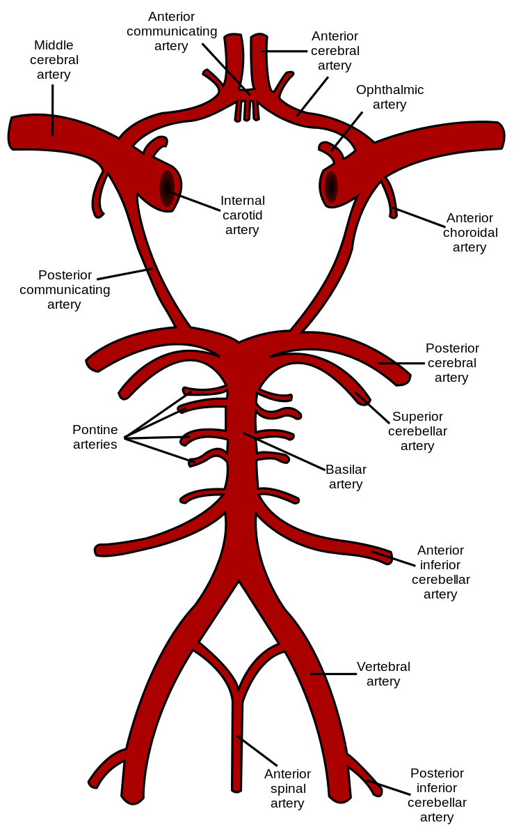
2c. Splanchnic circulation: is the circulation of the gastrointestinal tract originating at the celiac trunk, the superior mesenteric artery and the inferior mesenteric artery. It is also known as the Visceral circulation and constitutes three portions: Mesenteric circulation supplying blood to GI tract; Splenic circulation supplying blood to spleen; Hepatic circulation supplying blood to liver.

2d. Coronary circulation: is the circulation of blood through blood vessels of the heart muscle (myocardium). It is responsible for functional blood supply to heart muscle itself. Blood flowing through the chambers of the heart does not nourish the myocardium but the coronary vessels supply adequate oxygen to the myocardium. Coronary arteries supply oxygenated blood to the myocardium while the cardiac veins drain away the blood once deoxygenated. Coronary artery diseases are caused due to inadequate blood supply to the myocardium via coronary artery.

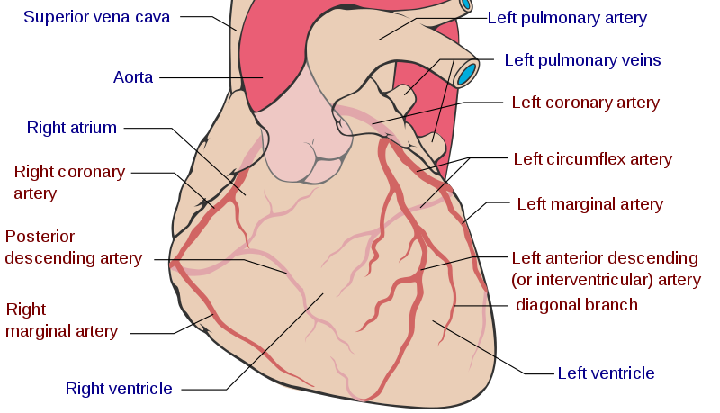
2e. Cutaneous circulation: is the circulation of the blood in the skin through cutaneous blood vessels. The function of this blood flow is supply of nutrition to skin and regulation of body temperature by heat loss. This circulation is regulated mainly by body temperature in which the hypothalamus plays an important role.
Below is the architectural structure of the cutaneous blood vessels in the skin
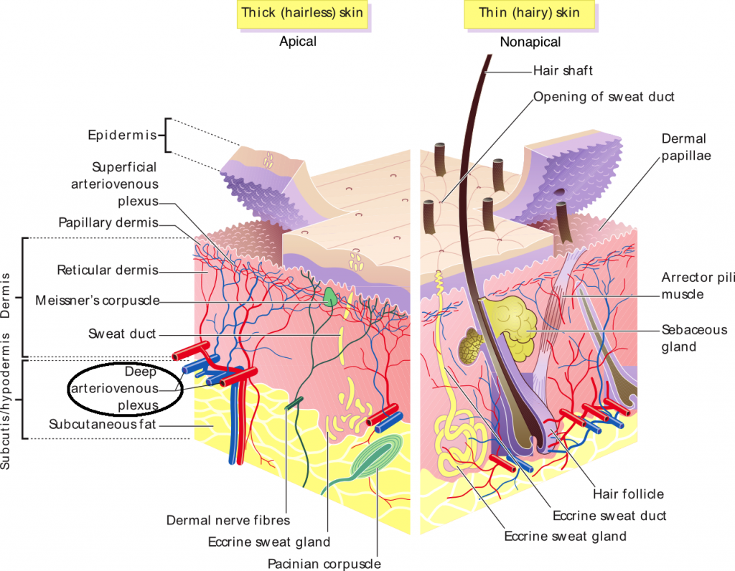

- During exercise, there are various adjustments in the body aimed at supplying various metabolic requisites like nutrient and oxygen to muscles and other tissues involved in exercise and prevention of increase in body temperature.
The adjustments of the cardiovascular system during exercise are;
- On the blood: mild hypoxia develops during exercise stimulating the juxtaglomerular apparatus to secrete erythropoietin causing the production of RBC.
- On the heart size: the muscular walls of the heart increase in thickness, particularly the left ventricle, providing more powerful contraction.
- On stroke volume: the increase in the heart enables the left ventricle to stretch more and thus fill with more blood. The increase in the muscle wall thickness also increases the contractility resulting in increased stroke volume during exercise, increasing blood supply.
- On heart rate: Heart rate is increased greatly due to vagal withdrawal ie the reduction in vagal tone as a result of impulses from the cerebral cortex to the medullary nerve.
- On cardiac output: Cardiac output increases during exercise due to increase in heart rate and stroke volume. Because of vagal contraction, sympathetic activity increases leading to increase in rate and forceful contraction.
- On venous return: it increases during exercise due to muscle pump, respiratory pump and splanchnic vasoconstriction.
- On blood pressure: The peripheral resistance increases, thereby, increasing both the diastolic and systolic pressures.

