NAME: ALFA UNEKWU-OJO MICHELLE
MATRIC NUMBER: 17/MHS01/051
COURSE: RENAL PHYSIOLOGY
DEPARTMENT: MEDICINE AND SURGERY
LEVEL: 300
ASSIGNMENT
- Discuss the pathophysiological process involved in renal failure
Renal failure is a progressive disease characterized by an increasing inability of the kidney to maintain normal low levels of the products of:
- protein metabolism (such as urea)
- normal blood pressure
- hematocrit
- sodium
- water
- potassium
- acid-base balance
Chronic kidney disease (CKD) is initially described as diminished renal reserve or renal insufficiency, which may progress to renal failure (end-stage renal disease). Initially, as renal tissue loses function, there are few noticeable abnormalities because the remaining tissue increases its performance (renal functional adaptation).
Decreased renal function interferes with the kidneys’ ability to maintain fluid and electrolyte homeostasis. The ability to concentrate urine declines early and is followed by decreases in ability to excrete excess phosphate, acid, and potassium. When renal failure is advanced (glomerular filtration rate [GFR] ≤ 15 mL/min/1.73 m²), the ability to effectively dilute or concentrate urine is lost; thus, urine osmolality is usually fixed at about 300 to 320 mOsm/kg, close to that of plasma (275 to 295 mOsm/kg), and urinary volume does not respond readily to variations in water intake.

Creatinine and urea
Plasma concentrations of creatinine and urea (which are highly dependent on glomerular filtration) begin a hyperbolic rise as GFR diminishes. These changes are minimal early on. When the GFR falls below 15 mL/min/1.73 m² (normal > 90 mL/min/1.73 m²), creatinine and urea levels are high and are usually associated with systemic manifestations (uremia). Urea and creatinine are not major contributors to the uremic symptoms; they are markers for many other substances (some not yet well defined) that cause the symptoms.

Sodium and water
Despite a diminishing GFR, sodium and water balance is well maintained by increased fractional excretion of sodium in urine and a normal response to thirst. Thus, the plasma sodium concentration is typically normal, and hypervolemia is infrequent unless dietary intake of sodium or water is very restricted or excessive. Heart failure can occur due to sodium and water overload, particularly in patients with decreased cardiac reserve.

Potassium
For substances whose secretion is controlled mainly through distal nephron secretion (eg, potassium), renal adaptation usually maintains plasma levels at normal until renal failure is advanced or dietary potassium intake is excessive. Potassium-sparing diuretics, angiotensin-converting enzyme inhibitors, beta-blockers, nonsteroidal anti-inflammatory drugs, cyclosporine, tacrolimus, trimethoprim/sulfamethoxazole, pentamidine, or angiotensin II receptor blockers may raise plasma potassium levels in patients with less advanced renal failure.

Calcium and phosphate
Abnormalities of calcium, phosphate, parathyroid hormone (PTH), and vitamin D metabolism can occur, as can renal osteodystrophy. Decreased renal production of calcitriol (1,25(OH)₂D, the active vitamin D hormone) contributes to hypocalcemia. Decreased renal excretion of phosphate results in hyperphosphatemia. Secondary hyperparathyroidism is common and can develop in renal failure before abnormalities in calcium or phosphate concentrations occur. For this reason, monitoring PTH in patients with moderate CKD, even before hyperphosphatemia occurs, has been recommended.
Renal osteodystrophy (abnormal bone mineralization resulting from hyperparathyroidism, calcitriol deficiency, elevated serum phosphate, or low or normal serum calcium) usually takes the form of increased bone turnover due to hyperparathyroid bone disease (osteitis fibrosa) but can also involve decreased bone turnover due to adynamic bone disease (with increased parathyroid suppression) or osteomalacia. Calcitriol deficiency may cause osteopenia or osteomalacia.

pH and bicarbonate
Moderate metabolic acidosis (plasma bicarbonate content 15 to 20 mmol/L) is characteristic. Acidosis causes muscle wasting due to protein catabolism, bone loss due to bone buffering of acid, and accelerated progression of kidney disease.

Anemia
Anemia is characteristic of moderate to advanced CKD (≥ stage 3). The anemia of CKD is normochromic-normocytic, with an Hct of 20 to 30% (35 to 40% in patients with polycystic kidney disease). It is usually caused by deficient erythropoietin production due to a reduction of functional renal mass. Other causes include deficiencies of iron, folate, and vitamin B12.
Summary of pathophysiology of renal failure
- Regardless of the primary cause of nephron loss, some usually survive or are less severely damaged
- These nephrons then adapt and enlarge, and clearance per nephron markedly increases.
- If the initiating process is diffuse, sudden, and severe, such as in some patients with rapidly progressive glomerulonephritis (crescentic glomerulonephritis), acute or subacute renal failure may ensue with the rapid development of end-stage renal disease (ESRD).
- In most patients, however, disease progression is more gradual and nephron adaptation is possible.
- Focal glomerulosclerosis develops in these glomeruli, and they eventually become non-functional.
- At the same time that focal glomerulosclerosis develops, proteinuria markedly increases and systemic hypertension worsens.
- This process of nephron adaptation has been termed the "final common path."
- Adapted nephrons enhance the ability of the kidney to postpone uremia, but ultimately the adaptation process leads to the demise of these nephrons.
- Adapted nephrons have not only an enhanced GFR but also enhanced tubular functions in terms of, for example, potassium and proton secretion.

- With the aid of suitable diagrams discuss the types of dialysis
What is dialysis?
People with failed or damaged kidneys may have difficulty eliminating waste and unwanted water from the blood. Dialysis is an artificial way of carrying out this process. Dialysis substitutes the natural work of the kidneys, so it is also known as renal replacement therapy (RRT).
Healthy kidneys regulate the body’s levels of water and minerals and remove waste. The kidneys also secrete certain products that are important in metabolism, but dialysis cannot do this.
A person who has lost 85 to 90 percent of their kidney function will be a likely candidate for dialysis. Around 14 percent of the population of the United States are thought to have chronic kidney disease (CKD).
A healthy person’s kidneys filter around 120 to 150 quarts of blood each day. If the kidneys are not working correctly, waste builds up in the blood. Eventually, this can lead to coma and death.
The cause might be a chronic, or long-term condition, or an acute problem, such as an injury or a short-term illness that affects the kidneys.
Dialysis prevents the waste products in the blood from reaching hazardous levels. It can also remove toxins or drugs from the blood in an emergency setting.
TYPES OF DIALYSIS
There are different types of dialysis. The three main approaches are:
- Intermittent hemodialysis (IHD)
- Peritoneal dialysis (PD)
- Continuous renal replacement therapies (CRRT)
The choice will depend on factors such as the patient’s situation, availability, and cost.

Intermittent hemodialysis
In hemodialysis, the blood circulates outside the body. It goes through a machine with special filters.
The blood comes out of the patient through a flexible tube known as a catheter. The tube is inserted into the vein.
Like the kidneys, the filters remove the waste products from the blood. The filtered blood then returns to the patient through another catheter. The system works like an artificial kidney.
Those who are going to have hemodialysis need surgery to enlarge a blood vessel, usually in the arm. Enlarging the vein makes it possible to insert the catheters.
Hemodialysis is usually done three times a week, for 3 to 4 hours a day, depending on how well the kidneys work, and how much fluid weight they have gained between treatments.
Hemodialysis can be done in a special dialysis center in a hospital or at home.
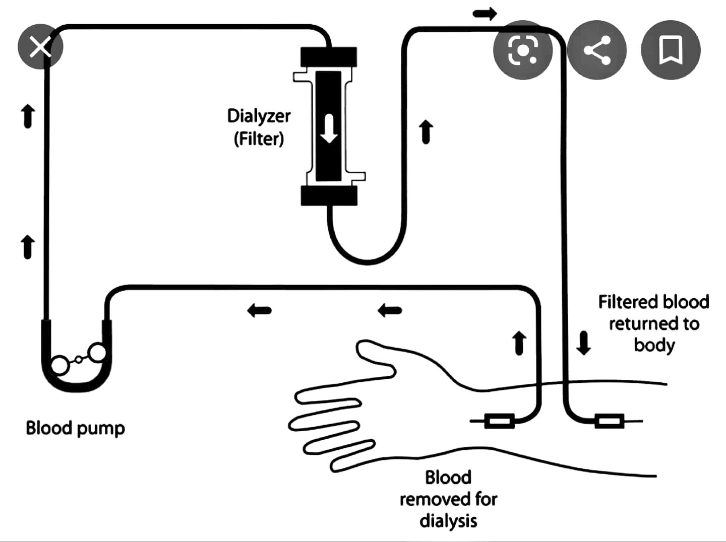
Peritoneal dialysis
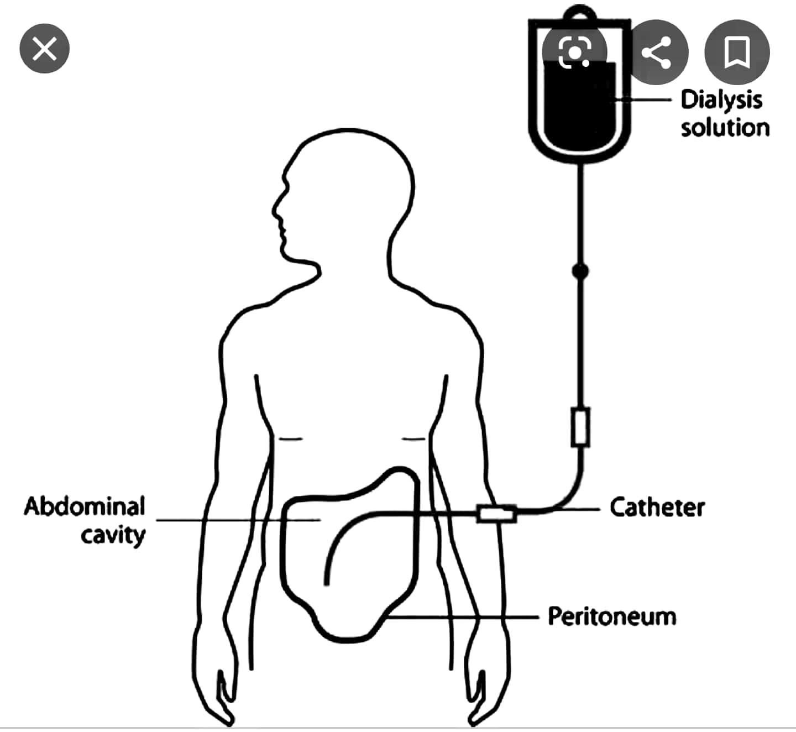
While hemodialysis removes impurities by filtering the blood, peritoneal dialysis works through diffusion.
In peritoneal dialysis, a sterile dialysate solution, rich in minerals and glucose, is run through a tube into the peritoneal cavity, the abdominal body cavity that surrounds the intestine. It has a semi-permeable membrane, the peritoneal membrane.
Peritoneal dialysis uses the natural filtering ability of the peritoneum, the internal lining of the abdomen, to filter waste products from the blood.
The dialysate is left in the peritoneal cavity for some time, so that it can absorb waste products. Then it is drained out through a tube and discarded.
This exchange, or cycle, is normally repeated several times during the day, and it can be done overnight with an automated system.
The elimination of unwanted water, or ultrafiltration, occurs through osmosis. The dialysis solution has a high concentration of glucose, and this causes osmotic pressure. The pressure causes the fluid to move from the blood into the dialysate. As a result, more fluid is drained than is introduced.
Peritoneal dialysis is less efficient than hemodialysis. It takes longer periods, and it removes around the same amount of total waste product, salt, and water as hemodialysis.
However, peritoneal dialysis gives patients more freedom and independence, because it can be done at home instead of going to the clinic several times each week. It can also be done while traveling with a minimum of specialized equipment.
Before starting peritoneal dialysis, the patient needs a small surgical procedure to insert a catheter into the abdomen. This is kept closed off, except when being used for dialysis.
There are two main types of peritoneal dialysis:
Continuous ambulatory peritoneal dialysis (CAPD) requires no machinery, and the patient or a caregiver can do it.
The dialysate is left in the abdomen for up to 8 hours and then replaced with a fresh solution straight away. This happens every day, four or five times per day.
Continuous cyclic peritoneal dialysis (CCPD), or automated peritoneal dialysis uses a machine to exchange the fluids. It is generally done every night, while the patient sleeps.
Each session lasts from 10 to 12 hours. After spending the night attached to the machine, most people keep the fluid inside their abdomen during the day. Some patients may need another exchange during the day.
Peritoneal dialysis is a suitable option for patients who find hemodialysis too exhausting, such as elderly people, infants, and children. It can be done while traveling, so it is more convenient for those who work or attend school.

Continuous renal replacement therapy
Dialysis can be intermittent or continuous.
While a session of intermittent dialysis lasts for up to 6 hours, continuous renal replacement therapies (CRRT) are designed for 24-hour use in an intensive care unit (ICU).
There are different types of CRRT. It can involve either filtration or diffusion. It is better tolerated than intermittent dialysis, because the solute or fluid removal is slower. This leads to fewer complications, for example, a lower chance of hypotension.

Temporary dialysis
Sometimes dialysis is given for a limited period of time.
People who may benefit from temporary dialysis include those who:
- Have a sudden, or acute, kidney condition
- Have consumed toxic substances or taken a drug overdose
- Have had a traumatic injury to the kidney
- Have chronic heart disease

