NAME: OKWONU ESEOGHENE GIFT

MATRIC NUMBER : 18/MHS01/278

DEPARTMENT : MEDICINE AND SURGERY

COURSE: PHYSIOLOGY

ASSIGNMENT .

- Discuss the long term regulation of mean arterial blood pressure.
Long-term regulation of blood pressure is primarily accomplished by altering blood volume. The loss of blood through hemorrhage, accident, or donating a pint of blood will lower blood pressure and trigger processes to restore blood volume and therefore blood pressure back to normal. Long-term regulatory processes promote the conservation of body fluids via renal mechanisms and stimulate intake of water to normalize blood volume and blood pressures.
Loss of blood
When there is a loss of blood, blood pressure and blood volume decreases.
Kidney Juxtaglomerular Cells.
The Juxtaglomerular cells in the kidney monitor alterations in the blood pressure. If blood pressure falls too low, these specialized cells release the enzyme renin into the bloodstream.
Renin-Angiotensin Mechanism.
The renin/angiotensin mechanism consists of a series of steps aimed at increasing blood volume and blood pressure.
Step 1: Catalyzing Formation of Angiotensin I: As renin travels through the bloodstream, it binds to an inactive plasma protein, angiotensinogen, activating it into angiotensin I.
Step 2: Converting Angiotensin I to Angiotensin II: As angiotensin I passes through the lung capillaries, an enzyme in the lungs converts angiotensin I to angiotensin II.
Step 3: Angiotensin II Stimulates Aldosterone Release: Angiotensin II continues through the bloodstream until it reaches the adrenal gland. Here it stimulates the cells of the adrenal cortex to release the hormone aldosterone.
Angiotensin II as a Vasoconstrictor
A secondary effect is that angiotensin II is a vasoconstrictor and therefore raises blood pressure in the body's arterioles.
Aldosterone Mechanism
Long-Term Regulation: Aldosterone Mechanism: The target organ for aldosterone is the kidney. Here aldosterone promotes increased reabsorption of sodium from the kidney tubules.
In the distal Convoluted Tubule; Long-Term Regulation: Aldosterone Mechanism:
Each distal convoluted tubule winds through the kidney and eventually empties its contents into a urine-collecting duct. The peritubular capillaries absorb solutes and water from the tubule cells as these substances are reclaimed from the filtrate.

Sodium Reabsorption
Aldosterone stimulates the cells of the distal convoluted tubule to increase the active transport of sodium ions out of the tubule into the interstitial fluid, accelerating sodium reabsorption.
Water Reabsorption : As sodium moves into the bloodstream, water follows. The reabsorbed water increases the blood volume and therefore the blood pressure.
Increase in Osmolarity: Dehydration due to sweating, diarrhea, or excessive urine flow will cause an increase in osmolarity of the blood and a decrease in blood volume and blood pressure.
Long-Term Effect of Osmolarity on BP: As increased osmolarity is detected there is both a short and long-term effect. For the long-term effect, the hypothalamus sends a signal to the posterior pituitary to release antidiuretic hormone(ADH).
Antidiuretic Hormone: ADH increases water reabsorption in the kidney.
ADH in Distal Convoluted Tubule: ADH promotes the reabsorption of water from the kidney by stimulating an increase in the number of water channels in the distal convoluted tubules and collecting tubules (ducts). These channels aid in the movement of water back into the capillaries, decreasing the osmolarity of the blood volume and therefore blood pressure.
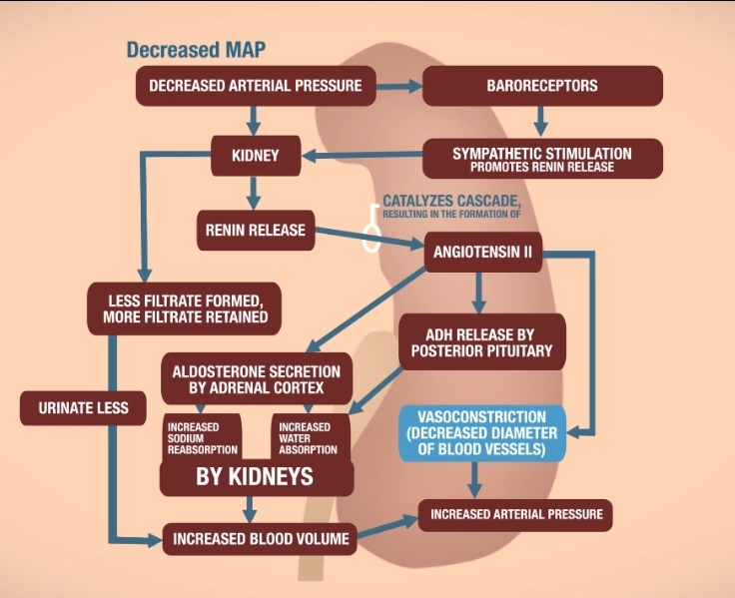

- Write short notes on

- Pulmonary circulation
Pulmonary circulation is the circulation of blood between the heart and the lungs which carries deoxygenated blood away from the right ventricle, to the lungs and returns oxygenated blood to the left atrium and ventricle of the heart. The pulmonary artery divides into right and left branches. Each branch enters the corresponding lung along with primary bronchus. After entering the lung, branch of the pulmonary artery divides into small vessels and finally forms the capillary plexus that is in intimate relationship to alveoli. Capillary plexus is solely concerned with alveolar gas exchange. Oxygenated blood from the alveoli is carried to the left atrium by one pulmonary vein from each side.
- Circle of Willis
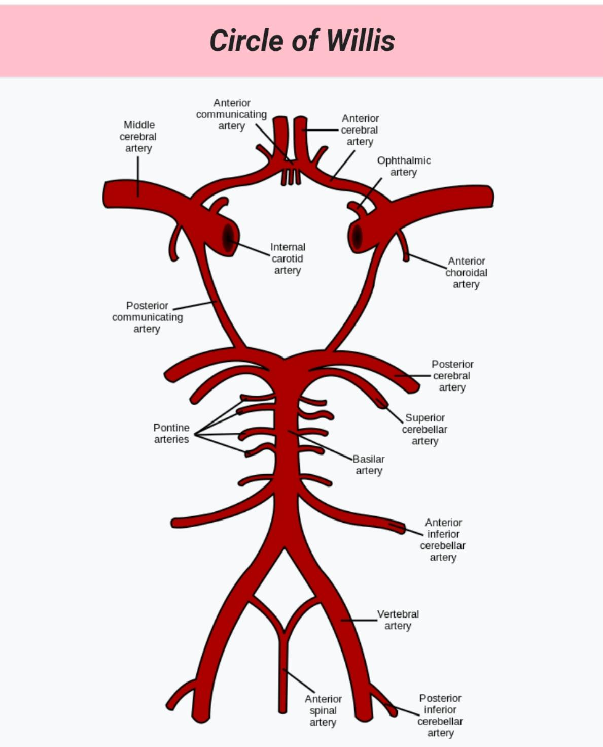
The circle of Willis is a part of the cerebral circulation and it is composed of the following arteries: ... Internal carotid artery (left and right) Posterior cerebral artery (left and right) Posterior communicating artery (left and right). The Circle of Willis is the joining area of several arteries at the bottom (inferior) side of the brain. At the Circle of Willis, the internal carotid arteries branch into smaller arteries that supply oxygenated blood to over 80% of the cerebrum. The arrangement of the brain's arteries into the circle of Willis creates redundancy (analogous to engineered redundancy) for collateral circulation in the cerebral circulation. If one part of the circle becomes blocked or narrowed (stenosed) or one of the arteries supplying the circle is blocked or narrowed, blood flow from the other blood vessels can often preserve the cerebral perfusion well enough to avoid the symptoms of ischemia. Clinical significance includes aneurysms and subclavian steal syndrome.

- Splanchnic circulation
The splanchnic or visceral circulation constitutes three portions which include, the mesenteric circulation supplying blood to the gastrointestinal tract, splenic circulation supplying blood to the spleen and the hepatic circulation supplying blood to the liver. The splanchnic circulation is composed of the blood flow originating from the celiac, superior mesenteric, and inferior mesenteric arteries and is distributed to all abdominal viscera. The splanchnic circulation receives over 25% of the cardiac output and contains a similar percentage of the total blood volume under normal conditions. Thus, the splanchnic circulation can act as a site of regulation of distribution of cardiac output and also as a blood reservoir. Multiple regulatory pathways are involved in the distribution of the splanchnic circulation.
- Coronary circulation
Coronary circulation is the circulation of blood through blood vessels of the heart muscle. It is responsible for the functional blood supply to the heart muscles itself. Blood flowing through the chambers of the heart donor nourish the myocardium. When functioning normally, the blood in the coronary blood vessels supply adequate oxygen to the myocardium.
Features of coronary circulation
- It is very short and very rapid
- Blood flow occurs mainly during diastolic phase
- There is no effective anastomosis between coronary vessels
- Coronary vessels are highly susceptible to degeneration and atherosclerosis
- Its regulation is mainly by metabolites and not neural

- Cutaneous circulation
The cutaneous circulation is the circulation and blood supply of the skin. The skin is not a very metabolically active tissue and has relatively small energy requirements, so its blood supply is different to that of other tissues. Its function is to supply nutrition to the skin and regulate body temperature by heat loss. Cutaneous blood flow is regulated mainly by body temperature. Hypothalamus plays an important role in regulating cutaneous bloodflow. When body temperature increases, the hypothalamus is activated and in turn this causes cutaneous vasodilation by acting through medullary vasomotor center. Now blood flow increases in skin. Increase in cutaneous blood flow causes the loss of heat from body through sweat. When body temperature Is low, vasoconstriction occurs in the skin. Therefore blood flow to the skin decreases and prevents the heat loss from skin.

- Discuss the cardiovascular adjustment that occurs during exercise.
During exercise 3 main adjustment are made by the cardiovascular system;
- Increased cardiac output
Increased pumping capacity of the heart enhances delivery of oxygen and fuel to working muscles.
- Increased muscle blood flow
Blood vessels in muscles dilate increasing local blood flow
- Decreased blood flow to kidneys, liver and gut
Redirects or shunts blood flow to working muscles.
During exercise, increase in cardiac stroke volume and heart rate increases cardiac output. Whereas cardiac output is the amount of blood pumped out of each ventricle per minute.
Cardiac output = Heartrate × stroke volume
Heart rate is increased through the following mechanisms;
- Reduction of the parasympathetic nervous system activity to the heart as parasympathetic stimulation reduces heart rate normal, so its reduction will increase heart rate.
- Increase in sympathetic nervous system activity to the heart. Normally sympathetic stimulation causes heart rate to increase, so increase in sympathetic stimulation will automatically increase heart rate
- Increase in the circulation of epinephrine or adrenaline in the blood will also stimulate an increase in heart rate
The increase in size of the heart enables the left ventricle to stretch more and thus fill with more blood. The increase in muscle wall thickness also increases the contractility resulting in increased stroke volume at rest and during exercise there by increasing blood supply to the body. Stroke volume increases with exercise intensity but may plateau before reaching max. Due to; increased sympathetic activity and increased circulating epinephrine.
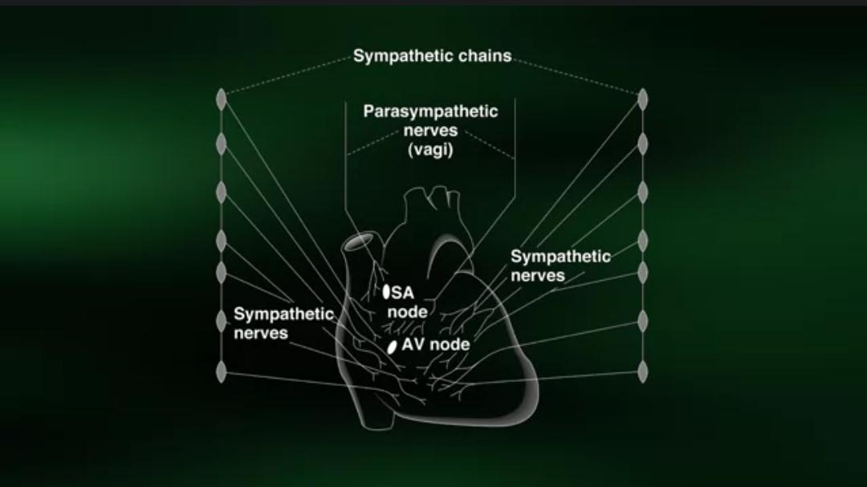
When the heartrate is increased, stroke volume also increases there by increasing cardiac output which is coupled with a transient increase in systemic vascular resistance and the mean arterial pressure elevates.

