NAME: OGWUEGBU U. CHARLES
MATRICULATION NUMBER: 17/MHS03/025
DEPARTMENT: MBBS
COURSE: RENAL PHYSIOLOGY BODY FLUID AND TEMPERATURE REGULATION
COURSE CODE: PHS303
ASSIGNMENT TITLE: RENAL PHYSIOLOGY FOR MBBS STUDENT (SECOND ASSIGNMENT)
- Discuss the pathophysiological process involves in renal failure?
PATHOPHYSIOLOGICAL PROCESS INVOLVED IN RENAL FAILURE
Chronic renal failure is characterized by decrease in glomerular filtration rate, occurring when the glomerular filtration rate has been reduced to its normal function (20ml/min). The major causes include; Diabetes mellitus, hypertension, glomerulonephritis, Polycystic kidney disease, chronic pyelonephritis. The pathophysiological process associated with this renal failure are as follows:
- FLUID/ELECTROLYTE DERANGEMENT:
SODIUM:
In a normal person, more than 25,000m/mol of sodium ions are filtered daily with <1% being excreted. Chronic renal failure is associated with sodium retention, depletion or sodium balance and is influenced by factors such as diuretic use and cardiac function. Patients with cardiac renal failure, also have impaired renal concentrating mechanisms and thus extra renal fluid losses e.g. via vomiting, diarrhea, or pyrexia may rapidly cause HYPOVOLAEMIA (Decrease in blood volume).
POTASSIUM AND MAGNESIUM:
Adaptive processes result in increased potassium secretions in the distal nephron (Collecting tubules) and also in the gut. Magnesium is handled just like potassium. Reduced excretion may result in HYPERMAGNESAEMIA and MUSCLE WEAKNESS.
CALCIUM, PHOSPHATE, PARATHORMONE AND RENAL OSTEODYSTROPHY:
In chronic renal failure, total plasma calcium concentration is decreased. Phosphate excretion decreases also as glomerular filtration falls below 20ml/min, resulting HYPERPHOSPHATEMIA. Both HYPOCALCEMIA and HYPERPHOSPHATEMIA are potent stimuli for parathormone secretion resulting in HYPERPLASIA OF THE PARATHYROID GLAND and ultimately, SECONDARY HYPERPARATHYROIDISM which further causes INCREASED OSTEOCLAST AND OSTEOBLAST ACTIVITY resulting OSTEITIS FIBROSA CYSTICA.
- HAEMATOLOGICAL ABNORMALITIES:
Normochromic normocystic anaemia is usually associated with chronic renal failure. Also there’s decreased erythropoietin production, decreasing stem cell transformation into erythrocytes while Uremic cell toxins decrease RBC life span. Renal failure is also associated with COAGULOPATHY i.e. Patients with renal failure tend to excessively bleed in the peri-operative period.
- CARDIOVASCULAR AND PULMONARY ABNORMALITIES:
Cardiovascular abnormalities are common in renal failure and accounts for 48% of deaths involving these patients. Systemic hypertension with an incidence of about 80%. Ischemic heart disease (IHD) is another frequent cause of mortality in patients with renal failure. Post-operative pulmonary complications are also common with patients with renal failure. All these are as a result of impairment of blood and electrolyte regulatory mechanism of the kidney.
- IMMUNITY PROBLEMS:
Sepsis (A serious condition in which the body is inflamed) is the leading cause of death in patients with chronic renal failure. Inhibition of cell-mediated immunity and humoral defence mechanism occurs, with little improvement after dialysis. There’s an increase in pro-inflammatory cytokines, suggesting that the activation of monocytes may play a role in UREMIC IMMUNE DYSFUNCTION. Also incidence of viral hepatitis can be associated with renal failure.
- GASTROINTESTINAL ABNORMALITIES:
Gastrointestinal abnormalities are frequent, with anorexia, nausea and vomiting contributing to malnutrition. Urea is a mucosal irritant, so bleeding can also at any part of the GIT (Gastrointestinal tract).
- NEUROLOGICAL ABNORMALITIES:
Patients with chronic renal failure have abnormalities in central and peripheral nervous system. There’s a very wide spectrum of central nervous system changes that can occur to patient ranging from mild personality alterations to asterixis (also known as FLAPPING TREMOR, abnormal muscular tremor characterized by involuntary jerking of hand). Peripheral neuropathy is common at the advanced stage of the renal failure.
- ENDOCRINE ABNORMALITIES:
Anomaly in parathyroid function and lipid clearance as seen above is associated with chronic renal failure. In conjunction with that, there’s an impairment in glucose tolerance and abnormalities with temperature regulation,
In addition to all these pathophysiological processes and changes associated with renal failure, there are many pharmacokinetic changes i.e. drug-related metabolism changes, in these patients.
- With the aid of suitable diagrams, discuss the types of dialysis you know

DIALYSIS
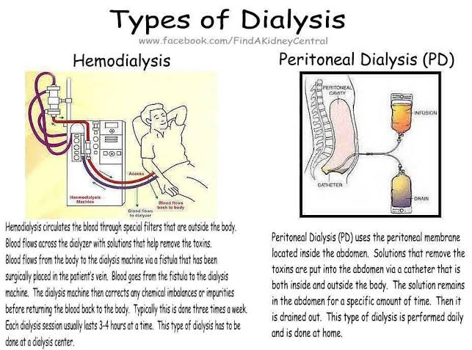
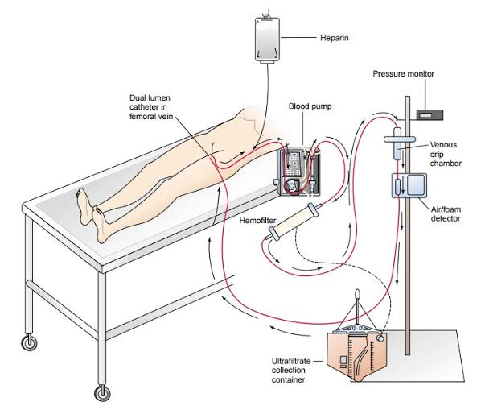
CONTINUOUS RENAL REPLACEMENT THERAPY
The kidneys filters blood by removing waste and excess fluid and electrolytes or substances from the body, which is then sent to the bladder to be excreted/eliminated when we urinate. Dialysis performs the functions of the kidney when they’ve failed (End-stage kidney failure, which according to National Kidney Foundation (NKF) occurs when the kidneys are performing at < 10-15% of their function), though it isn’t a cure for kidney problems. Dialysis, which has been in use since 1940s is a treatment that filters and purifies blood using a machine. It helps in keeping fluid and electrolyte in balance when the kidney can’t perform its functions. Without dialysis, salts, electrolytes and other waste products will accumulate in the blood, poisoning the body and damaging some other organs in the process. There are 3 different types of dialysis:
- Hemodialysis
- Peritoneal dialysis
- Continuous renal replacement therapy
HEMODIALYSIS: It is the most common type of dialysis. It involves using an artificial kidney (HEMODIALYZER) to remove waste, excess fluid and electrolyte from the body, after which the filtered blood is returned back to the body. To get the blood to flow to the hemodialyzer, the doctor will need to create entrance point into your vessels (VASCULAR ACCESS). The three types of entrance points are:
- ARTEROVENOUS FISTULA: The preferred option connecting the artery to the vein.
- ARTEROVENOUS GRAFT: This type is a LOOPED TUBE
- VASCULAR ACCESS (VA) CATHETER: Maybe inserted into a large vein in the neck
ARTEROVENOUS (AV) FISTULA AND GRAFT; are used in long term dialysis treatment. AV fistulas usually is usually ready 2-3 months after surgery while AV grafts are usually ready after 2-3 weeks. VA CATHETERS are used for short-term and temporary use.
HEMODIALYSIS TREATMENT is usually performed 3-5 hours, three times a week at the hospital, doctors’ office or dialysis center.
The length of this treatment depends on the following:
- Size of the person
- Amount of waste in the body
- Current health state
PERITONEAL DIALYSIS: Involves a surgery to implant peritoneal dialysis catheter (PDC). This catheter helps filter your blood through the peritoneum, a membrane in the abdomen. During this treatment, a special fluid, DIALYSATE flows into the peritoneum, which absorbs the waste. After sometime after it draws the waste from the bloodstream, it is drained from the abdomen. It is performed with few hours, 4-6 times a day and can be done when sleeping or awake.
There are different types of peritoneal dialysis, but the main ones include:
- CONTINUOUS AMBULATORY PERITONEAL DIALYSIS: The abdomen is filled and drained multiple times per day. This type doesn’t require machine and must be performed while awake.
- CONTINUOUS CYCLING PERITONEAL DIALYSIS: It involves use of machine to cycle the fluid in and out and performed at night while sleeping.
- INTERMITTENT PERITONEAL DIALYSIS: Similar to continuous cycling peritoneal dialysis but the process takes longer.
CONTINUOUS RENAL REPLACEMENT THERAPY: It is also known as HEMOFILTRATION. It is primarily used in the intensive care unit for patients with ACUTE RENAL FAILURE. A machine passes blood through tubing, a filter removes the waste and excess/extra fluid/water, then the blood is returned to the body along with the replacement fluid. It is done for 12-24 hours, generally everyday.

