ADEKANYE ITUNU OLUWADARA
17/MHS01/017
RENAL PHYSIOLOGY
300L

ASSIGNMENT
1. Discuss the pathophysiological process involves in renal failure?
2. With the aid of suitable diagrams discuss the types of dialysis you know?

1. The Pathophysiological Processes of Renal Failure
Renal failure refers to the failure of excretory functions of the kidney, ending end with terminal kidney damage. It is usually characterized by decrease in glomerular filtration rate (GFR) during this time, there is modulation and adaptation in the still-functional glomeruli, which keeps the kidneys functioning normally for as long as possible. The remaining glomeruli, therefore, experience a rise in pressure through hyper filtration.
The release of various cytokines and growth factors leads to hypertrophy and hyperplasia. At the same time, the function of the glomeruli suffers due to the excessive demands on them, leading to increased permeability and proteinuria. Increased protein concentrations in the proximal tube system are direct nephrotoxins and can further impair kidney function.
There are four phases of chronic renal failure:
1. Reduction in Excretory Function: Breakdown of excretory function is the consequence of an accumulation of endogenous andextraneous substances. This leads to changes in pharmacokinetics and an increase in the concentration of various medications. Breakdown occurs when the remaining glomeruli are confronted by a surplus of waste products, leading to osmotic diuresis. There is a reduction in the maximal concentrating capacity of the kidney. In order to filter the physiological quantity of dissolved substances, the nephrons produce between 3 and 4 times as much urine during renal failure, resulting in an accumulation of waste substances.
2. Reduction in Incretory Renal Function: Because the kidney plays a part in the regulation of many important hormonal cycles, chronic renal failure also has endocrinal consequences. Through a shortage of erythropoietin, there is a reduction in erythrocyte synthesis, which leads to renal anemia; uremia then leads to a reduction of functional erythrocytes due to hemolysis or hemorrhages.
Vitamin D production is also impaired, and phosphate excretion is reduced. Secondary hyperparathyroidism and the associated renal osteopathy (‘high-turnover’ osteopathy) develop as a result of hyperphosphatemia. Parallel to this, other pathomechanisms lead to a disruption in bone metabolism: osteomalacia occurs due to a disruption of mineralization, and adynamic bone disease occurs due to a reduction in bone cell activity (particularly in dialysis patients).
3. Over-hydration and the Disruption of Electrolyte Balance: As long as the glomeruli can manage to compensate, diuresis and fractional sodium excretion rise. If the glomerular filtration rate noticeably drops, then the ability to compensate is exhausted, leading to increased retention of water and electrolytes.
Hypertension, pulmonary edema, and peripheral edema result from over hydration. Water and salt excretion are thereby inextricably linked. Diuretics can aid in water and salt excretion where critical glomerular damage is present. Early loss of salts as a result of the disturbance in the resorption process can actually be made worse by the use of diuretics.
Thus, as the glomeruli adapt to compensate, the tubular transport mechanisms also adapt in order to prevent hyperkalemia through increased potassium secretion. Hyperkalemia only develops as a result of hyper stimulation of the resorption capacity. As many patients are treated with calcium-sparing diuretics due to previous conditions, it is vital to refer to patient’s medication history and adapt the treatment plan accordingly.
Acidosis also rises alongside hyperkalemia. The kidneys can no longer sufficiently eliminate accumulating protons due to a strongly reduced glomerular filtration rate. This metabolic acidosis leads to increased bone calcium release and strengthening renal osteopathy, an increase in gastrointestinal problems, and the impairment of protein metabolism.
4. Toxic Organ Damage as a Result of Retention of Urinary Excreted Metabolites: Toxic organ damage can be explained under the umbrella term ‘uremic syndrome.’ The rise in urinary excreted metabolites in the blood is called azotemia. These metabolites include urea, creatinine, beta-2 microglobulin, parathyroid hormone, among others. Uremic syndrome (uremia) principally describes a systemic disruption of all organ functions, especially the circulatory system, central nervous system, blood, and membranes.
Clinically, many symptoms of chronic renal failure can be detected via the skin. Patients often have macules (‘café au lait’ spots), are conspicuously pale, and have a gray, dirty-looking complexion. They often complain of pruritus. Internal membranes are also affected, leading to pericarditis, peritonitis, and pleurisy.
Uremia can also lead to hemolysis with anemia. Simultaneously, thrombocyte and leukocyte dysfunctions or deficiencies can arise.
People with chronic renal failure have a generally increased risk of atherosclerosis with an elevated cardiovascular risk. This leads to media calcification caused by calcium phosphate and to intima calcification through inflammatory factors and cholesterol plaques. Hypertension is common, along with edemas and pulmonary congestion.
Impairments of the central nervous system are indicated by a reduction in vigilance, from general drowsiness to uremic coma. Seizures can occur. Uremia also causes polyneuropathy with paresthesia.

2. There are three different types of dialysis.
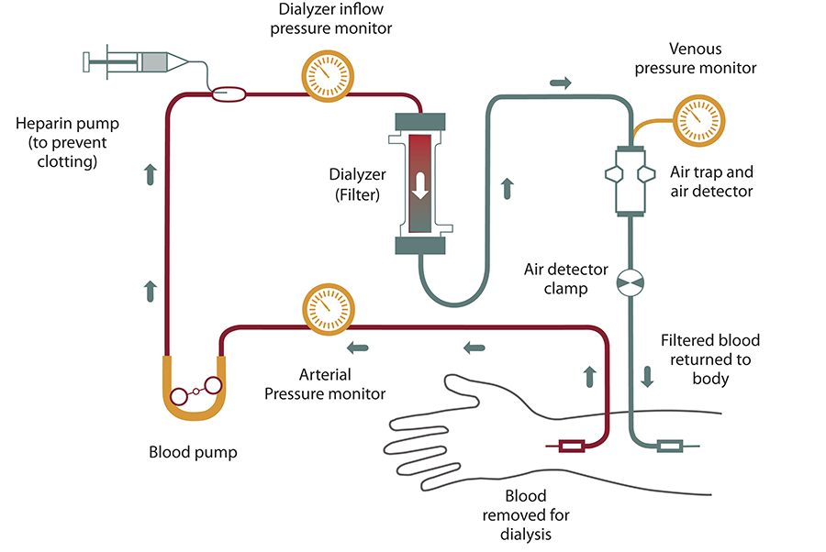
1. Haemodialysis: It is the most common type of dialysis. This process uses an artificial kidney (hemodialyzer) to remove waste and extra fluid from the blood. The blood is removed from the body and filtered through the artificial kidney. The filtered blood is then returned to the body with the help of a dialysis machine. To get the blood to flow to the artificial kidney, your doctor will perform surgery to create an entrance point (vascular access) into your blood vessels. The three types of entrance points are:
- Arteriovenous (AV) fistula: This type connects an artery and a vein. It’s the preferred option.
- AV graft: This type is a looped tube.
- Vascular access catheter: This may be inserted into the large vein in your neck.
Both the AV fistula and AV graft are designed for long-term dialysis treatments. People who receive AV fistulas are healed and ready to begin hemodialysis two to three months after their surgery. People who receive AV grafts are ready in two to three weeks. Catheters are designed for short-term or temporary use.
Hemodialysis treatments usually last three to five hours and are performed three times per week. However, hemodialysis treatment can also be completed in shorter, more frequent sessions. The length of treatment depends on your body size, the amount of waste in your body, and the current state of your health.
Hemodialysis risks include: low blood pressure, muscle cramping, difficulty sleeping, itching, high blood potassium levels, etc.
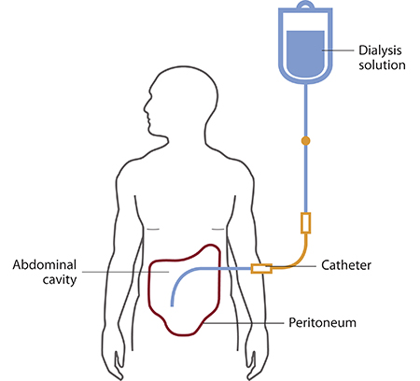
2. Peritoneal dialysis: It involves surgery to implant a peritoneal dialysis (PD) catheter into your abdomen. The catheter helps filter your blood through the peritoneum, a membrane in your abdomen. During treatment, a special fluid called dialysate flows into the peritoneum. The dialysate absorbs waste. Once the dialysate draws waste out of the bloodstream, it’s drained from your abdomen. This process takes a few hours and needs to be repeated four to six times per day. However, the exchange of fluids can be performed while you’re sleeping or awake.
There are numerous different types of peritoneal dialysis. The main ones are:
- Continuous ambulatory peritoneal dialysis (CAPD). In CAPD, your abdomen is filled and drained multiple times each day. This method doesn’t require a machine and must be performed while awake.
- Continuous cycling peritoneal dialysis (CCPD). CCPD uses a machine to cycle the fluid in and out of your abdomen. It’s usually done at night while you sleep.
- Intermittent peritoneal dialysis (IPD). This treatment is usually performed in the hospital, though it may be performed at home. It uses the same machine as CCPD, but the process takes longer.
Risks associated with peritoneal dialysis include: weight gain, hernia, fever, stomach pain, etc.
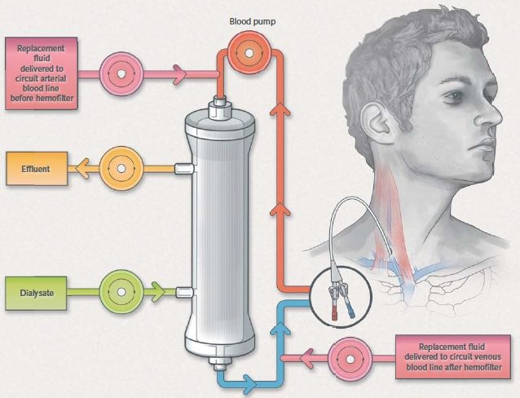
3. Continuous renal replacement therapy (CRRT): This therapy is used primarily in the intensive care unit for people with acute renal failure. It’s also known as hemofiltration. A machine passes the blood through tubing. A filter then removes waste products and water. The blood is returned to the body, along with replacement fluid. This procedure is performed 12 to 24 hours a day, generally every day.
The risks associated with CRRT include: infection, hypothermia, low blood pressure, electrolyte disturbances, bleeding, etc.

