NAME: SADIQ AYOTOMIWA S.
MATRIC NUMBER: 17/MHS01/290
COURSE: PHS 303
DATE: 26TH JUNE, 2020
ASSIGNMENT: 1. Discuss the pathophysiological process involved in renal failure
2. With the aid of suitable diagrams, discuss the types of dialysis you know.

1.
Renal failure is the significant loss of renal functions in both kidneys to the point where less than 10-20% of normal glomerular filtration rate (GFR). Renal failure may occur as an acute and rapidly progressing process or may present as a chronic form in which there is a progressive loss of renal function over a number of years.
Acute renal failure has an abrupt onset and is potentially reversible while chronic renal failure progresses slowly over at least three months and can lead to permanent renal failure.
PATHOPHYSIOLOGY OF RENAL FAILURE
In renal failure, there is either glomerular of tubular dysfunction.
- Glomerular dysfunction: As the main function of glomeruli is filtration, glomerular dysfunction leads to fall in GFR with retention of those substances usually cleared by filtration, including water. Glomerulonephritis primarily causes glomerular damage.
- Tubular dysfunction: As the main function of tubules is reabsorption, tubular failure results in voiding of large volumes of dilute urines(polyuria) of low specific gravity, along with electrolytes and nutrients.
Acute renal failure
This refers to the sudden decrease in renal function. Acute renal failure may be pre-renal, intra-renal or post-renal in nature. Acute renal failure is often reversible so far permanent injury to the kidneys has not occurred.
Manifestations: Oliguria(reduced urine output), possible edema and fluid retention, elevated blood urea nitrogen (BUN) levels and serum creatinine and alterations in serum electrolytes.
Causes of acute renal failure: Myocardial infarction, rhabdomyolysis, decreased blood flow, obstruction, hemolytic uremic syndrome and glomerulonephritis are common causes of acute renal failure.
Pre-renal failure results from impaired or reduced blood flow to the kidney. Possible causes include shock, hypotension, anaphylaxis and ischemic formation
Intra-renal failure results from acute damage to renal structures and acute tubular necrosis(ATN, it is the most common cause of acute renal failure). Possible causes include acute glomerulonephritis, pyelonephritis, and exposure to drugs, toxin, solvents and heavy metals.
Post-renal failure results from conditions blocking urine outflow. Possible causes include obstruction of urine outflow by calculi, tumors and prostatic hypertrophy.
Symptoms of acute renal failure: Decreased kidney functions (electrolyte imbalance), obstructions in the urinary tracts, blood in urine, reduced urine output, dehydration, detectable abnormal mass, pale skin and poor appetite.
Diagnosis: Routine laboratory test (creatinine and blood urea nitrogen), ultrasound (helps to determine whether acute or chronic), kidney biopsy and computed tomography scan.
Treatment:
- Preventing acute renal failure through support of blood pressure and blood volume
- Correction of fluids and electrolyte imbalance
- Dialysis, which may be employed while the kidneys are in the recovery phase
- Low protein, high carbohydrate diet to minimize the formation of nitrogenous wastes.
CHRONIC RENAL FAILURE
Chronic renal failure is the end result of progressive kidney damage and loss of function. It is often classified into four progressive stages based on the loss of glomerular filtration rate (GFR):
- Diminished renal reserve- GFR decreased to 35-50% of normal
- Renal insufficiency- GFR decreased to 20-35% of normal
- Renal failure- GFR reduced to less than 20% of normal
- End-stage renal disease- GFR is less than to 5% of normal
Causes of renal failure: Chronic glomerularnephtitis, chronic infection, renal obstructions (prolonged), exposure to toxic chemicals, toxins or drugs(aminoglycosides antibiotics and nephrotoxicity), diabetes, hypertension, nephrosclerosis, diabetic nephropathy, alport syndrome, polycystic kidney disease and interstitial nephritis or pyelonephritis.
Symptoms of chronic renal failure: Anemia, increased levels of phosphates in the blood, dry skin, poor appetite, vomiting, bone pain, metallic taste in mouth and detectable abdominal mass.
Manifestations of chronic renal failure: Renal failure is a multisystem disease so it causes problems in the other systems of the body.
System | Effect | Causes
Body fluids | Polyuria, metabolic acidosis, abnormal Na⁺, K⁺, Ca²⁺, PO4⁻ | Metabolic acidosis, Reduced H⁺ excretion and loss of tubular function.
Hematologic | Anemia, excess bleeding | Impaired erythropoietin
Cardiovascular | Hypertension, edema | Activation of renin-angiotensin system
Gastrointestinal tract | Anorexia, nausea | Accumulation of metabolic wastes
Neurologic | Uremia encephalopathy | Accumulation of ammonia and nitrogenous wastes
Musculoskeletal | Muscle and bone weakness(Renal osteodystrophy) | Loss of minerals

Treatment of chronic renal failure:
- Careful management of fluids and electrolytes
- prudent use of diuretics
- careful dietary management; restriction of dietary protein intake
- recombinant erythropoietin to treat anemia
- renal dialysis and
- renal transplantation

2.
The kidneys filter the blood by removing waste and excess fluid from the body. This waste is sent to the bladder to be eliminated during urination. Dialysis performs the function of the kidneys if they’ve failed. End-stage kidney failure occurs when the kidneys are performing at only 10 to 15 percent of their normal function.
Dialysis is a treatment that filters and purifies the blood using a machine. This helps keep the fluids and electrolytes in balance when the kidneys can’t do their job. Properly functioning kidneys prevent extra water, waste, and other impurities from accumulating in your body. They also help control blood pressure and regulate the levels of chemical elements in the blood. These elements may include sodium and potassium. The kidneys also activate a form of vitamin D that improves the absorption of calcium.
There are two different types of dialysis.
- HEMODIALYSIS
Hemodialysis is the most common type of dialysis. This process uses a hemodialyzer to remove waste and extra fluid from the blood. The blood is removed from the body and filtered through the hemodialyzer. The filtered blood is then returned to the body with the help of a dialysis machine.
To get the blood to flow to the hemodialyzer, a surgery is performed to create a vascular access into the blood vessels. The three types of entrance points are:
- Arteriovenous (AV) fistula. This type connects an artery and a vein.
- AV graft. This type is a looped tube.
- Vascular access catheter. This may be inserted into the large vein in the neck.
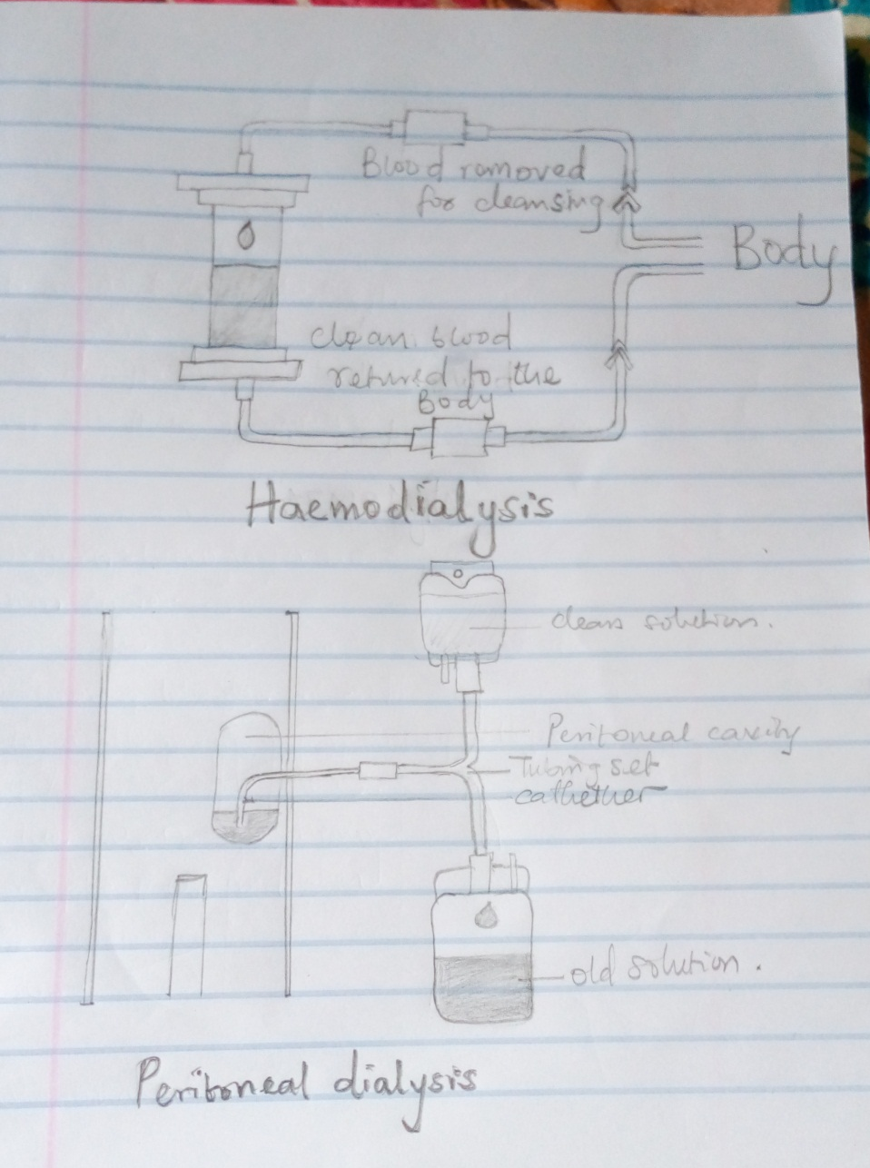
Both the AV fistula and AV graft are designed for long-term dialysis treatments. People who receive AV fistulas are healed and ready to begin hemodialysis two to three months after their surgery. People who receive AV grafts are ready in two to three weeks. Catheters are designed for short-term or temporary use. Hemodialysis treatments usually last three to five hours and are performed three times per week. However, hemodialysis treatment can also be completed in shorter, more frequent sessions.
- PERITONEAL DIALYSIS
Peritoneal dialysis involves surgery to implant a peritoneal dialysis (PD) catheter into the abdomen. The catheter helps filter the blood through the peritoneum, a membrane in the abdomen. During treatment, a special fluid called dialysate flows into the peritoneum, dialysate absorbs waste. Once the dialysate draws waste out of the bloodstream, it’s drained from the abdomen. This process takes a few hours and needs to be repeated four to six times per day. However, the exchange of fluids can be performed while the patient is asleep or awake.
There are numerous different types of peritoneal dialysis. The main ones are:
- Continuous ambulatory peritoneal dialysis (CAPD): In CAPD, the abdomen is filled and drained multiple times each day. This method does not require a machine and must be performed while the patient is awake.
- Continuous cycling peritoneal dialysis (CCPD): CCPD uses a machine to cycle the fluid in and out of the abdomen and it is usually done at night while the patient is asleep.
- Intermittent peritoneal dialysis (IPD): This treatment is usually performed in the hospital, though it may be performed at home. It uses the same machine as CCPD, but the process takes longer.
All types of dialysis has risks, hemodialysis risks include:
Low blood pressure, anemia, muscle cramping, difficulty sleeping, itching, high blood potassium levels, pericarditis, sepsis, bacteremia, irregular heartbeat and sudden cardiac death which is the leading cause of death in people undergoing dialysis.
Risks associated with peritoneal dialysis
Peritoneal dialysis is associated with an increased risk for infections in or around the catheter site in the abdominal cavity. For example, after catheter implantation, a patient can experience peritonitis. Other risks include: abdominal muscle weakening, high blood sugar due to the dextrose in the dialysate, weight gain, hernia, fever and stomach pain.
Patients who undergo long-term dialysis treatments are also at risk of developing other medical conditions, including amyloidosis. This disease can occur when amyloid proteins produced in bone marrow build up in organs such as the kidneys, liver, and heart. This usually causes joint pain, stiffness, and swelling. Some people may also develop depression after receiving a diagnosis of long-term kidney failure.

