NAME: MOTAJO OLAKUNLE OLUWATOSIN
MATRIC NUMBER: 17/MHS01/190
DEPARTEMENT: MEDICINE AND SURGERY
COURSE: RENAL PHYSIOLOGY
COURSE CODE: PHS 303

QUESTION 1: DISCUSS THE PATHOPHYSIOLOGICAL PROCESS INVOLVED IN RENAL FAILURE.
Answer: Renal failure is a condition in which the kidneys stop working and are not able to remove waste and extra water from the blood or keep body chemicals in balance. Acute renal failure happens suddenly (for example, after an injury) and may be treated and cured. Chronic renal failure develops over many years, may be caused by conditions like high blood pressure or diabetes, and cannot be cured. Chronic renal failure may lead to total and long-lasting renal failure, called end-stage renal disease (ESRD).
ACUTE RENAL FAILURE
Acute renal failure is a syndrome characterised by rapid onset of renal dysfunction, chiefly oliguria or anuria, and sudden increase in metabolic waste-products (urea and creatinine) in the blood with consequent development of uraemia.
Etiopathogenesis ( Causes) of Acute renal failure
The causes of Acute renal failure may be classified as pre-renal, intra-renal and post-renal in nature.
- Pre-renal causes: Pre-renal diseases are those which cause sudden decrease in blood flow to the nephron. Renal ischemia ultimately results in functional disorders or depression of the Glomerular Filtration Rate (cardiac output and hypovolemia). Causes of pre-renal disease are hemorrhage, diarrhea or vomiting, burns, myocardial infarction,, valvular damge, anaphylactic shock, anesthesia, sepsis etc.

- Intra-renal causes: This includes diseases of renal tissue itself, which could be vascular disease of the arteries and arterioles within the kidney ( vasculitis, cholesterol emboli, malignant hypertension), diseases of glomeruli, acute tubular necrosis due to ischemia, or the effect of a nephrotoxin, acute tubulointerstitial nephritis and pyelonephritis.
- Post-renal causes: this is caused by obstruction to the flow of urine anywhere along the renal tract distal to the opening of the collecting ducts, ureter, bladder neck or urethra. The most common causes of obstruction of the urinary tract outside the kidney are kidney stones, caused by precipitation of calcium, urate , or cystine.
It is important to note that Acute renal failure originating from pre and post-renal disease, such as by renal ischemia or renal infection, eventually leads to intra-renal disease.
Physiological effects Of Acute renal failure (symptoms)
A major physiological effect of acute renal failure is the retention of water, waste products of metabolism, and electrolytes in the blood and extracellular fluid. This can lead to water and salt overload, which, in turn, can lead to edema and hypertension. Excessive retention of potassium, however, is often a more serious threat to patients with acute renal failure because increase in plasma potassium concentration (hyperkalemia) above 8mEq/L can be fatal. Because the kidneys are also unable to excrete sufficient hydrogen ions, patients with acute renal failure may experience metabolic acidosis, which in itself can be lethal or can aggravate the hyperkalemia. In the most severe cases of acute renal failure, complete anuria occurs. The patient will die in 8 to 14 days unless kidney function is restored or unless an artificial kidney is used to rid the body of the excessive retained water, electrolytes, and waste products of metabolism.
CHRONIC RENAL FAILURE
Chronic renal failure is the progressive, long standing, and irreversible impairment of renal functions. When some of the nephrons loose their function, the unaffected nephrons can compensate for it. However, when more and more nephrons start losing function over the months or years, the compensatory mechanism fails and chronic renal failure develops.
Causes of Chronic Renal Failure
All chronic nephropathies can lead to chronic renal failure. The diseases causing chronic renal failure can be classified into 2 major groups.
1) Diseases causing Glomerular pathology: A number of glomerular disease leading to chronic renal failure have their pathogenesis in immune mechanisms. Glomerular destructions results in changes in filtration process and leads to development of the nephrotic syndrome characterised by proteinuria, hypoalbuminaemia and edema. The important examples of chronic glomerular diseases causing chronic renal failure are covered under two headings: primary and systemic
- Primary glomerular pathology: The major cause of Chronic Renal Failure is chronic glomerulonephritis, initiated by glomerulo-nephritis, membrano proliferative glomerulonephritis, lipoid nephrosis (minimal change disease) and anti-glomerular basement membrane nephritis.

- Systemic glomerular pathology: Certain conditions originate outside the renal system but induce changes in the nephrons secondarily. Major examples of this type are systemic lupus erythematosus, serum sickness nephritis and diabetic nephropathy.
2) Diseases causing tubulointerstitial pathology: Damage to tubulointerstitial tissues results in alterations in reabsorption and secretion of important constituents, leading to excretion of large volumes of dilute urine. Tubulointerstitial diseases can be categorized according to 4 major causes:
- Vascular causes: Long-standing primary or essential hypertension produces characteristic changes in renal arteries and arterioles referred to as nephrosclerosis.
- Infectious causes: A good example of chronic renal infection causing chronic renal failure is chronic pyelonephritis. The chronicity of process results in progressive damage to increasing Number of nephrons leading to chronic renal failure.
- Toxic causes: The most common example is intake of high doses of analgesics such as phenacetin, aspirin and acetaminophen (chronic analgesic nephritis). Other substances that can cause chronic renal failure after prolonged exposure are lead, cadmium and uranium.
- Obstructive causes: Chronic obstruction in the urinary tract leads to progressive damage to the nephron due to fluid backpressure. The examples of this type of chronic injury are stones, blood clots, tumours, strictures and enlarged prostate.
Regardless of the initiating cause, chronic renal failure evolves progressively through 3 stages:
1) Decreased renal reserve: At this stage, damage to renal parenchyma is marginal and the kidneys remain functional. The GFR is about 50% of normal, BUN and creatinine values are normal and the patients are usually asymptomatic except at times of stress. 2) Renal insufficiency: At this stage, about 75% of functional renal parenchyma has been destroyed. The GFR is about 25% of normal, accompanied by elevation in BUN and serum creatinine. Polyuria and nocturia occurs. 3) Renal failure. At this stage, about 90% of functional renal tissue has been destroyed. The GFR is approximately 10% of normal. Tubular cells are essentially nonfunctional. As a result, the regulation of sodium and water is lost resulting in edema, metabolic acidosis, hypocalcaemia, and signs and symptoms of uraemia.
Physiological Effect (symptoms) of Chronic Renal Failure
1) Uremia: is the condition characterized by excess accumulation of end products of protein metabolism such as urea, nitrogen and creatinine in blood. There is also accumulation of some toxic substances like organic acids and phenols. Uremia occurs because of the failure of kidneys to excrete the metabolic end products and toxic substances. Common features of uremia includes i) Anorexia ( loss of appetite) ii) lethargy iii) Drowsiness iv) Nausea and Vomiting v) Pigmentation of skin vi) Muscular twitching, tetany and convulsion. vii) Confusion and mental deterioration viii) Coma
2) Acidosis: Each day the body normally produces about 50 to 80 millimoles more metabolic acid than metabolic alkali. Therefore, when the kidneys fail to function, acid accumulates in the body fluids. Acidosis leads to coma, which eventually leads to death.
3) Edema: Failure of the kidney to excrete sodium and electrolytes causes increase in extracellular fluid volume resulting in development of edema.
4) Blood loss: Gastrointestinal bleeding accompanied by platelets dysfunction leads to heavy blood loss.
5) Anemia: almost always develops in patients with severe chronic renal failure. The most important cause of this anemia is decreased renal secretion of erythropoietin, which stimulates the bone marrow to produce red blood cells. If the kidneys are seriously damaged, they are unable to form adequate quantities of erythropoietin, which leads to diminished red blood cell production and consequent anemia.
6) Hyperparathyroidism: secondary hyperparathyroidism is developed due to the deficiency of calcitriol (1,25-dihydroxycholecalciferol). It increases the removal of calcium from bones resulting in osteomalacia.
QUESTION 2: WITH THE AID OF SUITABLE DIAGRAMS DISCUSS THE TYPES OF DIALYSIS YOU KNOW
Answer:
Dialysis is the procedure to remove waste materials and toxic substances and to restore normal volume and composition of body fluid in severe renal failure. Dialysis performs the function of the kidney if they’ve failed. There are basically 3 types of dialysis which are:
1) Hemodialysis: Hemodialysis is the most common type of dialysis. This process uses an artificial kidney (hemodialyzer) to remove waste and extra fluid from the blood. The blood is removed from the body and filtered through the artificial kidney. The filtered blood is then returned to the body with the help of a dialysis machine. To get the blood to flow to the artificial kidney, the medical practitioner will perform surgery to create an entrance point (vascular access) into your blood vessels. The three types of entrance points are: i) Arteriovenous (AV) fistula: This type connects an artery and a vein. It’s the preferred option. ii) AV graft: This type is a looped tube. iii) Vascular access catheter: This may be inserted into the large vein in the neck.
Hemodialysis treatments usually last three to five hours and are performed three times per week. However, hemodialysis treatment can also be completed in shorter, more frequent sessions.

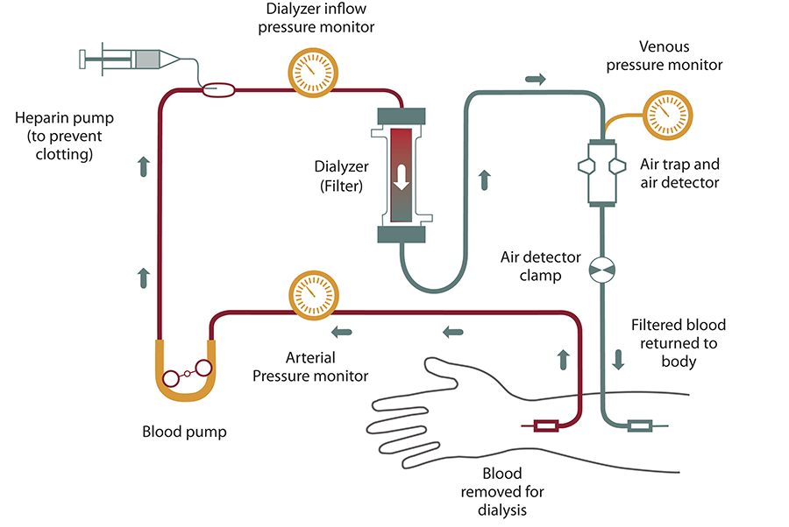
2) Peritoneal dialysis: is the technique in which peritoneal membrane is used as a semipermeable membrane. It is also used to treat the patients suffering from renal failure. A catheter is inserted into the peritoneal cavity through anterior abdominal wall and sutured. The dialysate is passed through this catheter under gravity. The required electrolyte from dialysate pass through vascular peritoneum into blood vessels of abdominal cavity. Urea, creatinine, phosphate, and other unwanted substances diffuse from blood vessels into dialysate. Later, dialysate is drained from peritoneal cavity by gravity. Peritoneal dialysis is a simple, convenient and less- expensive technique, compared to hemodialysis. Patients themselves can change the fluid on an outpatient basis. However, it has few drawbacks. It is less efficient in removing some of the toxic substances and it may lead to complications by infections.
.
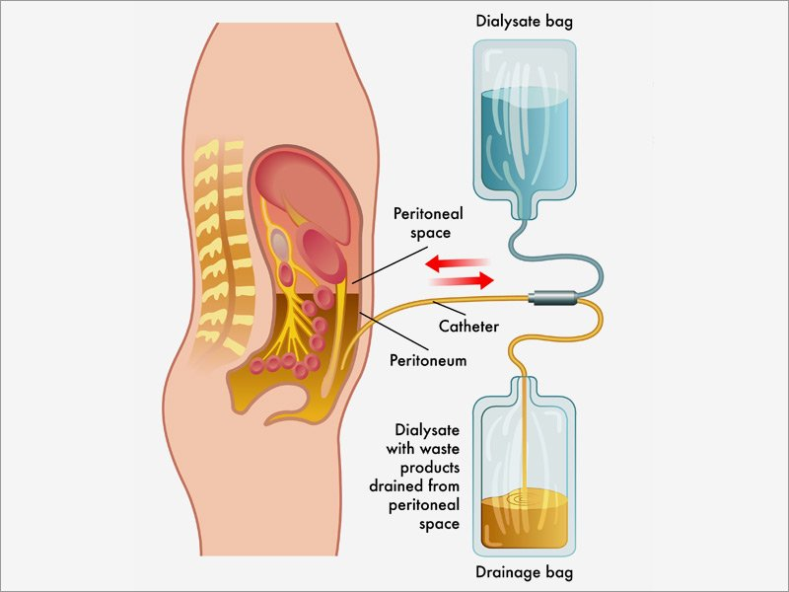
3) Continuous renal replacement therapy (CRRT): This therapy is used primarily in the intensive care unit for people with acute kidney failure. It’s also known as hemofiltration. A machine passes the blood through tubing. A filter then removes waste products and water. The blood is returned to the body, along with replacement fluid. This procedure is performed 12 to 24 hours a day, generally every day. Continuous Renal Replacement Therapy (CRRT) is a slow and continuous extracorporeal blood purification therapy. CRRT mimics the functions of the kidneys in regulating water, electrolytes, and toxic products by the continuous slow removal of solutes and fluid. The risks associated with CRRT include:
- infection
- hypothermia
- low blood pressure
- electrolyte disturbances
- bleeding
- delayed renal recovery
- weakening of bones
- anaphylaxis

