NAME: ABDULAZIZ HALIMAH BOLANLE
LEVEL: 300 LEVEL
DEPARTMENT: MBBS
MATRIC NO: 17/MHS01/003

PATHOPHYSIOLOGY OF RENAL FAILURE
Renal failure refers to failure of excretory functions of kidney. It is usually, characterized by decrease in glomerular filtration rate (GFR). So GFR is considered as the best index of renal failure.
However, decrease in GFR is not affected much during the initial stages of renal failure. If 50% of the nephrons are affected, GFR decreases only by 20% to 30%. It is because of the compensatory mechanism by the unaffected nephrons.
The renal failure may be either acute or chronic. Renal failure is always accompanied by other complications such as:
- Deficiency of calcitriol (activated vitamin D) resulting in reduction of calcium absorption from intestine and hypocalcemia . Deficiency of calcitriol and hypocalcemia may cause secondary hyperparathyroidism in some patients
- Deficiency of erythropoietin resulting in anemia
- Disturbances in acid­base balance.
The National Kidney Foundation (NKF) created a guideline to help doctors identify each level of kidney disease. The NKF divided kidney disease (CKD) into five stages. Identifying the stage of kidney disease a person is in helps health care practitioners provide the best care, since each stage requires different treatment.
To understand each stage, we must first understand how kidney function is measured. The universally accepted measure of kidney function is the Glomerular Filtration Rate (GFR). Kidney function is measured by how effectively your kidneys clean your blood. The main way of estimating GFR is a blood test to determine the level of Creatinine in the blood, or serum creatinine. As kidney function declines, the levels of creatinine increase.
The five stages of kidney disease, or CKD, and the GFR for each stage, is shown below:
- Stage 1 with normal or high GFR (GFR > 90 mL/min)
- Stage 2 Mild CKD (GFR = 60-89 mL/min)
- Stage 3A Moderate CKD (GFR = 45-59 mL/min)
- Stage 3B Moderate CKD (GFR = 30-44 mL/min
- Stage 4 Severe CKD (GFR = 15-29 mL/min)
- Stage 5 End Stage CKD (GFR <15 mL/min)
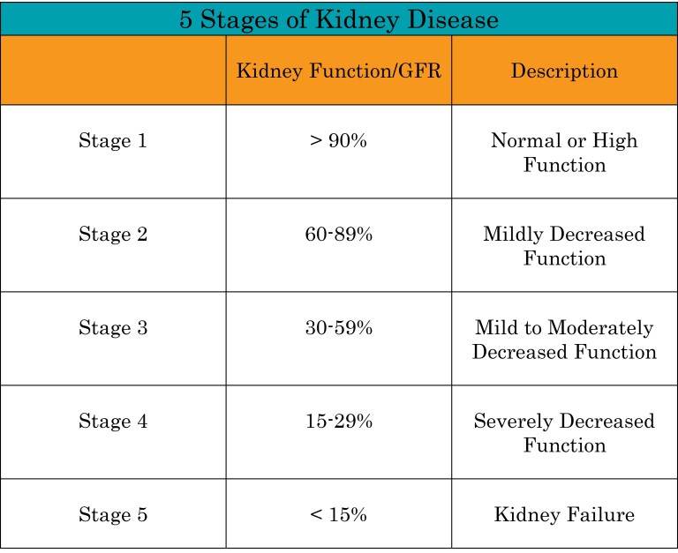
credit: nephcure.org
STAGE 1
A person with stage 1 chronic kidney disease (CKD) has kidney damage with a glomerular filtration rate (GFR) at a normal or high level greater than 90 ml/min. There are usually no symptoms to indicate the kidneys are damaged. Because kidneys do a good job even when they’re not functioning at 100 percent, most people will not know they have stage 1 CKD. If they do find out they’re in stage 1, it’s usually because they were being tested for another condition such as diabetes or high blood pressure (the two leading causes of kidney disease).

Symptoms of stage 1 kidney disease
Other ways a person may discover they are in stage 1 CKD include:
- Higher than normal levels of creatinine or urea in the blood
- Blood or protein in the urine
- Evidence of kidney damage in an MRI, CT scan, ultrasound or contrast X-ray
- A family history of polycystic kidney disease (PKD)
TREATMENT: A healthy diet rich in whole grains, fresh fruits and vegetable.

STAGE 2
A person with stage 2 chronic kidney disease (CKD) has kidney damage with a mild decrease in their glomerular filtration rate (GFR) of 60-89 ml/min. There are usually no symptoms to indicate the kidneys are damaged. Because kidneys do a good job even when they’re not functioning at 100 percent, most people will not know they have stage 2 CKD. If they do find out they’re in stage 2, it’s usually because they were being tested for another condition such as diabetes or high blood pressure–the two leading causes of kidney disease.

Signs of stage 2 kidney disease
Other ways a person may discover they are in stage 2 CKD include:
- Higher than normal levels of creatinine or urea in the blood
- Blood or protein in the urine
- Evidence of kidney damage in an MRI, CT scan, ultrasound or contrast X-ray
- A family history of polycystic kidney disease (PKD)

STAGE 3
A person with stage 3 chronic kidney disease (CKD) has moderate kidney damage. This stage is broken up into two: a decrease in glomerular filtration rate (GFR) for Stage 3A is 45-59 mL/min and a decrease in GFR for Stage 3B is 30-44 mL/min. As kidney function declines waste products can build up in the blood causing a condition known as “uremia.” In stage 3 a person is more likely to develop complications of kidney disease such as high blood pressure, anemia (a shortage of red blood cells) and/or early bone disease.

Symptoms of stage 3 CKD
Symptoms may start to become present in stage 3:
- Fatigue
- Fluid retention, swelling (edema) of extremities and shortness of breath:
- Urination changes (foamy; dark orange, brown, tea-colored or red if it contains blood; and urinating more or less than normal)
- Kidney pain felt in their back
- Sleep problems due to muscle cramps or restless legs

Seeing a doctor when you have stage 3 CKD
As stage 3 progresses, a patient should see a nephrologist (a doctor who specializes in treating kidney disease). Nephrologists examine patients and perform lab tests so they can gather information about their condition to offer the best advice for treatment. The nephrologist’s goal is to help their patient keep their kidneys working as long as possible.

Meeting a dietitian when you have stage 3 CKD
Someone in stage 3 may also be referred to a dietitian. Because diet is such an important part of treatment, the dietitian will review a person’s lab work results and recommend a meal plan individualized for their needs. Eating a proper diet can help preserve kidney function and overall health.

STAGE 4
A person with stage 4 chronic kidney disease (CKD) has advanced kidney damage with a severe decrease in the glomerular filtration rate (GFR) to 15-30 ml/min. It is likely someone with stage 4 CKD will need dialysis or a kidney transplant in the near future.
As kidney function declines, waste products build up in the blood causing a condition known as uremia. In stage 4, a person is likely to develop complications of kidney disease such as high blood pressure, anemia (a shortage of red blood cells), bone disease, heart disease and other cardiovascular diseases.

Symptoms of stage 4 kidney disease
Symptoms that are experienced in stage 4 include:
- Fatigue
- Fluid retention, swelling (edema) of extremities and shortness of breath
- Urination changes (foamy; dark orange, brown, tea-colored or red if it contains blood; and urinating more or less than normal)
- Kidney pain felt in their back
- Sleep problems due to muscle cramps or restless legs
- Nausea and/or vomiting
- Taste changesa metallic taste in the mouth
- Bad breath due to urea buildup in the blood
- Loss of appetite: People may not feel like eating, and some people report having a metallic taste in their mouth or bad breath.
- Difficulty in concentrating: Having trouble doing everyday things such as balancing a checkbook or focusing on reading the newspaper can occur.
- Nerve problems: Numbness or tingling in the toes or fingers is a symptom of CKD.

Seeing a doctor when you have stage 4 CKD
At stage 4, it’s necessary to see a nephrologist (a doctor who specializes in treating kidney disease). The nephrologist examines the patient and orders lab tests to gather information to recommend treatment.
People in stage 4 CKD will usually visit their doctor at least every three months. Blood tests for creatinine, hemoglobin, calcium and phosphorus levels will be done to see how well the kidneys are working. The doctor will also monitor other conditions such as high blood pressure and diabetes. In addition to helping the patient keep their kidneys working as long as possible, the nephrologist will also help prepare the patient for dialysis or a kidney transplant.

STAGE 5
A person with stage 5 chronic kidney disease has end stage renal disease (ESRD) with a glomerular filtration rate (GFR) of 15 ml/min or less. At this advanced stage of kidney disease, the kidneys have lost nearly all their ability to do their job effectively, and eventually dialysis or a kidney transplant is needed to live.

Symptoms of stage 5 CKD
Symptoms that can occur in stage 5 CKD include:
- Loss of appetite
- Nausea or vomiting
- Headaches
- Being tired
- Being unable to concentrate
- Itching
- Making little or no urine
- Swelling, especially around the eyes and ankles
- Muscle cramps
- Tingling in hands or feet
- Changes in skin color
- Increased skin pigmentation
Because the kidneys are no longer able to remove waste and fluids from the body, toxins build up in the blood, causing an overall ill feeling. Kidneys also have other functions they are no longer able to perform such as regulating blood pressure, producing the hormone that helps make red blood cells and activating vitamin D for healthy bones.
If you are diagnosed with stage 5 CKD, you will need to see a nephrologist immediately. This is a doctor who is trained in kidney disease, kidney dialysis and transplant. The doctor will help you decide which treatment is best for you—hemodialysis, peritoneal dialysis (PD) or kidney transplant—and will recommend an access for dialysis. Your nephrologist will develop your overall care plan and manage your healthcare team.
Recommended treatment: Dialysis and possibly kidney transplant

QUESTION 2
Types of dialysis
Dialysis is a way of cleaning your blood when your kidneys can no longer do the job. It gets rid of your body's wastes, extra salt and water, and helps to control your blood pressure.
There are two kinds of dialysis:
- Hemodialysis
- Peritoneal dialysis
HEMODIALYSIS
In hemodialysis, blood is pumped out of your body to an artificial kidney machine, and returned to your body by tubes that connect you to the machine.
This treatment that can be done in a center or in a patient’s home with assistance from a care partner.
A dialysis machine removes a small amount of a patient’s blood through a man-made membrane called a dialyzer, or artificial kidney, to clean out toxins that the kidneys can no longer remove. The filtered blood is then returned to the body.

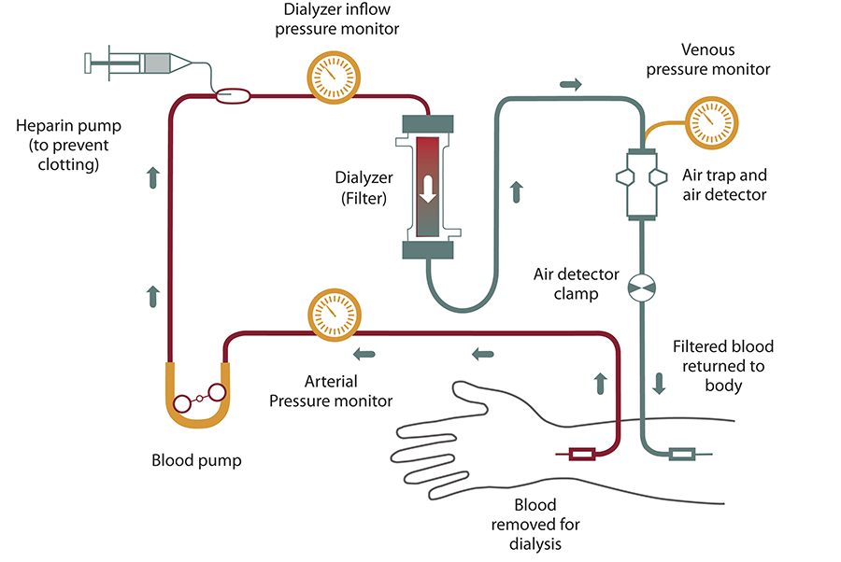
HEMODIALYSIS, CREDIT: NATIONAL INSTITUTE FOR DIABETES AND DIGESTIVE AND KIDNEY DISEASES.

PERITONEAL DIALYSIS
In peritoneal dialysis, the inside lining of your own belly acts as a natural filter. Wastes are taken out by means of a cleansing fluid called dialysate, which is washed in and out of your belly in cycles.
Unlike hemodialysis, PD is a needle-free treatment and a care partner is not required to to help assist during treatment. PD can be performed at home or at work.
A soft plastic tube (catheter) is placed in your belly by surgery. A sterile cleansing fluid is put into your belly through this catheter. After the filtering process is finished, the fluid leaves your body through the catheter.
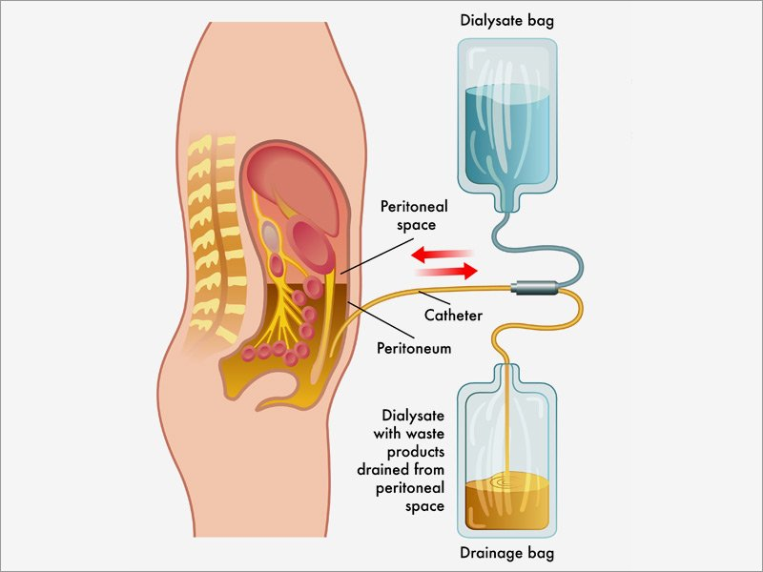
CREDIT: medscape
diagrammatic representation of peritoneal dialysis

There are two kinds of peritoneal dialysis:
- Continuous Ambulatory Peritoneal Dialysis (CAPD)
- Automated Peritoneal Dialysis (APD)
The basic treatment is the same for each. However, the number of treatments and the way the treatments are done make each method different.
CAPD is "continuous," machine-free and done while you go about your normal activities such as work or school. You do the treatment by placing about two quarts of cleansing fluid into your belly and later draining it. This is done by hooking up a plastic bag of cleansing fluid to the tube in your belly. Raising the plastic bag to shoulder level causes gravity to pull the fluid into your belly. When empty, the plastic bag is removed and thrown away.
When an exchange (putting in and taking out the fluid) is finished, the fluid (which now has wastes removed from your blood) is drained from your belly and thrown away. This process usually is done three, four or five times in a 24-hour period while you are awake during normal activities. Each exchange takes about 30 to 40 minutes. Some patients like to do their exchanges at mealtimes and at bedtime.
APD differs from CAPD in that a machine (cycler) delivers and then drains the cleansing fluid for you. The treatment usually is done at night while you sleep.
The type of peritoneal dialysis that is best for you depends on your personal choice and your medical condition. Your doctor will help you to choose the one that is best for you.

