Rotimi-Dairo Oluwatimilehin
17/MHS01/288

Pathophysiology of the chronic renal failure
Introduction
Chronic renal failure is defined as an irreversible decrease of not only glomerular and tubular function but also endocrine renal function. It presents as pathologically disturbed excretory and incretionary renal function. This damage has to have been exhibited for longer than 3 months.

The Pathophysiological Processes of Chronic Kidney Disease
Chronic renal failure is caused by a progressive decline of all kidney functions, ending end with terminal kidney damage. During this time, there is modulation and adaptation in the still-functional glomeruli, which keeps the kidneys functioning normally for as long as possible. The remaining glomeruli, therefore, experience a rise in pressure through hyperfiltration.
The release of various cytokines and growth factors leads to hypertrophy and hyperplasia. At the same time, the function of the glomeruli suffers due to the excessive demands on them, leading to increased permeability and proteinuria. Increased protein concentrations in the proximal tube system are direct nephrotoxins and can further impair kidney function.
There are four phases of chronic renal failure:
1. Reduction in Excretory Function
Breakdown of excretory function is the consequence of an accumulation of endogenous and extraneous substances. This leads to changes in pharmacokinetics and an increase in the concentration of various medications. Breakdown occurs when the remaining glomeruli are confronted by a surplus of waste products, leading to osmotic diuresis. There is a reduction in the maximal concentrating capacity of the kidney. In order to filter the physiological quantity of dissolved substances, the nephrons produce between 3 and 4 times as much urine during renal failure, resulting in an accumulation of waste substances.
2. Reduction in Incretory Renal Function
Because the kidney plays a part in the regulation of many important hormonal cycles, chronic renal failure also has endocrinal consequences. Through a shortage of erythropoietin, there is a reduction in erythrocyte synthesis, which leads to renal anemia; uremia then leads to a reduction of functional erythrocytes due to hemolysis or hemorrhages.
Vitamin D production is also impaired, and phosphate excretion is reduced. Secondary hyperparathyroidism and the associated renal osteopathy (‘high-turnover’ osteopathy) develop as a result of hyperphosphatemia. Parallel to this, other pathomechanisms lead to a disruption in bone metabolism: osteomalacia occurs due to a disruption of mineralization, and adynamic bone disease occurs due to a reduction in bone cell activity (particularly in dialysis patients).
3. Over-hydration and the Disruption of Electrolyte Balance
As long as the glomeruli can manage to compensate, diuresis and fractional sodium excretion rise. If the glomerular filtration rate noticeably drops, then the ability to compensate is exhausted, leading to increased retention of water and electrolytes.
Hypertension, pulmonary edema, and peripheral edema result from overhydration. Water and salt excretion are thereby inextricably linked. Diuretics can aid in water and salt excretion where critical glomerular damage is present. Early loss of salts as a result of the disturbance in the resorption process can actually be made worse by the use of diuretics.
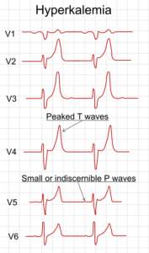
Picture: “Electrocardiography showing precordial leads in hyperkalemia” by Mikael Häggström. License: Public Domain
Thus, as the glomeruli adapt to compensate, the tubular transport mechanisms also adapt in order to prevent hyperkalemia through increased potassium secretion. Hyperkalemia only develops as a result of hyperstimulation of the resorption capacity. As many patients are treated with calcium-sparing diuretics due to previous conditions, it is vital to refer to patient’s medication history and adapt the treatment plan accordingly.
Acidosis also rises alongside hyperkalemia. The kidneys can no longer sufficiently eliminate accumulating protons due to a strongly reduced glomerular filtration rate. This metabolic acidosis leads to increased bone calcium release and strengthening renal osteopathy, an increase in gastrointestinal problems, and the impairment of protein metabolism.
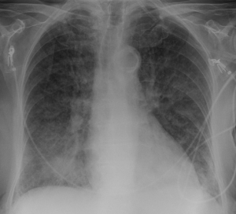
Picture: “Pulmonary Edema” by Hellerhoff.
4. Toxic Organ Damage as a Result of Retention of Urinary Excreted Metabolites
Toxic organ damage can be explained under the umbrella term ‘uremic syndrome.’ The rise in urinary excreted metabolites in the blood is called azotemia. These metabolites include urea, creatinine, beta-2 microglobulin, parathyroid hormone, among others. Uremic syndrome (uremia) principally describes a systemic disruption of all organ functions, especially the circulatory system, central nervous system, blood, and membranes.
Picture: “Café au lait spot” by Denise Nepraunig. License: Public Domain
Clinically, many symptoms of chronic renal failure can be detected via the skin. Patients often have macules (‘café au lait’ spots), are conspicuously pale, and have a gray, dirty-looking complexion. They often complain of pruritus. Internal membranes are also affected, leading to pericarditis, peritonitis, and pleurisy.
Uremia can also lead to hemolysis with anemia. Simultaneously, thrombocyte and leukocyte dysfunctions or deficiencies can arise.
People with chronic renal failure have a generally increased risk of atherosclerosis with an elevated cardiovascular risk. This leads to media calcification caused by calcium phosphate and to intima calcification through inflammatory factors and cholesterol plaques. Hypertension is common, along with edemas and pulmonary congestion.
Impairments of the central nervous system are indicated by a reduction in vigilance, from general drowsiness to uremic coma. Seizures can occur. Uremia also causes polyneuropathy with paresthesia.

2. Types of Dialysis with Diagrams
What is Dialysis
Dialysis is a treatment that filters and purifies the blood using a machine. This helps keep your fluids and electrolytes in balance when the kidneys can’t do their job.
Hemodialysis
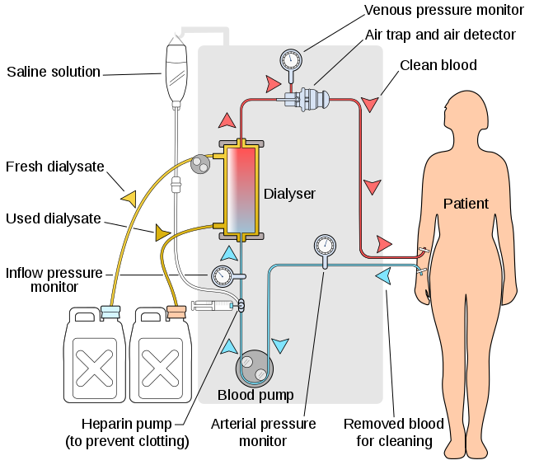
In hemodialysis, the patient's blood is pumped through the blood compartment of a dialyzer, exposing it to a partially permeable membrane. The dialyzer is composed of thousands of tiny hollow synthetic fibers. The fiber wall acts as the semipermeable membrane. Blood flows through the fibers, dialysis solution flows around the outside of the fibers, and water and wastes move between these two solutions. The cleansed blood is then returned via the circuit back to the body. Ultrafiltration occurs by increasing the hydrostatic pressure across the dialyzer membrane This usually is done by applying a negative pressure to the dialysate compartment of the dialyzer. This pressure gradient causes water and dissolved solutes to move from blood to dialysate and allows the removal of several litres of excess fluid during a typical 4-hour treatment.

Peritoneal dialysis
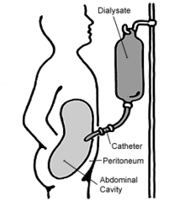
Schematic diagram of peritoneal dialysis
In peritoneal dialysis, a sterile solution containing glucose (called dialysate) is run through a tube into the peritoneal cavity, the abdominal body cavity around the intestine, where the peritoneal membrane acts as a partially permeable membrane.
This exchange is repeated 4–5 times per day; automatic systems can run more frequent exchange cycles overnight. Peritoneal dialysis is less efficient than hemodialysis, but because it is carried out for a longer period of time the net effect in terms of removal of waste products and of salt and water are similar to hemodialysis. Peritoneal dialysis is carried out at home by the patient, often without help. This frees patients from the routine of having to go to a dialysis clinic on a fixed schedule multiple times per week. Peritoneal dialysis can be performed with little to no specialized equipment (other than bags of fresh dialysate).

Hemofiltration
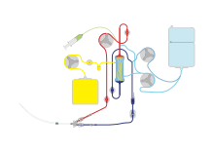
Continuous veno-venous haemofiltration with pre- and post-dilution (CVVH)
Hemofiltration is a similar treatment to hemodialysis, but it makes use of a different principle. The blood is pumped through a dialyzer or "hemofilter" as in dialysis, but no dialysate is used. A pressure gradient is applied; as a result, water moves across the very permeable membrane rapidly, "dragging" along with it many dissolved substances, including ones with large molecular weights, which are not cleared as well by hemodialysis. Salts and water lost from the blood during this process are replaced with a "substitution fluid" that is infused into the extracorporeal circuit during the treatment.
Hemodiafiltration
Hemodiafiltration is a combination of hemodialysis and hemofiltration, thus used to purify the blood from toxins when the kidney is not working normally and also used to treat acute kidney injury (AKI).
Intestinal dialysis
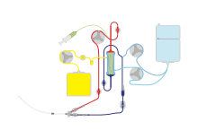
Continuous veno-venous haemodiafiltration (CVVHDF)
In intestinal dialysis, the diet is supplemented with soluble fibres such as acacia fibre, which is digested by bacteria in the colon. This bacterial growth increases the amount of nitrogen that is eliminated in fecal waste. An alternative approach utilizes the ingestion of 1 to 1.5 liters of non-absorbable solutions of polyethylene glycol or mannitol every fourth hour

