17/MHS01/204
- Discuss the pathophysiological process involved of renal physiology
The kidneys play key roles in body function, not only by filtering the blood and getting rid of waste products, but also by balancing the electrolyte levels in the body, controlling blood pressure, and stimulating the production of red blood cells. For example, renal disease is a prominent presentation of long-standing diabetes mellitus and hypertension and of autoimmune disorders such as systemic lupus erythematosus.
Urine that is made by each kidney flows through the ureter, a tube that connects the kidney to the bladder. Urine is stored within the bladder, and when urination occurs, the bladder empties urine through a tube called the urethra.
Renal function is clinically monitored by measurement of
- serum creatinine
- blood urea nitrogen (BUN)
- Urinalysis.
Once serum creatinine in an adult reaches about 3 mg/dL
- renal disease are irreversible
- progress to end-stage renal disease (ESRD)
In patients with an elevated serum creatinine level (1.5 to 3.0 mg/dL), the term chronic renal insufficiency is useful and implies that progression to CRF and ESRD is not inevitable.
Kidney failure, also known as end-stage kidney disease, is a medical condition in which the kidneys are functioning at less than 15% of normal. Kidney failure is classified as either acute kidney failure, which develops rapidly and may resolve and chronic kidney failure, which develops slowly. Symptoms may include leg swelling, feeling tired, vomiting, loss of appetite, and confusion. Complications of acute and chronic failure include uremia, high blood potassium, and volume overload. Complications of chronic failure also include heart disease, high blood pressure, and anemia.
Pathophysiology of chronic renal failure
- Regardless of the primary cause of nephron loss, some usually survive or are less severely damaged
- These nephrons then adapt and enlarge, and clearance per nephron markedly increases.
- If the initiating process is diffuse, sudden, and severe, such as in some patients with rapidly progressive glomerulonephritis (crescentic glomerulonephritis), acute or sub acute renal failure may ensue with the rapid development of ESRD.
- In most patients, however, disease progression is more gradual and nephron adaptation is possible.
- Focal glomerulosclerosis develops in these glomeruli, and they eventually become non-functional.
- At the same time that focal glomerulosclerosis develops, proteinuria markedly increases and systemic hypertension worsens.
- This process of nephron adaptation has been termed the "final common path."
- Adapted nephrons enhance the ability of the kidney to postpone uremia, but ultimately the adaptation process leads to the demise of these nephrons.
- Adapted nephrons have not only an enhanced GFR but also enhanced tubular functions in terms of, for example, potassium and proton secretion.
Pathophysiology and Clinical manifestations of Uremic syndrome
Patients are often not seen until late in the course of the disease, when much of their kidney function has already been lost Kidney adapts so well to progressive loss of nephrons and can maintain constancy of the internal environment until about 75% of renal function has been lost. Patients with uremic manifestations can have a myriad of different complaints referable to almost any organ system.
- All CRF patients with the exception of those with medullary cystic kidney disease have fixed proteinuria (>200 mg/24 hours).
- The syndrome may also come to attention because of an elevated BUN or serum creatinine concentration in laboratory testing done for a variety of reasons.
- Progressive metabolic acidosis
  - The major cause of the failure to excrete enough acid is diminished renal ammonia production and excretion.
  - Although the metabolic acidosis of CRF is commonly referred to as an anion gap acidosis, this gap does not develop until the serum creatinine concentration approaches 5 to 6 mg/dL.
  - Before this stage, serum chloride initially rises as the serum bicarbonate level falls.
  - High serum parathormone levels and extracellular fluid volume lead to proximal tubular acidosis but do not seem to fully account for the early hyperchloremic metabolic acidosis of CRF.
  - Patients who have hyperkalemic distal (type 4) renal tubular acidosis (e.g., in hyporeninemic hypoaldosteronism, common in diabetics) because of tubulointerstitial disease have a much more severe non-anion gap metabolic acidosis relative to the stage of progression of CRF.
- With the aids of diagrams. Discuss the types of dialysis you know.
The basic principle of the artificial kidney is to pass blood through the minute blood channels bounded by a thin membrane.

Types of Dialysis
There are two types of dialysis we may use:
- Peritoneal and
- Hemodialysis

PERITONEAL DIALYSIS
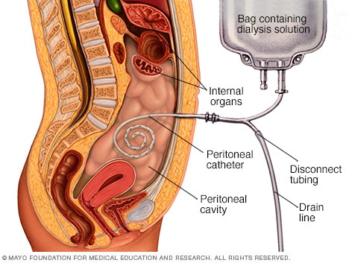
Peritoneal dialysis is a way to remove waste products from your blood when your kidneys can't adequately do the job any longer. This procedure filters the blood in a different way than does the more common blood-filtering procedure called hemodialysis.
During peritoneal dialysis, a cleansing fluid flows through a tube (catheter) into part of your abdomen. The lining of your abdomen (peritoneum) acts as a filter and removes waste products from your blood. After a set period of time, the fluid with the filtered waste products flows out of your abdomen and is discarded.
These treatments can be done at home, at work or while traveling. But peritoneal dialysis isn't an option for everyone with kidney failure. You need manual dexterity and the ability to care for yourself at home, or you need a reliable caregiver.
Benefits of peritoneal dialysis
- Greater lifestyle flexibility and independence. These can be especially important if you work, travel or live far from a hemodialysis center.
- A less restricted diet. Peritoneal dialysis is done more continuously than hemodialysis, resulting in less accumulation of potassium, sodium and fluid. This allows you to have a more flexible diet than you could have on hemodialysis.
- Longer lasting residual kidney function. People who use peritoneal dialysis might retain kidney function slightly longer than people who use hemodialysis.

Risks

Complications of peritoneal dialysis can include:
- Infections. An infection of the abdominal lining (peritonitis) is a common complication of peritoneal dialysis. An infection can also develop at the site where the catheter is inserted to carry the cleansing fluid (dialysate) into and out of your abdomen. The risk of infection is greater if the person doing the dialysis isn't adequately trained.
- Weight gain. The dialysate contains sugar (dextrose). Absorbing some of the dialysate might cause you to take in hundreds of extra calories daily, leading to weight gain. The extra calories can also cause high blood sugar, especially if you have diabetes.
- Hernia. Holding fluid in your abdomen for long periods may strain your muscles.
- Inadequate dialysis. Peritoneal dialysis can become ineffective after several years. You might need to switch to hemodialysis.

HEMODIALYSIS
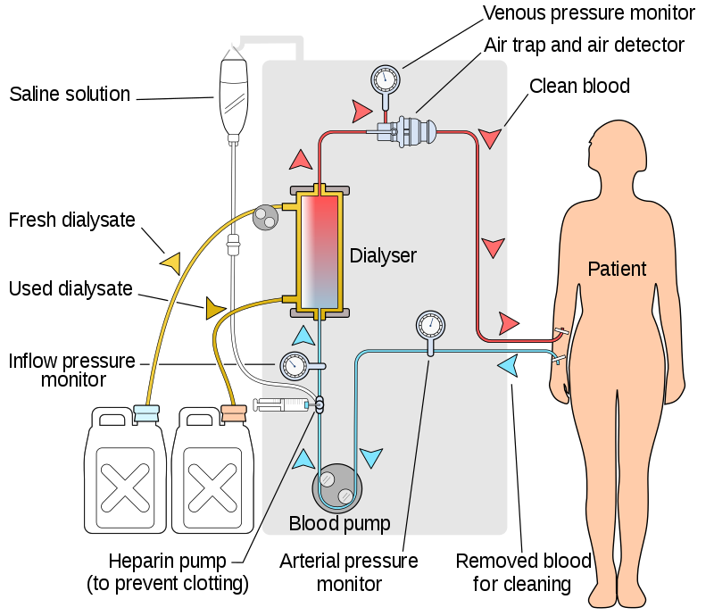
In hemodialysis, a machine filters wastes, salts and fluid from your blood when your kidneys are no longer healthy enough to do this work adequately. Hemodialysis is one way to treat advanced kidney failure and can help you carry on an active life despite failing kidneys.
Preparation for hemodialysis starts several weeks to months before your first procedure. To allow for easy access to your bloodstream, a surgeon will create a vascular access. The access provides a mechanism for a small amount of blood to be safely removed from your circulation and then returned to you in order for the hemodialysis process to work. The surgical access needs time to heal before you begin hemodialysis treatments.
There are three types of accesses:
- Arteriovenous (AV) fistula. A surgically created AV fistula is a connection between an artery and a vein, usually in the arm you use less often. This is the preferred type of access because of effectiveness and safety.
- AV graft. If your blood vessels are too small to form an AV fistula, the surgeon may instead create a path between an artery and a vein using a flexible, synthetic tube called a graft.
- Central venous catheter. If you need emergency hemodialysis, a plastic tube (catheter) may be inserted into a large vein in your neck or near your groin. The catheter is temporary.

Types
There are three types of hemodialysis: conventional hemodialysis, daily hemodialysis, and nocturnal hemodialysis.

Conventional hemodialysis
Conventional hemodialysis is usually done three times per week, for about three to four hours for each treatment (Sometimes five hours for larger patients), during which the patient's blood is drawn out through a tube at a rate of 200–400 mL/min. The tube is connected to a 15, 16, or 17 gauge needle inserted in the dialysis fistula or graft, or connected to one port of a dialysis catheter. The blood is then pumped through the dialyzer, and then the processed blood is pumped back into the patient's bloodstream through another tube (connected to a second needle or port). During the procedure, the patient's blood pressure is closely monitored, and if it becomes low, or the patient develops any other signs of low blood volume such as nausea, the dialysis attendant can administer extra fluid through the machine. During the treatment, the patient's entire blood volume (about 5000 cc) circulates through the machine every 15 minutes. During this process, the dialysis patient is exposed to a week's worth of water for the average person.

Daily hemodialysis
Daily hemodialysis is typically used by those patients who do their own dialysis at home. It is less stressful (more gentle) but does require more frequent access. This is simple with catheters, but more problematic with fistulas or grafts. The "buttonhole technique" can be used for fistulas requiring frequent access. Daily hemodialysis is usually done for 2 hours six days a week.

Nocturnal hemodialysis
The procedure of nocturnal hemodialysis is similar to conventional hemodialysis except it is performed three to six nights a week and between six and ten hours per session while the patient sleeps.

The procedure

During treatments, you sit or recline in a chair while your blood flows through the dialyzer ― a filter that acts as an artificial kidney to clean your blood. You can use the time to watch TV or a movie, read, nap, or perhaps talk to your "neighbors" at the center. If you receive hemodialysis at night, you can sleep during the procedure.
- Preparation. Your weight, blood pressure, pulse and temperature are checked. The skin covering your access site — the point where blood leaves and then re-enters your body during treatment — is cleansed.
- Starting. During hemodialysis, two needles are inserted into your arm through the access site and taped in place to remain secure. Each needle is attached to a flexible plastic tube that connects to a dialyzer. Through one tube, the dialyzer filters your blood a few ounces at a time, allowing wastes and extra fluids to pass from your blood into a cleansing fluid called dialysate. The filtered blood returns to your body through the second tube.
- Symptoms. You may experience nausea and abdominal cramps as excess fluid is pulled from your body — especially if you have hemodialysis only three times a week rather than more often. If you're uncomfortable during the procedure, ask your care team about minimizing side effects by such measures as adjusting the speed of your hemodialysis, your medication or your hemodialysis fluids.
- Monitoring. Because blood pressure and heart rate can fluctuate as excess fluid is drawn from your body, your blood pressure and heart rate will be checked several times during each treatment.
- Finishing. When hemodialysis is completed, the needles are removed from your access site and a pressure dressing is applied to prevent bleeding. Your weight may be recorded again. Then you're free to go about your usual activities until your next session.

Risks
Most people who require hemodialysis have a variety of health problems. Hemodialysis prolongs life for many people, but life expectancy for people who need it is still less than that of the general population.
While hemodialysis treatment can be efficient at replacing some of the kidney's lost functions, you may experience some of the related conditions listed below, although not everyone experiences all of these issues. Your dialysis team can help you deal with them.
- Low blood pressure (hypotension). A drop in blood pressure is a common side effect of hemodialysis, particularly if you have diabetes. Low blood pressure may be accompanied by shortness of breath, abdominal cramps, muscle cramps, nausea or vomiting.
- Muscle cramps. Although the cause is not clear, muscle cramps during hemodialysis are common. Sometimes the cramps can be eased by adjusting the hemodialysis prescription. Adjusting fluid and sodium intake between hemodialysis treatments also may help prevent symptoms during treatments.
- Itching. Many people who undergo hemodialysis have itchy skin, which is often worse during or just after the procedure.
- Sleep problems. People receiving hemodialysis often have trouble sleeping, sometimes because of breaks in breathing during sleep (sleep apnea) or because of aching, uncomfortable or restless legs.
- Anemia. Not having enough red blood cells in your blood (anemia) is a common complication of kidney failure and hemodialysis. Failing kidneys reduce production of a hormone called erythropoietin (uh-rith-roe-POI-uh-tin), which stimulates formation of red blood cells. Diet restrictions, poor absorption of iron, frequent blood tests, or removal of iron and vitamins by hemodialysis also can contribute to anemia.
- Bone diseases. If your damaged kidneys are no longer able to process vitamin D, which helps you absorb calcium, your bones may weaken. In addition, overproduction of parathyroid hormone — a common complication of kidney failure — can release calcium from your bones.
- High blood pressure (hypertension). If you consume too much salt or drink too much fluid, your high blood pressure is likely to get worse and lead to heart problems or strokes.
- Fluid overload. Since fluid is removed from your body during hemodialysis, drinking more fluids than recommended between hemodialysis treatments may cause life-threatening complications, such as heart failure or fluid accumulation in your lungs (pulmonary edema).
- Inflammation of the membrane surrounding the heart (pericarditis). Insufficient hemodialysis can lead to inflammation of the membrane surrounding your heart, which can interfere with your heart's ability to pump blood to the rest of your body.
- High potassium levels (hyperkalemia). Potassium is a mineral that is normally removed from your body by your kidneys. If you consume more potassium than recommended, your potassium level may become too high. In severe cases, too much potassium can cause your heart to stop.
- Access site complications. Potentially dangerous complications ― such as infection, narrowing or ballooning of the blood vessel wall (aneurysm), or blockage ― can impact the quality of your hemodialysis. Follow your dialysis team's instructions on how to check for changes in your access site that may indicate a problem.
- Amyloidosis. Dialysis-related Amyloidosis develops when proteins in blood are deposited on joints and tendons, causing pain, stiffness and fluid in the joints. The condition is more common in people who have undergone hemodialysis for more than five years.
- Depression. Changes in mood are common in people with kidney failure. If you experience depression or anxiety after starting hemodialysis, talk with your health care team about effective treatment options.

