NAME: IKPEAZU PRINCESS
MATRIC NUMBER: 17/MHS01/156
QUESTION
- Discuss the pathophysiological process involve in renal failure.
- With the aid of suitable diagrams discuss the type of dialysis you know.
ANSWERS
NUMBER 1
Several kidney diseases can be broadly divided into 2 main groups
- ACUTE RENAL FAILURE : This is when the kidneys abruptly stop working or partially stop working for a few days or weeks but may recover after a while to its normal renal functions
- CHRONIC RENAL FAILURE: This is the progressive failure of more and more nephrons which may entirely decrease kidney functions. Serious medical conditions do not occur till the number of functional nephrons fall below 70-75 percent below normal.
Within these two broad categories lie a great number of diseases affecting kidney related organs, tissues, tissues or cells and part of the urinary tracts outside the kidneys like the ureter and bladder.

- Acute renal failures can be grouped into 3 main categories.
- PRERENAL ACUTE RENAL FAILURE: This is as a result of inadequate blood supply to the kidneys. It occurs from malfunctions outside the kidneys. For example prerenal acute renal failure can be as a consequence of heart failure which can cause reduced cardiac output and low blood pressure, in conditions such as hemorrhage, renal ischaemia etc.
- INTRARENAL ACUTE RENAL FAILURE: This is a result of abnormalities in the kidneys itself as well as its tubules, glomeruli and blood vessels. For example, acute nephritis, acute tubular necrosis etc.
- POSTRENAL ACUTE RENAL FAILURE: This is as a result of obstruction to the urinary collecting system anywhere from the calyces to the urinary bladder. For example, renal stone etc.
NB: Conditions that result from diminished blood flow to the kidneys causes OLIGURIA ie diminished urine output compared to the water and solutes intake. This causes accumulation of water and solutes in the body. If renal blood flow is markedly reduced with total cessation of urine output can lead to a condition called ANURIA.
- There are several causes of chronic renal failure which include; (from the mnemonic DAMAGE TO NEPHRONS
- Diabetic nephropathy
- Analgesic nephropathy
- Multiple myeloma
- Arteriosclerosis
- Glomerulonephritis
- Endocrinopathy
- Toxins
- Other ( v-u reflex etc)
- Nephrocalcinosis
- Etiology unknown
- Polycystic kidney disease/ Prostatic hypertrophy
- Hypertensive neuropathy
- Retroperitoneal fibrosis
- Obstructive uropathy
- Nephritis
- Scleroderma
NUMBER 2
There are 2 types of dialysis; hemodialysis and peritoneal dialysis
- Hemodialysis: it uses an external machine and a special type of filter to remove waste products and water from the blood. During hemodialysis, blood is taken from the patient’s body to the dialysis machine through sterile tubing and into a filter. For this procedure, the patient has a specialized vascular tube paced in between the artery and vein in the arm or leg, called FISTULA OR GORTEX GRAFT. Needles are now placed in the graft or fistula and blood passes the dialysis machine, through the filter and back into the patient. In the dialysis machine, a solution on the other side of the filter receives the waste products from the patient.
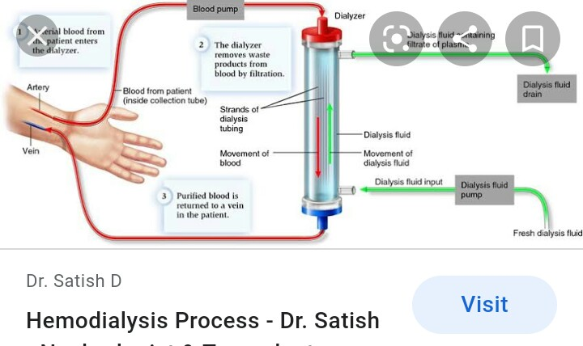

- Peritoneal dialysis; Uses a fluid (dialysate) that is placed into the patient’s abdominal cavity to remove waste products and fluid from the body. Peritoneal dialysis uses the patient’s own body tissues inside the body to act as the filter. A plastic tube called the peritoneal dialysis catheter is placed inside the abdominal cavity and a special fluid called the dialysalate is then flushed into the abdominal cavity to wash the intestines. The peritoneal membrane acts a filter between the fluid and blood stream. By using different types of solutions, waste products and excess water can be removed from the body.

