NNANNA NANCY CHINEMEREM

17/MHS01/203

MBBS 300LEVEL

PHS 303

RENAL PHYSIOLOGY BODY FLUID & TEMPERATURE
REGULATION ASSIGNMENT

QUESTION:
- Discuss the pathophysiological process involved in renal failure?

Chronic renal failure (CRF) and end-stage renal disease (ESRD) are functional diagnoses characterised by a progressive decrease in glomerular filtration rate (GFR). CRF occurs where GFR has been reduced to 10% of normal function (20 ml min–1) and ESRD when GFR falls below 5% (10 ml min–1). renal trans- plant (46%), 37% haemodialysis and 16% ambulatory peritoneal dialysis .

Pathological process involved in renal failure are:

Neurological abnormalities
Many patients with CRF have abnormalities in central (CNS) and peripheral nervous system function. There is a wide spectrum of CNS changes. for example, from mild personality alterations to asterixis (i.e. lapse of posture, usually manifest by bilateral flapping tremor), myoclonus, encephalopathy and convulsions. Peripheral neuropathy is common in advanced stages of the disease. Initially, it presents as a distal ‘glove and stocking’ sensory loss but then progresses to motor changes. Both dialysis and renal transplantation may improve the neuropathy. The presence of a peripheral neuropathy should alert the anaesthetist to the presence of an autonomic neuropathy with delayed gastric emptying, postural hypotension and silent myocardial ischaemia. Two types of neurological disturbances are unique to patients on dialysis. Dialysis dementia with dyspraxia, myoclonus and dementia aluminium toxicity. The dialysis disequilibrium syndrome is associated with rapid initial reduction in plasma urea concentrations at the start of dialysis.

Endocrine disturbances
Changes in parathyroid function and lipid clearance have been noted above. Glucose tolerance is impaired but there is a reduced requirement for exogenous insulin in diabetic patients, probably related to the reduced metabolism of insulin by the failing kidney. Patients with CRF have abnormalities of temperature regulation with reduced basal metabolic rate and a tendency to hypothermia. This is may by important when assessing fever.

Immune function
Sepsis is a leading cause of death in patients with CRF. Inhibition of cell-mediated immunity and humoral defence mechanisms occurs, with little improvement following dialysis. There is an increased production of pro-inflammatory cytokines suggesting that activation of monocytes may play a role in uraemic immune dysfunction. Superficial infections are common in fistula and catheter sites; wound healing is poor.
The incidence of viral hepatitis B has decreased somewhat following the introduction of erythropoietin and hepatitis B vaccination. There is also an increased incidence of hepatitis C infection in patients on haemodialysis and, although there is often little effect on liver function, it is of concern in patients undergoing renal trans- plantation and immunosuppression. Hospital staff must take pre- cautions against blood-borne viruses in these patients.

Acidosis
Chronic metabolic acidosis is a common feature of ESRD. The inability to secrete protons and buffers (e.g. phosphate) or to regenerate bicarbonate limits the clearance of hydrogen ions. Furthermore, reduction in glutamine utilisation reduces ammonia production and secretion into the proximal tubule. Retention of organic anions causes a progressive increase in the anion gap and a further fall in plasma bicarbonate concentration. Although plasma bicarbonate concentrations rarely fall below 12–15 mmol litre–1, there is little reserve to counter acute acidosis caused by ketoacidosis or sepsis.

pharmacokinetic changes
There are many pharmacokinetic changes in patients with CRF. Hypoalbuminaemia and acidosis increase free-drug availability
of highly protein bound drugs. The doses of benzodiazepines and thiopental should be reduced by 30–50%. Although the pharma- codynamics of propofol are unchanged in CRF and the metabolites lack sedative activity, changes in volume of distribution and mental state mean that a reduction in induction dose is also appropriate. The elimination of highly ionised, lipid-insoluble drugs is partially or completely dependent on renal excretion and may be markedly reduced. However, the duration of action of a single loading dose will be dependent on redistribution rather than excretion.
Most lipid-soluble analgesics are metabolised by the liver to water-soluble metabolites for renal excretion. Some of these metabolites may have far greater activity than the parent drug (e.g. morphine-6-glucuronide) or significant side-effects (e.g. nor-pethidine). Although fentanyl undergoes hepatic metabolism and is not thought to have active metabolites, its clearance is decreased in severe uraemia.
The elimination of volatile anaesthetic agents is not dependent on renal function and their activity is unaffected by CRF. The metabolism of both enflurane and sevoflurane will theoretically produce nephrotoxic fluoride ions and their use should be discouraged for prolonged durations. Nitrous oxide has little effect on the kidney. Atracurium and cisatracurium are obvious choices for muscle relaxation but limited doses of vecuronium and rocuronium are acceptable alternatives. Plasma cholinesterase activity is not thought to be affected by CRF. The excretion of anticholinesterases and anticholinergic agents will be prolonged.
Local anaesthetics are valuable agents for peri-operative pain control in CRF but their duration of action is reduced. Maximum doses of local anaesthetics should also be reduced by 25% because of reduced protein binding and a lower CNS seizure threshold.

Haematological abnormalities
A normochromic normocytic anaemia is a common finding in CRF. Decreased renal parenchymal erythropoietin production reduces stem cell transformation into erythrocytes, while uraemic toxins reduce red cell life. Chronic upper GI tract losses and those from dialysis further compound the problem. Dietary deficiency in iron and folate also occurs. The introduction in 1989 of synthetic erythropoietin has revolutionised the management of anaemia in these patients but a compensated relative anaemia is still to be expected. A rapid increase in haemoglobin concentration above 10 g dlitre–1 often worsens hypertension and may precipitate heart failure. Compensatory mechanisms increase 2,3-diphosphoglycerate production and move the oxyhaemoglobin dissociation curve to the right.

Calcium, phosphate, parathormone and renal osteodystrophy
Total plasma calcium concentration is reduced in CRF. Renal production of calcitriol (1,25-(OH)2D3) declines causing decreased intestinal absorption of calcium. Phosphate excretion is impaired as GFR falls below 20 ml min–1 and hyperphosphataemia develops. As phosphate concentrations increase, calcium phosphate is deposited in soft tissues such as skin and blood vessels further lowering plasma calcium concentration. Hyperphosphataemia also has a negative effect on 1-α-hydroxylase, the enzyme responsible for renal calcitriol production. Both hypocalcaemia and hyperphosphataemia are potent stimuli to parathormone secretion, leading to hyperplasia of the parathyroid gland and secondary hyperparathyroidism. This causes increased osteoclast and osteoblastic activity causing osteitis fibrosa cystica. Patients usually tolerate hypocalcaemia remarkably well, whilst oral calcitriol is prescribed and calcium carbonate is used both as an intestinal phosphate binder and a source of calcium.

Coagulopathy
Patients with CRF have a tendency to excessive bleeding in the peri-operative period. Standard tests of coagulation are usually normal (i.e. prothrombin time, activated partial thromboplastin.
time, international normalised ratio) and platelet count is with- in normal limits. However, platelet activity is deranged with decreased adhesiveness and aggregation, probably caused by inadequate vascular endothelial release of a von Willebrand factor/fac- tor VIII complex which binds to and activates platelets. Increased platelet release of thromboglobulin and vascular production of PGI2 also contribute to the coagulopathy. Defects in platelet adhesion may also be related to excessive nitric oxide (NO) production. The plasma from patients with CRF has been shown to be a potent inducer of endothelial NO production.
Measured bleeding time may be prolonged beyond 10 sec. Thrombocytopathy is not corrected by platelet transfusion but, where operative bleeding is problematical, it can be improved by dialysis. Rapid improvements in coagulation require the use of pooled cryoprecipitate or DDAVP (which enhances release of von Willebrand factor). DDAVP 0.3 μg kg–1 is effective within 1–2 h but has a duration of only 6–8 h and is subject to tachyphylaxis. Intravenous conjugated oestrogens have a slower onset but a longer duration of action (5–7 days). The risks of coagulopathic complications should be considered when choosing regional anaesthetic techniques in CR.

2) with the aid of suitable diagrams discuss the types of dialysis you know?
Dialysis is a treatment that filters and purifies the blood using a machine. This helps keep your fluids and electrolytes in balance when the kidneys can’t do their job.
Dialysis has been used since the 1940s to treat people with kidney problems.

Why is dialysis used?
Properly functioning kidneys prevent extra water, waste, and other impurities from accumulating in your body. They also help control blood pressure and regulate the levels of chemical elements in the blood. These elements may include sodium and potassium Your kidneys even activate a form of vitamin D that improves the absorption of calcium.
When your kidneys can’t perform these functions due to disease or injury, dialysis can help keep the body running as normally as possible. Without dialysis, salts and other waste products will accumulate in the blood, poison the body, and damage other organs.
However, dialysis isn’t a cure for kidney disease or other problems affecting the kidneys. Different treatments may be needed to address those concerns.
There are different types of dialysis:
- Primary (hemodialysis)
- Peritoneal dialysis ( primary)
- Hemofiltration ( primary)
- Hemodiafiltration (secondary)
- Intestinal dialysis ( secondary)

Hemodialysis
Hemodialysis is the most common type of dialysis. This process uses an artificial kidney (hemodialyzer) to remove waste and extra fluid from the blood. The blood is removed from the body and filtered through the artificial kidney. The filtered blood is then returned to the body with the help of a dialysis machine.
To get the blood to flow to the artificial kidney, your doctor will perform surgery to create an entrance point (vascular access) into your blood vessels. The three types of entrance points are:
- Arteriovenous (AV) fistula. This type connects an artery and a vein. It’s the preferred option.
- AV graft. This type is a looped tube.
- Vascular access catheter. This may be inserted into the large vein in your neck.
Both the AV fistula and AV graft are designed for long-term dialysis treatments. People who receive AV fistulas are healed and ready to begin hemodialysis two to three months after their surgery. People who receive AV grafts are ready in two to three weeks. Catheters are designed for short-term or temporary use.
Hemodialysis treatments usually last three to five hours and are performed three times per week. However, hemodialysis treatment can also be completed in shorter, more frequent sessions.
Most hemodialysis treatments are performed at a hospital, doctor’s office, or dialysis center. The length of treatment depends on your body size, the amount of waste in your body, and the current state of your health.
After you’ve been on hemodialysis for an extended period of time, your doctor may feel that you’re ready to give yourself dialysis treatments at home. This option is more common for people who need long-term treatment.

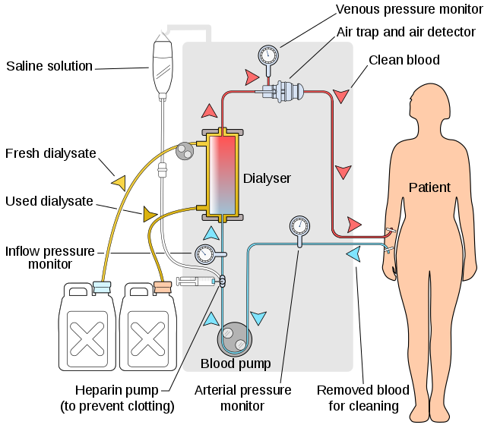
HEMODIALYSIS DIAGRAM

Peritoneal dialysis
Peritoneal dialysis involves surgery to implant a peritoneal dialysis (PD) catheter into your abdomen. The catheter helps filter your blood through the peritoneum, a membrane in your abdomen. During treatment, a special fluid called dialysate flows into the peritoneum. The dialysate absorbs waste. Once the dialysate draws waste out of the bloodstream, it’s drained from your abdomen.
This process takes a few hours and needs to be repeated four to six times per day. However, the exchange of fluids can be performed while you’re sleeping or awake.
There are numerous different types of peritoneal dialysis. The main ones are:
- Continuous ambulatory peritoneal dialysis (CAPD). In CAPD, your abdomen is filled and drained multiple times each day. This method doesn’t require a machine and must be performed while awake.
- Continuous cycling peritoneal dialysis (CCPD). CCPD uses a machine to cycle the fluid in and out of your abdomen. It’s usually done at night while you sleep.
- Intermittent peritoneal dialysis (IPD). This treatment is usually performed in the hospital, though it may be performed at home. It uses the same machine as CCPD, but the process takes longer.

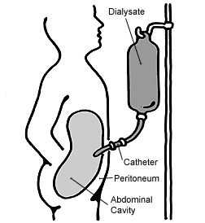
Peritoneal cavity

Continuous renal replacement therapy (CRRT)
This therapy is used primarily in the intensive care unit for people with acute kidney failure. It’s also known as hemofiltration. A machine passes the blood through tubing. A filter then removes waste products and water. The blood is returned to the body, along with replacement fluid. This procedure is performed 12 to 24 hours a day, generally every day.

Hemofiltration

Continuous veno-venous haemofiltration with pre- and post-dilution (CVVH)
Hemofiltration is a similar treatment to hemodialysis, but it makes use of a different principle. The blood is pumped through a dialyzer or "hemofilter" as in dialysis, but no dialysate is used. A pressure gradient is applied; as a result, water moves across the very permeable membrane rapidly, "dragging" along with it many dissolved substances, including ones with large molecular weights, which are not cleared as well by hemodialysis. Salts and water lost from the blood during this process are replaced with a "substitution fluid" that is infused into the extracorporeal circuit during the treatment.

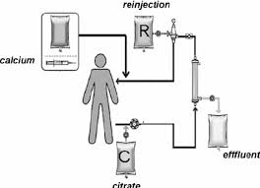
Continuous veno-venous haemofiltration with pre- and post-dilution (CVVH)

Hemodiafiltration
Hemodiafiltration is a combination of hemodialysis and hemofiltration, thus used to purify the blood from toxins when the kidney is not working normally and also used to treat acute kidney injury.

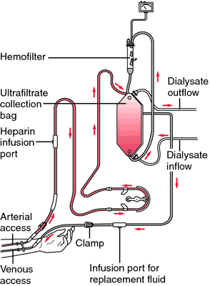

HEMODIAFLITRATION DIAGRAM

Intestinal dialysis

Continuous veno-venous haemodiafiltration (CVVHDF)
In intestinal dialysis, the diet is supplemented with soluble fibres such as acacia fibre which is digested by bacteria in the colon. This bacterial growth increases the amount of nitrogen that is eliminated in fecal waste. An alternative approach utilizes the ingestion of 1 to 1.5 liters of non-absorbable solutions of polyetheneglycol or mannitol every fourth hour.

