17/MHS06/049
Obikpo Chisom
MBBS
300 level
PHS 303
Renal Physiology, Body Fluid and Temperature regulation

- Discuss the pathophysiological process involved in renal failure
- With the aid of a suitable diagram, discuss the types of dialysis you know

- Pathophysiological process involved in renal failure
Renal failure is said to be a condition in which the kidneys lose the ability to remove waste and also lose the ability to balance fluids. diseases of the kidney are divided into four major groups according to the predominant involvement of corresponding morphological components:
- Glomerular diseases: these are most often immunologically-mediated and may be chronic or acute.
- Tubular diseases: these are more likely to be caused by toxic or infectious agents and are often acute.
- Interstitial diseases: these are likewise commonly due to toxic or infectious agents and quite often involve the interstitium as well as the tubules (tubulo-interstitial diseases).
- Vascular diseases: these include changes in the nephron as a consequence of increased imtraglomerular pressure such as hypertension or impaired blood flow.

Severe kidney diseases can be grouped into 2 namely:
- Chronic Kidney Disease (CKD).
- Acute Kidney Injury (AKI).

CHRONIC KIDNEY DISEASES
This is a disease of the kidney i’m which there is progressive loss of kidney function of more and more nephrons that gradually decrease the overall function. Chronic kidney disease (CKD) is usually defined as the presence of kidney damage or decreased kidney function that persists for at least 3 months. CKD is often associated with progressive and irreversible loss of large numbers of functioning neurons. Serious clinical symptoms usually don’t occur until the number of functional nephrons falls to at least 70-75% below normal. This is largely due to the shifting of pressure from one functional nephron to the other so that glomerular filteration can occur but once the number of functional nephrons decreases below 20-25% of normal, symptoms begin to manifest.
There are about four common causes of chronic kidney diseases, they include:
- Acute kidney injury
- Hypertension
- Diabetes Mellitus
- Other diseases

Acute Kidney injury
Often referred to as acute renal failure (ARF) for when there is severe acute kidney injury where the kidneys may abruptly stop working entirely. It is a syndrome characterized by rapid onset of renal dysfunction, chiefly oliguria or anuria and sudden increase in metabolic waste products in the blood with consequent development of uranemia. It is associated with abrupt loss of kidney function within a few days. The causes of AKI/ARF can be divided into 3 main categories:
- Prerenal AKI resulting from decreased blood supply to the kidneys, it is termed prerenal to reflect the abnormality originating from outside the kidneys. For example, prerenal aki can be a consequence of heart failure, decreased cardiac output and low blood pressure. Renal ischemia ultimately results in functional disorders or depression of the glomerulafiltration rate. Examples of some causes of prerenal AKI may include diarrhea, hemorrhages, cardiac failure, myocardial infarction, valvular damage, sepsis, anaphylactic shock and renal artery stenosis or embolism.
- Intrarenal AKI (disease of the renal tissue) resulting from abnormalities within the kidneys itself including those that affect the blood vessels, the glomeruli or the tubules. For example, acute tubular necrosis due to ischemia, disease of the glomeruli, or the effect of nephrotixin, or pyelonephritis caused by bacteria from the urinary tract. Example of some causes of intrarenal AKI may include cholesterol emboli, acute glomerulonephritis, malignant hypertension, acute pyelonephritis, acute allergic interstitial nephritis.
- Postremal AKI resulting from the obstruction of the urinary collecting system anywhere from the calyces.
It is important to note that AKI originating from prerenal or postrenal diseases such as renal ischemia or renal infection eventually leads to intrarenal diseases.

The effect of decreased blood flow to the kidneys causes decreased glomeruli filtration rate (GFR) which decreases the urine output of water and solutes. The main purpose of high blood flow to the kidneys is to provide enough plasma for the high rates of glomerular filtration needed for effective regulation of body fluids volumes and solute concentrations.

Abnormalities that originate within the kidney and that abruptly diminish urine output fall into the general category of intrarenal AKI. This category of AKI can be further divided into (1) conditions that injure the glomerular capillaries or other small renal vessels, (2) conditions that damage the renal tubular epithelium, and (3) conditions that cause damage to the renal interstitium. This type of classification refers to the primary site of injury, but because the renal vasculature and tubular system are functionally interdependent, damage to the renal blood vessels can lead to tubular damage, and primary tubular damage can lead to damage of the renal blood flow.

Multiple abnormalities in the lower urinary tract can block or partially block urine flow and therefore lead to AKI even when the kidneys’ blood supply and other functions re initially normal. If the urine output of only one kidney is diminished, no major change in body fluid com­ position will occur because the contralateral kidney can increase its urine output sufficiently to maintain relatively normal levels of extracellular electrolytes and solutes, as well as normal extracellular fluid volume. With this type of renal injury, normal kidney function can be restored if the basic cause of the problem is corrected within a few hours. However, chronic obstruction of the urinary tract that lasts for several days or weeks can lead to irreversible kidney damage. Some of the causes of postrenal AKI include (1) bilateral obstruction of the ureters or renal pelvises caused by large stones or blood clots, (2) bladder obstruction, and (3) obstruction of the urethra.
Hypertension

Hypertension often occurs when the artery of one kidney is constricted while the artery of the other kidney is still normal. Hypertension can exacerbate injury to the glomeruli and blood vessels of the kidneys and is a major cause of ESRD. Abnormalities of kidney function can also cause hypertension, thus, the relation between hypertension and kidney disease can, in some instances, propagate a vicious cycle: primary kidney damage leads to increased blood pressure, which causes further damage to the kidneys, further increases in blood pressure, and so forth, until ESRD develops.
Your kidneys and your circulatory system depend on each other for good health. The kidneys help filter wastes and extra fluids from blood, and they use a lot of blood vessels to do so. When the blood vessels become damaged, the nephrons that filter your blood don’t receive the oxygen and nutrients they need to function well. This is why high blood pressure (HBP or hypertension) is the second leading cause of kidney failure

Over time, uncontrolled high blood pressure can cause arteries around the kidneys to narrow, weaken or harden. These damaged arteries are not able to deliver enough blood to the kidney tissue. Damaged kidney arteries do not filter blood well. The nephrons in the kidneys are supplied with a dense network of blood vessels, and high volumes of blood flow through them.

Damaged kidney arteries do not filter blood well. Kidneys have small, finger-like nephrons that filter your blood. Each nephron receives its blood supply through tiny hair-like capillaries, the smallest of all blood vessels. When the arteries become damaged, the nephrons do not receive the essential oxygen and nutrients — and the kidneys lose their ability to filter blood and regulate the fluid, hormones, acids and salts in the body.
Damaged kidneys fail to regulate blood pressure. Healthy kidneys produce a hormone called aldosterone to help the body regulate blood pressure. Kidney damage and uncontrolled high blood pressure each contribute to a negative spiral. As more arteries become blocked and stop functioning, the kidneys eventually fail.
Excess weight gain is also a major cause of essential hypertension, accounting for as much as 65 to 75 percent of the risk for developing hypertension in adults.

Diabetes Mellitus

DM is a metabolic disease that causes renal failure, and renal failure increases the need for insulin in diabetic patients.
The accumulation of uremic toxins and increased parathyroid hormone levels in patients with chronic renal failure (CRF) cause insulin resistance in tissues, particularly skeletal muscle tissues. This has been attributed to damage in the process after insulin binding to its receptors, which disturbs glucose metabolism and glycogen production. It also seems that anemia caused by CRF has an impact on insulin resistance, and the correction of anemia by erythropoietin has been shown to increase insulin sensitivity in the body.]

Insulin secretion is also reduced in patients with CRF, which appears to be due to metabolic acidosis, elevated levels of parathyroid hormone, and decreased level of vitamin D.

VICIOUS CYCLE OF CHRONIC KIDNEY DISEASE LEADING TO END-STAGE RENAL DISEASE

In some cases, an initial insult to the kidney leads to progressive deterioration of kidney function and further loss of nephrons to the point where the person must receive dialysis treatment or undergo transplantation with a functional kidney to survive. This condition is referred to as end-stage renal disease (ESRD).
The most common causes of ESRD are both hypertension and diabetes mellitus. Studies in laboratory animals have shown that surgical removal of large portions of the kidney initially causes adaptive changes in the remaining nephrons that lead to increased blood flow, increased GFR, and increased urine output in the surviving nephrons. The exact mechanisms responsible for these changes are not well understood but involve hypertrophy (growth of the various structures of the surviving nephrons), as well as functional changes that decrease vascular resistance and tubular reabsorption in the surviving nephrons. These adaptive changes permit a person to excrete normal amounts of water and solutes even when kidney mass is reduced to 20 to 25 percent of normal. Over a period of several years, however, these renal adaptive changes may lead to further injury of the remaining nephrons, particularly to the glomeruli of these nephrons.
The cause of this additional injury is not fully undestood

Clinical Features

Clinical manifestations of full blown CKD culminating in uraemic syndrome are described under 2 main headings:
- Primary (renal) uraemic manifestation.
- Secondary ( systemic or extra-renal) uraemic.

Primary (renal) uraemic manifestations: primary symptoms of uraemia develop when there is slow and progressive retardation of renal function. The resulting and balances causes the following
- metabolic acidosis.As a result of renal dysfunction, acid base balance is progressively lost. Excess of hydrogen ions accumulate meanwhile there is a decline of bicarbonate ions resulting in metabolic acidosis.
The clinical symptoms for metabolic acidosis include: Compensatory breathing, hyperkalemia and hypercalcemia
- hyperkalemia: A decreased GFR results in excess accumulation of potassium ions in the blood since potassium is normally excreted in the urine. The clinical features include; muscle weakness, cardiac arrhythmias, nausea, intestinal colic, diarrhea, muscular irritability & paralysis.
- Sodium and water imbalance: as GFR declines sodium and water cannot pass sufficiently into the bowmans capsule leading to their retention. Release of reninfrom
- apparatus further aggravates sodium and water retention.
- Hyperuricemia: decreased GFR results in increased accumulation of uric acid in the blood. Uric acid crystals may be deposited in the joints and soft tissues resulting in gout.
- Azotemia: The waste products of protein metabolism fail to be excreted resulting in elevation in blood levels of urea, creatinine, phenols and guanidines resulting in this abnormality.

Secondary uraemic (extra-renal) manifestations
A number of extra-renal systemic manifestations develop secondarily following fluid-electrolyte and acid-base balance. These include:
- Anemia: Decrease production of erythropoiesis seen by the diseased kidney results in decline of erythropoietin and anemia. Besides, gastrointestinal bleeding may further aggravate anemia
- Integumentary system: deposit of urinary pigment such as urochrome in the skin causes sallow -yellow color. The urea content in the sweat as well as in the plasma rises.
- cardiovascular system. Fluid retention secondarily causes Cardiovascular symptoms such as increased workload on the heart due to hypervolaemia and eventually congestive heart failure.
- Respiratory system: Hypervolaemia and heart failure cause pulmonary congestion and pulmonary oedema due to back pressure.
- digestive system: Azotaemia directly induces mucosal ulceration sin the lining of the stomach and the intestines. Subsequent bleeding can aggravate existing anemia. Gastrointestinal irritation may cause nausea, vomiting and diarrhea.

Types of dialysis

Dialysis also referred to as renal replacement therapy is a treatment for kidney failure that rids your body of unwanted wastes and toxins and excess fluid by filtering your blood. Dialysis performs the function of the kidneys if they’ve failed. Dialysis is a treatment that filters and purifies the blood using a machine. This helps keep your fluids and electrolytes in balance when the kidneys can’t do their job.

Dialysis is also used in certain types of AKI to tide the patient over until the kidneys resume their function. If the loss of kidney function is irreversible, it is necessary to perform dialysis chronically to maintain life. Because dialysis cannot maintain completely normal body fluid composition and cannot replace all the multiple functions performed by the kidneys, the health of patients maintained with use of artificial kidneys usually remains significantly impaired

Basic Principles of Dialysis
The basic principle of the artificial kidney is to pass blood through minute blood channels bounded by a thin membrane. On the other side of the membrane is a dialyzing fluid into which unwanted substances in the blood pass by diffusion.

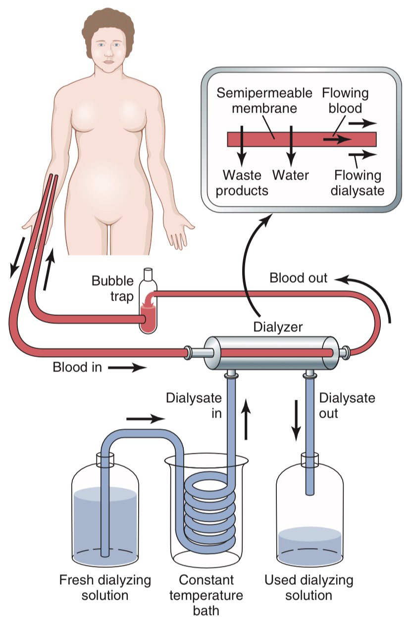
Types of dialysis
There are 3 different types of dialysis:

Hemodialysis

Hemodialysis is the most common type of dialysis. This process uses an artificial kidney (hemodialyzer) to remove waste and extra fluid from the blood. The blood is removed from the body and filtered through the artificial kidney. The filtered blood is then returned to the body with the help of a dialysis machine.

To get the blood to flow to the artificial kidney, your doctor will perform surgery to create an entrance point (vascular access) into your blood vessels. The three types of entrance points are:

-Arteriovenous (AV) fistula. This type connects an artery and a vein. It’s the preferred option.
- AV graft. This type is a looped tube.
- Vascular access catheter. This may be inserted into the large vein in your neck.
Both the AV fistula and AV graft are designed for long-term dialysis treatments. People who receive AV fistulas are healed and ready to begin hemodialysis two to three months after their surgery. People who receive AV grafts are ready in two to three weeks. Catheters are designed for short-term or temporary use.

Hemodialysis treatments usually last three to five hours and are performed three times per week. However, hemodialysis treatment can also be completed in shorter, more frequent sessions.

Most hemodialysis treatments are performed at a hospital, doctor’s office, or dialysis center. The length of treatment depends on your body size, the amount of waste in your body, and the current state of your health.

After you’ve been on hemodialysis for an extended period of time, your doctor may feel that you’re ready to give yourself dialysis treatments at home. This option is more common for people who need long-term treatment.
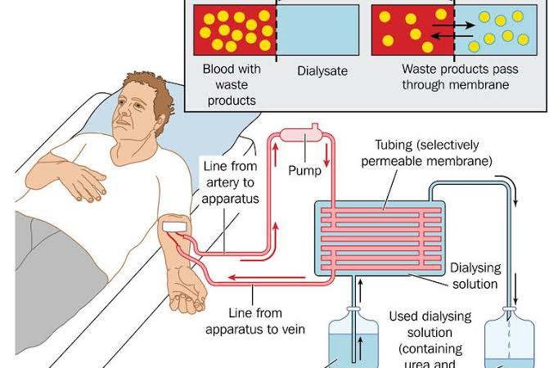
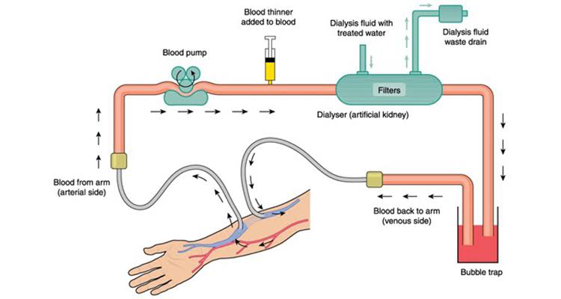

Peritoneal dialysis

Peritoneal dialysis involves surgery to implant a peritoneal dialysis (PD) catheter into your abdomen. The catheter helps filter your blood through the peritoneum, a membrane in your abdomen. During treatment, a special fluid called dialysate flows into the peritoneum. The dialysate absorbs waste. Once the dialysate draws waste out of the bloodstream, it’s drained from your abdomen.

This process takes a few hours and needs to be repeated four to six times per day. However, the exchange of fluids can be performed while you’re sleeping or awake.

There are numerous different types of peritoneal dialysis. The main ones are:

- Continuous ambulatory peritoneal dialysis (CAPD). In CAPD, your abdomen is filled and drained multiple times each day. This method doesn’t require a machine and must be performed while awake.
- Continuous cycling peritoneal dialysis (CCPD). CCPD uses a machine to cycle the fluid in and out of your abdomen. It’s usually done at night while you sleep.
- Intermittent peritoneal dialysis (IPD). This treatment is usually performed in the hospital, though it may be performed at home. It uses the same machine as CCPD, but the process takes longer.

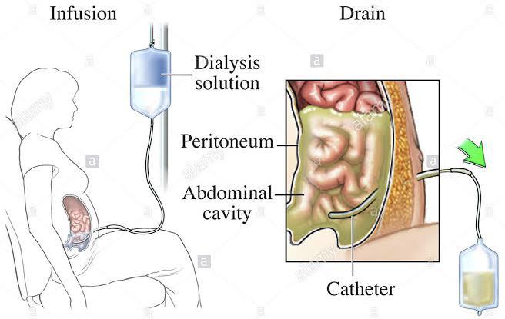
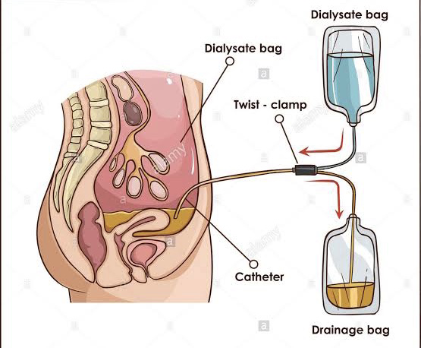

Continuous renal replacement therapy (CRRT)

This therapy is used primarily in the intensive care unit for people with acute kidney failure. It’s also known as hemofiltration. A machine passes the blood through tubing. A filter then removes waste products and water. The blood is returned to the body, along with replacement fluid. This procedure is performed 12 to 24 hours a day, generally every day.

