NAME: SOJI-OYE IREOLUWA FAITH

MATRIC NO: 17/ MHS05/019

DEPARTMENT: MEDICINE AND SURGERY

COURSE TITLE: RENAL PHYSIOLOGY, BODY FLUIDS AND TEMPERATURE REGULATION

- PATHOPHYSIOLOGICAL PROCESS INVOLVING RENAL FAILURE
Renal failure is also called Kidney Failure. This is a condition in which the kidneys lose the ability to remove waste and balance fluids. Renal failure could be chronic or acute but which ever it is, there are underlying pathophysiological processes involved before the kidneys fails.
CHRONIC KIDNEY DISEASE (C.K.D): CKD is usually defined as the presence of kidney damage or decreased kidney function that persists for at least 3 months. CKD is often associated with progressive and irreversible loss of large numbers of functioning nephrons. Serious clinical symptoms usually do not occur until the number of functional nephrons falls to at least 70 to 75 percent below normal. In fact, relatively normal blood concentrations of most electrolytes and normal body fluid volumes can still be maintained until the number of
functioning nephrons decreases below 20 to 25 percent of normal. When discussing the pathophysiology of CKD, renal structural and physiological characteristics, as well as the principles of renal tissue injury and repair should be taken into consideration.

INJURY TO THE GLOMERULI AS A CAUSE OF CHRONIC KIDNEY
DISEASE—GLOMERULONEPHRITIS; chronic glomerulonephritis can be caused by several diseases that cause inflammation and damage to the capillary
loops in the glomeruli of the kidneys. In contrast to the acute form of this disease, chronic glomerulonephritis is a slowly progressive disease that often leads to irreversible renal failure. It may be a primary kidney disease, following acute glomerulonephritis, or it may be secondary to systemic diseases, such as systemic lupus erythematosus.
In most cases, chronic glomerulonephritis begins with accumulation of precipitated antigen-antibody complexes in the glomerular membrane. In contrast to acute glomerulonephritis, streptococcal infections account for
only a small percentage of patients with the chronic form of glomerulonephritis. Accumulation of antigen-antibody complex in the glomerular membranes causes inflammation, progressive thickening of the membranes, and eventual invasion of the glomeruli by fibrous tissue. In the later stages of the disease, the glomerular capillary filtration coefficient becomes greatly reduced because of decreased numbers of filtering capillaries in the glomerular tufts and because of thickened glomerular membranes. In the final stages of the disease, many glomeruli are
replaced by fibrous tissue and are, therefore, unable to filter fluid.

INJURY TO THE RENAL INTERSTITIUM AS A CAUSE OF CHRONIC KIDNEY DISEASE—INTERSTITIAL NEPHRITIS; primary or secondary disease of the renal interstitium is referred to as interstitial nephritis. In general, this condition can result from vascular, glomerular, or tubular damage that destroys individual nephrons, or it can involve primary damage to the renal interstitium by poisons, drugs, and bacterial infections.
Renal interstitial injury caused by bacterial infection is called pyelonephritis. The infection can result from different types of bacteria but especially from Escherichia coli that originate from fecal contamination of the urinary
tract. These bacteria reach the kidneys either by way of the blood stream or, more commonly, by ascension from the lower urinary tract by way of the ureters to the kidneys.
Although the normal bladder is able to clear bacteria readily, there are two general clinical conditions that may interfere with the normal flushing of bacteria from the bladder: (a) the inability of the bladder to empty completely, leaving residual urine in the bladder, and (b) obstruction of urine outflow. With impaired ability to flush bacteria from the bladder, the bacteria multiply and the bladder becomes inflamed, a condition termed cystitis. Once cystitis has occurred, it may remain localized without ascending to the kidney, or in some people, bacteria
may reach the renal pelvis because of a pathological condition in which urine is propelled up one or both of the ureters during micturition. This condition is called
vesicoureteral reflux and is due to the failure of the bladder wall to occlude the ureter during micturition; as a result, some of the urine is propelled upward toward the kidney, carrying with it bacteria that can reach the renal pelvis
and renal medulla, where they can initiate the infection and inflammation associated with pyelonephritis. Pyelonephritis begins in the renal medulla and therefore usually affects the function of the medulla more than it affects the cortex, at least in the initial stages. Because one of the primary functions of the medulla is to provide the countercurrent mechanism for concentrating urine,
patients with pyelonephritis frequently have markedly impaired ability to concentrate the urine. With long-standing pyelonephritis, invasion of the
kidneys by bacteria not only causes damage to the renal medulla interstitium but also results in progressive damage of renal tubules, glomeruli, and other structures throughout the kidney. Consequently, large parts of functional
renal tissue are lost and CKD can develop.

NEPHROTIC SYNDROME—EXCRETION OF PROTEIN IN THE URINE BECAUSE OF
INCREASED GLOMERULAR PERMEABILITY; Nephrotic syndrome, which is characterized by loss of large quantities of plasma proteins into the urine,
develops in many patients with kidney disease. In some instances, this syndrome occurs without evidence of other major abnormalities of kidney function, but more often it is associated with some degree of CKD. The cause of the protein loss in the urine is increased permeability of the glomerular membrane. Therefore, any disease that increases the permeability of this membrane can cause the nephrotic syndrome.
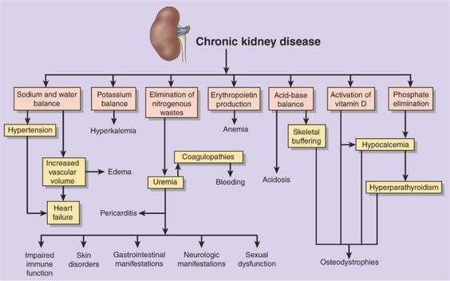

ACUTE KIDNEY DISEASE (A.K.D): also known as ACUTE KIDNEY INJURY (A.K.I) is the disease in which there is an abrupt loss of kidney function within a few days; the term acute renal failure is usually reserved for severe acute kidney injury where the kidneys may abruptly stop working entirely or almost entirely, necessitating renal replacement therapy such as dialysis. In some instances, patients with AKI may eventually recover nearly normal kidney function.
The causes of AKI can be divided into three main categories:
- AKI resulting from decreased blood supply to the kidneys. This condition is often referred to as prerenal AKI to reflect an abnormality originating outside the kidneys. For example, prerenal AKI can be a consequence of heart failure with reduced cardiac output and low blood pressure or conditions associated with diminished blood volume and low blood pressure, such as severe hemorrhage.
- Intrarenal AKI resulting from abnormalities within the kidney itself, including those that affect the blood vessels, glomeruli, or tubules.
- Postrenal AKI, resulting from obstruction of the urinary collecting system anywhere from the calyces to the outflow from the bladder. The most common causes of obstruction of the urinary tract outside the kidney are kidney stones, caused by precipitation of calcium, urate, or cystine.

PRERENAL ACUTE KIDNEY INJURY CAUSED BY DECREASED BLOOD
FLOW TO THE KIDNEY; the kidneys normally receive an abundant blood supply
of about 1100 ml/min, or about 20 to 25 percent of the cardiac output. The main purpose of this high blood flow to the kidneys is to provide enough plasma for the
high rates of glomerular filtration needed for effective regulation of body fluid volumes and solute concentrations. Therefore, decreased renal blood flow is usually accompanied by decreased GFR and decreased urine output of water and solutes. Consequently, conditions that acutely diminish blood flow to the kidneys usually cause oliguria, which refers to diminished urine output
below the level of intake of water and solutes. This condition causes accumulation of water and solutes in the body fluids. If renal blood flow is markedly reduced, total cessation of urine output can occur, a condition referred to
as anuria.
As long as renal blood flow does not fall below about 20 to 25 percent of normal, AKI can usually be reversed if the cause of the ischemia is corrected before damage to the renal cells has occurred. Unlike some tissues, the kidney can endure a relatively large reduction in blood flow before actual damage to the renal cells occurs. The reason for this phenomenon is that as renal blood flow is
reduced, the GFR and the amount of sodium chloride filtered by the glomeruli (as well as the filtration rate of water and other electrolytes) are reduced. This decreases the amount of sodium chloride that must be reabsorbed by the tubules, which use most of the energy and oxygen consumed by the normal kidney. Therefore, as renal blood flow and GFR fall, the requirement for renal oxygen consumption is also reduced. As the GFR approaches zero, oxygen consumption of the kidney approaches the rate that is required to keep the renal tubular cells alive even when they are not reabsorbing sodium. When blood flow
is reduced below this basal requirement, which is usually less than 20 to 25 percent of the normal renal blood flow, the renal cells become hypoxic, and further decreases in renal blood flow, if prolonged, will cause damage or even
death of the renal cells, especially the tubular epithelial cells.
If the cause of prerenal AKI is not corrected and ischemia of the kidney persists longer than a few hours, this type of renal failure can evolve into intrarenal AKI, as
discussed later. Acute reduction of renal blood flow is a common cause of AKI in hospitalized patients, especially those who have sustained severe injuries.

INTRARENAL ACUTE KIDNEY INJURY CAUSED BY ABNORMALITIES WITHIN
THE KIDNEY; abnormalities that originate within the kidney and that abruptly diminish urine output fall into the general category of intrarenal AKI. This category of AKI can be further divided into (a) conditions that injure the
glomerular capillaries or other small renal vessels, (b) conditions that damage the renal tubular epithelium and (c) conditions that cause damage to the renal interstitium. This type of classification refers to the primary site of injury, but because the renal vasculature and tubular system are functionally interdependent, damage to the renal blood vessels can lead to tubular damage, and primary tubular damage can lead to damage of the renal blood vessels.

Acute Kidney Injury Caused by Glomerulonephritis; acute glomerulonephritis is a type of intrarenal AKI usually caused by an abnormal immune reaction that
damages the glomeruli. In about 95 percent of the patients with this disease, damage to the glomeruli occurs 1 to 3 weeks after an infection elsewhere in the body, usually caused by certain types of group A beta streptococci. The infection may have been a streptococcal sore throat, streptococcal tonsillitis, or even streptococcal infection of the skin. It is not the infection itself that damages
the kidneys. Instead, over a few weeks, as antibodies develop against the streptococcal antigen, the antibodies and antigen react with each other to form an insoluble immune complex that becomes entrapped in the glomeruli, especially in the basement membrane portion of the glomeruli.
Once the immune complex has deposited in the glomeruli, many of the cells of the glomeruli begin to proliferate but mainly the mesangial cells that lie between
the endothelium and the epithelium. In addition, large numbers of white blood cells become entrapped in the glomeruli. Many of the glomeruli become blocked by this inflammatory reaction, and those that are not blocked usually become excessively permeable, allowing both protein and red blood cells to leak from the blood of the glomerular capillaries into the glomerular filtrate. In severe cases, either total or almost complete renal shutdown occurs.
The acute inflammation of the glomeruli usually subsides in about 2 weeks and, in most patients, the kidneys return to almost normal function within the next few
weeks to few months. Sometimes, however, many of the glomeruli are destroyed beyond repair, and in a small percentage of patients, progressive renal deterioration continues indefinitely, leading to CKD.

Tubular Necrosis as a Cause of Acute Kidney Injury; another cause of intrarenal acute renal failure is tubular necrosis, which means destruction of epithelial cells in the tubules. Some common causes of tubular necrosis are (a) severe ischemia and inadequate supply of oxygen and nutrients to the tubular epithelial cells and (b) poisons, toxins, or medications that destroy the tubular epithelial cells.

Acute Tubular Necrosis Caused by Severe Renal Ischemia; severe ischemia of the kidney can result from circulatory shock or other disturbances that severely impair the blood supply to the kidneys. If the ischemia is severe enough to seriously impair the delivery of nutrients and oxygen to the renal tubular epithelial cells, and if the insult is prolonged, damage or eventual destruction of the epithelial cells can occur. When this damage occurs, tubular cells “slough off” and plug many of the nephrons, so that there is no urine output from the blocked nephrons; the affected nephrons often fail to excrete urine even when renal blood flow is restored to normal, as long as the tubules remain plugged. The most common causes of ischemic damage to the tubular epithelium are the prerenal
causes of AKI associated with circulatory shock.
Acute Tubular Necrosis Caused by Toxins or Medications; there is a long list of renal poisons and medications that can damage the tubular epithelium and cause
AKI. Some of these substances are carbon tetrachloride, heavy metals (such as mercury and lead), ethylene glycol (which is a major component in antifreeze), various insecticides, some medications (such as tetracyclines) used as
antibiotics, and cis-platinum, which is used in treating certain cancers. Each of these substances has a specific toxic action on the renal tubular epithelial cells, causing death of many of them. As a result, the epithelial cells slough away from the basement membrane and plug the tubules. In some instances, the basement membrane also is destroyed. If the basement membrane remains intact,
new tubular epithelial cells can grow along the surface of the membrane, so the tubule may repair itself within 10 to 20 days.

POSTRENAL ACUTE KIDNEY INJURY CAUSED BY ABNORMALITIES
OF THE LOWER URINARY TRACT; multiple abnormalities in the lower urinary tract can block or partially block urine flow and therefore lead to AKI even when the kidneys’ blood supply and other functions are initially normal. If the urine output of only one kidney is diminished, no major change in body fluid composition
will occur because the contralateral kidney can increase its urine output sufficiently to maintain relatively normal levels of extracellular electrolytes and solutes, as well as normal extracellular fluid volume. With this type of renal injury, normal kidney function can be restored if the basic cause of the problem is corrected within a few hours. However, chronic obstruction of the urinary tract
that lasts for several days or weeks can lead to irreversible kidney damage. Some of the causes of postrenal AKI include; (a) bilateral obstruction of the ureters or renal pelvises caused by large stones or blood clots, (b) bladder obstruction, and (c) obstruction of the urethra.

- TYPES OF DIALYSIS
Dialysis is the process of removing excess water, solutes, and toxins from the blood in people whose kidneys can no longer perform these functions naturally. Dialysis is used in patients with rapidly developing loss of kidney function, called acute kidney injury, or slowly worsening kidney function, called stage 5 chronic kidney disease. Types of dialysis are:
- Hemodialysis

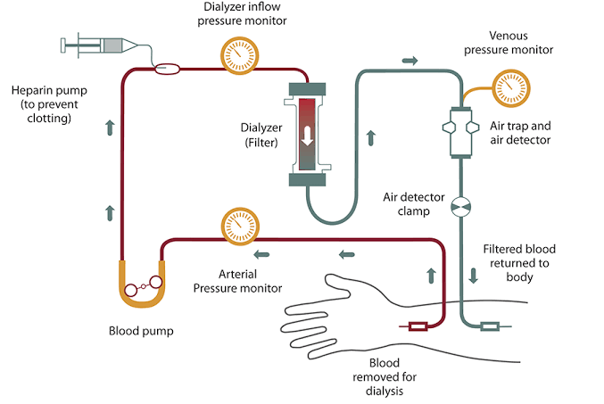
In hemodialysis, the patient's blood is pumped through the blood compartment of a dialyzer, exposing it to a partially permeable membrane. The dialyzer is composed of thousands of tiny hollow synthetic fibers. The fiber wall acts as the semipermeable membrane. Blood flows through the fibers, dialysis solution flows around the outside of the fibers, and water and wastes move between these two solutions. The cleansed blood is then returned via the circuit back to the body. Ultrafiltration occurs by increasing the hydrostatic pressure across the dialyzer membrane. This usually is done by applying a negative pressure to the dialysate compartment of the dialyzer. This pressure gradient causes water and dissolved solutes to move from blood to dialysate and allows the removal of several litres of excess fluid during a typical 4-hour treatment.

Disadvantages
- Restricts independence, as people undergoing this procedure cannot travel around because of supplies' availability.
- Requires more supplies such as high water quality and electricity.
- Requires reliable technology like dialysis machines.
- The procedure is complicated and requires that care givers have more knowledge.

- Peritoneal dialysis

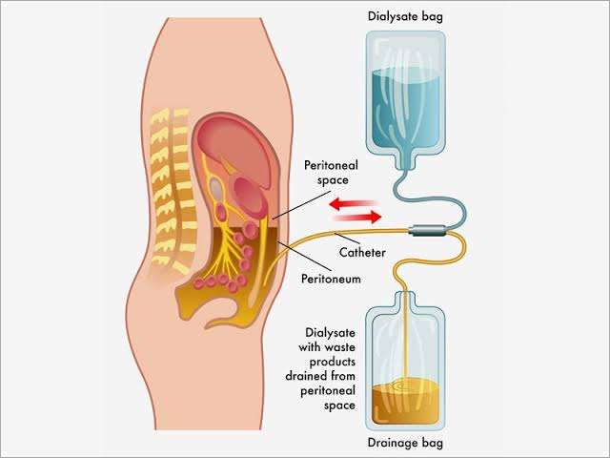
In peritoneal dialysis, a sterile solution containing glucose (called dialysate) is run through a tube into the peritoneal cavity, the abdominal body cavity around the intestine, where the peritoneal membrane acts as a partially permeable membrane.
This exchange is repeated 4–5 times per day; automatic systems can run more frequent exchange cycles overnight. Peritoneal dialysis is less efficient than hemodialysis, but because it is carried out for a longer period of time the net effect in terms of removal of waste products and of salt and water are similar to hemodialysis. Peritoneal dialysis is carried out at home by the patient, often without help. This frees patients from the routine of having to go to a dialysis clinic on a fixed schedule multiple times per week. Peritoneal dialysis can be performed with little to no specialized equipment (other than bags of fresh dialysate).
Complications may include infections within the abdomen, hernias, high blood sugar, bleeding in the abdomen, and blockage of the catheter. Use is not possible in those with significant prior abdominal surgery or inflammatory bowel disease. It requires some degree of technical skill to be done properly.
- Continuous Renal Replacement Therapy (CRRT)
This therapy is used primarily in the intensive care unit for people with acute kidney failure. It is also known as Hemofiltration. A machine passes the blood through a tubing, a filter then removes waste product and excess water. The blood is returned to the body along with replacement fluid. This procedure is performed 12 to 24 hours a day, generally every day.

